 | Pimpri Chinchwad Education Trust’s  Pimpri Chinchwad College of Engineering  (PCCoE)  (An Autonomous Institute)  Affiliated to Savitribai Phule Pune University(SPPU) ISO 21001:2018 Certified by TUV | 

Course: Software Testing and Quality Assurance Laboratory | Code: BIT26PE11
Name: Amar Vaijinath Chavan | PRN: 124B2F001
Assignment 4: Prepare a Defect Tracking Report / Bug Report using any Defect Tracking Tool

Aim
To prepare a Defect Tracking Report / Bug Report using a defect tracking tool to identify, record, and manage software defects in a web-based Hotel Management System.
Objectives
- To understand the concept of defect tracking in software testing.
- To learn how to use Jira for managing bugs.
- To identify and report defects in the Hotel Management System.
- To record bug details such as summary, priority, and status.
- To understand the bug life cycle in defect management.

Theory:
Jira is a popular issue and defect tracking tool developed by Atlassian. It helps teams manage software development tasks, track bugs, assign issues to developers, and monitor project progress. Jira provides features like issue tracking, workflow management, and reporting.
Bug in HMS:
After successful user registration in the Hotel Management System, the user is unable to log in using the same username and password. The system displays an error message “Invalid username or password” even though the credentials entered are correct. This indicates a possible issue with the login validation or database storage of user credentials.

- Created an account on Jira.



- Created a new space for the Hotel Management System.
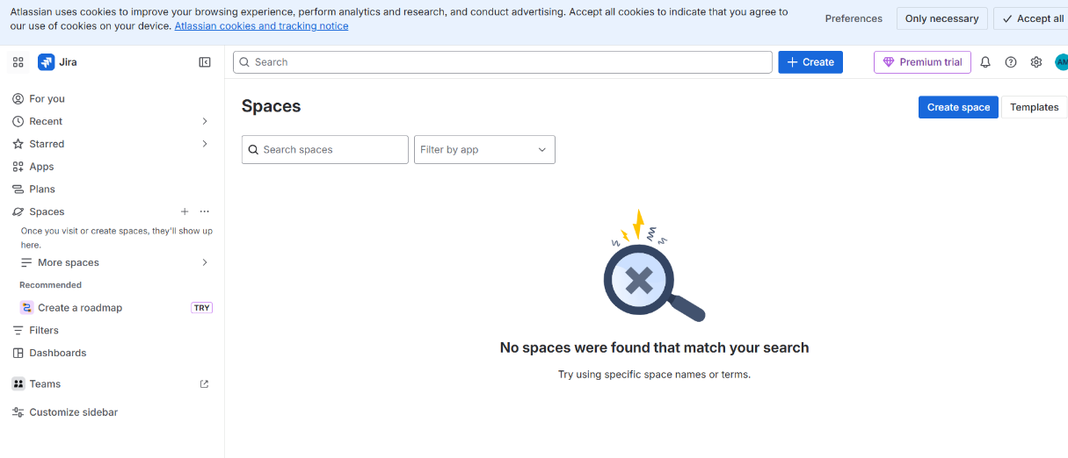
- Selected the Bug Tracking template.
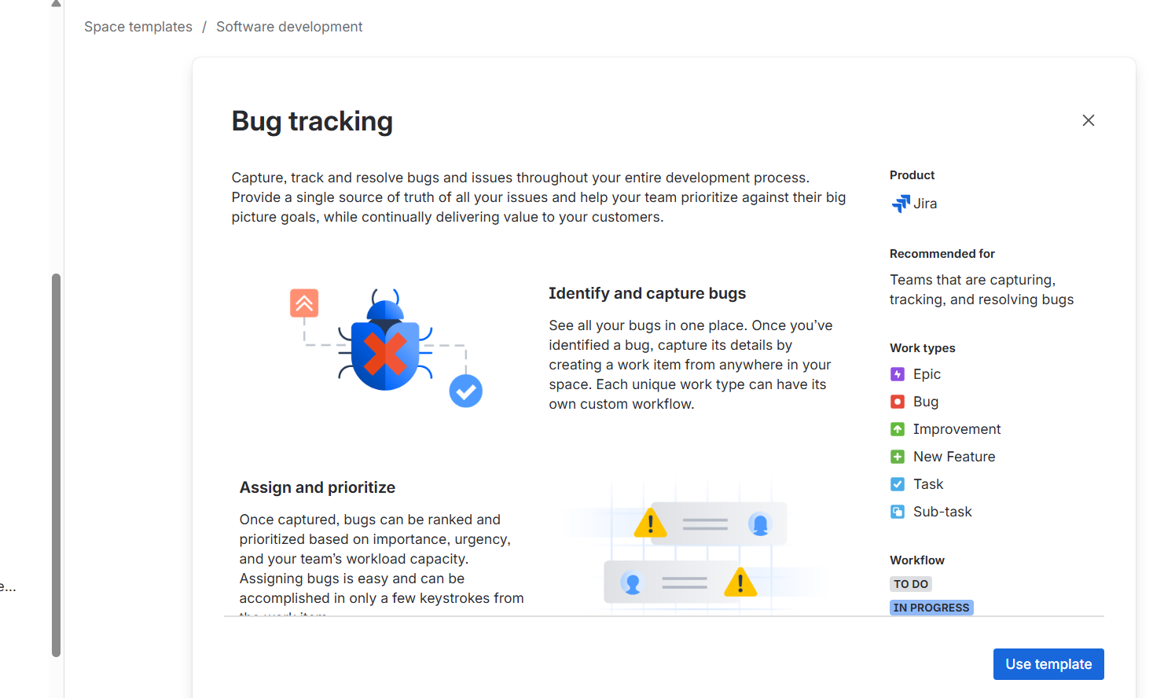
- Created bug issues using the "Create" button.
- Added bug details such as summary, description, priority, and status.

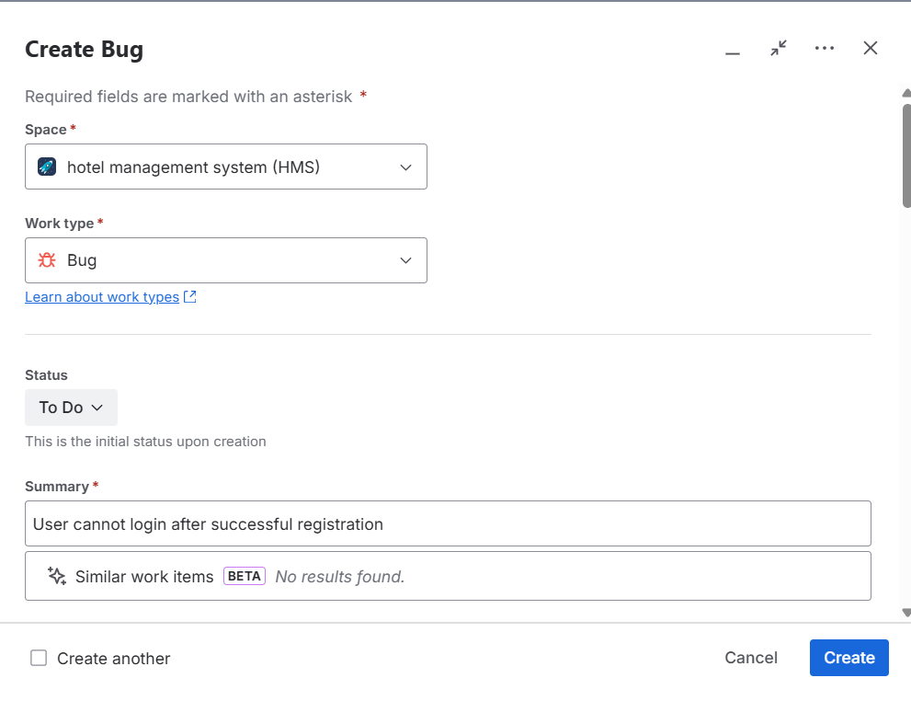
- Tracked bugs using the Jira issue list and workflow.

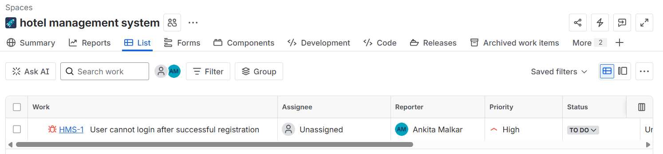

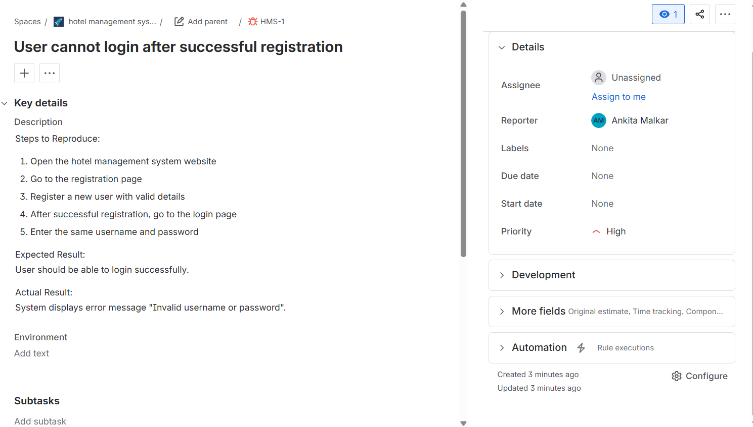

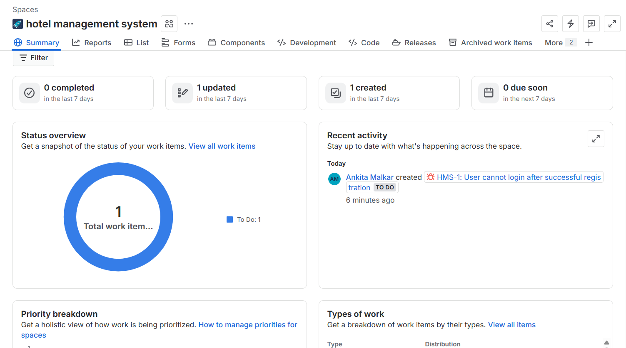

Conclusion
This assignment helped to understand the concept of defect tracking in software testing. Using Jira, bugs in the Hotel Management System were identified and recorded efficiently. The tool made it easier to track issues, assign priorities, and monitor their status. Defect tracking helps improve software quality by ensuring that problems are properly documented and resolved during development.

