 | Pimpri Chinchwad Education Trust’s  Pimpri Chinchwad College of Engineering  (PCCoE)  (An Autonomous Institute)  Affiliated to Savitribai Phule Pune University(SPPU) ISO 21001:2018 Certified by TUV | 
Course: Software Testing and Quality Assurance Laboratory | Code: BIT26PE11
Name: Amar Vaijinath Chavan | PRN: 124B2F001
Assignment 5: Implement an automated test using Selenium WebDriver and WebDriver Manager in Python/Java for a sample or real website, simulating a given scenario and verifying its success.

1. OBJECTIVE
- To design and implement automated System Test cases for the "Hotel Management System" login module.
- To utilize Selenium WebDriver for simulating real-world user interactions within a web browser.
- To verify the end-to-end integrity of the User Authentication flow using Python-based automation scripts.
2. TEST ENVIRONMENT & CONFIGURATION
2.1 Software Stack
- Operating System: Windows 11 (XAMPP Environment)
- Language: Python 3.11
- Automation Tool: Selenium WebDriver 4
- Driver Management: WebDriver Manager for Python
2.2 Browser Automation Configuration
The automation script serves as the test runner, defining the browser lifecycle and interaction synchronization.
- Service: Uses ChromeDriverManager to automatically resolve and install the correct chromedriver.exe.
- Implicit/Explicit Waits: Ensures elements like Bootstrap Modals are fully rendered before interaction.
- Window Management: Automatically maximizes the browser to ensure all UI elements are interactable.
3. PROJECT STRUCTURE
Project Root: C:\xampp\htdocs\hbwebsite
- index.php — The Landing Page containing the Login/Register Modals (System Under Test).
- Root folder— Python scripts containing Selenium test cases.
- inc/header.php — Contains the UI triggers for the Login Modal.
- ajax/login_register.php — The backend target for authentication requests.
4. IMPLEMENTATION DETAILS (AUTOMATION LOGIC)
The automation logic focuses on the Black-box Testing of the system, interacting with the frontend precisely as a user would. This ensures that the integration between the UI, JavaScript, and PHP backend is seamless.
4.1 Browser & Session Initialization
This module handles the launching of the Chrome browser and navigating to the local server environment.
- Description: Logic for environment setup, window maximizing, and navigating to the hbwebsite root URL.
4.2 Modal Interactivity & Synchronization
Logic for triggering the Bootstrap Login Modal and managing the timing of animations.
- Description: Implementation of WebDriverWait to handle the asynchronous "fade-in" of the Login Modal.
4.3 Element Location & Data Entry
Uses advanced locators (XPath/Name) to identify specific input fields within the modal container.
- Description: Targeting and populating the email_mob and pass fields with valid test credentials.
4.4 Form Submission & Event Handling
Simulates the clicking of the "LOGIN" submit button to trigger the AJAX authentication request.
- Description: Logic for identifying the submit button and executing the click action to send data to the server.
4.5 Session Verification & Assertion
The final logic to determine if the login was successful by checking the state of the post-login UI.
- Description: Automated check for the "Logout" button in the page source to verify a successful PHP session start.
5. SYSTEM TEST SUITE DEVELOPMENT
Test cases were developed using the Selenium Python API. These tests target the frontend components to verify that user-side authentication requirements are met.
5.1 Positive Login Test Case
Testing the successful journey of a registered user using valid credentials.
- Description: Selenium test methods utilizing EC.element_to_be_clickable to verify the primary login requirement.
5.2 Synchronization & Timing Validation
Validation of the script's ability to handle network latency and local server response times.
- Description: Implementation of time.sleep() and Explicit Waits to ensure test stability on a local XAMPP server.
6. TEST EXECUTION & REPORTING
The test suite was executed via the VS Code Terminal to provide real-time feedback on the browser's state and the final test outcome.
from selenium import webdriver
from selenium.webdriver.chrome.service import Service
from webdriver_manager.chrome import ChromeDriverManager
from selenium.webdriver.common.by import By
from selenium.webdriver.support.ui import WebDriverWait
from selenium.webdriver.support import expected_conditions as EC
import time

# Credentials provided by user
USER_EMAIL = "Test001@gmail.com"
USER_PASS = "123456"

# Initialize WebDriver
service = Service(ChromeDriverManager().install())
driver = webdriver.Chrome(service=service)

try:
# Step 1: Navigate to the Hotel Website
driver.get("http://localhost/hbwebsite")
driver.maximize_window()
wait = WebDriverWait(driver, 10)
time.sleep(2) # For screenshot: Home Page

# Step 2: Trigger the Login Modal
print("Opening Login Modal...")
login_trigger = wait.until(EC.element_to_be_clickable((By.XPATH, "//button[contains(text(), 'Login')]")))
login_trigger.click()

# Wait for the modal to be visible
wait.until(EC.visibility_of_element_located((By.ID, "loginModal")))
time.sleep(2) # For screenshot: Login Modal Visible

# Step 3: Enter Existing Credentials
print(f"Entering credentials for {USER_EMAIL}...")
driver.find_element(By.XPATH, "//div[@id='loginModal']//input[@name='email_mob']").send_keys(USER_EMAIL)
time.sleep(1)
driver.find_element(By.XPATH, "//div[@id='loginModal']//input[@name='pass']").send_keys(USER_PASS)
time.sleep(1) # For screenshot: Credentials filled

# Step 4: Submit the Form
submit_btn = driver.find_element(By.XPATH, "//div[@id='loginModal']//button[@type='submit']")
submit_btn.click()
print("Login submitted.")

# Step 5: Final Verification
time.sleep(5) # Wait for page refresh and session creation
if "Logout" in driver.page_source:
print("Test Result: LOGIN SUCCESSFUL - PASS")
else:
print("Test Result: LOGIN FAILED - Check credentials or Server response.")

finally:
# Keep browser open for a few seconds to verify visually
time.sleep(3)
driver.quit()

6.1 Execution Command
The following command was used to trigger the automated Selenium script: python selenium_login_test.py
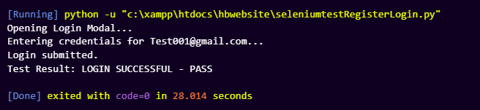
6.2 Final Test Execution Output
The console report confirms that the browser automation was successful and the user was authenticated.
- Description: CLI output displaying "Browser opened," "Login submitted," and the final "Test Result: LOGIN SUCCESSFUL - PASS" status.

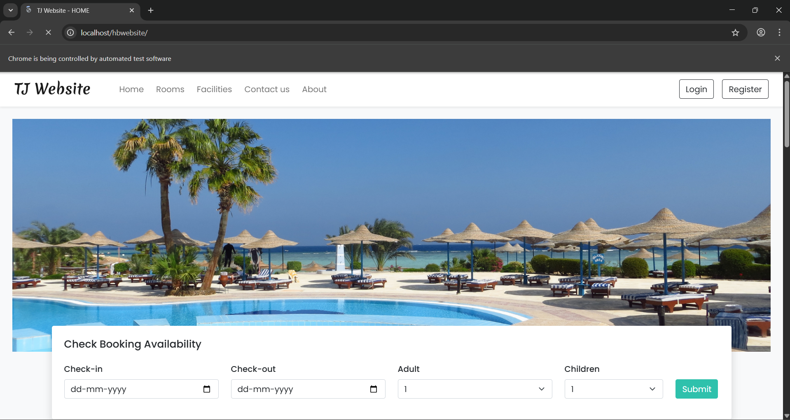

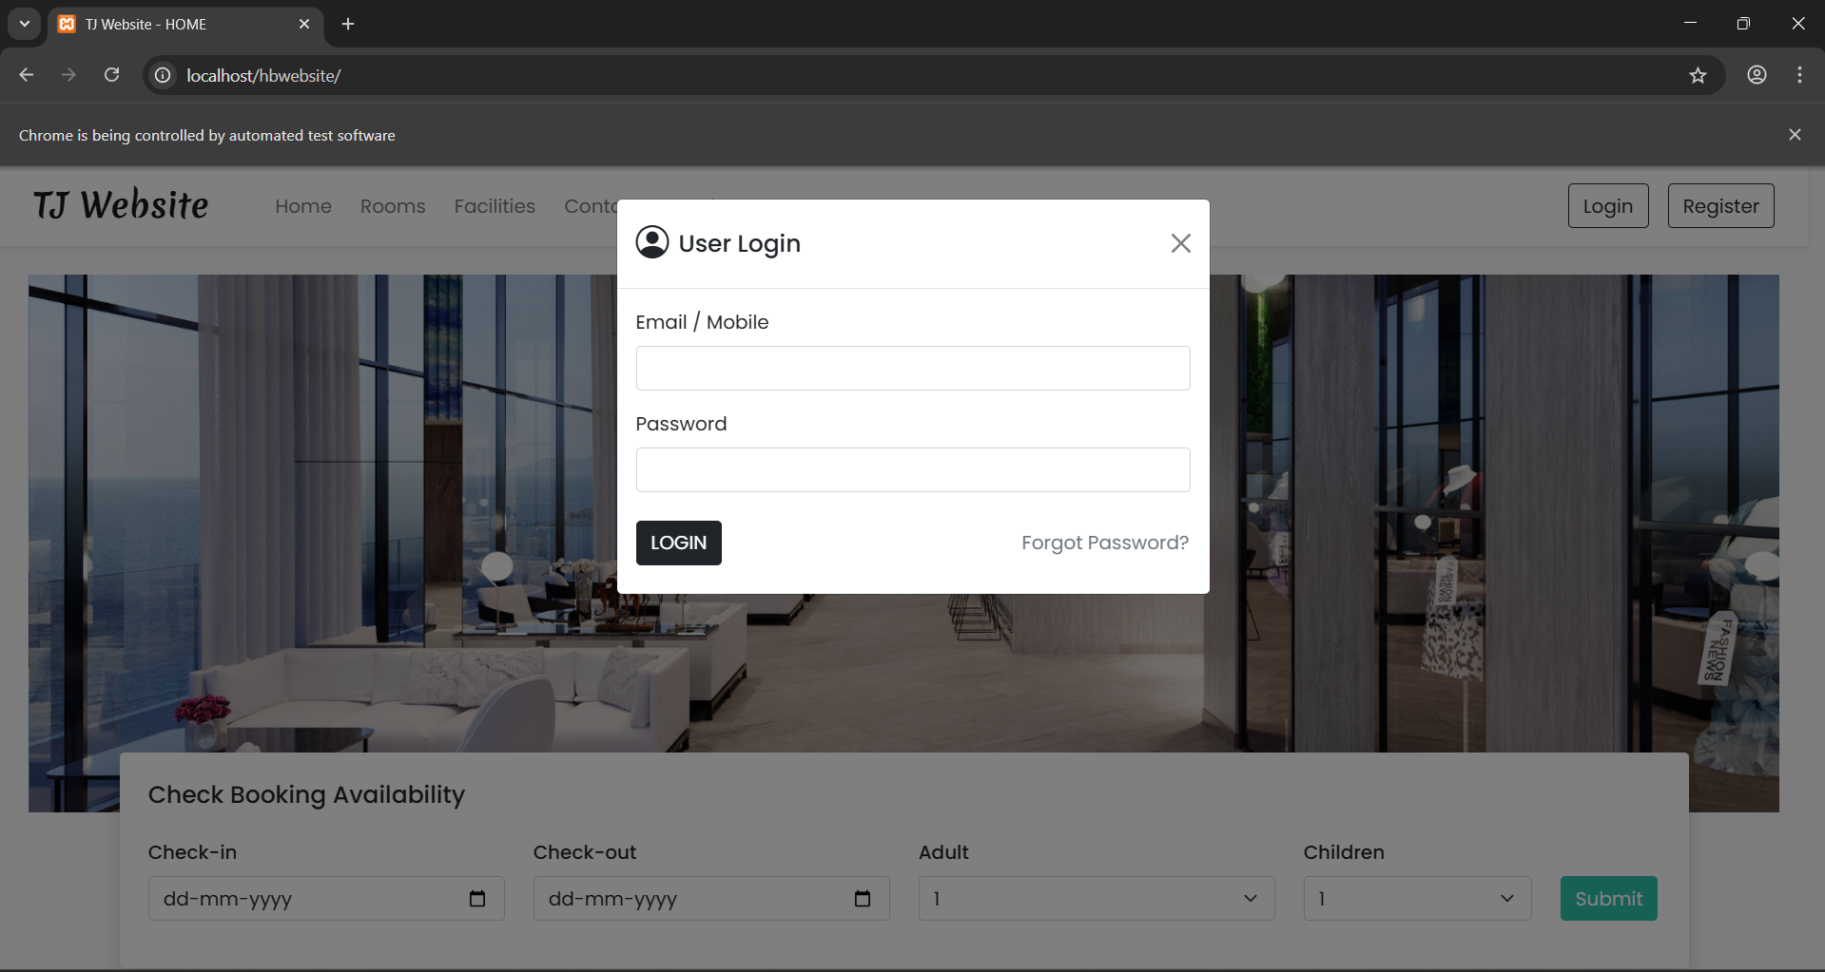
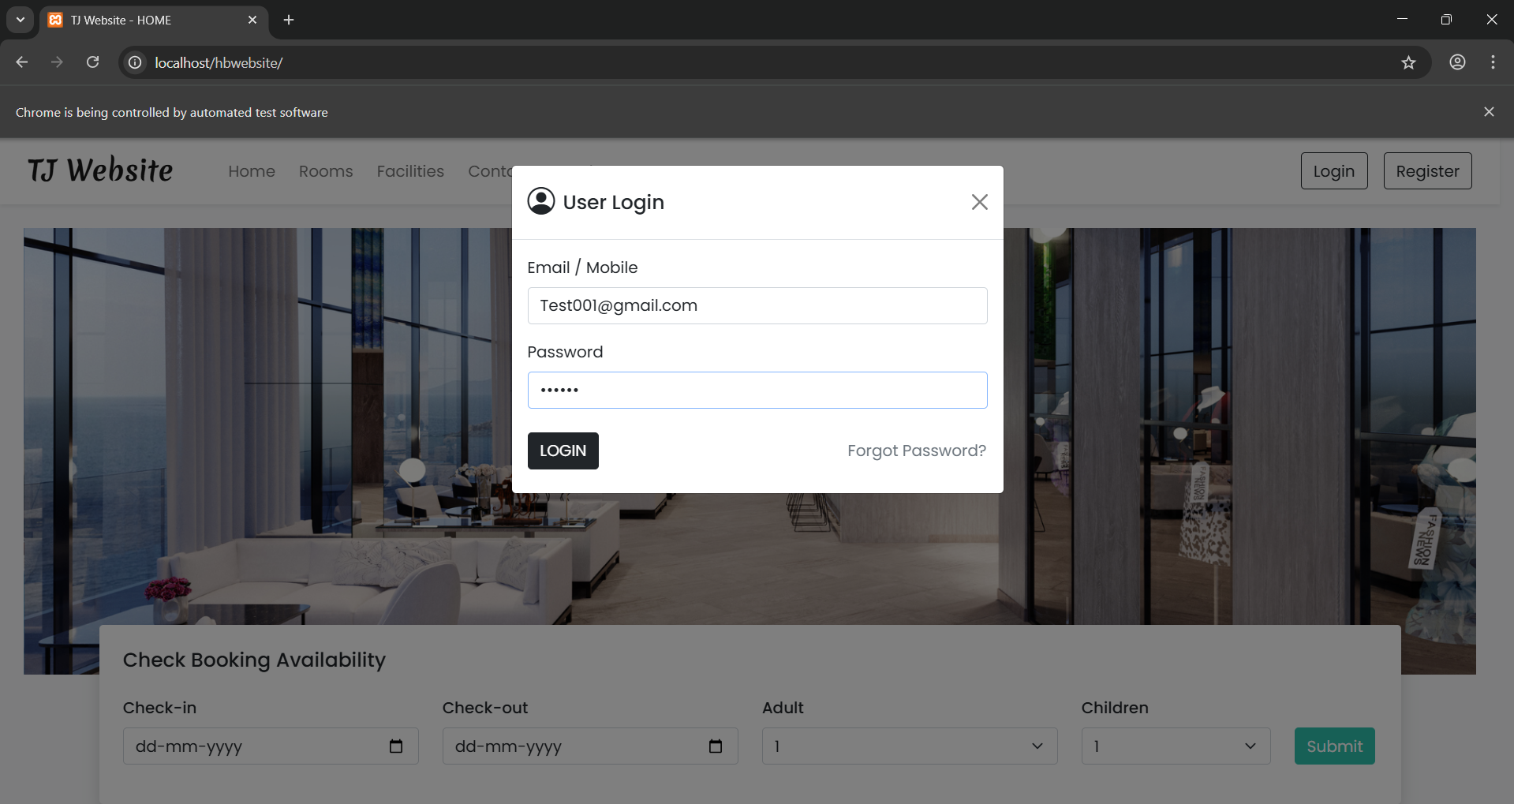
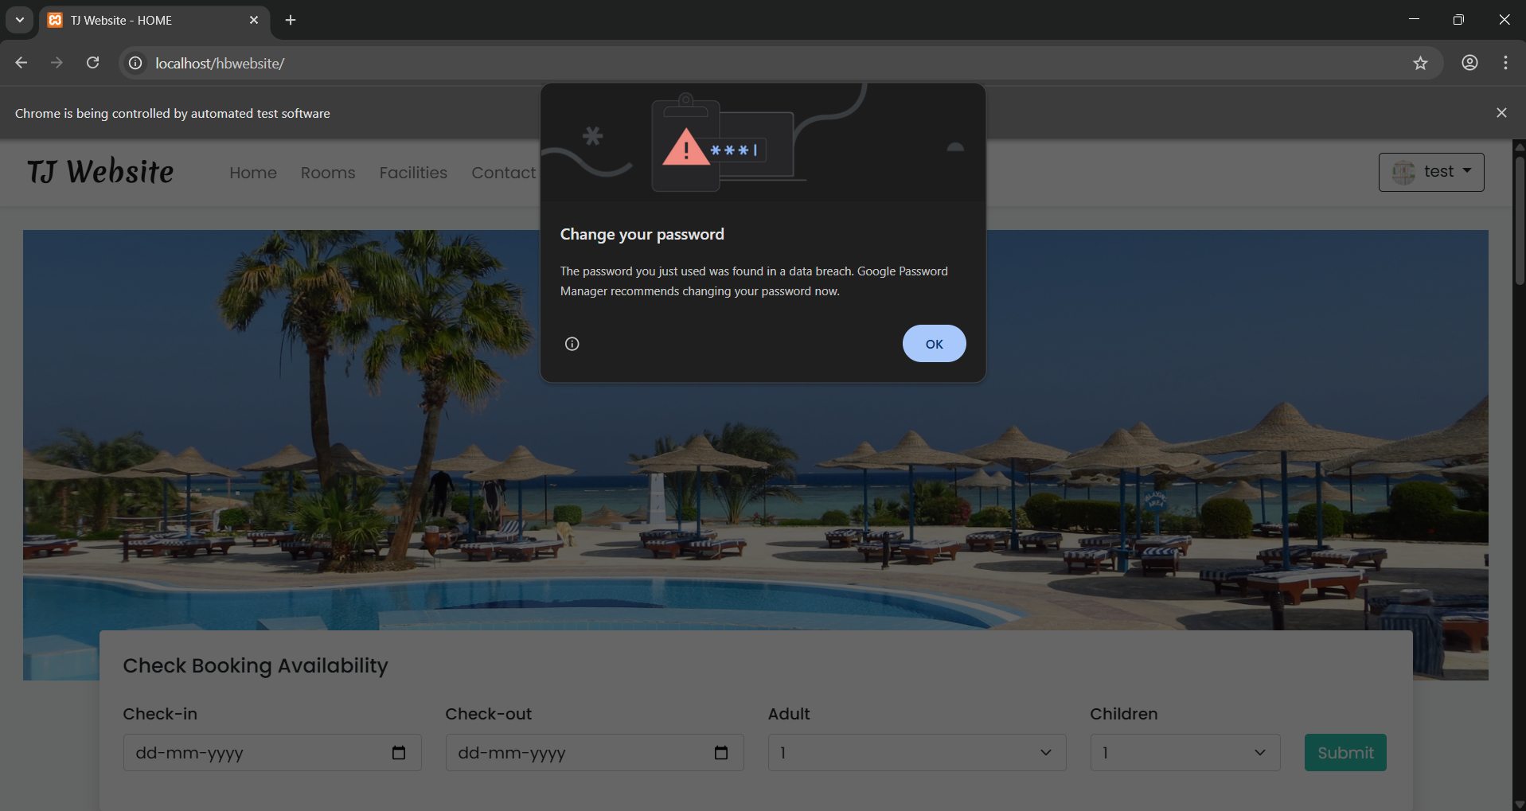

7. CONCLUSION
The implementation of automated system testing successfully validates the User Authentication flow of the Hotel Management System. By utilizing Selenium WebDriver and WebDriver Manager, the project ensures that the frontend interactions correctly trigger the backend logic. With a successful login and session verification, the application is verified as functionally stable for the user-side environment.

