 | Pimpri Chinchwad Education Trust’s  Pimpri Chinchwad College of Engineering  (PCCoE)  (An Autonomous Institute)  Affiliated to Savitribai Phule Pune University(SPPU) ISO 21001:2018 Certified by TUV | 
Course: Software Testing and Quality Assurance Laboratory | Code: BIT26PE11
Name: Amar Vaijinath Chavan | PRN: 124B2F001
Assignment 6: Perform Black Box testing using automated testing tools on an application. Testing Points to be covered – data driven wizard

1. OBJECTIVE
- To design and implement automated Black Box test cases that verify the "Add Room" functionality using a Data-Driven Wizard.
- To decouple test logic from test data by utilizing an external data source.
- To verify the system's ability to process multiple sequential data entries without manual intervention.

2. TEST ENVIRONMENT & CONFIGURATION
- Operating System: Windows 11 (XAMPP Environment).
- Automation Tool: Selenium WebDriver for Python.
- Data Source: External CSV file (room_data.csv) containing 5 test records.
- Browser: Google Chrome managed via WebDriverManager.

3. IMPLEMENTATION DETAILS (DATA-DRIVEN LOGIC)
Black Box testing focuses on the functional requirements of the application. In this assignment, we use a "Wizard" pattern to automate the complex, multi-input "Add Room" form.
3.1 Data Source Preparation (room_data.csv)
The "Wizard" relies on an external file to provide input values for each iteration.
- Test Data: Contains 5 unique records (testroom1 to testroom5) with varying area, price, and capacity values.
room_data.csv
name,area,price,quantity,adult,children,desc
testroom1,200,500,5,2,1,Standard automated test room 1
testroom2,250,600,4,2,2,Standard automated test room 2
testroom3,300,750,3,3,1,Standard automated test room 3
testroom4,350,900,2,2,3,Standard automated test room 4
testroom5,400,1100,2,4,2,Standard automated test room 5

3.2 Wizard Automation Logic
- Iterative Execution: The script implements a for loop that reads each row of the CSV and executes the "Add Room" workflow.
- Form Mapping: The script maps CSV columns directly to the name, area, price, quantity, adult, children, and desc fields found in the add-room modal.
- Dynamic Selection: The automation identifies and interacts with checkboxes for Features and Facilities, simulating a full user experience.
4. TEST EXECUTION SCRIPT
import csv
import time
from selenium import webdriver
from selenium.webdriver.common.by import By
from selenium.webdriver.chrome.service import Service
from webdriver_manager.chrome import ChromeDriverManager

service = Service(ChromeDriverManager().install())
driver = webdriver.Chrome(service=service)

def run_room_wizard_assignment6(csv_file):
try:
driver.get("http://localhost/hbwebsite/admin/index.php")
driver.maximize_window()
driver.find_element(By.NAME, "admin_name").send_keys("####")
driver.find_element(By.NAME, "admin_pass").send_keys("####")
driver.find_element(By.NAME, "login").click()
time.sleep(2)

driver.get("http://localhost/hbwebsite/admin/rooms.php")
time.sleep(2)

with open(csv_file, 'r') as file:
reader = csv.DictReader(file)
for row in reader:
print(f"Wizard is processing: {row['name']}")
driver.find_element(By.XPATH, "//button[@data-bs-target='#add-room']").click()
time.sleep(1)

driver.find_element(By.NAME, "name").send_keys(row['name'])
driver.find_element(By.NAME, "area").send_keys(row['area'])
driver.find_element(By.NAME, "price").send_keys(row['price'])
driver.find_element(By.NAME, "quantity").send_keys(row['quantity'])
driver.find_element(By.NAME, "adult").send_keys(row['adult'])
driver.find_element(By.NAME, "children").send_keys(row['children'])
driver.find_element(By.NAME, "desc").send_keys(row['desc'])

features = driver.find_elements(By.NAME, "features")
if features:
features[0].click()

driver.find_element(By.XPATH, "//button[contains(text(), 'SUBMIT')]").click()
print(f"Record {row['name']} added successfully.")

time.sleep(3)
driver.refresh()

except Exception as e:
print(f"Automation Error: {e}")

if __name__ == "__main__":
run_room_wizard_assignment6("room_data.csv")
driver.quit()

5. TEST RESULTS & OBSERVATIONS
5.1 Pre-Execution State (Before)
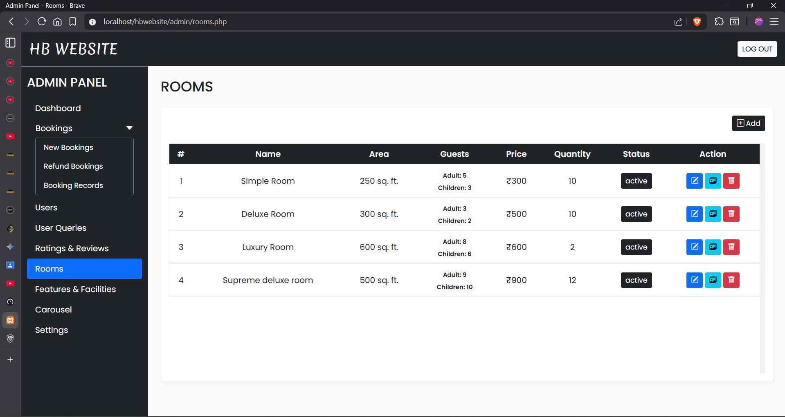
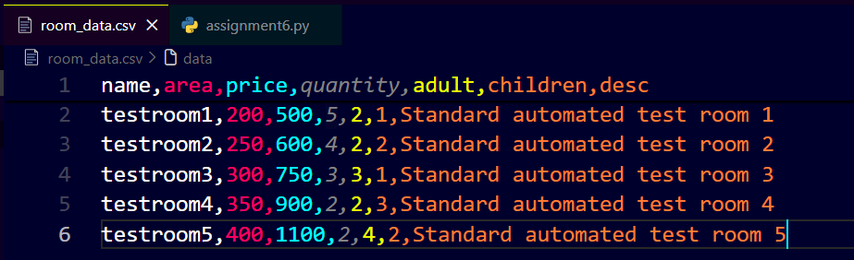
5.2 Post-Execution State (After)
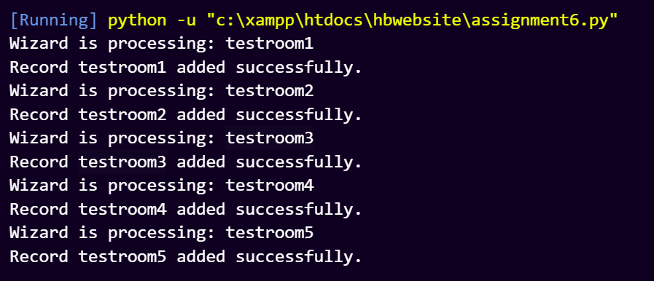
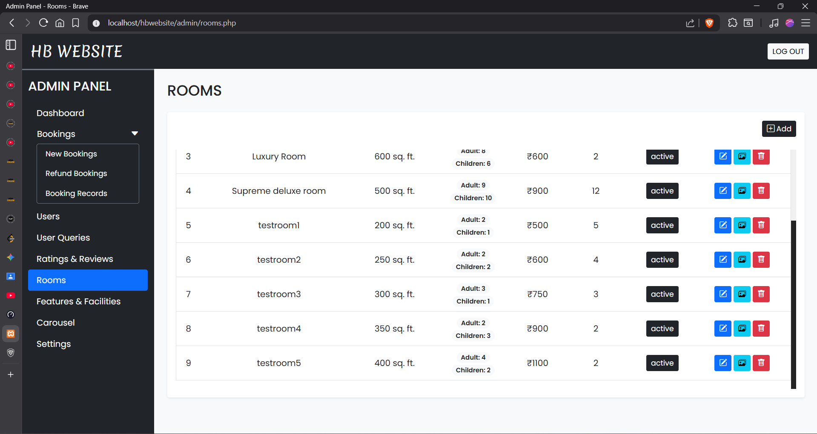

6. CONCLUSION
The use of an automated Data-Driven Wizard significantly increases test coverage while reducing the need for redundant script writing. By automating the "Add Room" module, we verified that the Admin Panel can handle high-volume data entries and correctly interface with the underlying MySQL database.

