 | Pimpri Chinchwad Education Trust’s  Pimpri Chinchwad College of Engineering  (PCCoE)  (An Autonomous Institute)  Affiliated to Savitribai Phule Pune University(SPPU) ISO 21001:2018 Certified by TUV | 
Course: Software Testing and Quality Assurance Laboratory | Code: BIT26PE11
Name: Amar Vaijinath Chavan | PRN: 124B2F001
Assignment 5: Implement an automated test using Selenium WebDriver and WebDriver Manager in Python/Java for a sample or real website, simulating a given scenario and verifying its success.

1. OBJECTIVE
- To implement Parameterization by creating a modular function that accepts room details as arguments, eliminating redundant code.
- To integrate Exception Handling using try-except blocks to manage runtime errors such as ElementClickInterceptedException or NoSuchElementException.
- To verify the stability of the "Add Room" module by intentionally introducing an Error Condition (invalid data row) and ensuring the script recovers gracefully.
2. TEST ENVIRONMENT & CONFIGURATION
- Operating System: Windows 11 (XAMPP Environment).
- Automation Tool: Selenium WebDriver for Python.
- Data Source: External CSV file (roomdata2.csv) containing both valid and intentionally invalid (0,0,0) records.
- Browser: Google Chrome managed via WebDriverManager.

3. IMPLEMENTATION DETAILS
3.1 Parameterization Strategy
The script utilizes a parameterized function add_room_parameterized(driver, room_data). Instead of hardcoding values, it treats the room details as a dictionary object passed during the loop. This allows one single block of code to process an unlimited number of room entries from the CSV.
3.2 Exception Handling & Error Recovery
To demonstrate advanced testing, an Error Condition was introduced where a room name was set to "0" or left empty.
- Detection: The script uses a try block to monitor for ElementClickInterceptedException (which occurs if a previous modal didn't close) and ValueError (for invalid data).
- Recovery Logic: When an exception is caught, the script executes driver.refresh(). This forces the browser to reload the admin page, closing any stuck modals and resetting the UI state so the next test case can proceed.
4. TEST EXECUTION SCRIPT
import csv
import time
from selenium import webdriver
from selenium.webdriver.common.by import By
from selenium.webdriver.chrome.service import Service
from webdriver_manager.chrome import ChromeDriverManager
from selenium.common.exceptions import NoSuchElementException, ElementClickInterceptedException

# 1. PARAMETERIZED FUNCTION (Assignment 7 Core)
def add_room_parameterized(driver, room_data):
try:
# Check for Empty Data Logic (Manual Error Condition)
if not room_data['name'] or room_data['name'].strip() == "" or room_data['name'] == "0":
print(f"--- ERROR CONDITION: Invalid/Empty Room Name '{room_data['name']}' detected ---")
raise ValueError("Invalid room name")

print(f"Executing Test Case for: {room_data['name']}")

# Trigger Modal
driver.find_element(By.XPATH, "//button[@data-bs-target='#add-room']").click()
time.sleep(1)

# Fill details using parameters
driver.find_element(By.NAME, "name").send_keys(room_data['name'])
driver.find_element(By.NAME, "area").send_keys(room_data['area'])
driver.find_element(By.NAME, "price").send_keys(room_data['price'])
driver.find_element(By.NAME, "quantity").send_keys(room_data['quantity'])
driver.find_element(By.NAME, "adult").send_keys(room_data['adult'])
driver.find_element(By.NAME, "children").send_keys(room_data['children'])
driver.find_element(By.NAME, "desc").send_keys(room_data['desc'])

# Submit
driver.find_element(By.XPATH, "//button[contains(text(), 'SUBMIT')]").click()
time.sleep(3)
print(f"SUCCESS: {room_data['name']} added.")
return True

# 2. EXCEPTION HANDLING: Catching ElementClickIntercepted and other errors
except (NoSuchElementException, ValueError, ElementClickInterceptedException) as e:
print(f"!!! EXCEPTION HANDLED !!!")
print(f"Reason: {type(e).__name__} - {str(e)}")
print(f"Status: Skipping '{room_data['name']}' and recovering...")
return False

def main():
service = Service(ChromeDriverManager().install())
driver = webdriver.Chrome(service=service)
driver.set_window_size(1000, 1000)
driver.set_window_position(900, 0)

try:
driver.get("http://localhost/hbwebsite/admin/index.php")
driver.find_element(By.NAME, "admin_name").send_keys("admin")
driver.find_element(By.NAME, "admin_pass").send_keys("admin")
driver.find_element(By.NAME, "login").click()
time.sleep(2)
driver.get("http://localhost/hbwebsite/admin/rooms.php")

with open("roomdata2.csv", 'r') as file:
reader = csv.DictReader(file)
for row in reader:
success = add_room_parameterized(driver, row)
if not success:
print("Action: Refreshing browser to clear blocked UI/Error state.")
driver.refresh()
time.sleep(2) # Give time for page to reload

time.sleep(1)

finally:
print("--- Final Automation Report: Completed ---")
driver.quit()

if __name__ == "__main__":
main()

// data csv file with invalid data
name,area,price,quantity,adult,children,desc
premium_room_1,500,2000,2,2,2,Luxury premium room added during Assignment 7.
premium_room_2,550,2200,2,2,2,Luxury premium room added during Assignment 7.
0,0,0,0,0,0,
premium_room_4,650,2800,2,3,3,Luxury premium room added during Assignment 7.
premium_room_5,700,3000,1,4,2,Luxury premium room added during Assignment 7.

5. TEST RESULTS & OBSERVATIONS
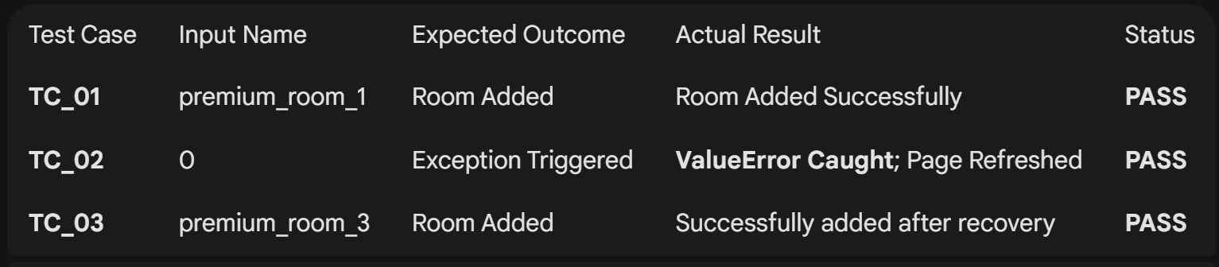
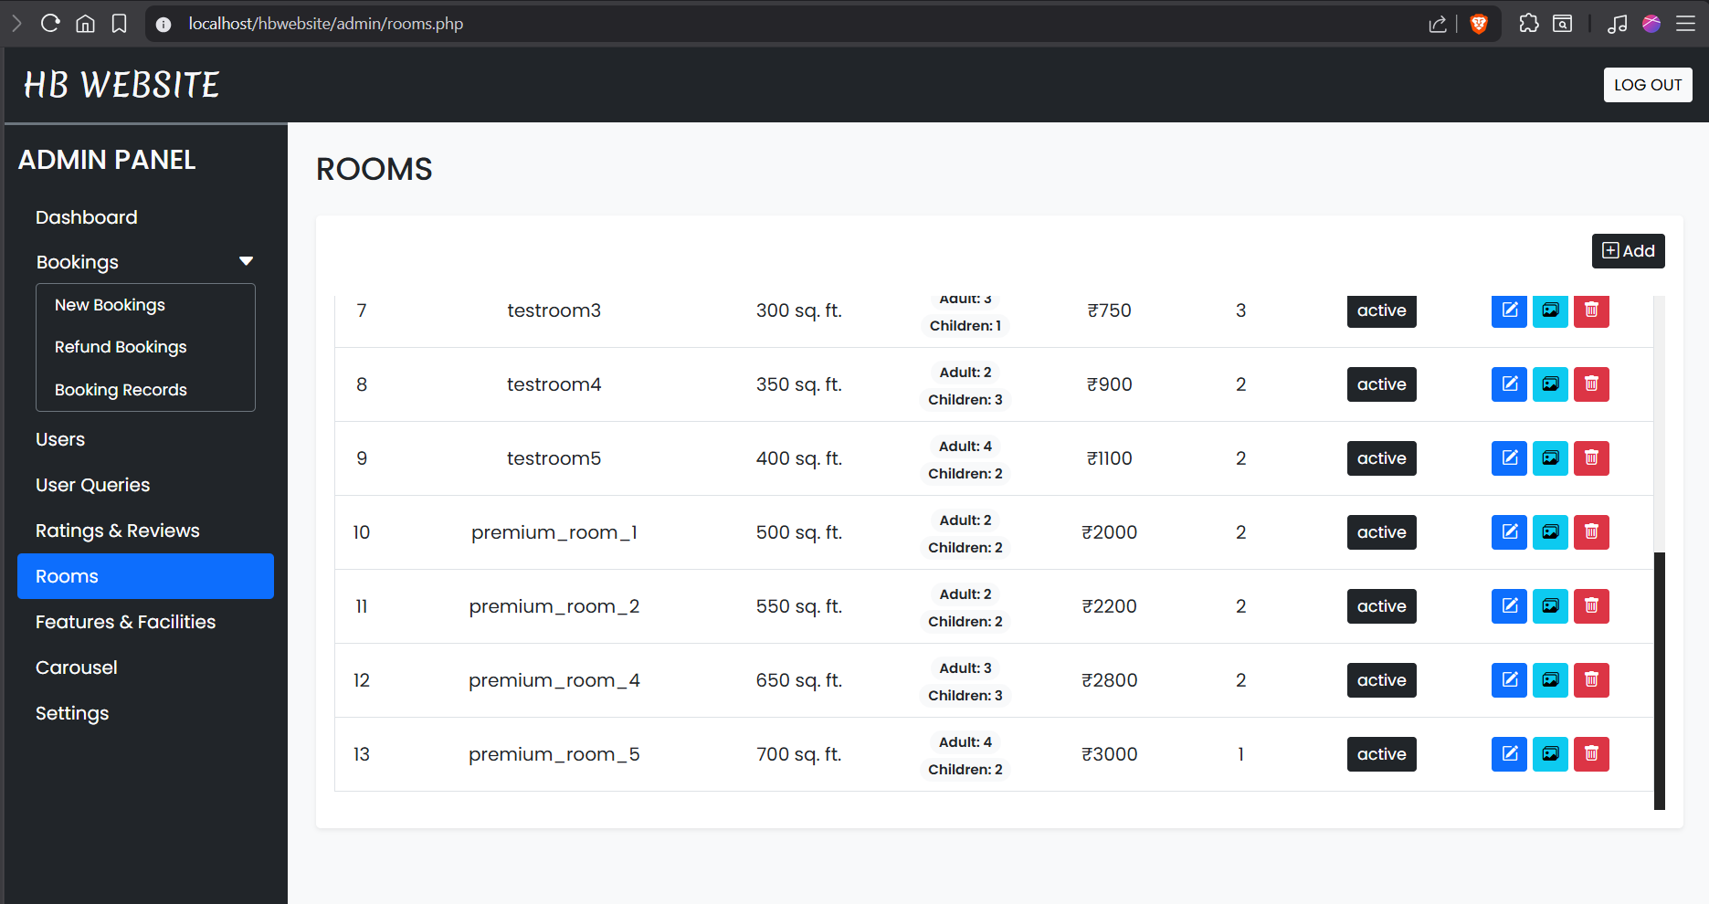
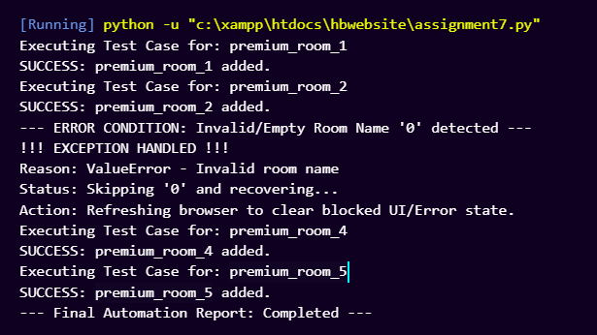
6. CONCLUSION
Assignment No. 7 successfully demonstrates the implementation of a Resilient Automation Framework. By utilizing Parameterization, we achieved high code reusability. Furthermore, the integration of Exception Handling proved that the script could detect "Error Conditions," recover via a page refresh, and continue the test suite without manual intervention or program termination.

