 | Pimpri Chinchwad Education Trust’s  Pimpri Chinchwad College of Engineering  (PCCoE)  (An Autonomous Institute)  Affiliated to Savitribai Phule Pune University(SPPU) ISO 21001:2018 Certified by TUV | 
Course: Software Testing and Quality Assurance Laboratory | Code: BIT26PE11
Name: Amar Vaijinath Chavan | PRN: 124B2F001
Assignment 8: Performance & Stress Testing of Web Applications.

1. Aim
To perform Load and Stress testing on a real-world web application (blazedemo.com) and a local enterprise project (Hotel Management System) using Apache JMeter.
2. Objectives
- To understand the difference between Load Testing and Stress Testing.
- To measure system performance using metrics like Throughput, Latency, and Error Rate.
- To identify the Breaking Point of a local server vs. a cloud-hosted environment.
3. Key Concept Definitions
Keyword | Technical Meaning
Thread | Represents a Virtual User. Multiple threads simulate concurrent traffic.
Ramp-up Period | The time taken to bring all threads online. (e.g., 100 users in 10s = 10 users/sec).
Constant Timer | Simulates "Think Time." It adds a delay between requests to mimic human behavior.
Throughput | The number of requests the server can handle per second/minute.
Latency | The time taken for the first byte of the response to reach the client.
90% Line | A quality metric; 90% of the users experienced a response time better than this value.
Standard Deviation | Measures the consistency of the server. High Std. Dev means unstable performance.

4 . Practical Steps:
Scenario 1:Load Testing on BlazeDemo (Real Website)
4.1.1 Steps to Perform Load Testing (BlazeDemo)
- Test Plan Creation: Open Apache JMeter and create a new Test Plan named "BlazeDemo_Performance_Test".
- Thread Group Configuration: Add a Thread Group to the Test Plan.
  - Set Number of Threads (Users) to 500.
  - Set Ramp-up Period (e.g., 10 seconds) to gradually increase the load.
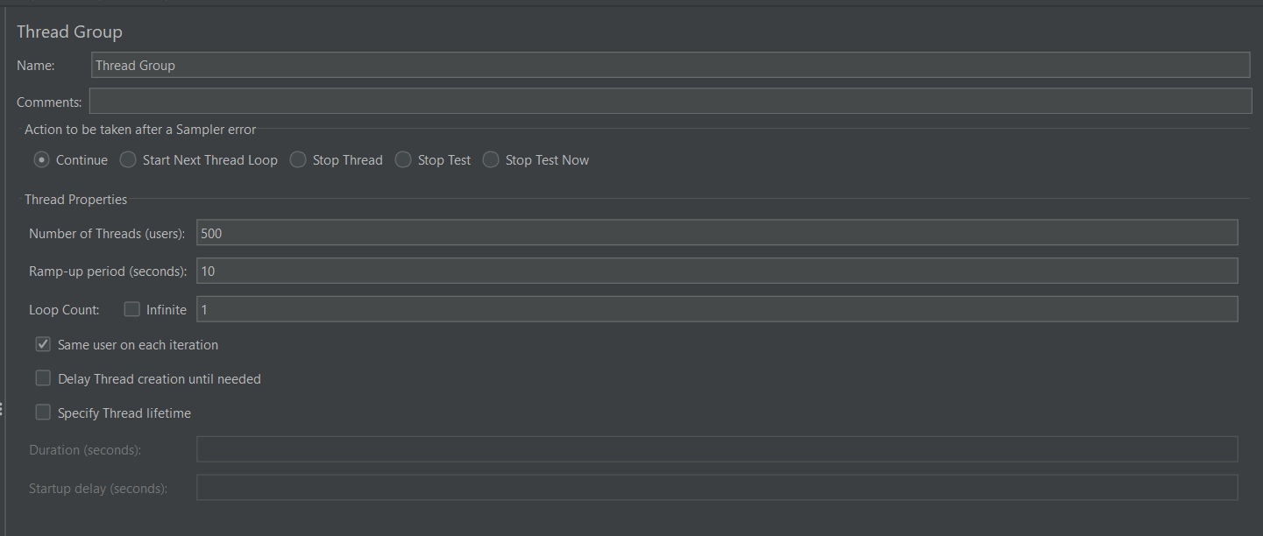
- Sampler Configuration (HTTP Request):
  - Add an HTTP Request Sampler under the Thread Group.
  - Set Protocol to https and Server Name to blazedemo.com.
  - Set HTTP Method to GET and Path to /.
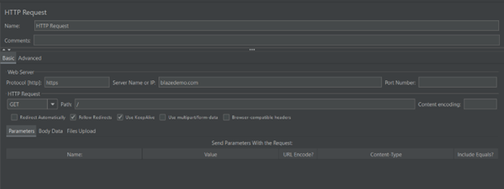
- Timer Integration: Add a Constant Timer to the HTTP Request to simulate "Think Time".
  - Set Thread Delay to 300 milliseconds.
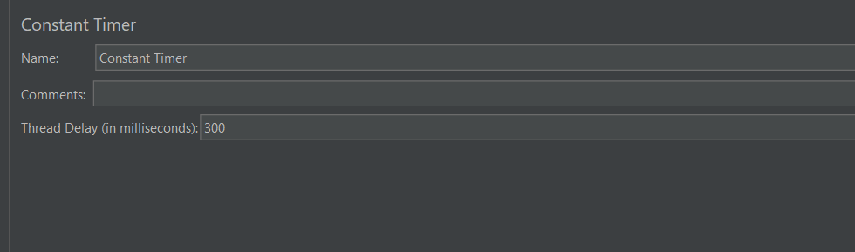
- Adding Listeners:
  - Add View Results Tree to verify individual request/response success.
  - Add Summary Report (or Aggregate Report) to capture statistical performance data.
- Execution: Click the Start button to begin the test and monitor the metrics in real-time.
4.1.2 Interpretation of Results (Result Analysis)
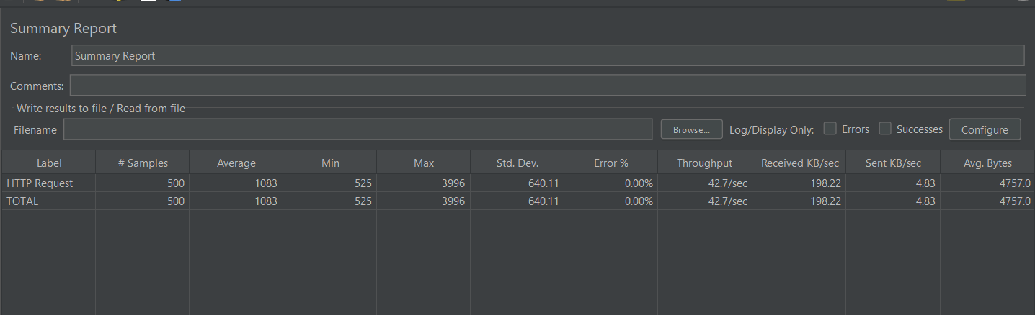
- Success Rate & Stability: The Error % is recorded as 0.00% across 500 samples. This indicates that the server successfully handled all concurrent requests without a single failure.
- Response Code Verification: The View Results Tree confirms a Response code: 200 and Response message: OK for the samples. This validates that the application logic remained intact under the simulated load.
- System Throughput: The system achieved a Throughput of 42.7/sec. This means the server can process approximately 43 transactions every second under the current configuration.
- Response Time Analysis:
  - Average Response Time: 1083 ms.
  - Min/Max Latency: The response time varied from 525 ms to 3996 ms. This variance is typical for real-world internet-hosted websites due to network fluctuations.
- Resource Efficiency: The Received KB/sec (198.22) shows the network bandwidth consumed during the peak load period.
4.1.3 Final Interpretation
"The Load Test on blazedemo.com successfully demonstrates that the application is Robust and Scalable. The system maintained a 0% error rate while handling 500 samples with a healthy throughput. The use of a 300ms Constant Timer ensured that the performance metrics reflect realistic human interaction patterns rather than a brute-force automated attack."
Scenario 2: Stress Testing on BlazeDemo (Real Website)
4.2.1 Steps to Perform Stress Testing
- Thread Group Configuration: Increased the Number of Threads to simulate 5,000 users.
- Ramp-up Adjustment: Set a short ramp-up period to inject a large volume of traffic quickly to stress the server infrastructure.
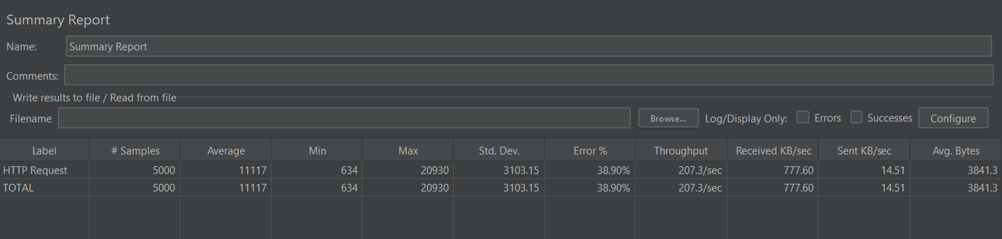
- Sampler Configuration: The HTTP Request was maintained with the GET method for the blazedemo.com domain.
- Timer Implementation: A Constant Timer of 300ms was used, but the high thread count ensured the server remained under heavy stress.
- Execution: Ran the test and monitored the Summary Report to identify the failure rate and throughput capacity.
4.2.2 Interpretation of Results (Result Analysis)

- System Failure Point: The Error % spiked to 38.90% across 5,000 samples. This indicates that the server could not handle the concurrent load and began rejecting or timing out nearly 40% of the requests.
- Response Time Degradation: The Average Response Time jumped significantly to 11,117 ms (approx. 11 seconds). This shows severe congestion, as users would face unacceptable delays in a real-world scenario.
- Maximum Latency: The Max response time reached 20,930 ms. This 20-second delay is a clear indicator that the server was struggling with resource exhaustion.
- Throughput Bottleneck: Despite the errors, the system maintained a Throughput of 207.3/sec. This suggests that while the server is fast, it has a strict limit on how many concurrent connections it can successfully maintain.
4.2.3 Final Interpretation
"The Stress Test on blazedemo.com clearly identifies the application's breaking point. By increasing the load to 5,000 threads, we observed a transition from a stable system to one with a 38.90% failure rate. This test proves that while the infrastructure is scalable, it requires additional load balancing or auto-scaling resources to handle massive spikes in traffic without degrading the user experience to an 11-second average wait time."

Scenario 3: Load Testing on Local Project (hbwebsite)
4.3.1 Steps to Perform Load Testing
- Test Plan Creation: Open Apache JMeter and create a new Test Plan specifically for the local Hotel Booking Website environment.
- Thread Group Configuration:
  - Add a Thread Group to the Test Plan.
  - Set Number of Threads (users) to 1000 to simulate a high volume of local concurrent users.
  - Set Ramp-up period (seconds) to 25 to gradually introduce users (creating a load of 40 users per second).
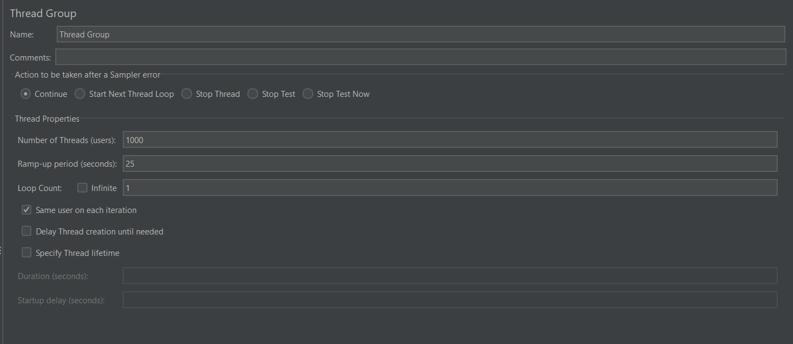
- Sampler Configuration (HTTP Request):
  - Add an HTTP Request Sampler under the Thread Group.
  - Set Protocol to http and Server Name or IP to localhost.
  - Set HTTP Method to GET and Path to /hbwebsite/ to target the local project landing page.
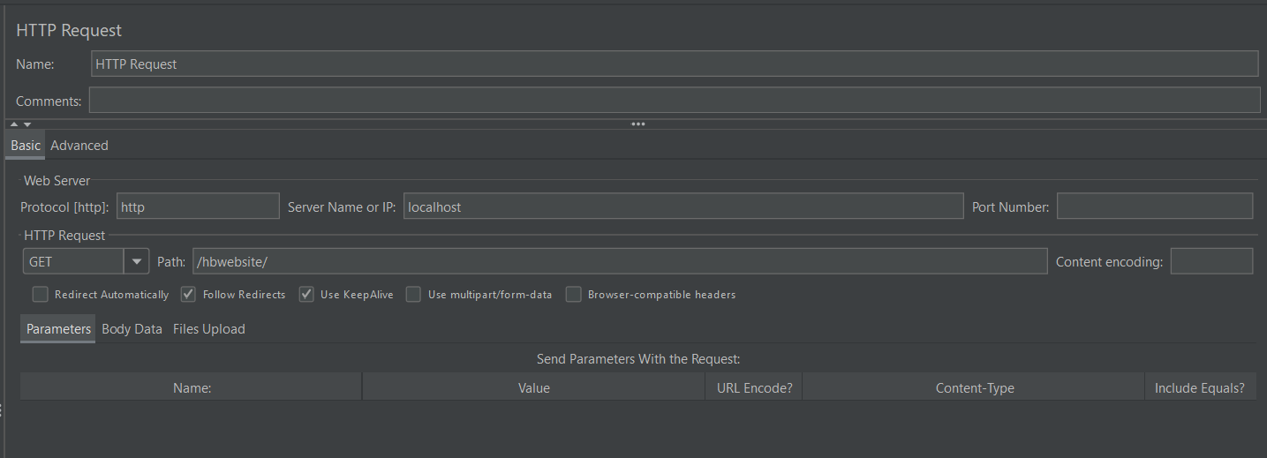
- Adding Listeners:
  - Add a Summary Report to capture and analyze the overall performance statistics of the 1000 samples.
- Execution: Click the Start button to run the test and monitor how the local Apache server handles the 1000-thread load in real-time.

4.3.2 Interpretation of Results (Result Analysis)
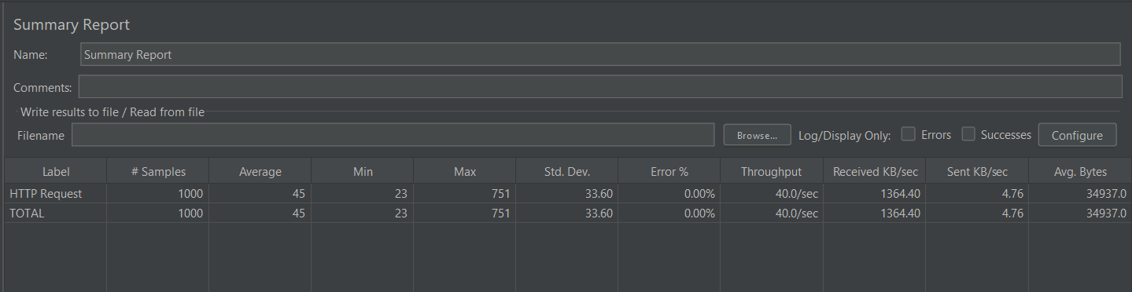
- Success Rate & Stability: The Error % is recorded as 0.00% across all 1000 samples. This confirms that the local XAMPP/Apache server successfully processed every request without any failure during the load test.
- Response Time Analysis:
  - Average Response Time: 45 ms.
  - Min/Max Latency: The response time ranged from 23 ms to 751 ms. Since the project is hosted on localhost, the response is significantly faster than internet-hosted sites due to the absence of network lag.
- System Throughput: The system achieved a Throughput of 40.0/sec. This matches the ramp-up configuration and proves the local machine's capability to maintain a steady flow of traffic.
- Resource Efficiency: The Received KB/sec was 1364.40, showing the data transfer rate between the local server and the JMeter client.
4.3.3 Final Interpretation
"The Load Test on localhost/hbwebsite/ confirms that the application is Stable and High-Performing for a localized environment. Even with a high load of 1000 concurrent threads, the server maintained a 0% error rate and an impressive average response time of 45ms. This proves that the local project setup is well-optimized for handling multiple simultaneous internal requests efficiently."

Scenario 4: Stress Testing on Local Project (hbwebsite)
4.4.1 Steps to Perform Stress Testing
- Thread Group Configuration: Increased the Number of Threads (users) to 5000 to push the local Apache/XAMPP server beyond its stable operating limit.
- Ramp-up Adjustment: Maintained a Ramp-up period (seconds) of 25 to simulate a rapid surge of incoming traffic (injecting 200 users per second).
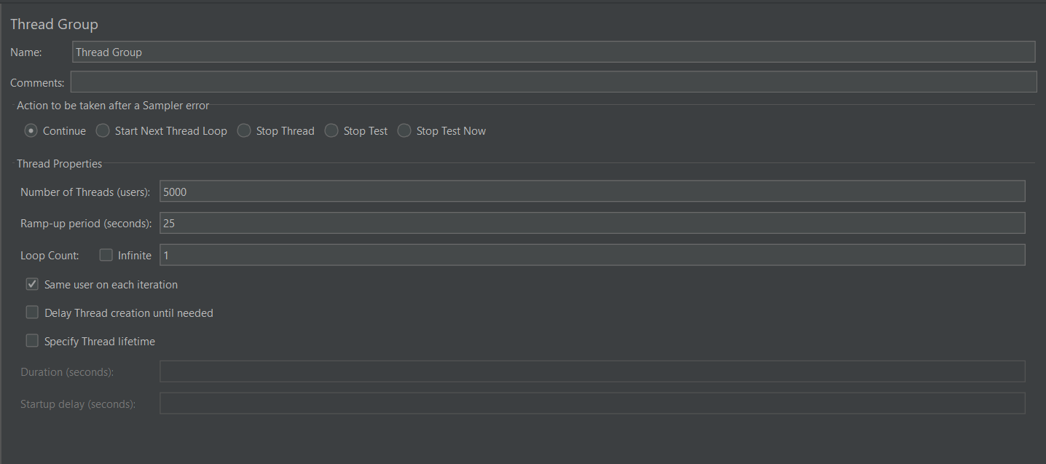
- Sampler Configuration: The HTTP Request sampler was maintained with the GET method targeting the localhost/hbwebsite/ directory to stress the main landing page logic.

- Timer Modification: The Constant Timer was either disabled or significantly reduced to increase the request frequency, ensuring the server remains under constant heavy pressure.
- Execution: Ran the test and monitored the Summary Report to identify the failure rate and the server's breaking point.
4.4.2 Interpretation of Results (Result Analysis)
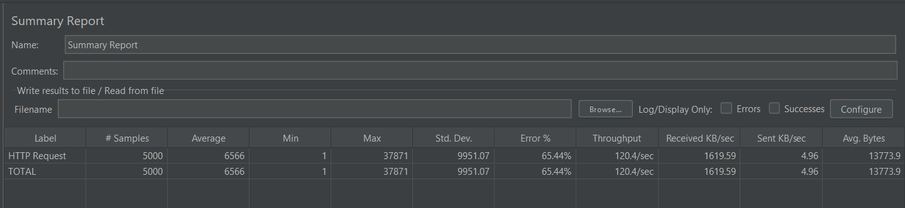
- System Failure Point: The Error % spiked to 65.44% across the 5000 samples. This indicates a major failure point where the local server began rejecting or failing to process over half of the incoming requests due to resource exhaustion.
- Response Time Degradation:
  - Average Response Time: 6566 ms (approx. 6.5 seconds).
  - Max Latency: The response time reached as high as 37,871 ms (approx. 38 seconds). This massive delay proves the server's request queue was completely overwhelmed.
- Standard Deviation: A very high Std. Dev. of 9951.07 was observed. This shows that the server performance became extremely unstable and unpredictable under stress.
- Throughput Bottleneck: Despite the high error rate, the system maintained a Throughput of 120.4/sec. However, since most of these were errors, it confirms that the hardware reached its physical processing limit.
4.4.3 Final Interpretation
"The Stress Test on the local hbwebsite project identifies the clear breaking point of the development environment. By increasing the load to 5000 threads, we observed a transition from stability to a 65.44% error rate. This test proves that the local XAMPP/Apache setup cannot handle massive traffic spikes and would require a professional production-grade server with load balancing to maintain service quality under such extreme conditions."

Conclusion
The performance testing experiment conducted using Apache JMeter effectively demonstrated the critical operational differences between Load Testing and Stress Testing across both cloud-hosted and local environments.
Through the analysis of the four scenarios, the following key insights were gained:
- Scalability vs. Breaking Point: Load testing on blazedemo.com and the local hbwebsite project successfully validated that both systems are robust and scalable under expected traffic conditions, maintaining a 0% error rate. In contrast, stress testing identified the exact breaking points—38.90% error for the cloud site and 65.44% for the local server—revealing how systems behave when pushed beyond their physical and architectural limits.
- Performance Metrics as Quality Indicators: Metrics such as Throughput and Latency provided quantifiable data on system health. The significant jump in average response time (from 45 ms to over 6 seconds on the local project) during stress testing served as a clear indicator of resource exhaustion and request queuing.
- Infrastructure Impact: The experiment highlighted that while the local XAMPP/Apache setup is highly efficient for internal use (low latency), it lacks the auto-scaling and load-balancing capabilities of professional cloud environments to survive massive traffic spikes.
- Realistic Simulation: The strategic use of Constant Timers and Ramp-up periods proved essential in simulating realistic human behavior, ensuring that the performance profile gathered was accurate and not just a result of a brute-force automated attack.
Ultimately, this assignment underscores that Software Quality Assurance for web applications must include continuous performance monitoring to ensure stability, prevent service degradation, and plan for future infrastructure requirements.

