 | Pimpri Chinchwad Education Trust’s  Pimpri Chinchwad College of Engineering  (PCCoE)  (An Autonomous Institute)  Affiliated to Savitribai Phule Pune University(SPPU) ISO 21001:2018 Certified by TUV | 
Course: Software Testing and Quality Assurance Laboratory | Code: BIT26PE11
Name: Amar Vaijinath Chavan | PRN: 124B2F001
Assignment 9: Implement and execute REST API tests using the Karate DSL framework, applying behaviourdriven development (BDD) style to validate HTTP endpoints.

1. Introduction
In modern software applications, RESTful APIs play a critical role in enabling communication between distributed systems. Ensuring that these APIs function correctly is essential for system reliability and performance. API automation testing helps validate API behavior early in the development lifecycle and reduces manual testing effort.
Karate DSL is a modern API automation framework that enables testers to implement and execute REST API tests efficiently using a Behaviour-Driven Development (BDD) approach.

2. What is Karate DSL?
Karate DSL is an open-source test automation framework designed specifically for API testing. It is built on top of Cucumber and uses Gherkin syntax (Given, When, Then) to define test scenarios in a readable and structured format.
Unlike traditional frameworks that require extensive Java coding, Karate allows users to write test cases using a domain-specific language (DSL). It natively supports HTTP requests, JSON and XML processing, assertions, and validations without relying on additional libraries.

3. Importance of Using Karate DSL for API Automation
Karate DSL provides several advantages that make it suitable for modern software development practices:
- Minimal Coding Requirement
Tests can be written without creating Java classes, controllers, or helper methods.
- Native JSON and XML Handling
Karate supports deep comparison of responses, allowing entire payloads to be validated in a single statement.
- Readable and Maintainable Tests
The BDD-style syntax makes test cases easy to understand for developers, testers, and business stakeholders.
- Fast Setup and Execution
Karate requires minimal configuration and can be executed easily using Maven or an IDE.

4. Traditional API Testing vs. Karate DSL
Feature | Traditional API Testing (RestAssured/JUnit) | Karate DSL
Code Complexity | High – requires Java classes and methods | Low – Gherkin-based scripts
Assertion Style | Manual, field-by-field | Deep and fuzzy matching
Data Parsing | External libraries required | Built-in JSON/XML support
Execution Setup | Time-consuming | Simple and fast

5. Behaviour-Driven Development (BDD) with Karate DSL
Behaviour-Driven Development (BDD) focuses on defining application behavior using clear, business-readable language. Karate DSL fully supports BDD by structuring test scenarios into:
- Given – Defines the preconditions and API configuration
- When – Executes the HTTP request
- Then – Validates the response status and payload
This approach ensures that API tests also act as living documentation of system behavior.

6. Advanced Features of Karate DSL
6.1 Fuzzy Matching
Karate supports fuzzy matching to validate response data types instead of exact values, making tests more resilient to dynamic data.

6.2 Data-Driven Testing
Using Scenario Outline, Karate allows the same test to be executed with multiple datasets sourced from CSV or JSON files.

6.3 Reusable Authentication (Call Single)
Authentication logic can be executed once and reused across all test scenarios.
Java Interoperability
Karate can directly invoke Java methods for advanced processing such as encryption or unique data generation.

6.5 API Mocking
Karate provides built-in support for mocking APIs, enabling testing even when dependent services are unavailable.

7. Execution and Reporting
Karate automatically generates an interactive HTML report after test execution.
Report Features:
- Step-by-step execution results
- Detailed request and response logs
- Execution time for each API call
- No additional configuration required
Reports are generated in the target/karate-reports/ directory.

8. Implementation Steps

To perform REST API testing using the Karate DSL framework, it is first necessary to develop the APIs that will be tested. A Java-based Spring Boot project is used for this purpose.

Step 1: Create a Java-Based Spring Boot Project
- Open the Spring Initializr website: https://start.spring.io
- Select Project: Maven
- Select Language: Java
- Select Spring Boot version (default)
- Enter Group and Artifact name
- Add dependencies: Spring Web
- Click Generate and extract the project
- Open the project in an IDE (IntelliJ / Eclipse)

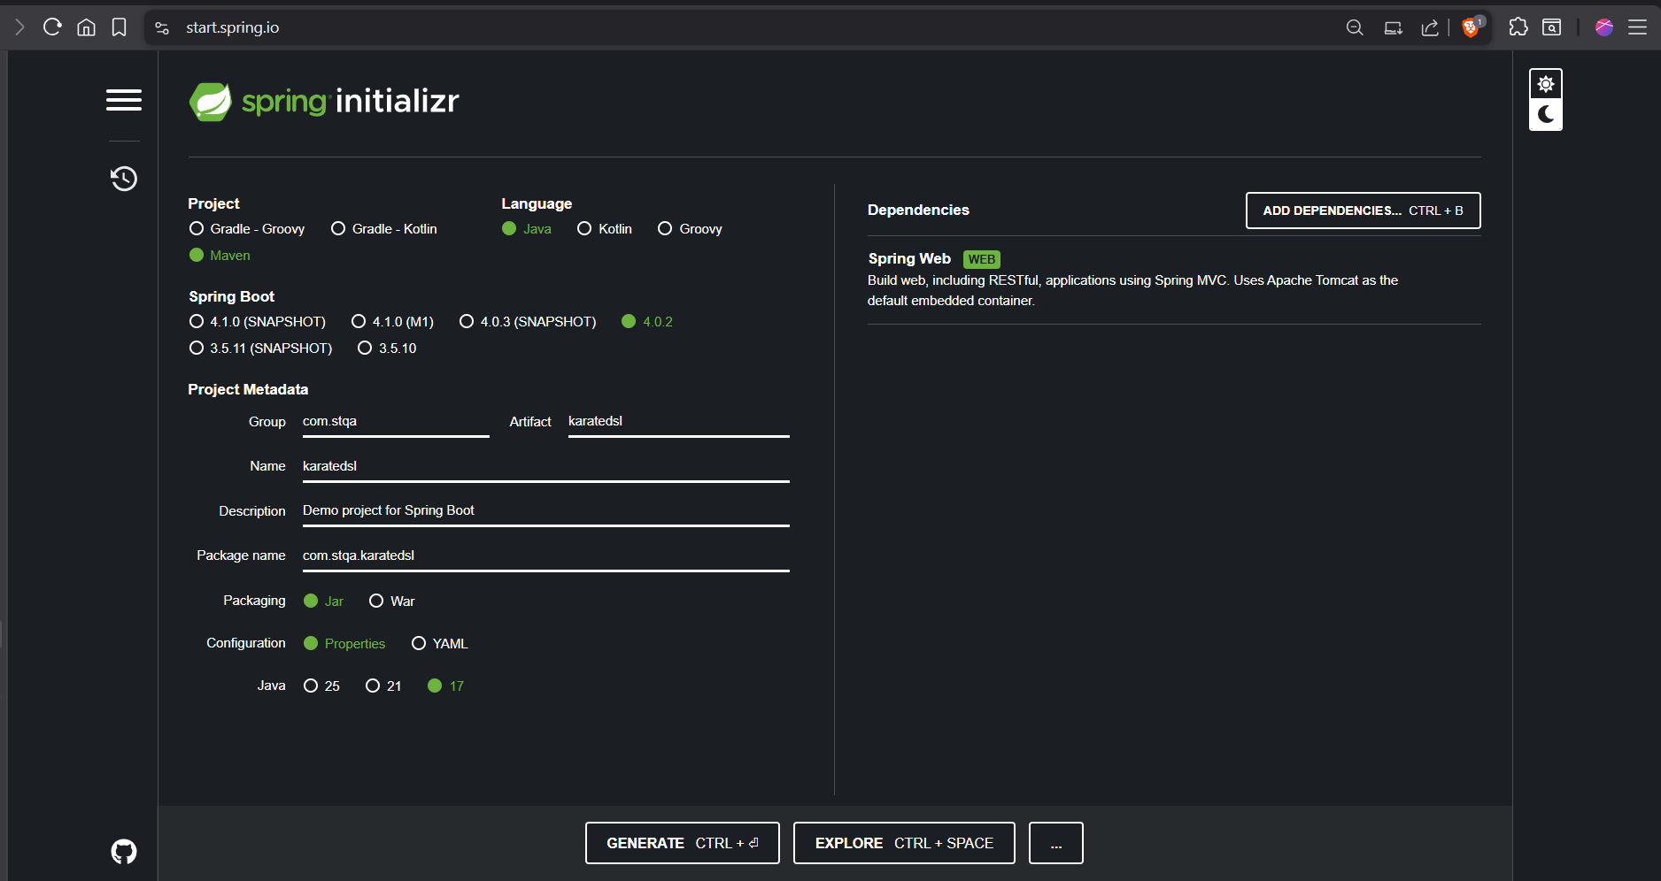

Step 2: Develop REST API Endpoints
- Navigate to: src/main/java
- Create a Controller class
- Annotate the class with @RestController
- Define REST endpoints using annotations such as:
  - @GetMapping
  - @PostMapping
  - @PutMapping
  - @DeleteMapping
- Write the code and save the API implementation code
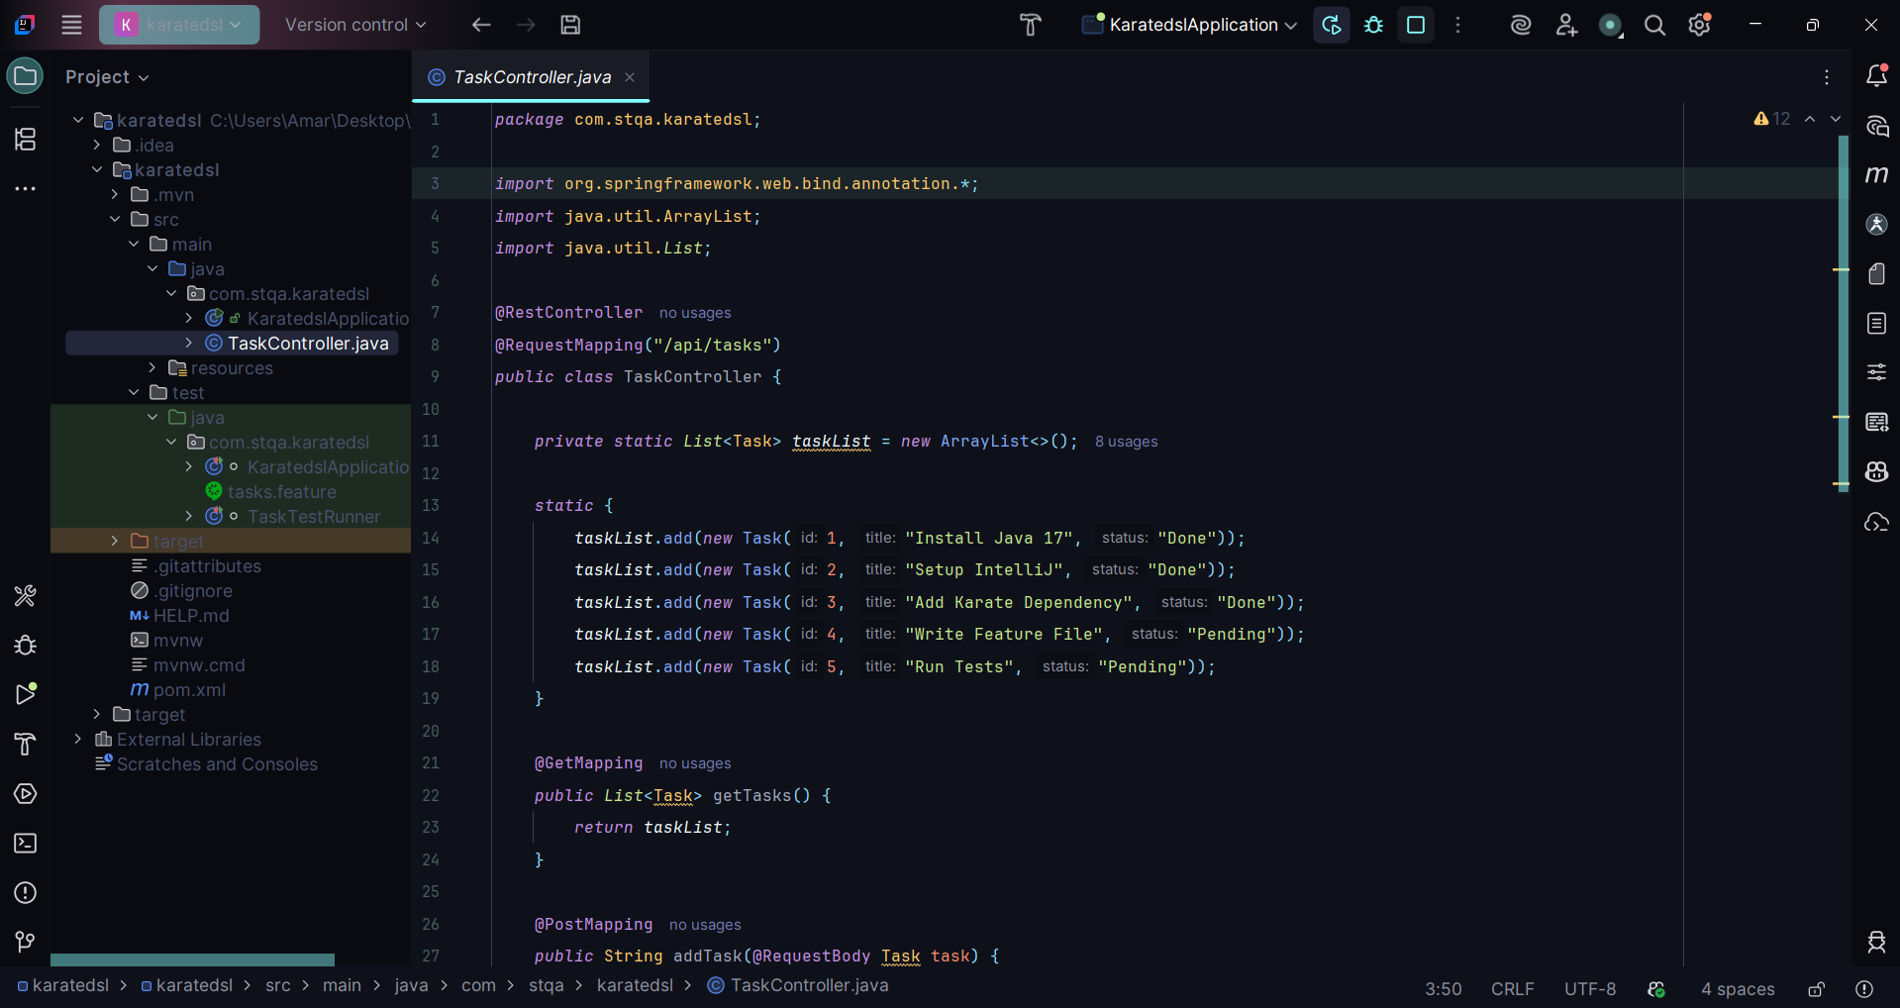

Code to add in the TaskController.java

package com.stqa.karatedsl;
import org.springframework.web.bind.annotation.*;
import java.util.ArrayList;
import java.util.List;
@RestController
@RequestMapping("/api/tasks")
public class TaskController {
private static List<Task> taskList = new ArrayList<>();
static {
taskList.add(new Task(1, "Install Java 17", "Done"));
taskList.add(new Task(2, "Setup IntelliJ", "Done"));
taskList.add(new Task(3, "Add Karate Dependency", "Done"));
taskList.add(new Task(4, "Write Feature File", "Pending"));
taskList.add(new Task(5, "Run Tests", "Pending"));
}
@GetMapping
public List<Task> getTasks() {
return taskList;
}
@PostMapping
public String addTask(@RequestBody Task task) {
taskList.add(task);
return "Task added successfully!";
}
@DeleteMapping("/{id}")
public String deleteTask(@PathVariable int id) {
boolean removed = taskList.removeIf(t -> t.getId() == id);
return removed ? "Task deleted!" : "Task not found";
}
}
class Task {
private int id;
private String title;
private String status;
public Task() {}
public Task(int id, String title, String status) {
this.id = id;
this.title = title;
this.status = status;
}
public int getId() { return id; }
public void setId(int id) { this.id = id; }
public String getTitle() { return title; }
public void setTitle(String title) { this.title = title; }
public String getStatus() { return status; }
public void setStatus(String status) { this.status = status; }
}

Note:- check the package according to your project name it may cause error if mismatch

Step 3: Configure Maven with Karate Dependency
- Open the pom.xml file
- Add the karate-junit5 dependency inside the <dependencies> section
- Save the file and allow Maven to download dependencies
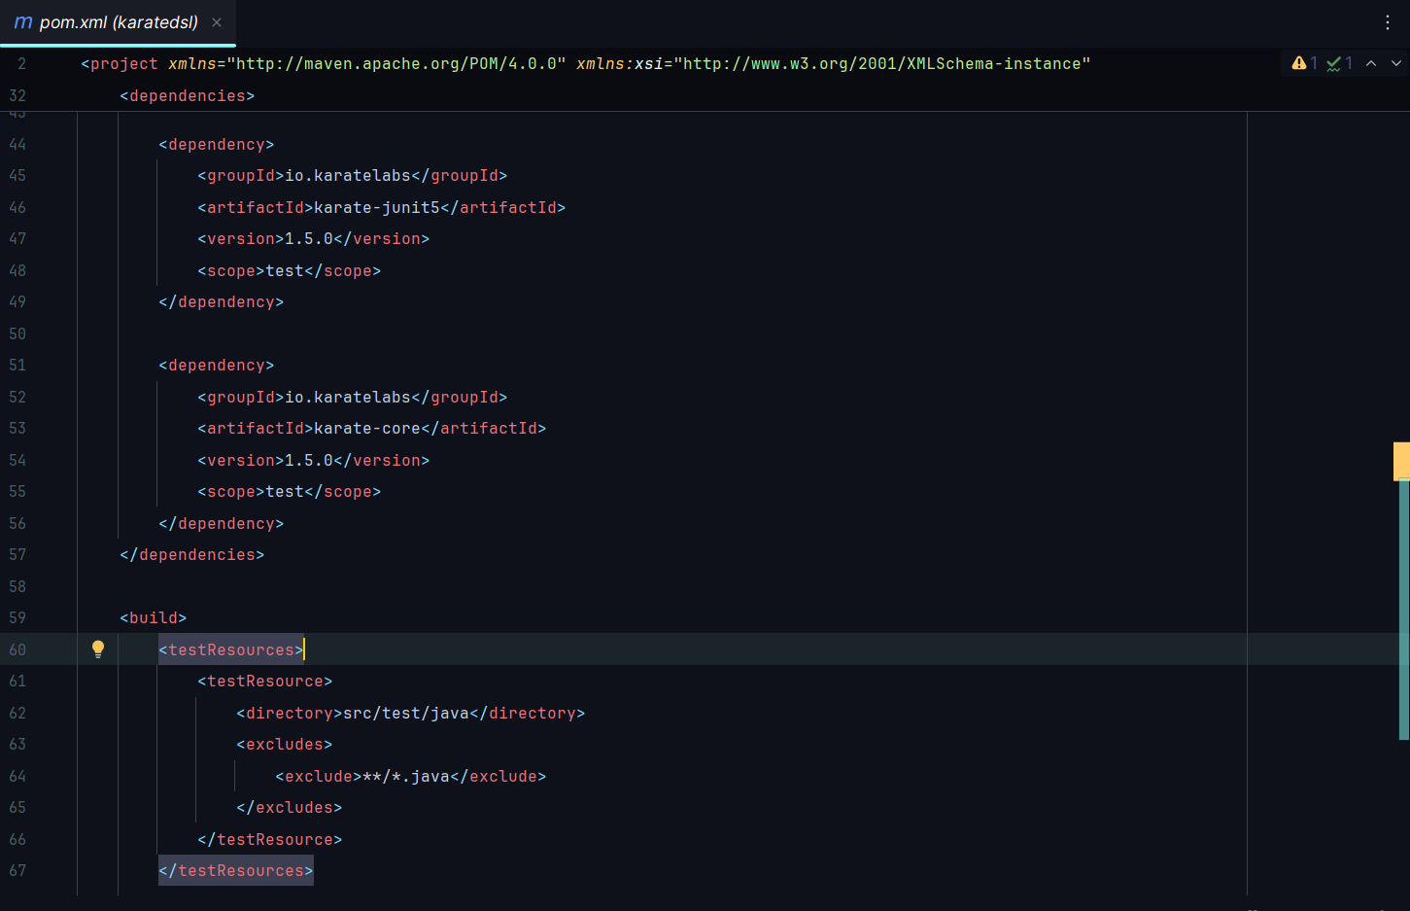

Code to add in the pom.xml

<?xml version="1.0" encoding="UTF-8"?>
<project xmlns="http://maven.apache.org/POM/4.0.0" xmlns:xsi="http://www.w3.org/2001/XMLSchema-instance"
xsi:schemaLocation="http://maven.apache.org/POM/4.0.0 https://maven.apache.org/xsd/maven-4.0.0.xsd">
<modelVersion>4.0.0</modelVersion>
<parent>
<groupId>org.springframework.boot</groupId>
<artifactId>spring-boot-starter-parent</artifactId>
<version>4.0.2</version>
<relativePath/> <!-- lookup parent from repository -->
</parent>
<groupId>com.stqa</groupId>
<artifactId>karatedsl</artifactId>
<version>0.0.1-SNAPSHOT</version>
<name>karatedsl</name>
<description>Demo project for Spring Boot</description>
<url/>
<licenses>
<license/>
</licenses>
<developers>
<developer/>
</developers>
<scm>
<connection/>
<developerConnection/>
<tag/>
<url/>
</scm>
<properties>
<java.version>17</java.version>
</properties>
<dependencies>
<dependency>
<groupId>org.springframework.boot</groupId>
<artifactId>spring-boot-starter-webmvc</artifactId>
</dependency>
<dependency>
<groupId>org.springframework.boot</groupId>
<artifactId>spring-boot-starter-webmvc-test</artifactId>
<scope>test</scope>
</dependency>
<dependency>
<groupId>io.karatelabs</groupId>
<artifactId>karate-junit5</artifactId>
<version>1.5.0</version>
<scope>test</scope>
</dependency>
<dependency>
<groupId>io.karatelabs</groupId>
<artifactId>karate-core</artifactId>
<version>1.5.0</version>
<scope>test</scope>
</dependency>
</dependencies>
<build>
<testResources>
<testResource>
<directory>src/test/java</directory>
<excludes>
<exclude>**/*.java</exclude>
</excludes>
</testResource>
</testResources>
<plugins>
<plugin>
<groupId>org.springframework.boot</groupId>
<artifactId>spring-boot-maven-plugin</artifactId>
</plugin>
</plugins>
</build>
</project>

Step 4: Create Karate Feature Files
- Navigate to: src/test/java
- Create a package for Karate tests
- Create a .feature file
- Write test scenarios using Gherkin syntax:
  - Given – API URL and headers
  - When – HTTP request method
  - Then – Response validation

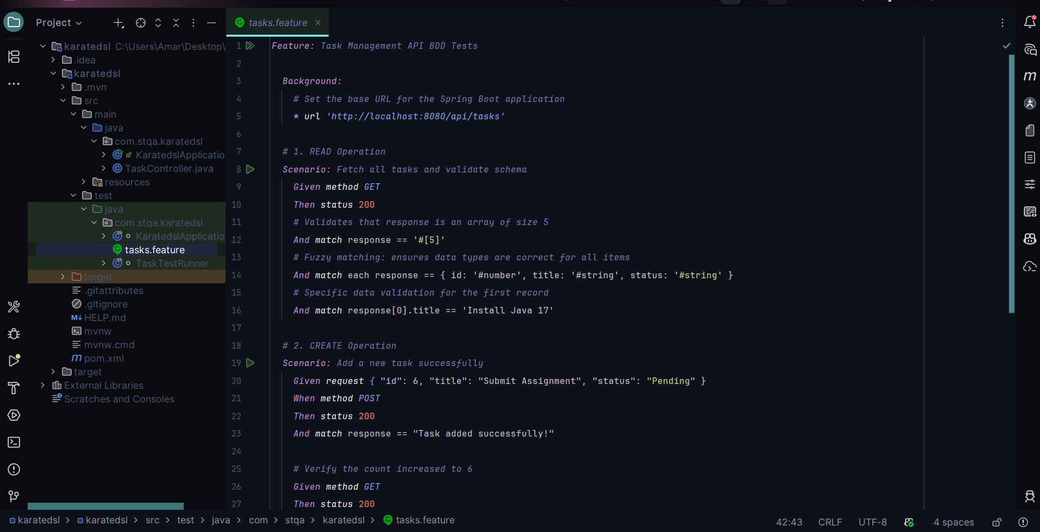

Code to add in the tasks.feature [test scenarios]

Feature: Task Management API BDD Tests
Background:
# Set the base URL for the Spring Boot application
* url 'http://localhost:8080/api/tasks'
# 1. READ Operation
Scenario: Fetch all tasks and validate schema
Given method GET
Then status 200
# Validates that response is an array of size 5
And match response == '#[5]'
# Fuzzy matching: ensures data types are correct for all items
And match each response == { id: '#number', title: '#string', status: '#string' }
# Specific data validation for the first record
And match response[0].title == 'Install Java 17'
# 2. CREATE Operation
Scenario: Add a new task successfully
Given request { "id": 6, "title": "Submit Assignment", "status": "Pending" }
When method POST
Then status 200
And match response == "Task added successfully!"
# Verify the count increased to 6
Given method GET
Then status 200
And match response == '#[6]'
# 3. DELETE Operation (Success Case)
Scenario: Delete an existing task
Given path '1'
When method DELETE
Then status 200
And match response == "Task deleted!"
# 4. DELETE Operation (Failure Case/Negative Test)
Scenario: Attempt to delete a task that does not exist
Given path '99'
When method DELETE
Then status 200
And match response == "Task not found"

Step 5: Implement a JUnit 5 Test Runner
- Navigate to: src/test/java
- Create a Java class for the test runner
- Annotate the class with @Karate.Test
- Link the runner to the feature files
- Save the runner class
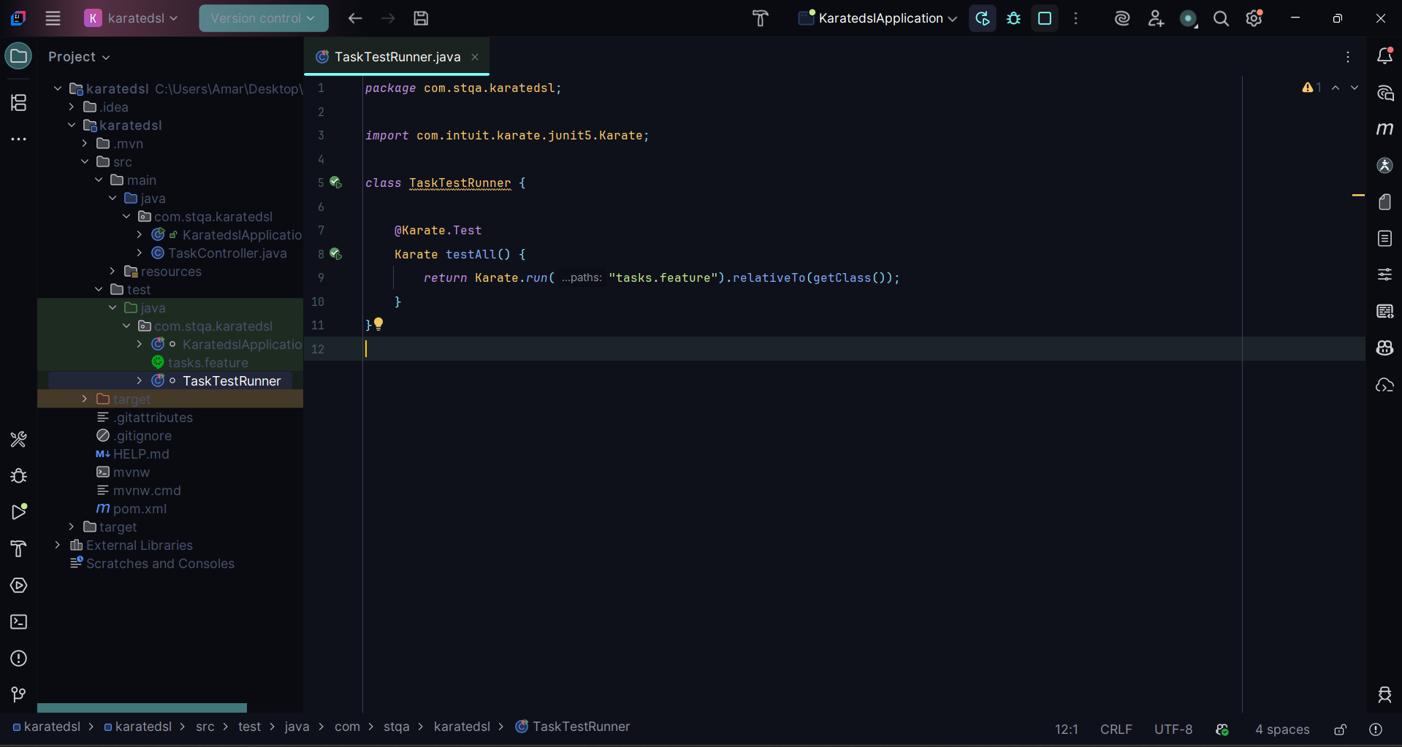

Code to add in the TaskTestRunner.java

package com.stqa.karatedsl;
import com.intuit.karate.junit5.Karate;
class TaskTestRunner {
@Karate.Test
Karate testAll() {
return Karate.run("tasks.feature").relativeTo(getClass());
}
}

Step 6: Execute the Tests
- Right-click the runner class and select Run
OR
- Open terminal and execute:
mvn test

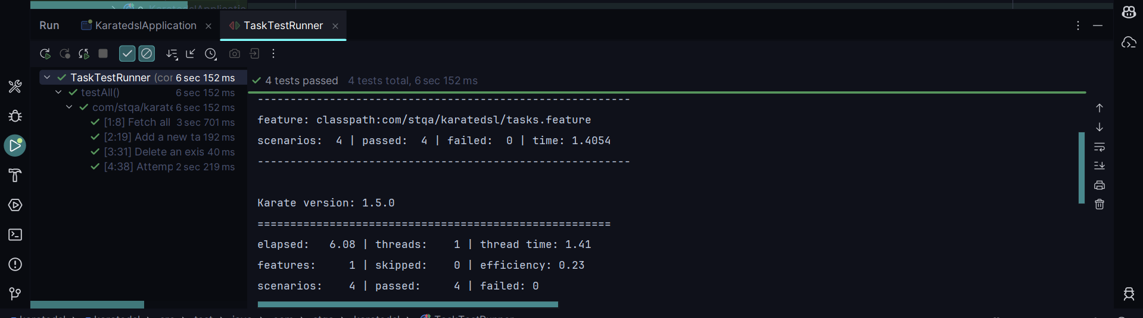
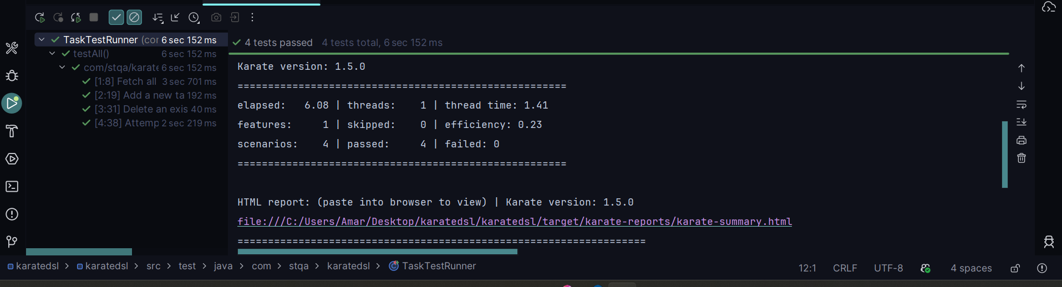

Step 7: Review the HTML Test Report
- Navigate to the target/karate-reports/ directory
- Open the generated HTML report in a browser
- Verify test results, request/response details, and execution status

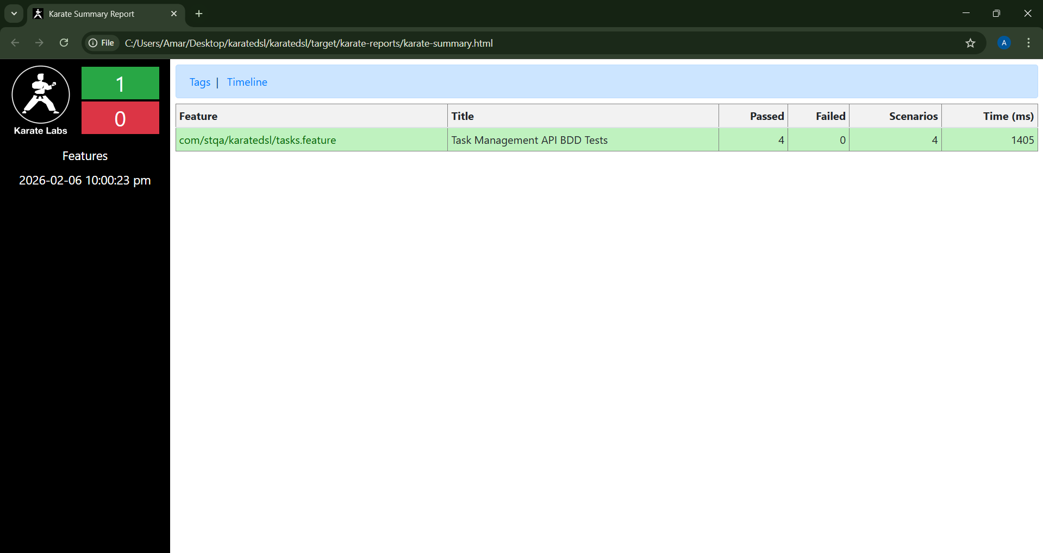
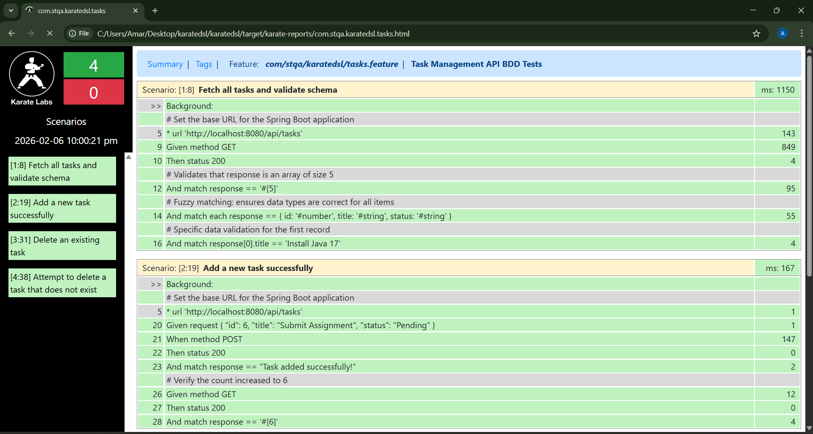
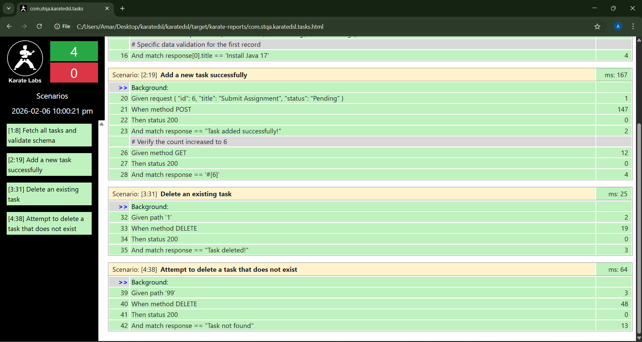

9. Conclusion
This assignment successfully demonstrated the implementation and execution of REST API tests using the Karate DSL framework with a Behaviour-Driven Development (BDD) approach. A Spring Boot application was used to develop RESTful endpoints, which were validated using Karate feature files written in Gherkin syntax. Karate DSL simplified API automation by reducing coding effort, improving test readability, and providing powerful validation features. The use of JUnit 5 and automated HTML reports ensured easy execution and clear result analysis. Overall, this approach highlights the effectiveness of Karate DSL for modern, maintainable, and efficient API testing.

