Assignment 1 Applied Remote Sensing
Andrea Marcheschi – Lorenzo Ranise

The radiometric resolution of each band is 12 bits. This means the values that are representable are 2 to the power of 12, which is equal to 4096 different values (0-4095). However, the values are stored in 16bit. However, in computer science numbers are usually not represented in 12 bits, which is equal to 1 byte and a half (12=8+4). The closest commonly used representation that can contain 12 bits is 16 bits, and in fact the images acquired by sentinel are stored with a 16bit integer.

We loaded in qgis each image at the highest resolution available. Even if the resolution of the sentinel satellite is 12 bit, we can see higher values than 4096. This happens for two reasons, the first is the way that physical values are stored in memory: when the photons hit the sensors, a voltage is generated, and adc converts the voltage to an integer value, this is the DN; the images are then processed (boa correction, geometric correction…) and quantized. The second one has to do with the shape and the material of the surface being analyzed, a slope, glass, snow, water surfaces, clouds can act as mirrors and have a reflectance above 1 when the image is processed and corrections are applied

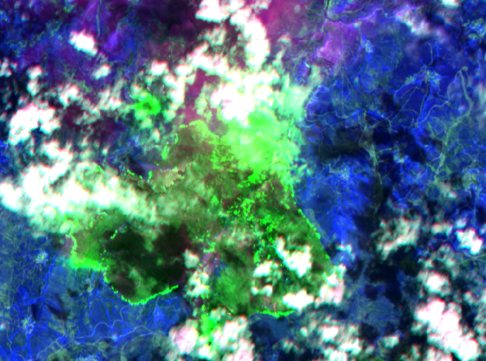
For each band, the values mostly sit in a range of a few hundreds to 12000. Notable exceptions however, are bands 9 and 12. Band 12, swir, reaches about 16k as maximum value while band 9 reaches 22k. Band 12 reaches those values in only a tiny portion of the image, most of the image has “regular” values except a crown shaped region in the upper right part. If we create a true color visualization of the image, that part looks like the edge of a forest fire with a smoke plume. If the view is combined with other bands including band 8a and 4, we can have a better and clear view of a forest fire.

For the band 9, if we clip the image to keep only the brightest part of the images, it is trivial to see that the resulting image shows where clouds are present in white and everything else in black.

In this case, we do not need to perform any boa correction as l2a products already have corrections applied. It is useful to note that BOA reflectance is now called SR or Surface Reflectance.

If we load the scene classification layer, we see that every pixel has assigned a value from 0 to 11, representing different surfaces (or no data/saturation/defective). If we apply a raster table we can fix to 0 all the cloud related bands (3,8,9,10) and get a black and white image containing 0 or 1 for surface or clouds. If we want to exclude clouds, we can use the raster calculator and multiply the band that we want times the mask and get the resulting band with cloudy areas set to 0.

