Part 1
Stage A
K | AP
256 | 0.4889
512 | 0.5509
1024 | 0.5500
How do you choose the number of visual words for BoVW?
The number of words should be selected by evaluating performance on a validation set while considering computational cost. A small vocabulary may not capture visual variability producing a coarse image representation whereas an excessively large vocabulary can increase dimensionality and computational cost without improving accuracy. In our experiments performance increased when moving from K=256 (AP=0.4889) to K=512 (AP=0.5509). No further gain was obtained at K=1024 (AP=0.5500). Therefore K=512 provides the trade-off between performance and complexity.
How does spatial tiling encode useful layout information?
Spatial tiling preserves the location of visual words inside the image. Of only counting visual words globally separate histograms are computed for different image regions and concatenated. This allows the representation to capture arrangements, such as wheels appearing near the bottom of a motorbike image or the sky appearing above an aeroplane.
How does vocabulary size affect representation capacity, quantization error, computation and storage?
Increasing the size increases the representation capacity because more visual patterns can be represented. A larger vocabulary also reduces quantization error since different descriptors are less likely to be assigned to the same visual word. However larger vocabularies increase computation time feature dimensionality and storage requirements. The experimental results show that increasing K from 256 to 512 retrieval performance but increasing K further to 1024 did not provide additional benefits suggesting that the extra complexity was not justified for this dataset.
Stage B
What do you anticipate the results to be? What do you predict will occur?
Since the BoVW representation captures local patterns of motorbikes the linear SVM is expected to assign higher scores to motorbike images and lower scores to background images. Consequently most motorbike images should appear near the top of the ranked list while unrelated images should appear near the bottom.

Do the highest-ranked images share object features, contextual cues or background patterns?
The ranked images mainly share characteristic motorbike structures such as wheels, handlebars and other distinctive vehicle parts. This suggests that the classifier has learned object- visual patterns rather than relying solely on the background.
Why can a classifier achieve high training performance but fail on new images?
A classifier may achieve training performance but perform poorly on unseen images because of overfitting. Of learning general motorbike characteristics it may memorize specific visual patterns, backgrounds, viewpoints or image conditions present in the training set. As a result the learned decision boundary may not generalize well to examples.
Stage C

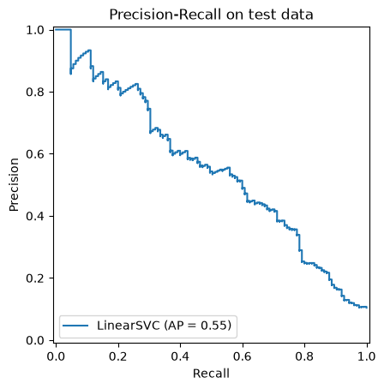

Why is the bias term irrelevant to the ordering of images scored by one fixed binary linear classifier?
A linear SVM ranks images according to the decision function. Since the bias term b is added equally to every image it shifts all scores by the constant value. Therefore the relative ordering of the images remains unchanged. The bias can influence the classification threshold. Does not affect the ranking used for image retrieval.
How does the ordering of positive and negative examples affect the precision–recall curve and AP?
The Precision-Recall curve depends directly on the ranking produced by the classifier. When positive images appear near the top of the ranked list precision remains high while recall increases, resulting in an Average Precision. Conversely if negative images are ranked before positive images precision drops more quickly and the AP decreases. Therefore AP measures how effectively the classifier places images ahead of irrelevant ones in the ranking.
Stage D
Class | AP
motorbike | 0.5509
aeroplane | 0.5231
person | 0.6998
horses | 0.5660
cars | 0.6724
How do intra-class variation, sample count, object scale and background diversity help explain differences in AP?
The results indicate that retrieval performance is not solely determined by the feature representation but by the visual characteristics of each category. Categories with recurring local patterns are easier for BoVW histograms and linear SVMs to model whereas categories with strong appearance variation or complex backgrounds present a greater challenge. These observations highlight the limitations of handcrafted representations when dealing with variable object classes.
Stage E
Normalization | AP
no normalization | 0.5188
L1 | 0.4131
L2 | 0.5509
No spatial imformation | 0.3430
How does L2 normalization affect the self-similarity of a nonzero feature vector under a linear kernel?
L2 normalization scales every -zero feature vector to unit length. Under a kernel the self-similarity of a vector corresponds to its dot product with itself. Therefore after L2 normalization every feature vector has a self-similarity to 1.
Regarding the L2 normalized BoVW histogram 𝐡, what can be inferred about its self-similarity 𝐾(𝐡,𝐡)?
For any L2-normalized histogram h the self-similarity K(h,h) is equal to 1 because the histogram has unit norm.
How does the self-similarity 𝐾(𝐡, 𝐡) of an L2 normalized BoVW histogram 𝐡 compare to the similarity 𝐾(𝐡, 𝐡′)) of two distinct L2 normalized BoVW histograms 𝐡 and 𝐡′?
The self-similarity K(h,h) is always equal to 1 where the similarity K(h,h’) between two L2-normalized histograms is generally less than 1. The value reaches 1 only when the two histograms are identical.
Would the same hold true for unnormalized or L1 normalized histograms?
No. Without L2 normalization self-similarity depends on the magnitude of the histogram. Therefore varies across images. Similarly L1 normalization constrains the histogram sum but does not enforce unit Euclidean norm, so K(h,h) is not necessarily equal to 1.
Is there a correlation between classification performance and the use of L2 normalization?
Yes. The experimental results show a correlation between classification performance and L2 normalization. L2 normalization achieved the AP (0.5509) outperforming both unnormalized histograms (0.5188) and L1-normalized histograms (0.4131). This suggests that L2 normalization improves the effectiveness of the SVM by placing all feature vectors on a common scale.
Why can removing spatial information help some classes but hurt others?
Spatial information captures the location of visual words within the image. For motorbikes characteristic components such as wheels, handlebars and the vehicle body often appear in consistent spatial arrangements. Therefore preserving information significantly improves discrimination as demonstrated by the substantial AP drop from 0.5509 to 0.3430 when spatial information was removed. However for classes whose objects appear at variable locations, scales or poses spatial constraints may reduce generalization. In these cases removing information can sometimes improve performance because the representation becomes more invariant to object position.
Stage F
Method | AP
Linear SVM (L2) | 0.5509
Hellinger Kernel | 0.6438
Considering the rule of thumb mentioned earlier that suggests L2 normalization can improve the performance of linear SVMs, how should the BoVW histograms 𝐡 and 𝐡′ be normalized for the Hellinger kernel classifier?
The Hellinger kernel is defined for -negative histograms interpreted as probability distributions. Therefore the histograms should first be L1-normalized. Afterward the square-root mapping is applied to obtain the Hellinger feature representation. Finally L2 normalization can be used before training the SVM to ensure a consistent feature scale.
Is it recommended to perform the normalization before or after taking the square root of the histogram values?
L1 normalization should be performed before taking the root because the Hellinger kernel is defined on probability distributions. After applying the square-root transformation L2 normalization can be applied to improve compatibility with the SVM classifier.
L1 normalization should be performed before taking the root because the Hellinger kernel is defined on probability distributions. After applying the square-root transformation L2 normalization can be applied to improve compatibility with the SVM classifier.
Why does the square-root mapping change the relative contribution of frequent and rare visual words?
The square-root transformation compresses histogram values while preserving smaller ones. As a result frequent visual words have less influence on the similarity measure whereas less frequent visual words become relatively more important. This improves discriminative power because rare visual patterns often contain category-specific information.
Stage G
Fraction | AP
10% | 0.2912
25% | 0.2957
50% | 0.4223
100% | 0.5509

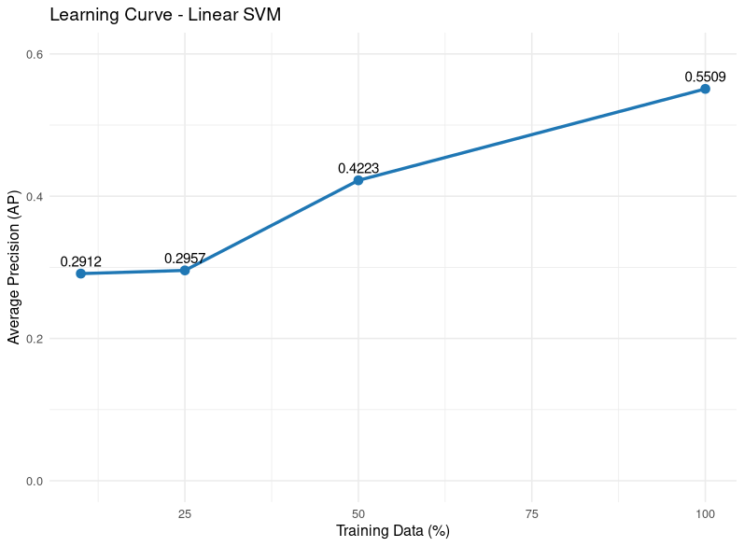
What performance do you get with the linear kernel? And with the Hellinger kernel?
Using the kernel the Average Precision increased as more training data became available. The AP values were 0.2912, 0.2957, 0.4223 and 0.5509 when using 10%, 25%, 50% and 100% of the training set. These results indicate that the classifier benefits substantially from training sets.
Does performance saturate?
The performance does not appear to have saturated. Although the improvement between 10% and 25% of the training data is minimal substantial gains are observed when increasing the training fraction to 50% and 100%. The upward trend suggests that the classifier could still benefit from training examples.
Would collecting more examples or improving their diversity likely help more? Support your answer with the performance curve.
Since the performance continues to improve as the amount of training data increases collecting examples would likely improve retrieval performance further. However increasing the diversity of the training data would also be beneficial because it would expose the classifier to a range of object appearances, viewpoints, scales and background conditions improving generalization.

