PROJECT SYNOPSIS
1. PROJECT TEAM:
- Amardeep Kumar – 1RN19IS020
- Amartya – 1RN19IS021
- Anushka jaiswal- 1RN19IS035
- Devendra Upadhyay – 1RN19IS056
2. PROJECT TITLE: Li-Fi Based Automatic Traffic Signal Control for Emergency Vehicle

3. AIM: Li-Fi Based Automatic Traffic Signal Control for Emergency Vehicle like ambulance and guiding them to nearest hospital making use of arduino uno.

4. ABSTRACT: India is one of the fastest developing country in the world. One of the disadvantages of this unprecedented growth is the ineffective traffic management. Light Fidelity (Li-Fi) is a form of bi-directional Visible Light Communication (VLC) in which light is modulated at speeds greater than a human eye can follow. Emergency vehicles such as Ambulances, Firefighting trucks, Police vehicles etc. can propagate faster through traffic-dense roads using Li-Fi based V2V communication system.

5. DOMAIN: IOT
6. DESCRIPTION:
Existing system
Research on traffic management, V2V communication, Ambulance based traffic control have been carried out since 1990s. Various communication protocols like GSM, RFID, IR, ZigBee etc. have been considered to implement emergency vehicle based traffic control. However, the above methods cannot be used in today’s world for various reasons.

Proposed System
Various research papers have proposed the use of Li-Fi for emergency vehicle based traffic control systems. It does not need any infrastructure like GSM. It offers a much secure communication compared to RFID. IR based emergency vehicle detection is unreliable as IR signals require line of sight and sunlight can cause interference with IR signals. It is relatively economical compared to ZigBee. It does not use the congested 2.4 GHz frequency like ZigBee. In this paper, Li-Fi based V2V communication system is implemented for smart control of traffic signal.

System Architecture :

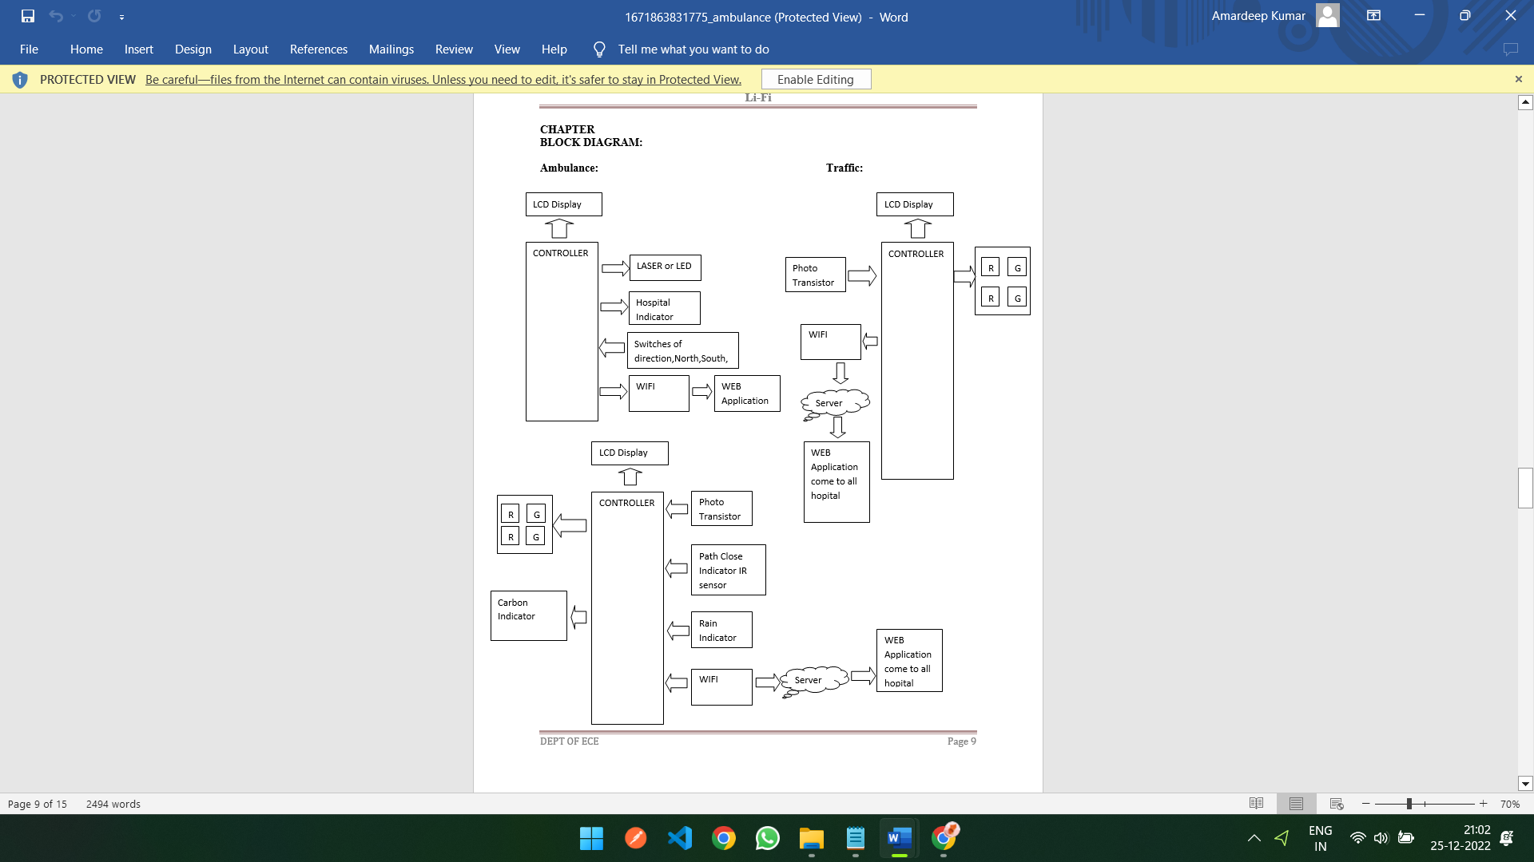

7. HARDWARE and SOFTWARE REQUIREMENTS
HARDWARE:
1.Controller(Arduino Uno)
2.LASER OR LED
3.Phototransistor
4.Rain sensor
5. Carbon mq5 sensor
6.LCD DISPLAY
7.WIFI
8.LEDs
SOFTWARE:
1.ARDUINO IDE
2.ADAFRUIT IO(WEB application)

8. APPLICATIONS
1. Li-fi technology can be implemented on ambulance so that patient can reach nearest hospital as soon as possible and patient life can easily be saved.
2. Li-fi technology can be implemented on firefighting trucks so that they can reach the accident area faster to extinguish hazardous fires that threaten life and property.
3. Li-fi technology can be implemented on police vehicles so that police can reach the crime location and take action needed faster.

