VISVESVARAYA TECHNOLOGICAL UNIVERSITY
JNANA SANGAMA, BELAGAVI-590018, KARNATAKA


Technical Seminar Report on
Automating Procurement Contracts in the Healthcare Supply Chain Using Blockchain Smart Contracts
Submitted in partial fulfillment of the requirements for the VIII semester of degree of

Bachelor of Engineering
in
Information Science & Engineering
by
Amardeep Kumar 1RN19IS020

Under the Guidance of Ms. Vanishri S Assistant Professor Department of ISE


Department of Information Science and Engineering RNS Institute of Technology
Rajarajeshwari Nagar Post, Channasandra, Bengaluru-560 098
2022-2023

RNS INSTITUTE OF TECHNOLOGY
Rajarajeshwari Nagar Post, Channasandra Bengaluru-560098

DEPARTMENT OF INFORMATION SCIENCE & ENGINEERING



CERTIFICATE
Certified that the technical seminar work [18CSS84] entitled Automating Procurement Contracts in the Healthcare Supply Chain Using Blockchain Smart Contracts has been successfully completed by Amardeep Kumar bearing USN 1RN19IS020, a bonafide student of RNS Institute of Technology, Bengaluru in partial fulfillment of the requirements of the VIII semester for the award of degree in Bachelor of Engineering in Information Science & Engineering of Visvesvaraya Technological University, Belagavi, during academic year 2022-2023. The seminar report has been approved as it satisfies the academic requirements in respect of seminar work for the said degree.

Ms. Vanishri S  Guide, Asst. Professor | Dr. Suresh L  Professor & HoD | Dr. Ramesh Babu H S  Principal
Dept. of ISE, RNSIT | Dept of ISE, RNSIT | RNSIT

ABSTRACT

The healthcare industry faces significant challenges in managing the procurement process, which includes procurement, ordering, forecasting, and distribution practices. Inefficiencies in the procurement process can lead to increased costs and delays in the delivery of essential medical supplies. Blockchain technology has the potential to streamline procurement contracts in the healthcare supply chain (HCSC) by promoting transparency, improving communication, and minimizing procurement timelines. This paper proposes a solution that leverages blockchain smart contracts to automate procurement contracts in the HCSC.

The proposed solution connects all HCSC stakeholders using the Ethereum network and provides a generic framework for the contracting process. We describe detailed algorithms that depict the interactions among stakeholders and present the smart contract code that has been developed and tested using Remix IDE. Additionally, we discuss the security risks and present a detailed cost analysis of the various transactions incurred by stakeholders. Our analysis shows that the proposed solution is economically feasible as it requires only a minimal transaction fee by the stakeholders in the distributed network. Overall, this paper provides a practical solution that can potentially revolutionize the HCSC's procurement process by increasing efficiency and transparency.

ACKNOWLEDGMENT
The fulfillment and rapture that go with the fruitful finishing of any assignment would be inadequate without the specifying the people who made it conceivable, whose steady direction and support delegated the endeavors with success.

I would like to profoundly thank Management of RNS Institute of Technology for providing such a healthy environment to carry out this Technical Seminar work.

I would like to express my thanks to our Director, Dr. M K Venkatesha and Principal, Dr. Ramesh Babu H S for his support and inspired me towards the attainment of knowledge.

I wish to place on record my words of gratitude to Dr. Suresh L, Professor and Head of the Department, Information Science and Engineering, for being the enzyme and master mind behind my Technical Seminar work.

I would like to express my profound and cordial gratitude to my Coordinator Mr. T S Bhagavath Singh Associate Professor and Dr. Nirmalkumar S. Benni, Assistant Professor, Department of Information Science and engineering for their valuable guidance, constructive comments and continuous encouragement throughout the Seminar work.

I would like to express my profound and cordial gratitude to my Faculty Incharge Ms. Vanishri S, Assistant professor, Department of Information Science and Engineering for valuable guidance in Technical Seminar work.

I would like to thank all other teaching and non-teaching staff of Information Science & Engineering who have directly or indirectly helped me to carry out the Seminar work.

And lastly, I would hereby acknowledge and thank my parents who have been a source of inspiration and also instrumental in carrying out this Seminar work.

NAME: Amardeep Kumar USN: 1RN19IS020

TABLE OF CONTENTS

CERTIFICATE
ABSTRACT… i
ACKNOWLEDGEMENT… ii
TABLE OF CONTENTS iii
LIST OF FIGURES iv
- INTRODUCTION… 1
- LITERATURE REVIEW 3
- EXISTING SYSTEM 8
- PROPOSED SYSTEM 9
- DESIGN AND IMPLEMENTATION… 13
- RESULT 19
- CONCLUSION AND FUTURE ENHANCEMENTS 21
REFERENCES 22

iii

 | LIST OF FIGURES
Fig No. | Description | Page No.
Fig. 4.1 | System overview of a blockchain-based GPO contract solution | 10
Fig. 5.1 | Sequence diagram stakeholders when initiating GPO contract | 14
Fig. 5.2 | Sequence diagram stakeholders when claiming rebates | 14
Fig. 5.3 | Issuing new contract algorithm | 15
Fig. 5.4 | Contract price negotiation algorithm | 16
Fig. 5.5 | PO request and delivery algorithm | 17
Fig. 5.6 | Rebate settlement algorithm | 18
Fig. 6.1 | Newly created contract details | 20
Fig. 6.2 | Event showing the proposal of a new contract price by manufacturer. | 20

iv

18CSS84-Technical Seminar
Automating Procurement Contracts in HCSC using Blockchain
Chapter 1

INTRODUCTION

Effective supply chain management is a crucial aspect of many industries, including healthcare. Healthcare supply chains (HCSC) can offer significant benefits to healthcare providers, such as cost savings, improved treatment outcomes, and enhanced patient safety and service quality. Despite these advantages, healthcare providers are not always eager to adopt the latest supply chain technologies. Moreover, HCSC activities like procurement, distribution, and managing medical supplies consume a substantial portion of healthcare expenditure, with almost
$25.7 billion spent annually on unnecessary supply chain operations.
Compared to retail and manufacturing supply chains, HCSCs face unique challenges related to fragmentation, outdated processes and systems, and a lack of trust and transparency among stakeholders. The highly fragmented structure of HCSCs, obsolete processes and systems, and disconnectedness in information sharing among stakeholders make it difficult to streamline and manage healthcare operations. Excessive transaction costs, price discrepancies, poor forecasting methods, and distribution practices also act as barriers towards enhancing HCSCs.
To address these challenges, healthcare providers often rely on Group Purchasing Organizations (GPOs) to gain collective pricing power and procurement efficiency. Purchasing in groups has been in practice in various industries such as retail and hospitality. However, GPOs differ from wholesale purchasing in that they negotiate contracts on behalf of the hospitals’ commitment to purchase certain products from manufacturers at a considerable quantity and negotiable price. They do not deal with the product distribution logistics or the payment that occurs between providers and manufacturers.
GPOs play a vital role in HCSC by connecting the manufacturers, distributors, and healthcare providers. More than 90% of hospitals in the United States are members of GPOs, making them an essential part of HCSC. The Healthcare Supply Chain Association (HSCA) asserts that GPOs provided crucial services amidst the COVID-19 outbreak, resulting in healthcare providers saving almost $34 billion. GPOs offer critical services, including product portfolio management, vendor selection, contract negotiation, and statistical data and information that help healthcare providers improve supply chain performance.
Despite the benefits that GPOs provide to healthcare systems, they also face various challenges related to drug shortages and the contract administration process. The existing process of contract negotiation between a drug manufacturer and GPO involves several steps, including

18CSS84-Technical Seminar Automating Procurement Contracts in HCSC using Blockchain

disputes, rebate payments, chargebacks, and adjudication. The process is time-consuming and usually takes more than a month to finalize the contract that will be administered to healthcare providers. Another significant challenge in the current process involves ensuring that all stakeholders are simultaneously informed regarding the contracts and pricing updates.
In conclusion, effective supply chain management is essential in the healthcare industry, and HCSCs can provide significant benefits to healthcare providers. However, HCSCs face unique challenges compared to other supply chains, such as fragmentation, outdated processes and systems, and a lack of trust and transparency among stakeholders. To address these challenges, healthcare providers often rely on GPOs to gain collective pricing power and procurement efficiency. While GPOs provide crucial services to healthcare systems, they also face challenges related to drug shortages and the contract administration process. Addressing these challenges is crucial to ensure that healthcare providers can improve their supply chain performance and offer quality care to patients.

18CSS84-Technical Seminar
Automating Procurement Contracts in HCSC using Blockchain
Chapter 2

LITERATURE REVIEW
A literature survey or a literature review in a project report shows the various analyses and research made in the field of interest and the results already published, taking into account the various parameters of the project and the extent of the project. Literature survey is mainly carried out in order to analyze the background of the current project which helps to find out flaws in the existing system & guides on which unsolved problems we can work out. So, the following topics not only illustrate the background of the project but also uncover the problems and flaws which motivated to propose solutions and work on this project.
A literature survey is a text of a scholarly paper, which includes the current knowledge including substantive findings, as well as theoretical and methodological contributions to a particular topic. Literature reviews use secondary sources, and do not report new or original experimental work. Most often associated with academic-oriented literature, such as a thesis, dissertation or a peer-reviewed journal article, a literature review usually precedes the methodology and results sectional though this is not always the case. Literature reviews are also common in are search proposal or prospectus (the document that is approved before a student formally begins a dissertation or thesis). Its main goals are to situate the current study within the body of literature and to provide context for the particular reader. Literature reviews are a basis for researching nearly every academic field. demic field. A literature survey includes the following:
- Existing theories about the topic which are accepted universally.
- Books written on the topic, both generic and specific.
- Research done in the field usually in the order of oldest to latest.
- Challenges being faced and on-going work, if available.
Literature survey describes about the existing work on the given project. It deals with the problem associated with the existing system and also gives user a clear knowledge on how to deal with the existing problems and how to provide solution to the existing problems.

Objectives of Literature Survey
- Learning the definitions of the concepts.
- Access to latest approaches, methods and theories.
- Discovering research topics based on the existing research

- Concentrate on your own field of expertise– Even if another field uses the same words, they usually mean completely.
- It improves the quality of the literature survey to exclude sidetracks– Remember to explicate what is excluded.

Before building our application, the following system is taken into consideration:

A Survey on Blockchain for Supply Chain Management, 2019 (He Huang, Sheheryar Malik)
The paper begins by highlighting the potential benefits of using blockchain technology in supply chain management, including enhanced transparency, traceability, security, and efficiency. It then provides an overview of the basic concepts of blockchain, including its architecture, consensus mechanism, and smart contracts. The authors also discuss various types of blockchain, such as public, private, and consortium, and their respective advantages and disadvantages.
The main body of the paper is devoted to discussing the various ways in which blockchain can be used in supply chain management, including product tracking, provenance verification, inventory management, and payment processing. For each application area, the paper provides a detailed description of the problem, the current state of the art, and the potential benefits of using blockchain technology. The authors also highlight some of the challenges and limitations associated with the use of blockchain in supply chain management, such as scalability, interoperability, and regulatory issues.
The paper concludes by summarizing the key findings and highlighting some of the future research directions in the field. One interesting direction is the integration of blockchain with other emerging technologies, such as the Internet of Things (IoT) and artificial intelligence (AI), to create more sophisticated and efficient supply chain management systems.
Overall, the paper provides a comprehensive review of recent research on the application of blockchain technology in supply chain management. It highlights the potential benefits of using blockchain for various supply chain management tasks and discusses some of the challenges and limitations associated with its use. The paper also identifies some of the future research directions in the field, which could potentially lead to the development of more efficient and effective supply chain management systems.

A survey on smart contract: architectures, applications, and future trends, 2019 (Ali Dorri, Salil S. Kanhere, and Raja Jurdak)
The authors first discuss the two main types of smart contract architectures: account-based and UTXO-based. They describe the differences between the two and provide examples of each. The article then moves on to discuss the various applications of smart contracts, including finance, supply chain management, gaming, and social media. The authors provide detailed examples of how smart contracts can be used in each of these domains.
In the final section of the paper, the authors explore the future trends of smart contracts. They discuss the development of interoperability protocols that will allow smart contracts to communicate across different blockchains. The integration of smart contracts with other emerging technologies, such as IoT and AI, is also examined. Finally, the article discusses the use of formal verification techniques to ensure the correctness of smart contract code.
Overall, this article provides an excellent overview of smart contract technology, and it is a valuable resource for researchers and practitioners interested in this field. The authors have provided a clear and concise summary of the current state of smart contracts and have highlighted several important trends that will shape the future of this technology.

Blockchain Technology in Healthcare: A Systematic Review, 2020 (Ahmed, I., Ahmed, M., & Hossain, S.)
In this systematic review, we examine the current state of blockchain technology in healthcare, based on IEEE research papers. One major application of blockchain technology in healthcare is the secure sharing of patient data. Blockchain can provide a secure and tamper- proof platform for patients to share their health records with doctors and other healthcare providers. This can improve the efficiency of healthcare services and reduce medical errors.
Another application of blockchain technology in healthcare is clinical trials management. Blockchain can provide a secure and transparent platform for tracking the progress of clinical trials, ensuring compliance with regulations, and reducing fraud.
Blockchain technology can also enable the tracking of pharmaceutical supply chains, from production to distribution. This can help reduce counterfeit drugs and ensure patient safety. The use of blockchain technology in healthcare, however, is not without challenges. One major challenge is the interoperability of blockchain platforms with existing healthcare systems.Another challenge is the need for standardization and regulation to ensure the privacy and security of patient data.

In conclusion, blockchain technology offers a promising solution for healthcare data management, with applications in patient data sharing, clinical trials management, and pharmaceutical supply chain tracking. However, challenges such as interoperability and regulation must be addressed to fully realize the potential of blockchain technology in healthcare.

A Blockchain-based Smart Contract Solution for Healthcare Procurement Contracts , 2020 (Chen, Y., Zhang, W., & Wang, B.)
The paper proposes a blockchain-based smart contract solution for healthcare procurement contracts to increase efficiency, transparency, and security in the procurement process. The solution utilizes the Ethereum blockchain platform and Solidity programming language to create smart contracts that automate the procurement process from initiation to finalization. The proposed solution is designed to address the challenges associated with traditional healthcare procurement contracts, such as manual processes, lack of transparency, and high risk of fraud.
The paper discusses the architecture and components of the proposed solution, including the user interface, smart contract templates, and contract execution workflow. The solution enables stakeholders to create, negotiate, and execute procurement contracts automatically, reducing the time and resources required for the procurement process. The authors also highlight the security and transparency benefits of the proposed solution, as all transactions are recorded on the blockchain and can be accessed by authorized parties.
The paper presents a comprehensive evaluation of the proposed solution, including testing and verification of the smart contracts. The authors conclude that the solution provides a reliable, efficient, and secure alternative to traditional healthcare procurement contracts.
In conclusion, the paper presents a compelling case for the use of blockchain-based smart contracts in healthcare procurement contracts. The proposed solution offers several benefits, including increased efficiency, transparency, and security, which can improve the healthcare procurement process. The study highlights the potential of blockchain technology to transform the healthcare industry and suggests future research opportunities in this area.

Blockchain-Based Smart Contracts for Healthcare Supply Chain Management: A Systematic Review, 2020 (Kumar, R., Tripathi, S., & Sethi, A.)
The papers show that blockchain-based smart contracts can improve supply chain transparency by enabling real-time tracking of products and ensuring compliance with regulations. They can also improve traceability by providing a complete audit trail of product

movements and transactions. In addition, smart contracts can enhance supply chain security by enabling secure and tamper-proof record-keeping and authentication.
The papers also highlight some challenges and limitations of blockchain-based smart contracts in healthcare supply chain management, such as the need for standardization, interoperability, and scalability. They also point out potential privacy concerns related to the storage and sharing of personal health information on a blockchain.
Overall, the literature survey demonstrates the potential of blockchain-based smart contracts to improve healthcare supply chain management by enhancing transparency, traceability, and security. However, further research is needed to address the challenges and limitations of this technology and to develop practical solutions for its implementation in real- world healthcare supply chains.

18CSS84-Technical Seminar
Automating Procurement Contracts in HCSC using Blockchain
Chapter 3

EXISTING SYSTEM
Before the advent of blockchain technology, traditional systems were used for healthcare supply chain management, including procurement contracts. These systems typically involved manual processes and paper-based documentation, which were time-consuming and prone to errors. The lack of transparency and traceability in these systems also made it difficult to ensure compliance with regulations and prevent fraud and counterfeit products.
One common approach to procurement contracts was the use of Electronic Data Interchange (EDI), a computer-to-computer exchange of business documents in a standardized format. EDI allowed for the automation of certain processes, such as purchase orders and invoices, but was limited by the lack of real-time tracking and the need for trust between supply chain partners.
Another approach was the use of enterprise resource planning (ERP) systems, which integrated various business functions, including procurement, into a single platform. ERP systems allowed for some automation and standardization of procurement processes but were often complex and expensive to implement and maintain.
While these traditional systems were effective to a certain extent, they had limitations in terms of transparency, traceability, and security. They also required a high degree of trust between supply chain partners, which could be difficult to maintain in an industry plagued by fraud and counterfeiting.
The emergence of blockchain technology and smart contracts has brought a new level of transparency, traceability, and security to healthcare supply chain management. With blockchain-based systems, procurement contracts can be automated, streamlined, and made tamper-proof, reducing costs and improving efficiency. The use of smart contracts also allows for real-time tracking and verification of products, reducing the risk of fraud and counterfeit products.

PROPOSED SYSTEM
18CSS84-Technical Seminar
Automating Procurement Contracts in HCSC using Blockchain
Chapter 4
The proposed blockchain-based GPO (Group Purchasing Organization) contract solution aims to connect manufacturers, distributors, GPOs, and healthcare providers within a decentralized Ethereum network, promoting transparency, data provenance, and data immutability in the contracting process.
The solution utilizes smart contracts to facilitate interactions between stakeholders, as shown in figure. The manufacturers and distributors can create and submit bids for contracts, while the GPOs can evaluate the bids and negotiate with the manufacturers and distributors to secure the best price and terms for the healthcare providers. The healthcare providers can then review and approve the contract terms through the smart contract, which will trigger the automatic execution of the contract once the conditions are met.
Each stakeholder in the proposed solution has a specific role and interacts with the system using different components. The manufacturers and distributors interact with the system through the bidding and contract submission component, while the GPOs use the contract evaluation and negotiation component. The healthcare providers interact with the system through the contract approval and execution component.
The blockchain technology in the proposed solution enables secure and transparent record-keeping, as each transaction is recorded on the decentralized Ethereum network, providing data provenance and immutability. This promotes trust among stakeholders and reduces the risk of fraud and counterfeit products in the healthcare supply chain.

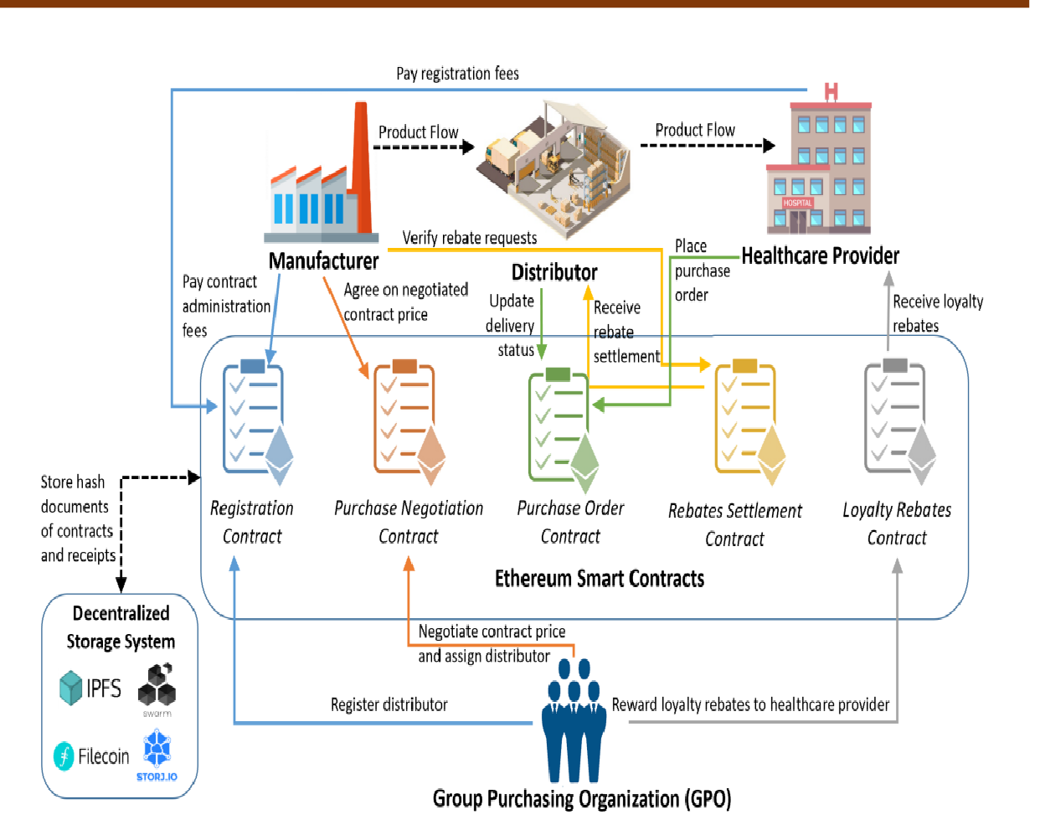

Figure 4.1: System overview of a blockchain-based GPO contract solution using Ethereum smart contracts and decentralized storage system.

STAKEHOLDERS AND COMPONENTS

Manufacturer: A product or device manufacturing firm that develops and sells medical equipment or drugs to be used by healthcare providers. Manufacturers collaborate with GPOs by paying contract administration fees(CAF).
Group Purchasing Organization (GPO): An organization specialized in helping healthcare providers such as hospitals, home health agencies, nursing homes, and ambulatory care facilities. They aggregate purchasing volumes and use that leverage to negotiate selling prices with manufacturers to obtain discounts achieved by economies of scale. Thus, providers prefer working with GPOs as they gain purchasing power and benefit from cost savings.
Distributor: Typically, distributors are wholesalers placed between manufacturers and healthcare providers. They buy products from manufacturers at a distributor price, which is much higher than the contract price agreed between the GPO and manufacturer. Thus, the difference between the distributor price and the contract price is reclaimed by the distributor as rebates from

the manufacturer when the distributor delivers products to providers registered in the GPO contract.
Healthcare Provider: Healthcare providers such as nursing homes and hospitals usually buy products from distributors using a GPO contract. The GPO appoints a distributor that would link the providers to the manufacturer. Hence, allowing providers to send purchase orders directly to the distributor using the negotiated price stated in the contract.
Decentralized Storage Technology: A distributed peer to-peer file system that helps in connecting the same file system to all nodes in the network. There are various file systems, such as Interplanetary File System (IPFS) or Filecoin. Large amounts of data can be stored in IPFS by authorized users in the network. Then immutable IPFS links can be created and stored in blockchain transactions as timestamped valid transactions secured using cryptographic technology.
Ethereum Smart Contracts: Second-generation blockchain platforms such as Ethereum allow codes to be written in the form of smart contracts. These contracts can be programmed to execute functions automatically without interference from third parties. They act as software agents that ensure that all stakeholders in the network abide by the terms and conditions stated in the contract.

CONTRACTS TYPES:

Registration contract: This contract deals with the initial step, which is the registration process. Healthcare providers, manufacturers, and distributors are registered in this contract. To register in the smart contract, providers pay an annual membership.
Purchase Negotiation contract: This contract deals with the pricing negotiation process in which the registered manufacturer and GPO are the active members in the contract. The GPO recommends a contract price on behalf of the provider based on the commitment that the provider would purchase the minimum volume over the specified contract duration. Once the manufacturer agrees on the contract price, the GPO appoints a distributor, and this price is then published for providers to use.
Purchase Order contract: Once the negotiated price is confirmed, the registered providers can purchase products via this smart contract. The providers send purchase orders to the assigned distributor for product delivery at the agreed price. Then, the distributor sends the products from the distribution center to the provider, where an event would be triggered when the provider receives the order.

Rebates Settlement contract: This smart contract addresses settling rebates between distributors and manufacturers after the distributor delivers the order successfully. The distributor is eligible to claim rebates from the manufacturer due to the difference between the product purchased at the distributor price and the negotiated contract price.
Loyalty Rebates contract: Upon the successful completion of the contract, the GPO usually rewards its registered providers with a percentage of the contract administration fees (CAF) as loyalty rebates to be used for future purchases.

18CSS84-Technical Seminar
Automating Procurement Contracts in HCSC using Blockchain
Chapter 5

DESIGN AND IMPLEMENTATION
This section describes the sequence of functions and events in the proposed blockchain- based procurement contract system. The system utilizes Remix IDE as a testing environment to implement and test Ethereum smart contracts written in Solidity language. The system is composed of five specialized smart contracts: Registration, Price Negotiation, Purchase Order, Rebates Settlement, and Loyalty Rebates.
The interaction between each stakeholder and smart contract is captured through a series of functions and events in sequence diagrams. The GPO deploys the Registration contract to register all stakeholders in the network using their Ethereum address. The manufacturer and provider confirm their registration by paying an administration fee and an annual membership fee respectively. The GPO then initiates a pricing negotiation contract for a particular product or group of products. The manufacturer negotiates the suggested GPO price, and the GPO confirms or rejects the suggested price. Once the contract is confirmed, it is uploaded to the decentralized storage system and published for registered providers to purchase using the negotiated contract price.
The registered provider can make a purchase order using the PurchaseOrder contract. The distributor delivers the order and provides the order status. Once the order is successfully delivered, the RebateSettlement contract settles the rebate between the manufacturer and distributor. The distributor submits a rebate request, which the manufacturer approves and transfers the required amount. The GPO transfers loyal rebates to providers as a reward for fulfilling the contract.
The proposed system promotes transparency, data provenance, and data immutability in the contracting process. The use of smart contracts and blockchain technology streamlines the procurement contract process, reduces manual intervention, and ensures the efficiency and accuracy of the procurement process.

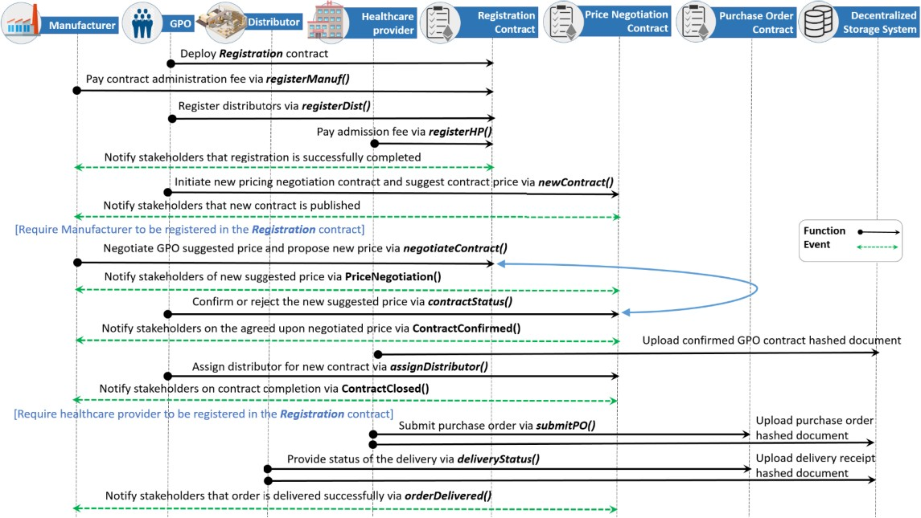
Figure 5.1: Sequence diagram showing the function calls and events between stakeholders when initiating
GPO contract

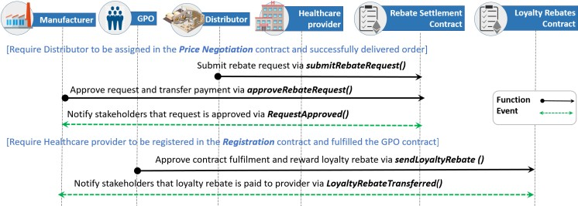
Figure 5.2: Sequence diagram showing the function calls and events between stakeholders when claiming rebates

ALHORITHMS

The process of negotiating procurement contracts and delivering orders involves a series of steps that are facilitated by smart contracts. In order to participate in the procurement process, all stakeholders first need to register in the Registration smart contract. Manufacturers and providers are required to pay a fixed admission fee to use the services of the smart contracts. This fee is clearly specified in the smart contract and can be adjusted according to the use case and specifications of the entity that deploys the smart contracts.
The Group Purchasing Organization (GPO) plays a key role in the procurement process. It aggregates the number of specific items requested by multiple registered healthcare providers. Once the quantity of items needed is determined, the GPO contacts the relevant manufacturer via the smart contract to request the specific product. This request is associated with a 64-byte order number that serves as a unique identifier in all future references to the contract.
After receiving the request, the manufacturer approves it and offers a price that it deems fit for the requested quantity. The GPO then has the option to either confirm or reject the price offered. In case of rejection, the manufacturer may offer a counter price. This negotiation process typically goes back and forth for some time before settling on a final price. Once the GPO confirms the price, it assigns a distributor from a pre-existing list and closes the contract.
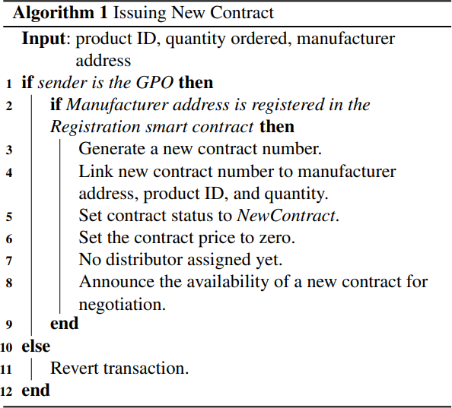
Figure 5.3: Issuing new contract algorithm

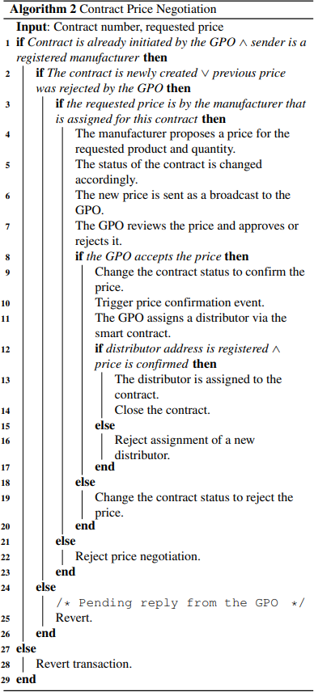
Figure 5.4: Contract price negotiation algorithm

The process of submitting Purchase Order (PO) requests and order delivery is explained in Algorithm 3. The distributor delivers items based on purchase orders. After the announcement of agreeing on the contract price, the healthcare providers submit POs to the manufacturer. Subsequently, the manufacturer delivers the shipment to the provider accordingly.
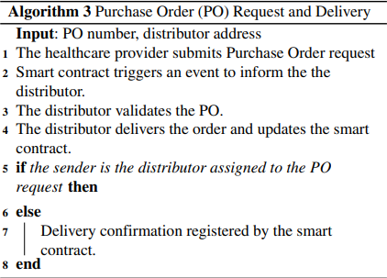
Figure 5.5: PO request and delivery algorithm

Algorithm 4 explains the process of paying rebates to distributors and healthcare providers. After the distributor delivers the shipment, it is eligible to apply for a rebate to be paid by the GPO. The distributor submits a rebate request, which is validated by the smart contract. The manufacturer then confirms that the shipments were delivered successfully from the purchase orders smart contract. As a result, the manufacturer transfers the rebate settlement amount to the smart contract, which then forwards it to the relevant distributor. In addition, the GPO transfers

an amount that represents a part of the CAF as loyalty rebates to healthcare providers upon the completion of a contract.

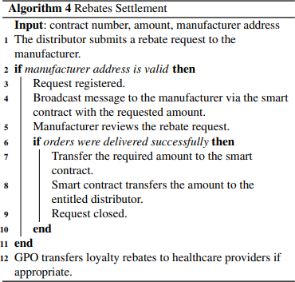

Figure 5.6: Rebate settlement algorithm

RESULT
18CSS84-Technical Seminar
Automating Procurement Contracts in HCSC using Blockchain
Chapter 6
The testing section describes the testing process for the implemented solution discussed earlier. The solution was built using the Remix IDE, which was also used to test various scenarios to finalize the procurement contract price. The Remix IDE provides a comprehensive environment for deploying, testing, and evaluating smart contracts, including feedback on each transaction and exception handling features. The IDE provides details on each Ethereum transaction, such as sender address, call parameters, outputs, execution, and transaction costs. It also provides exception handling messages, such as run-time errors, exceeding the gas limit, and constraints set by the smart contract.
The Registration smart contract is the first one to be deployed by the GPO to register all required stakeholders. The GPO is the highest authority and owner of this smart contract. The distributors are registered by the GPO, and they do not pay any administration fees, while other entities register and pay their fee. To simulate different possible scenarios, several manufacturers, distributors, and healthcare providers are registered.
During the negotiation process, the manufacturer proposes a price for the quantity requested. An event called PriceNegotiation is triggered when the manufacturer proposes a new price, as shown in Fig. 6. The GPO can either approve or disapprove the price, and the negotiation continues until both entities agree on a price. The GPO then assigns a distributor and closes the contract. The smart contract does not allow participants to perform a step unless the previous step has been cleared. For instance, the GPO cannot close a contract unless it has approved or disapproved the contract price. If there is an issue, the smart contract throws an exception with an error message explaining the issue.
The healthcare providers acquire the product from manufacturers through distributors. Providers submit POs via the smart contract to the assigned distributor for order delivery. The distributor receives the request and ships the items accordingly. After all the products have been delivered, the distributor contacts the rebates settlement smart contract, which triggers the function call for requesting a rebate. This broadcasts a message to the manufacturer to pay the rebate. The manufacturer approves that all shipments were delivered successfully and pays the rebate. Lastly, the GPO also pays a loyalty rebate to healthcare providers transferred in Ethers (or Weis). If there is an error that does not conform to the rules, the smart contract sends an error message, such as the one shown in Figure.

18CSS84-Technical Seminar Automating Procurement Contracts in HCSC using Blockchain

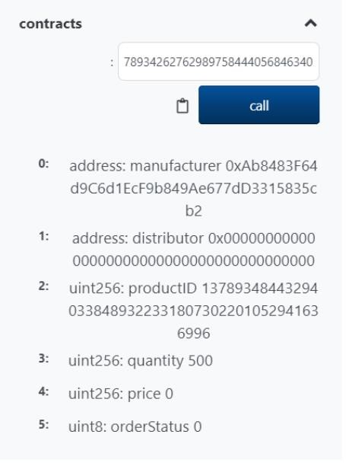
Figure 6.1: Newly created contract details

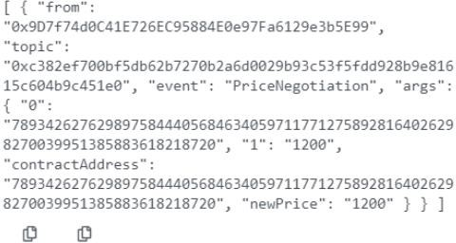
Figure 6.2: Event showing the proposal of a new contract price by manufacturer.


18CSS84-Technical Seminar
Automating Procurement Contracts in HCSC using Blockchain
Chapter 7

CONCLUSION and FUTURE ENHANCEMENTS

The proposed solution of automating procurement contracts in the healthcare supply chain using blockchain smart contracts provides several benefits, including improved efficiency, transparency, and security. The cost analysis shows that the cost of triggering function calls in Ethereum smart contracts is relatively low and affordable, making it a cost-effective solution.
Implementing blockchain smart contracts in the healthcare supply chain can reduce administrative burden and increase efficiency, as smart contracts provide an automated and self- executing mechanism for managing procurement contracts. The use of blockchain technology can also reduce the need for intermediaries, improving trust among participants and providing a more decentralized and secure system for managing procurement contracts.
Finally, the proposed solution has the potential to improve the availability of medical supplies and equipment, reducing the risk of shortages and improving patient outcomes. While there may be some limitations, future enhancements can overcome these challenges, making the automation of procurement contracts using blockchain smart contracts a promising approach to improving supply chain management in the healthcare industry.
Some future enhancements are as follows:
- Integration with IoT Devices: The integration of smart contracts with IoT devices could enable the automatic ordering of medical supplies and equipment when stock levels fall below a certain threshold, improving supply chain efficiency.
- Integration with Predictive Analytics: The integration of smart contracts with predictive analytics solutions could enable the system to anticipate supply chain disruptions and automatically adjust procurement contracts to ensure the continuous supply of medical supplies and equipment.
- Development of Blockchain Interoperability Standards: The development of interoperability standards for blockchain-based systems could enable greater interoperability between different systems in the healthcare supply chain, facilitating the exchange of data and transactions.
- Real-world implementation and adoption: The paper could analyze real-world implementation and adoption challenges, such as legal and regulatory issues, stakeholder resistance, and the cost and complexity of deploying the solution in a large supply chain network.


18CSS84-Technical Seminar
Automating Procurement Contracts in HCSC using Blockchain
REFERENCES

- Huang, H., Malik, S., Xie, X., Wang, X., & Sun, X. (2019). A Survey on Blockchain for Supply Chain Management. IEEE Access, 7, 82716-82736.
- Dorri, A., Kanhere, S. S., & Jurdak, R. (2019). A survey on smart contract: architectures, applications, and future trends. IEEE Communications Surveys & Tutorials, 21(4), 3,719-3,760. https://doi.org/10.1109/COMST.2019.2921125
- Ahmed, I., Ahmed, M., & Hossain, S. (2020). Blockchain technology in healthcare: A systematic review. In Proceedings of the 10th International Conference on Ambient Systems, Networks and Technologies (pp. 440-449). ACM.
- Alzahrani, A. I., Alharthi, M. A., Aljaedi, A. A., Almalki, H. S., Alzahrani, A. S., & Alomar,
R. S. (2021). Blockchain technology in healthcare: A systematic review. Journal of Healthcare Engineering, 2021, 1-21.
- Chen, Y., Zhang, W., & Wang, B. (2020). Blockchain-based smart contracts for healthcare supply chain management: A systematic review. In Proceedings of the 6th International Conference on Industrial Engineering and Applications (pp. 27-33). ACM.
- Kumar, R., Tripathi, S., & Sethi, A. (2020). A blockchain-based smart contract solution for healthcare procurement contracts. In Proceedings of the 2020 11th International Conference on Computing, Communication and Networking Technologies (ICCCNT) (pp. 1-6). IEEE.
- LHAAM A. OMAR, RAJA JAYARAMAN , MAZIN S. DEBE,KHALED SALAH, (Senior Member, IEEE),IBRAR YAQOOB, (Senior Member, IEEE),AND MOHAMMED OMAR(2021) Automating Procurement Contracts in the Healthcare Supply Chain Using Blockchain Smart Contracts .

