POLCYPORTAL2020

Mentor

1. **Assigning Next Phase**

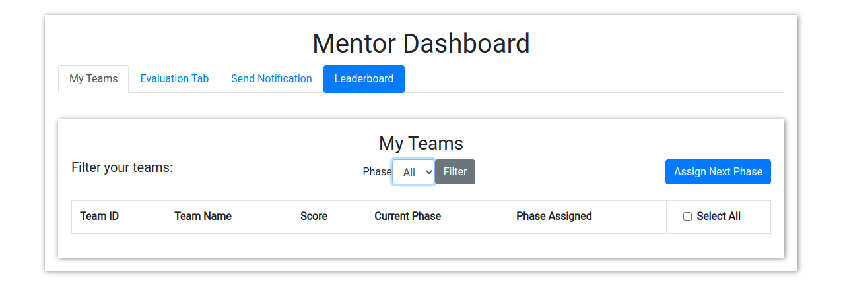



1. When a team is new and is in *phase-0* then using this button mentor can bring it to *phase-1*
2. When team completes the phase-x[ x can be 1, 2, 3, 4] then using this button mentor can bring them to phase-(x+1)

**NOTE**





1. If you want to ‘assign next phase’ you need to select the teams.
2. **SELECTING TEAMS**
   1. Check the checkbox of the beam to be selected
   2. To select all teams check the ‘Select All’ [ as shown in Image ]
   3. You can select multiple teams as well

**2. Task Evaluation**

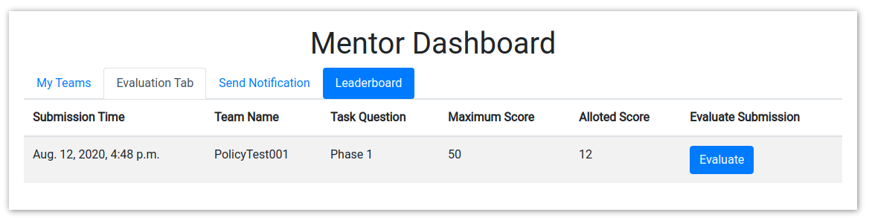

1. Go to Evaluation Tab
2. Select the task to be evaluated
3. Click on the  button

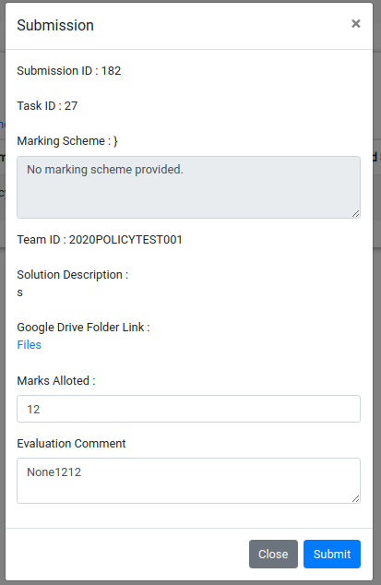

This modal will appear when you clicks on evaluate button

Evaluation

1. See the google doc submitted by the team
2. If the task is completed then allot them marks and submit it.
3. If still the task is pending ‘Send Notification’