**POLICYPORTAL2020**

Teams

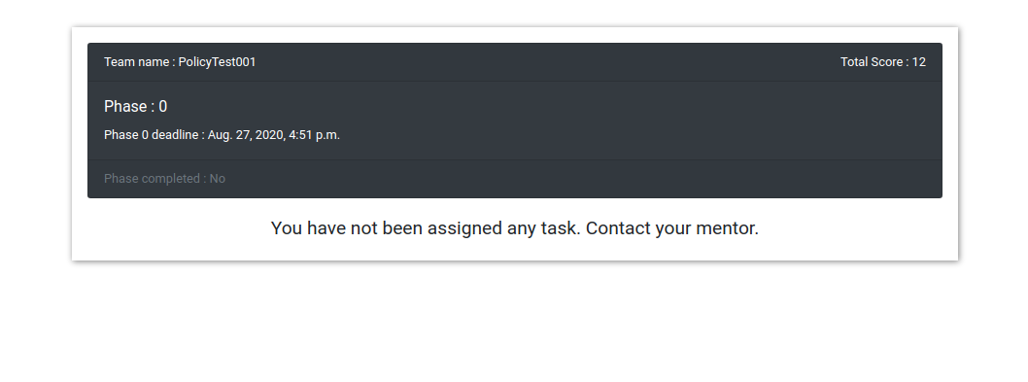

Team dashboard[ shown in above image ]

1. When you login for the first time you will be in phase-0
2. When mentor will assign you the next phase then you will be able to go to the next phase
3. **How to go from Phase-0 to phase-1**
4. When you will login to team dashboard for the first time your dashboard will look like the first image

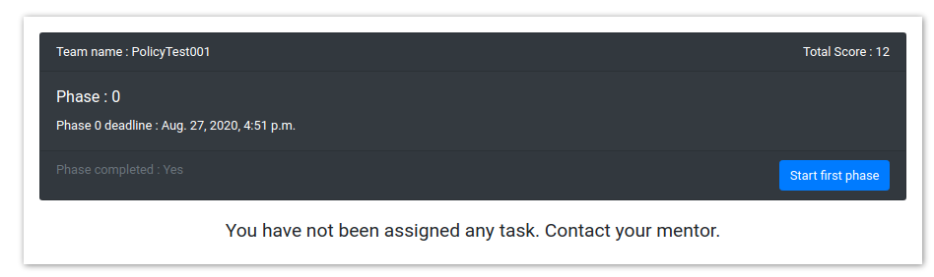

a. You will see  button once mentor assign you the

Next phase. Click on this button to increment your phase

1. Once you have clicked the button you will come to ‘phase-1’

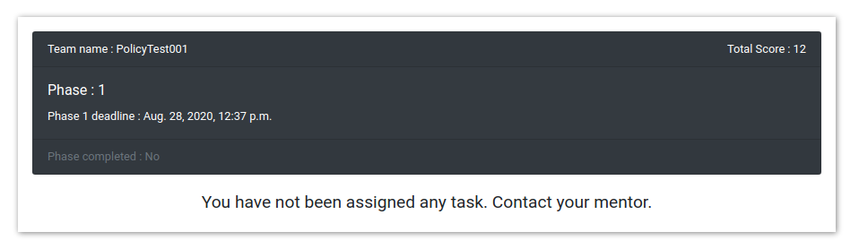

So this is what your dashborad will look like once you click on  button

**NOTE:**

1. Same procedure is followed when you have to go from phase-x[ x is 1, 2, 3, 4] to phase-(x+1)

**Task Management**

1. When mentor will assign you the task you it will be visible on your dashboard

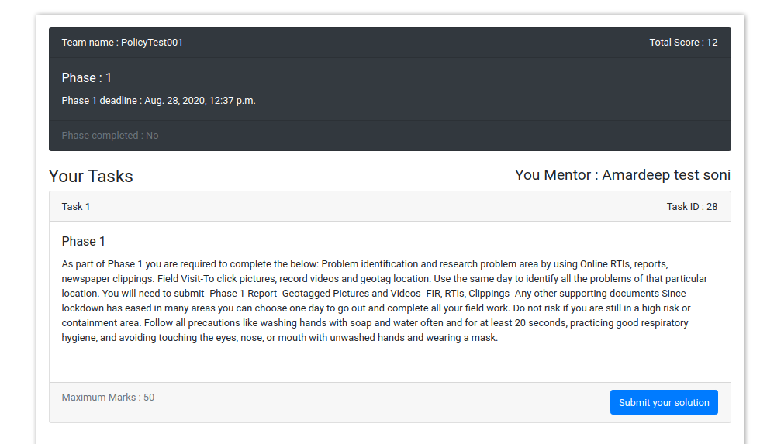

1. Once you get a task on your dashboard try to complete it before deadline and when it is completed submit it 
2. Once you have submitted the task, wait for the menor to evaluate it. If he is satisfied with the submission he will approve it and give you some marks based on your submission else he will notify you to make more changes.
3. To check the Notification  click on this dropdown (It’s located at the top of the dashboard page).