**SolidWorks DFM Plug-In and SculptPrint Feedback Application**

**Making machining knowledge more accessible to novice designers**

1. Installation

1a. SolidWorks Plug-In

1b. SculptPrint Feedback Application

2. Usage and Functionality

2a. General Usage Instructions

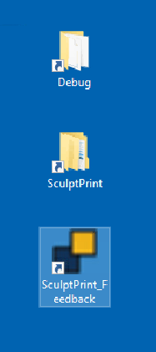 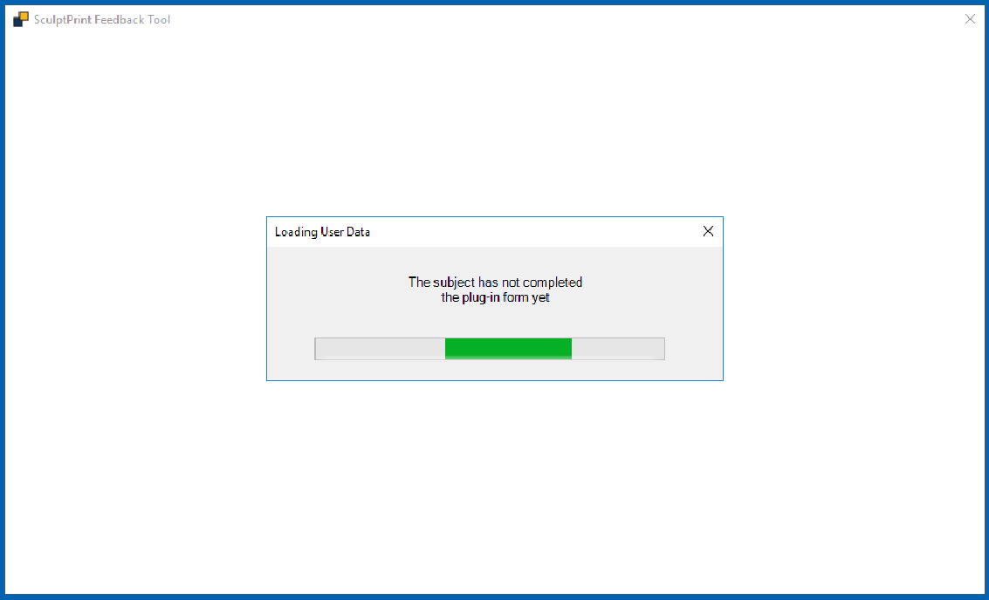

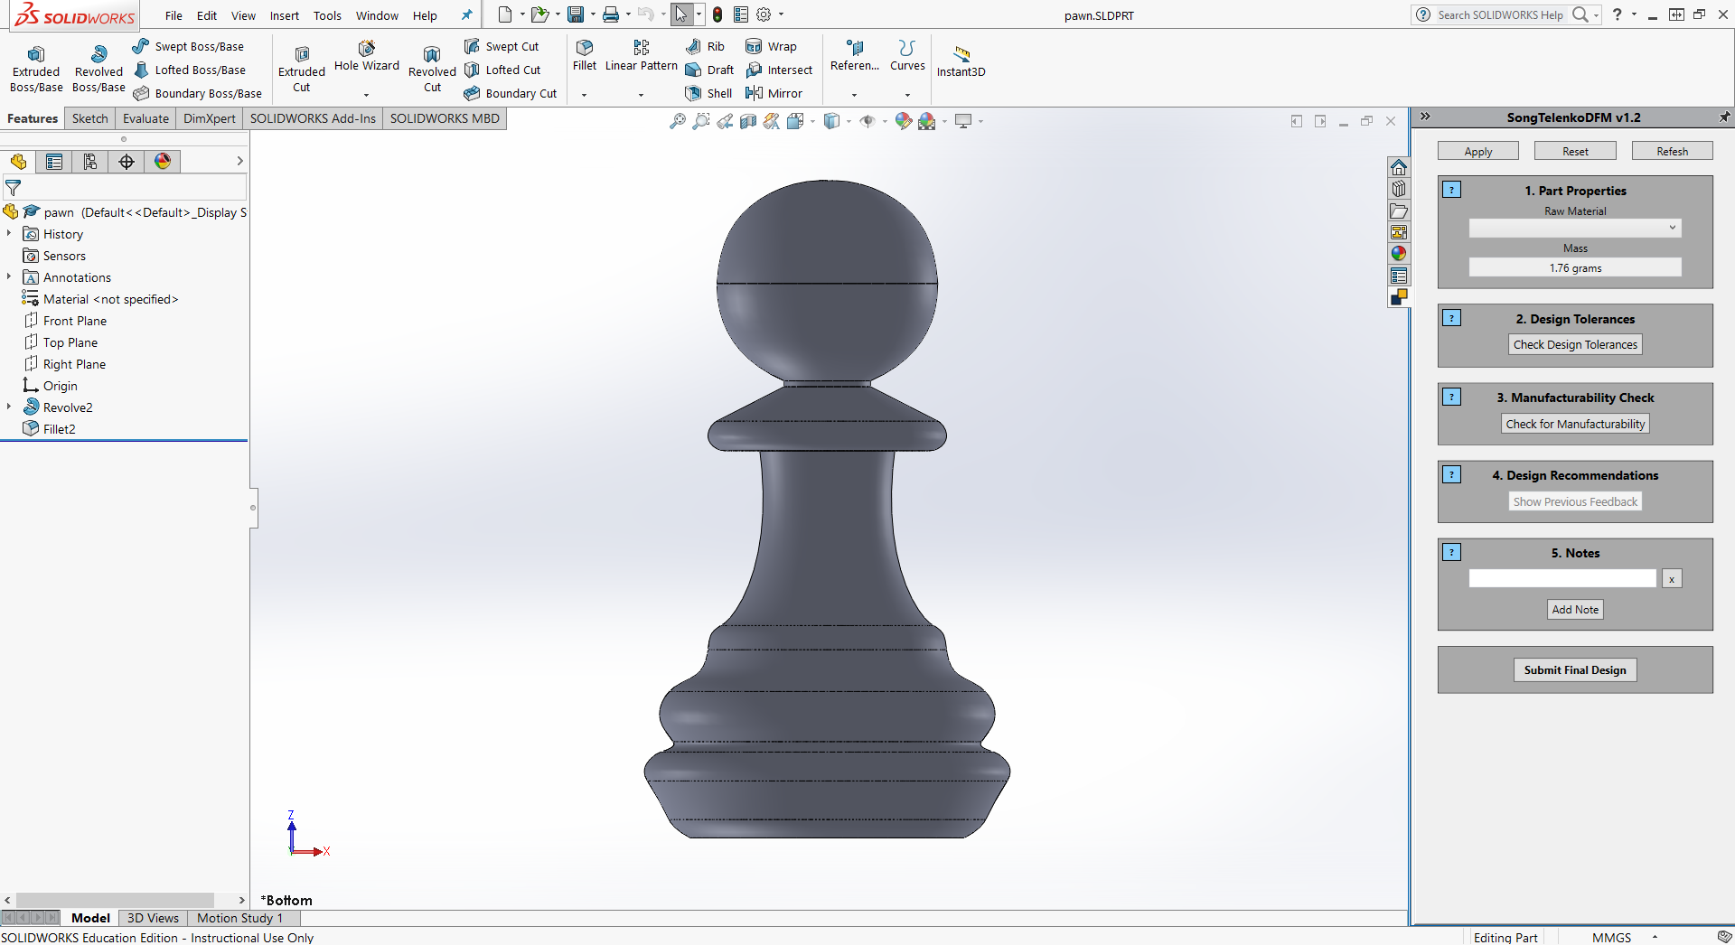

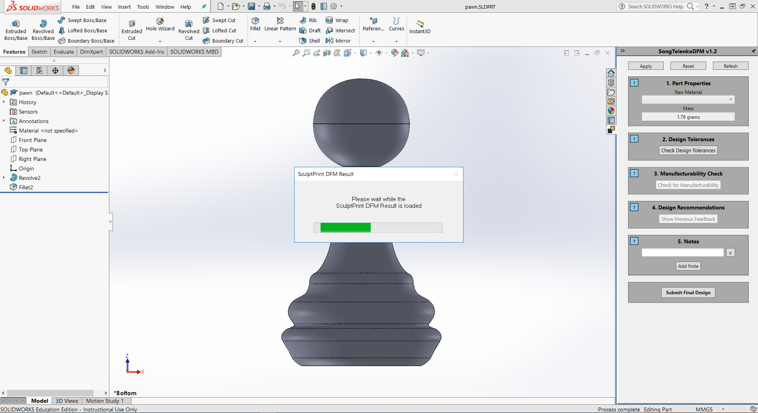

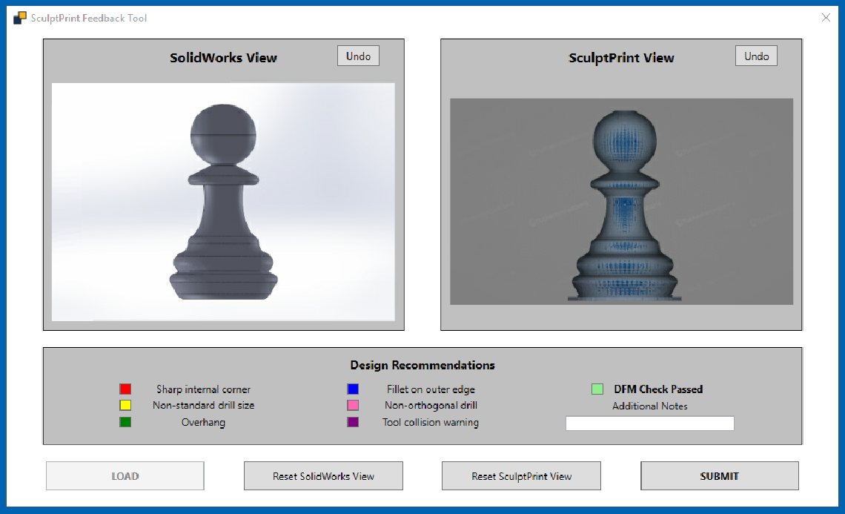

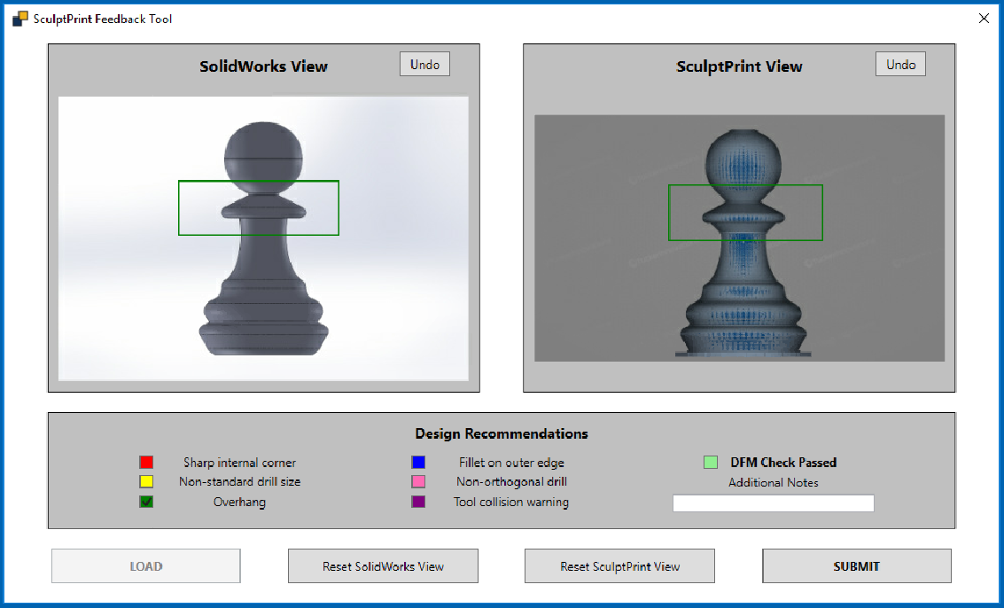

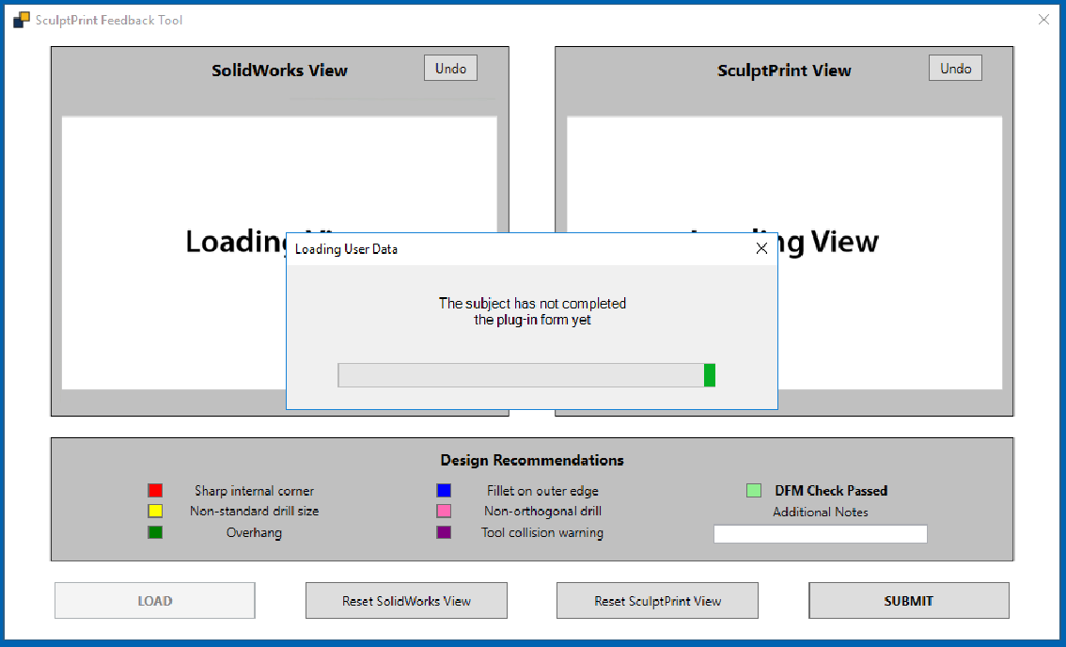

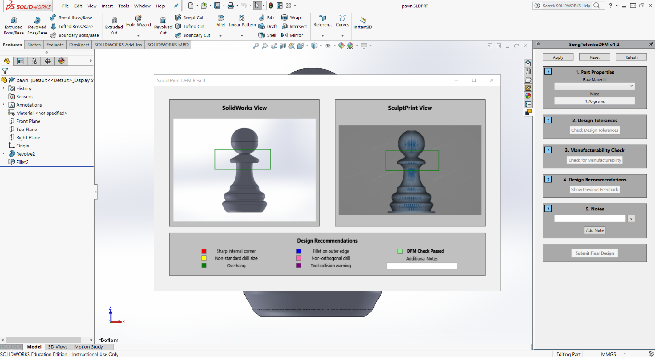

2b. Folder Structure

2c. Web Host and SFTP

3. Customization of Functionality

3a. SolidWorks Plug-In

3b. SculptPrint Feedback Application