# Progress Report 2014-15

Modeling & Control of Tele-operated Mobile Manipulators

By

Amaren P Das

2011MEZ8364)

DRHR, BARC, Mumbai

Phd, Student (External)

* Dr. D.N Badodkar, BARC, Mumbai

Supervisors

* Prof. S. K. Saha, IITD
* Dr. S. Bhasin, IITD

# Introduction

This report presents the work done in last one year as part of my PhD programmer on *modeling and control of tele-operated mobile manipulators*. Mobile manipulators are basically robotic arm mounted on a mobile platform. This configuration gives large work volume due to the mobility of the platform and better dexterity due to the presence of robotic arm. But these benefits come at a cost: the motion of the platform and robotic arm are dynamically interconnected, thus, complicating controller design. Another problem associated with such systems is that, in general these systems are teleoperated which may introduces time delays in the system. The time delay in the control loop induces instability, further complicating design of control system. In this report, I have proposed to address both these problem by using decentralized control of mobile manipulators, to take care of dynamic interaction and use of back-stepping controller for stabilization under time delay.

The first part of the report, presents the dynamic equation of a mobile wheeled platform with 2DOF robotic arm, based on the DNOC methodology proposed in [5]. This method has the advantage that non-holonomic constraints, (constrains on velocity, which cannot be integrated), are included in a natural way in the derivation of dynamic equation of a system. The simulation results clearly show the dynamic interaction between the platform and arm motion.

The second Part of the report deals with the development of control algorithm for the above system, based on decentralized control. Before attempting to design controller for the complete system, a 1-DOF platform with 1-DOF manipulator is examined and simulation results presented.

In the third part, role of time delay in destabilizing a system is demonstrated via simulation of, mass spring system. A back-stepping controller, based on 1st order PDE, is designed to stabilize the system with input delay.

# Part1

# Kinematic and dynamic of Wheeled Mobile robot [5]

Mobile wheel platform are dynamical system in which the rolling constrain of the wheels introduced non integrable velocity constrains. Such constrains are called non-holonomic constraint. This kind of constraint does not reduce the DOF of as system but rather prohibit instantaneous motion in certain directions. For the system in figure 1 the velocity constrains are written as



The purpose of this exercise was to understand the use Decoupled Natural Orthogonal method for dynamic simulation of non-holonomic systems.

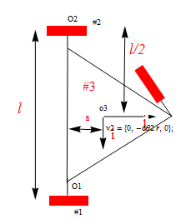

β

Path to be traced

Figure

The figure 1 shows the line diagram of a three wheeled mobile platform. It has wheel #1 and #2 actuated and the third wheel #3 is a caster wheel. The dynamic equation of the system was worked out. Simulation of forward and Inverse dynamics are presented. In the simulation the vehicle (point #03), is required to traces a circle of radius 5m and with β(t) as given below



## Inverse Dynamics

Using the Inverse Kinematic, the wheel velocity and acceleration are determined using pseudo Inverse from the equation given below. Where “r” is radius of the wheel and Ѳi is the wheel roll angle of wheel #1 and #2. The platform angular velocity is ω and the Cartesian velocity of point o3 is given by in body coordinate system



The wheel angle, velocity and acceleration are used in the dynamic equation to calculate the torque required by each motor. The results are plotted in figure 2. The size of generalized inertia matrix,  and convective term  are not reported here as there are size is very large.

## Forward Dynamics

The torque calculated above, is then used as input while integrating the dynamic equation  , to find the history of the wheel angles. The wheel angle thus found is compared with the wheel angle used earlier in the Inverse dynamics to ascertain the validity of numerical computation. Figure 2 indicate the error in calculating the wheel angle using the forward Dynamics and Inverse Dynamics.

For simulation the following data were used

l=0.4m,r=0.05m,a=0.1010m,I=diag[0.0025,0.00125,0.00125]kgm^2 for wheels , mass of platform 20Kg. Inertia a platform I=diag[.07083,0.7083,0.4083]kgm^2

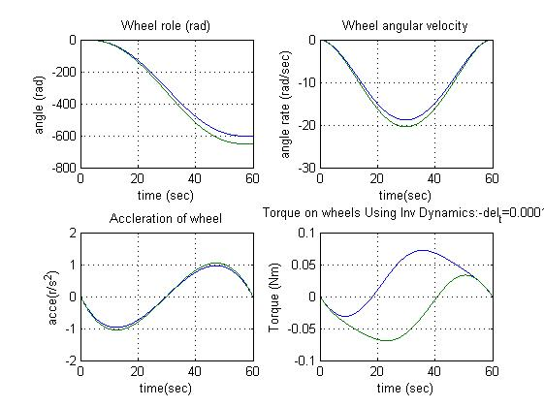

Figure

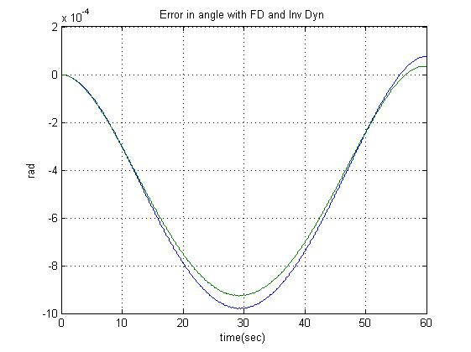

Figure

Observation: Numerical error are of the order  , which is acceptable for all practical purpose.

# Dynamic modeling of AGV with 2 DOF Manipulator

The dynamic model of Mobile manipulator shown in figure 4 was derived using DNOC methodology. The symbolic calculation was done use Mathmatica S/W. The closed form solution of the system was obtained. The actuated joint were the two rear wheels of the platform and the two joints a of the manipulator arm as indicated in 4, hence forth referred as  . Joint  are clearly marked in figure 4, whereas joints  are the roll angle of the wheel about 

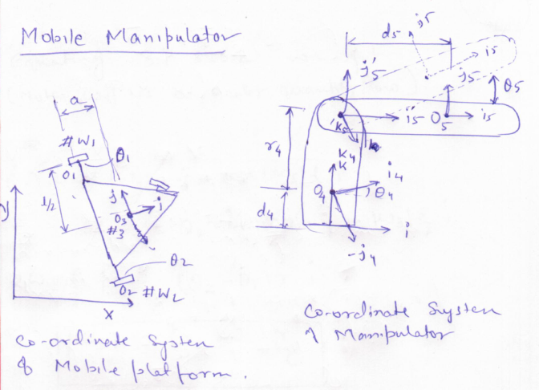

Figure

The final form of the dynamic equation is . Where M is the generalized inertia matrix,  is convective inertia term and  is torque on each actuated joint. To demonstrate the inter-coupling between the platform and the arm Inverse dynamic is carried out, in which the manipulator joints are moved in predefined profile, where as the wheels are held stationary. The result of simulation is presented next.

## Inverse Dynamics



Results are shown in figure 4, in which torques needed at all the four joints are plotted, it can be clearly seen that the motion of the arm induces force on the mobile platform. The wheels need torque τ1 and τ2 to maintain the stagnant position of the platform.

Following parameters were used in the simulation

Moment of Inertia of the platform is calculated assuming it as circular disk or Radius, "R" and Mass, m3, Moment of Inertia of links are calculated assuming them as slender rod.

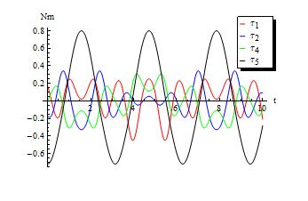

Figure

### Observation

There is a strong dynamic coupling between the platform and the arm. Though, it is possible to design controllers taking complete system into consideration, it may result into a very complicated design. It is therefore, preferable to find techniques, in which independent controllers can be designed for the platform and the arm, so that the desired performance can achieve.

# Part 2

# Decentralized control of Mobile manipulators.

Decentralized control technique treats the manipulator and the platform as two different system. The inter-coupling forces are treated as external forces on the system. The dynamics equation of the mobile manipulator can thus be split as follows [3]



Where “fr” can be considered as the disturbance term for the platform and “fv” can be considered as disturbance term for the manipulator. Such disturbance model has been considered in [2] for control of manipulator arm. Though in [2] , computed torque based PID controller was used we propose to use Sliding Mode control, which has excellent disturbance rejection capabilities, for matched disturbances.

To test the above concept simulation was carried out on a simplified model of a mobile manipulator, which consists of 1-DOF manipulator (z-Motion platform) mounted on a mobile vehicle. This model was chosen because a similar system is under developed at BARc, for monitoring radiation level inside cyclotron vault. Once the system is manufactured we can verify the simulation results with the real hardware.

## The Mobile manipulator

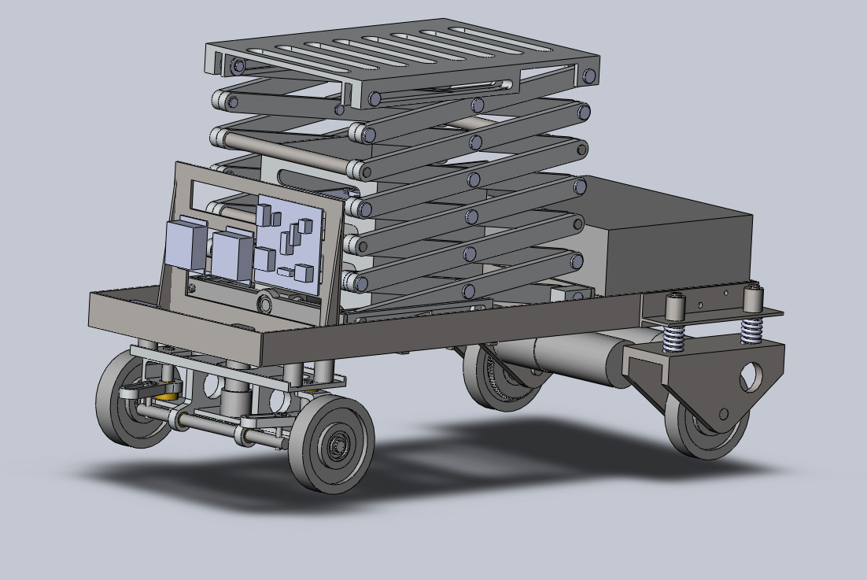

The dynamic equation of this system is derived assuming that the vehicle move along a straight line. The  angle in the equation represents the angle between the scissor link and the horizontal, x represent the linear displacement of the vehicle.

 

In the above equation  can be considered as disturbance term for the 1DOF manipulator, hence forth referred to as *Scissor.* Whereas  can be regards disturbance term for the vehicle dynamics.

Below is presented two controllers PID and Sliding Mode controller for the manipulator arm (Scissor). Using the concept of decentralized control the coupling forces will be considered as disturbance terms. Regulation controller for the scissor will be designed considering only the dynamics of the scissor.

### Dynamic simulation of Scissor with PID controller

Without the disturbance term the dynamic equation of the scissor can be written as 

The objective is to maintain the  at 45 degree. Computed torque with PID is used as a controller as indicated below.



The simulation is carried under following conditions

1. No disturbance term and Plant parameters exactly known
2. Plant Parameter varying within 10% of nominal value
3. Parameter variation and 

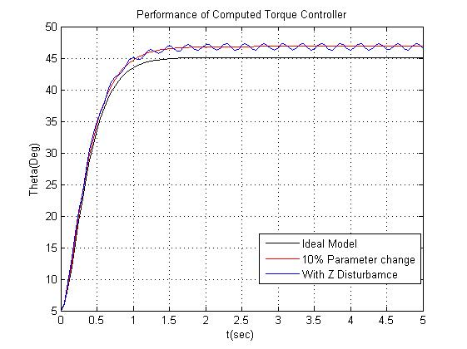

Figure

### Sliding Mode controller

The dynamic equation of the scissor after cancellation of the non linear terms , can be represented as

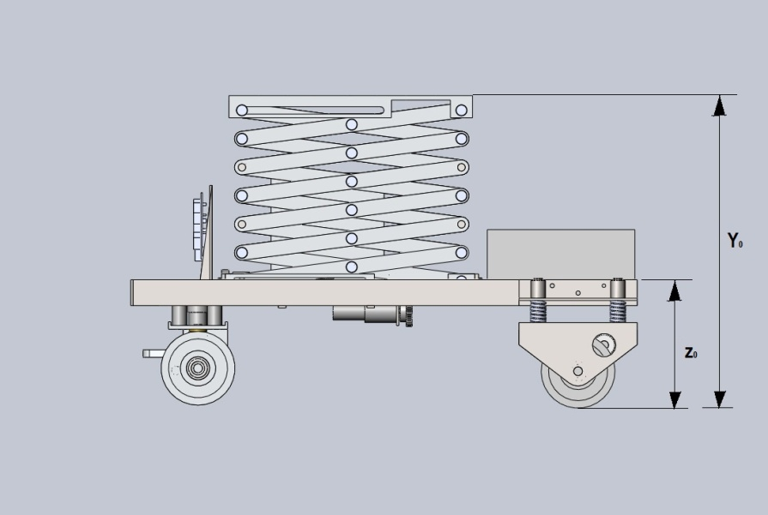



The simulation results are presented in figure 6 and 7,. The fig. 7 shows the comparision between the disturbance rejection achieved by PID based and SM controller. Clearly the SM controller performs better in term of disturbance rejection.

The effort required by each controller is compared in Fig. 8, here too SM controller scores over PID as it require less actuation power.

### ScissorwithDusterbance.jpg

Figure

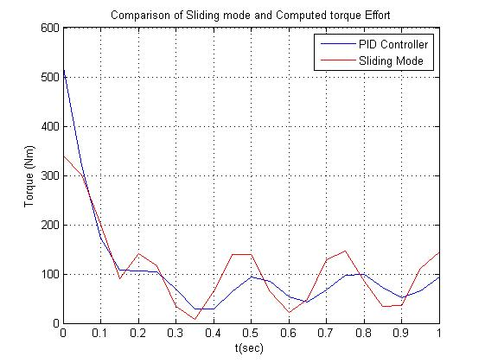

Figure

# Analysis of steering Mechanism

The mobile platform is equipped with Davis steering mechanism, and not castor wheels. The disadvantage of using passively oriented support wheels, is that it can get locked in case of medium size (1/8 of wheel wheel dia) discontinuities on the rolling surface. The figure of the mechanism is shown in figure 7.

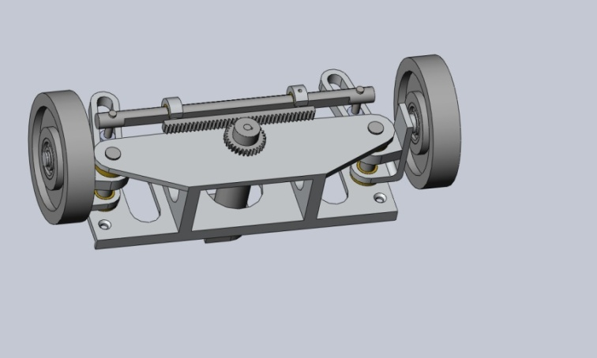 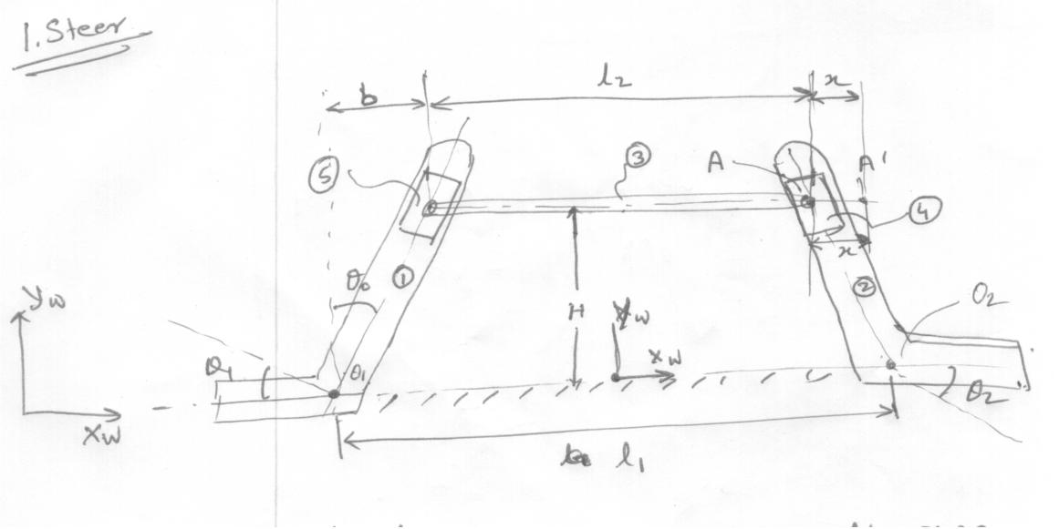

Figure

The following assumption are made in deriving the equation

1. Motion of the base frame is not considered (due to motion of vehicle)
2. The mass of Slider item #5 and #4 is neglected.



A simple PID controller is used to orient the wheels as per the commanded value.



### Simulation

The simulation of the above dynamic equation is carried out with the step change in steering angle as input . The results of the wheel orientations and the actuator effort required are given in figure 8 and 9 respectively.

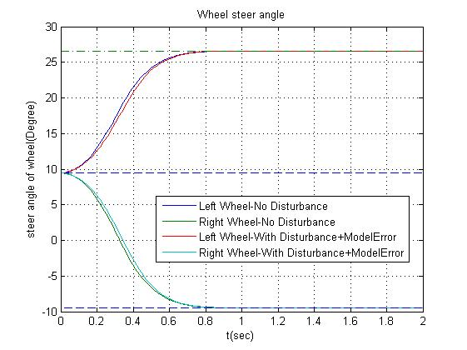

Figure

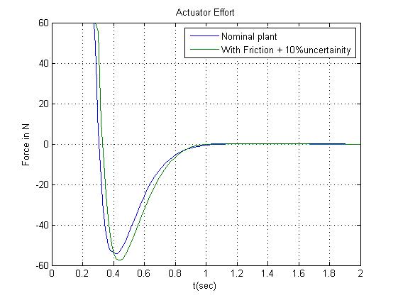

Figure

It is observed that the controller performs considerably well even under disturbance torque generated by wheel ground interaction and 10% modeling uncertainty. It is yet to be ascertained how the system behaves if base motion of the platform is also consider in the dynamic model. Though, it may be assumed that the motion of the platform will induce inertial forces on the steering mechanism. This can be treated as bounded disturbance and can be rejected by the controller.

# Part 3 Time delay Teleoperation

The above vehicle is to be teleoperated and hence it is required to analyze the system for stability under input delay. Though there are numerous method to design controller and check the stability of the system such as passivity method and prediction method. Our study is on using Partial differential equation (PDE) to model time delay. As a step towards it , a simple spring mass system is analyzed.

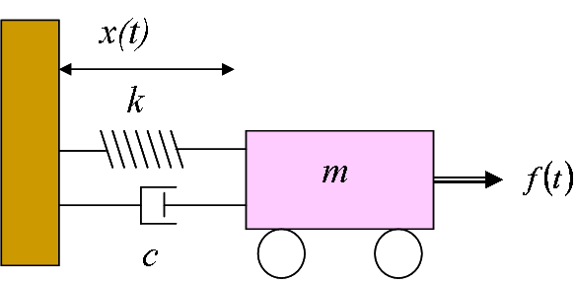



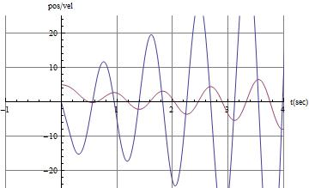

Figure : Plot of with input delay of 0.3sec

As can be seen the , input delay of 0.3 sec induces instability in the system.

### First Order PDE as delay model



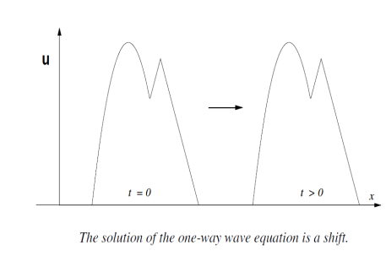



### The model with input delay

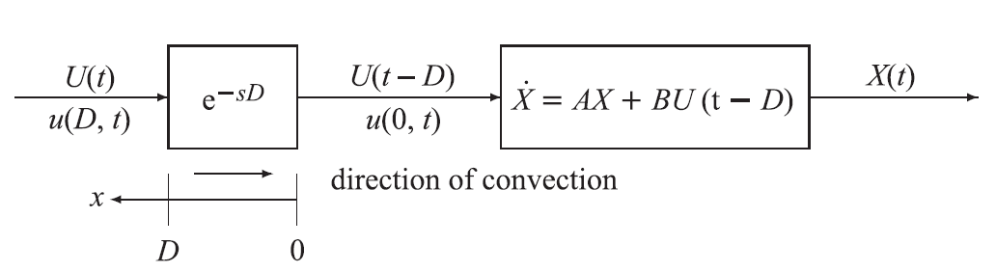

The objective is to suitable designing the feedback law give by



So that the *System* A gets converted to System *B.* The reason for such a conversion is that the system B is inherently stable. The gain matrix in System –B is chosedn so that the delay free system is stable.



For the above mass spring system the Control input is given as



The simulation result is shown in figure 11, Which clearly shows that the system is stable even under 0.3sec delay.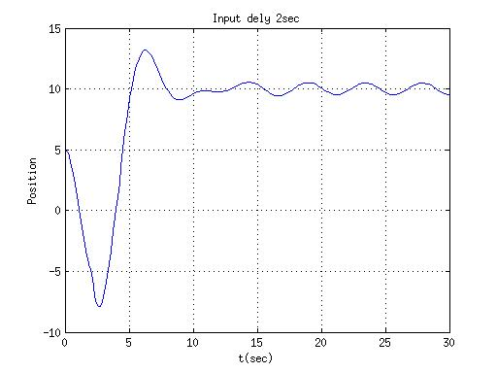

Figure

# Future work

* It is intended to carry out the decentralized control methodology for 2-DOF platform moving on a plane and 1-DOF arm mounted on it.
* A tracking controller based on decentralized control is to be designed for the mobile manipulator with 2 DOF Arm mounted on it. The performance results are to be compared with control designed while taking full system into consideration.
* Time delay control design using PDE to be extended to sensor delay for mass spring system discussed above.

# Referances

1. J.Y. Wong, Theory of Ground Vehicles. John Wiley and Sons, Inc. USA,2001
2. Joshi, J.; Desrochers, A.A., "Modeling and control of a mobile robot subject to disturbances," in Robotics and Automation. Proceedings. 1986 IEEE International Conference on , vol.3, no., pp.1508-1513, Apr 1986
3. Kai Liu; Lewis, F.L., "Decentralized continuous robust controller for mobile robots," in Robotics and Automation, 1990. Proceedings., 1990 IEEE International Conference on , vol., no., pp.1822-1827 vol.3, 13-18 May 1990
4. Edwards, Christopher, and Sarah Spurgeon. Sliding mode control: theory and applications. CRC Press, 1998.
5. Saha, Subir Kumar, and Jorge Angeles. "Kinematics and dynamics of a three-wheeled 2-DOF AGV." Robotics and Automation, 1989. Proceedings., 1989 IEEE International Conference on. IEEE, 1989.
6. Krstic, Miroslav, and Andrey Smyshlyaev. "Backstepping boundary control for first-order hyperbolic PDEs and application to systems with actuator and sensor delays." Systems & Control Letters 57.9 (2008): 750-758.
7. Krstic, Miroslav. Delay compensation for nonlinear, adaptive, and PDE systems. Birkhäuser Boston, 2009.