DBMS Mini Project
QR BASED ENTRY MANAGEMENT

Submitted To :
Dr. Gamini Joshi Mam
.
Submitted By :
Name : ARJUN SAI N | SRN : PES2UG23CS091
Name : AMAR FAROQUI | SRN : PES2UG24CS805
1]Problem Statement :
Managing event entries using manual ID checks or paper-based systems leads to long queues, delays, and inaccurate attendance tracking.
Without a structured database system, maintaining information about students, events, registrations, QR codes, and entry logs becomes inefficient and prone to errors.
Additionally, real-time entry verification cannot be ensured, causing inconsistencies between registration data and actual attendance.
There is a need for an automated solution that securely manages registrations, generates QR codes, logs entries, validates event participation, and maintains data integrity across all related modules.

2]Abstract :
This project implements a QR-Based Entry Management System designed to demonstrate the capabilities of a DBMS in managing event registrations and real-time entry tracking.
The system uses a relational database design with entities such as Admin, Student, Phone, Event, Venue, Registration, Enrolls, and Entry_log, along with their relationships and constraints.
QR codes are generated dynamically for each registration, enabling seamless and secure entry verification.
The system ensures consistency through foreign key constraints, cascading updates/deletes, triggers for automatic entry logging, stored procedures for event retrieval, and functions for statistical reporting.
A Tkinter-based GUI application interacts with the MySQL database, supporting real-time updates, QR code generation, and entry verification.
This system forms the foundation for scalable event management solutions, suitable for institutions, conferences, workshops, and automated entry systems.

3]User Requirement Specification (URS)
Functional Requirements
The system must store and manage detailed data about:
- Students (names, emails, phones—via Phone table)
- Events and their associated venues
- Registrations with QR code paths and entry status
- Admins responsible for event creation
- Enrollment records showing which students enrolled in which events
- Entry logs indicating the scanned entry time
Required functionalities:
- Generate a unique QR code for every registration.
- Automatically log entry when entry_status = TRUE using a trigger.
- Validate event existence before allowing registrations.
- Update and delete registrations with cascading effects.
- Allow real-time loading of:
  - Students
  - Events
  - Registrations
  - Entry logs
- Fetch event details via a stored procedure.
- Compute totals (e.g., number of events/admin, number of students/event) using functions.
Non-Functional Requirements
- Must maintain referential integrity using foreign keys with ON DELETE/UPDATE CASCADE.
- System must support concurrent access from multiple users (GUI + DB clients).
- Should be modular and scalable, allowing future additions such as:
  - RFID integration
  - Biometric attendance
  - Notification system
- Must maintain accurate logs of every scan (Entry_log table).
- Should ensure data consistency with triggers and constraints.
- GUI must be user-friendly and responsive.
User Roles
Admin
- Creates and manages events.
- Oversees student data and registrations.
- Generates reports using stored procedures and functions.
Operator
- Handles registration updates.
- Scans QR codes (simulated by updating entry_status).
- Monitors real-time entry logs through the GUI.

4]Software / Tools / Technologies Used
Category | Tool / Technology
Database | MySQL 8.0
Programming Language | Python
QR Generation | qrcode Library, Pillow (PIL)
GUI Framework | Tkinter
Image Handling | Pillow (ImageTk)
IDE / Editor | VS Code / PyCharm
Version Control | Git & GitHub

5. ER Diagram
The ER model defines the main entities — ADMIN, STUDENT, EVENT, REGISTRATION, VENUE and ENTRY_LOG — and shows the cardinalities between them

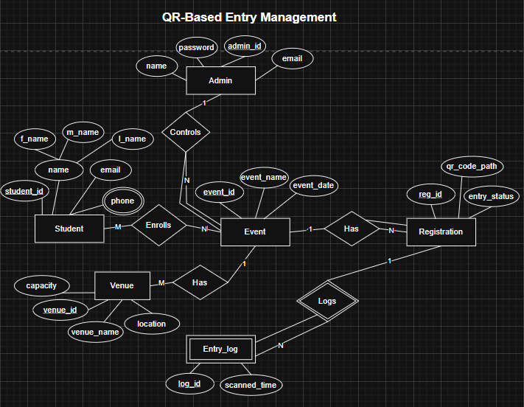

6. Relational Schema
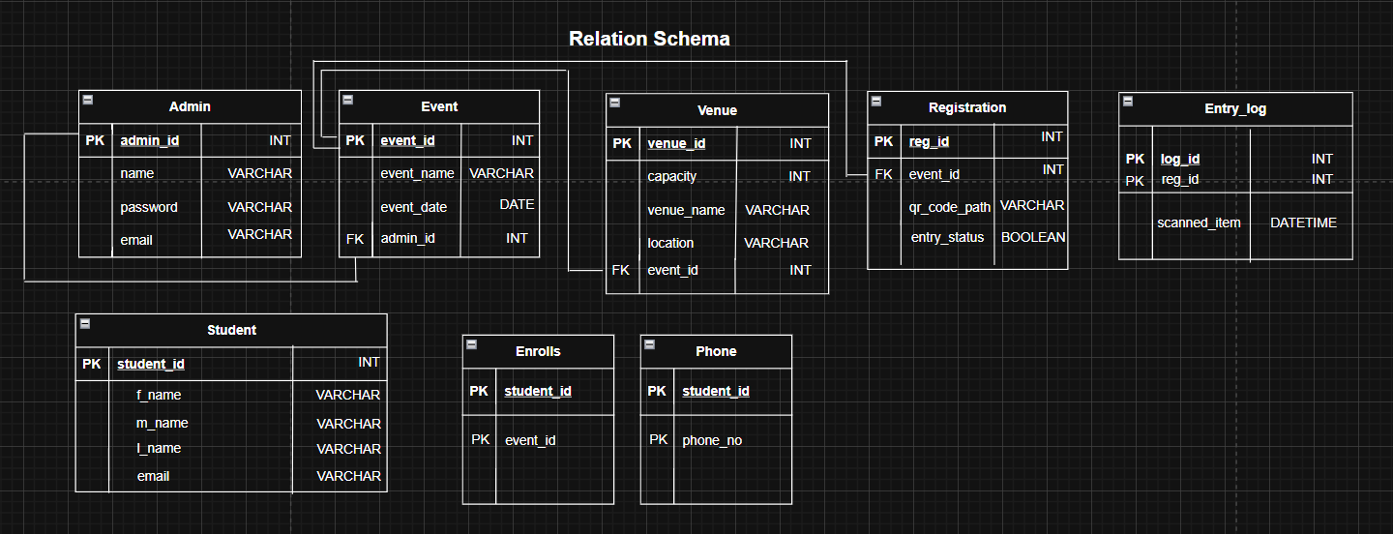

7]DDL Commands
Tables Created:
• ADMIN
• STUDENT
• PHONE
• EVENT
• VENUE
• REGISTRATION
• ENROLLS
• ENTRY_LOG
Example:
CREATE TABLE Student (
student_id INT PRIMARY KEY,
f_name VARCHAR(50),
m_name VARCHAR(50),
l_name VARCHAR(50),
email VARCHAR(100)
);

8] CRUD Operation Screenshots
Create: Before adding a new student
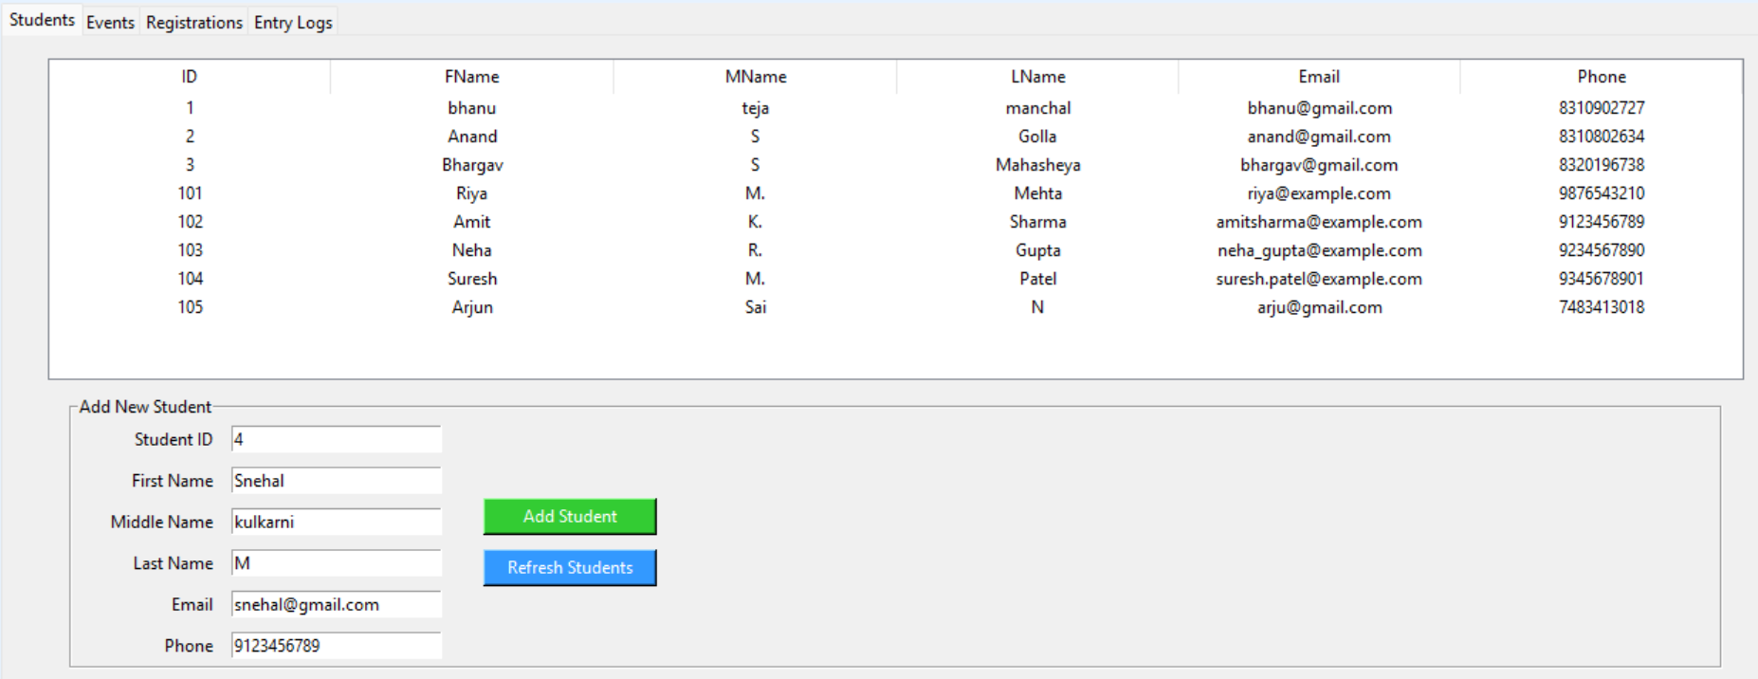
Read:
We can see the added student in below screenshot
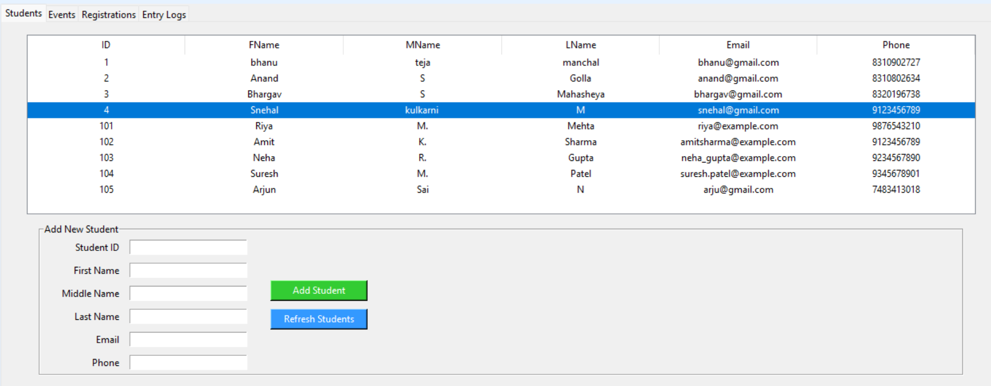

List of available Events
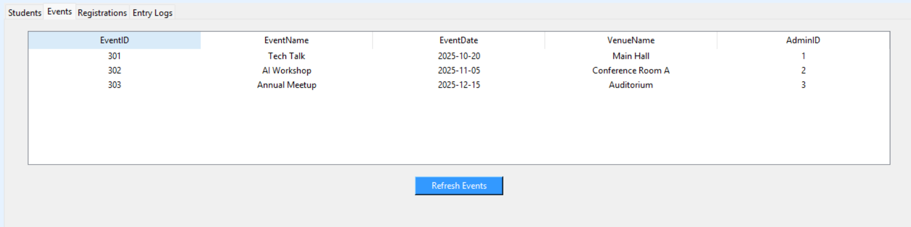
Update: Modifying the Registration
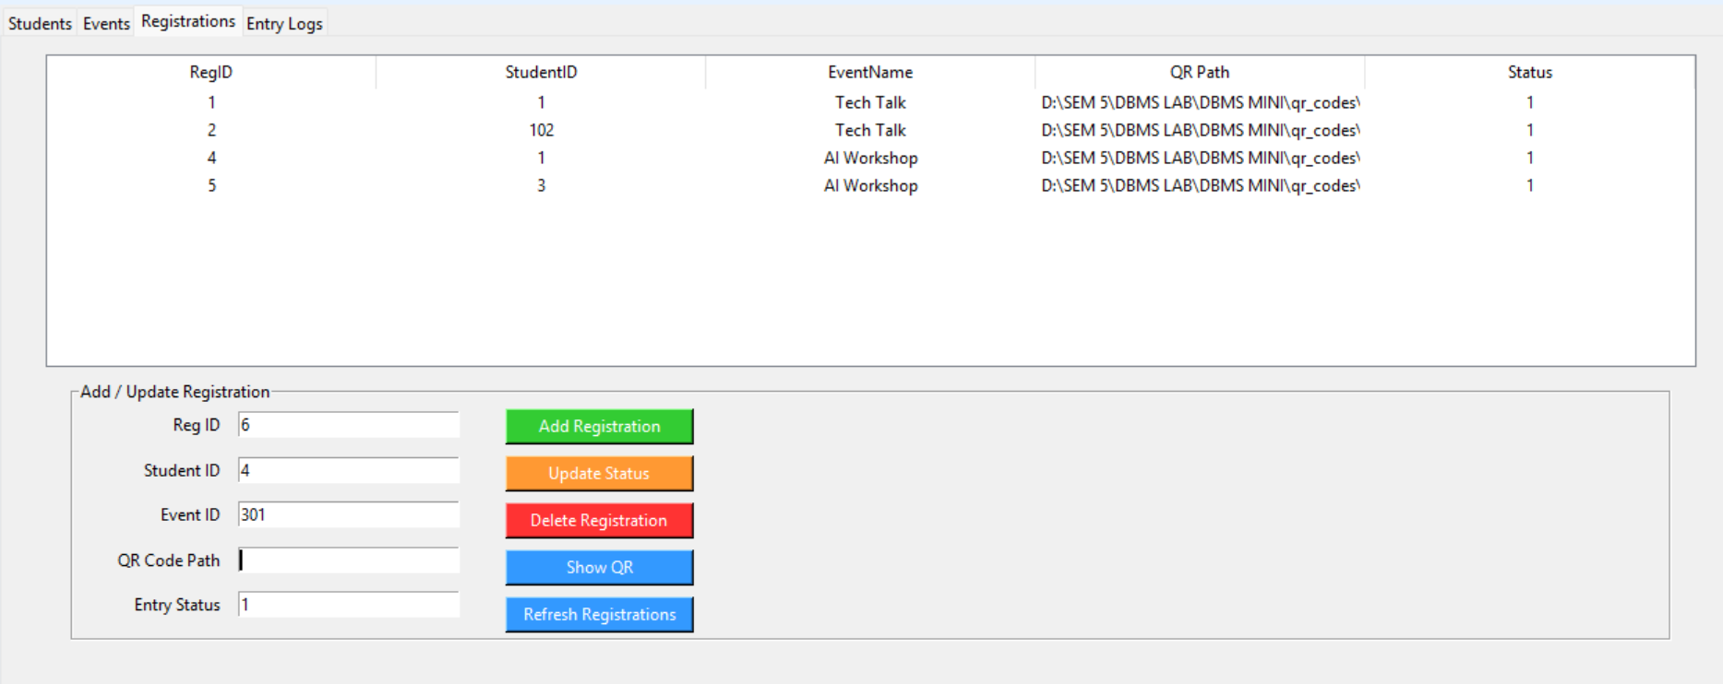
After adding the Registration
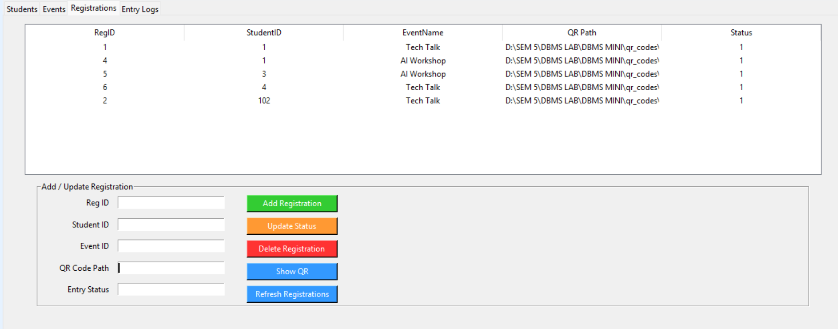
For updating or adding registration will add reg_id, std_id, event_id and updating the status

QR Code for the student
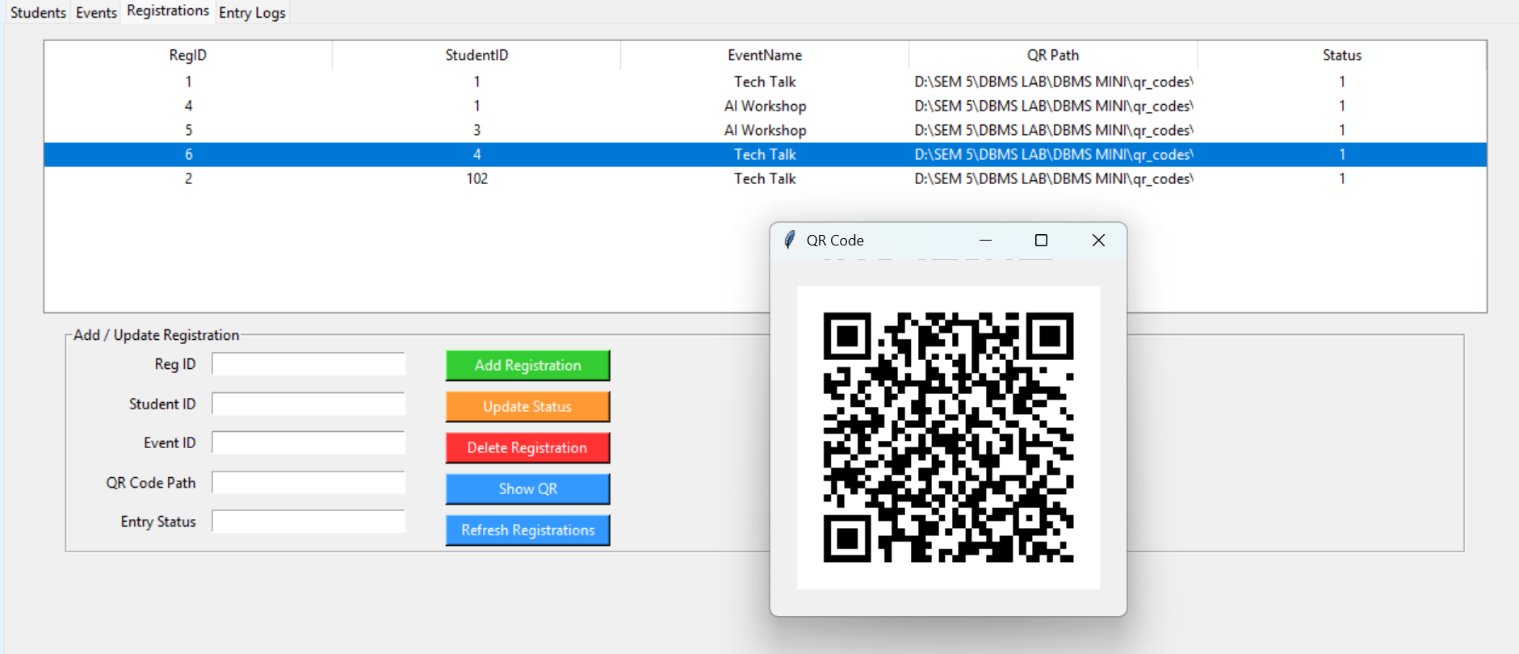

Delete: Remove Registration
Before:


After: deleted from registration

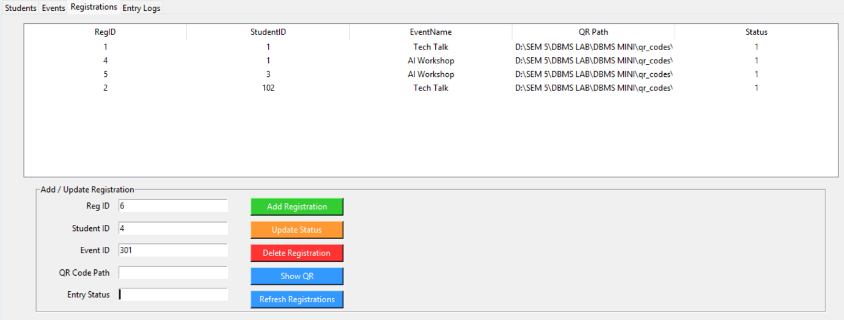
Updation of the Registration Table
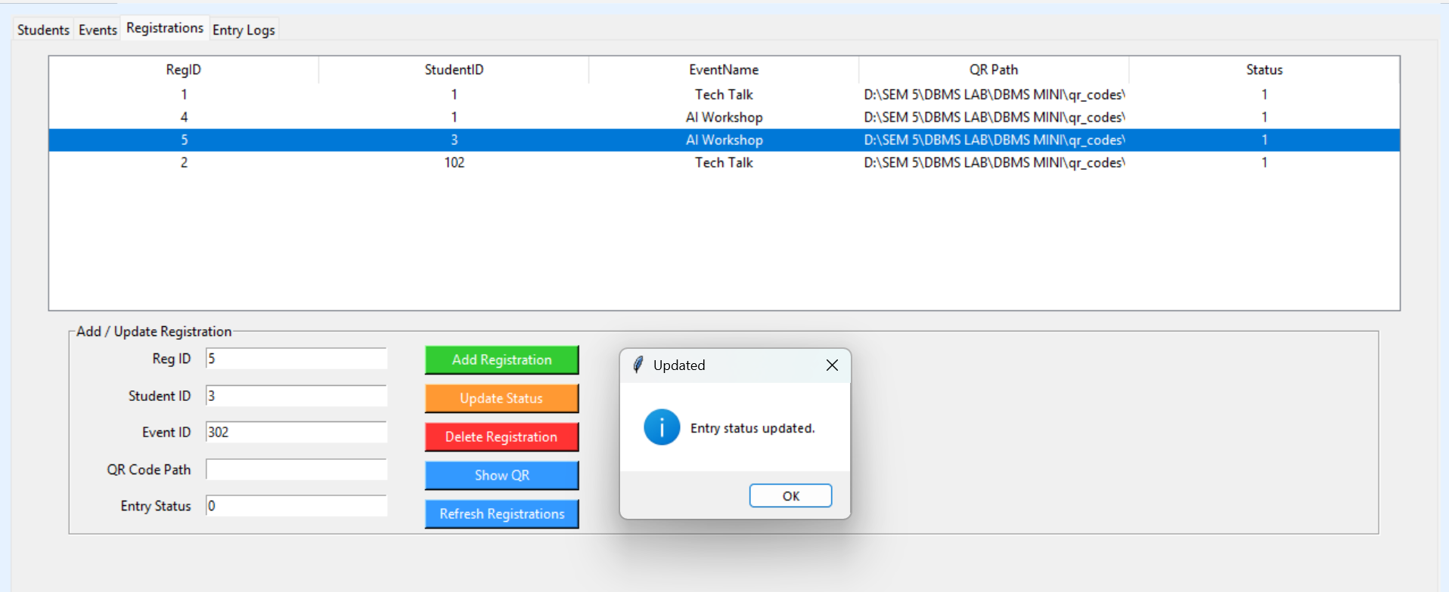

Entry log
when the status of the registration is 1 the entry log table will be automatically updated and when we update the status from 0 to 1 then also it automatically updates in the entry log table.
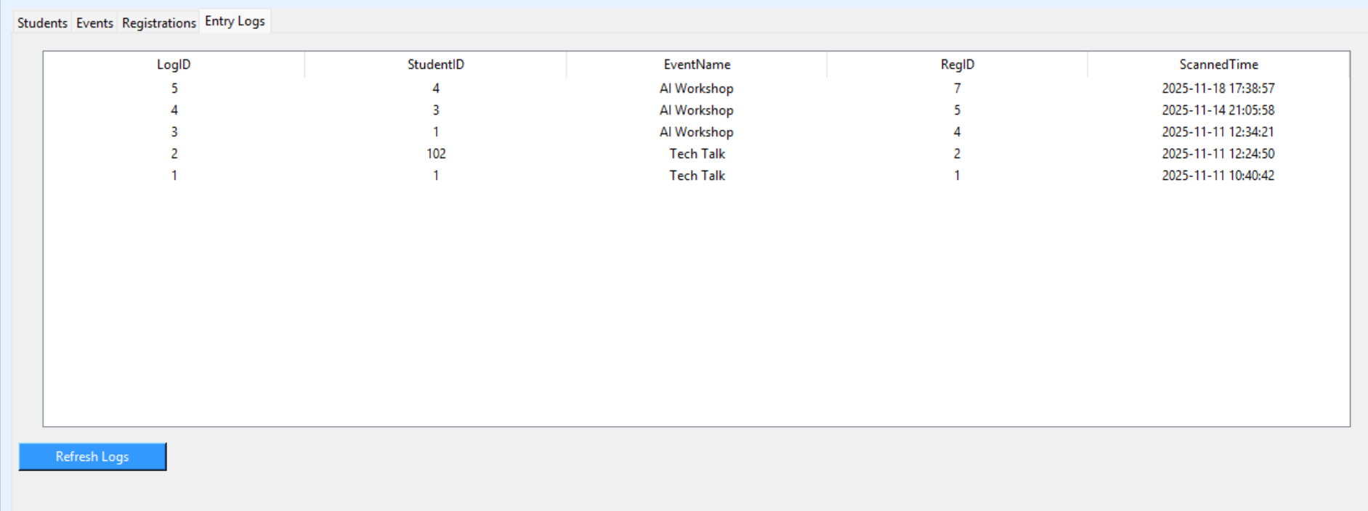

9] Functionalities & Features (Front-End)
Major Features:
- Interactive Desktop Interface using Tkinter
A dynamic and user-friendly GUI built with Tkinter, providing smooth navigation and visually organized screens for all operations.
- Template-Based Navigation System
Modular screen navigation implemented using Tkinter frames (replacing templates like entry.html, exit.html, fares.html, transactions.html, etc.).
Each screen loads independently, ensuring easy scalability and maintenance.
- Real-Time Data Display (Fare Display / Live Updates)
Real-time fare or metric updates handled using a dedicated update module (similar to fare_display.js functionality), ensuring instant visibility of computed values.
- Management Pages for Core Modules
Dedicated Tkinter pages/interfaces for:
  - Staff Management
  - Vehicle Management
  - Transaction History & Monitoring
  - User Inputs and Operation Handling
- Input Validation with Backend Logic
All user inputs are validated using backend triggers and Python-side checks to prevent incorrect or incomplete data entry.
- Full Database Integration via Python–MySQL Connector
Seamless communication with the MySQL database using mysql-connector-python, enabling:
  - Insert
  - Update
  - Fetch . Delete operations
directly from the Tkinter frontend.
10] Triggers, Procedures, and Functions
Functions
1]
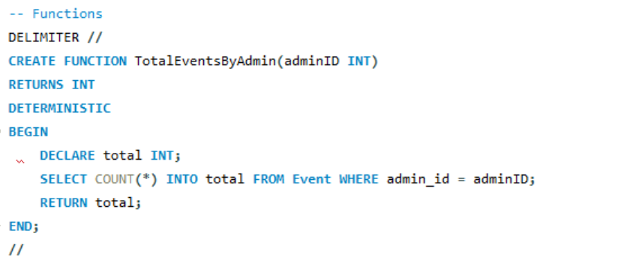
This MySQL function TotalEventsByAdmin(adminID INT) is used to calculate the total number of events created by a particular admin. It accepts an admin ID as input and returns an integer. Inside the function, a local variable total is declared to store the count value. The query SELECT COUNT(*) INTO total FROM Event WHERE admin_id = adminID; retrieves how many events are associated with that admin. The function is marked as DETERMINISTIC, meaning it always gives the same result for the same input. Finally, it returns the value stored in total. This function is useful for generating admin-specific event statistics in reports or dashboards.

2]
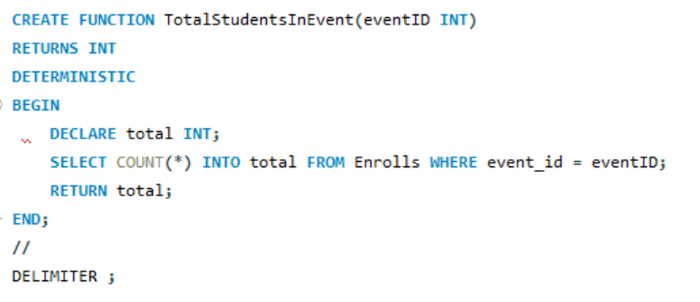
This MySQL function TotalStudentsInEvent(eventID INT) is designed to compute the number of students enrolled in a specific event. It takes the event ID as input and returns an integer. Inside the function, a local variable total is declared to hold the count value. The query SELECT COUNT(*) INTO total FROM Enrolls WHERE event_id = eventID; calculates how many students have enrolled for that event. The function is defined as DETERMINISTIC, meaning it always returns the same result for the same input. Finally, the function returns the value stored in total. This is useful for tracking event participation and generating reports.

Procedures
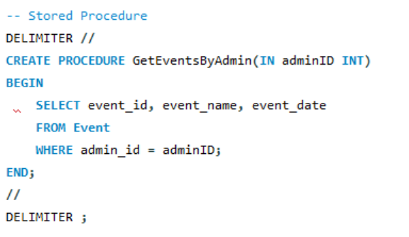
The stored procedure GetEventsByAdmin(IN adminID INT) is used to retrieve all events created by a specific admin. It takes adminID as an input parameter. Inside the procedure, a SELECT query is executed to fetch the event_id, event_name, and event_date from the Event table. Only records where admin_id matches the provided adminID are returned. The procedure does not return a single value but instead outputs a result set (table-like response). This is useful for displaying all events associated with a particular admin, such as in admin dashboards or reports. The DELIMITER is changed temporarily to allow proper creation of the procedure.
Triggers
1]
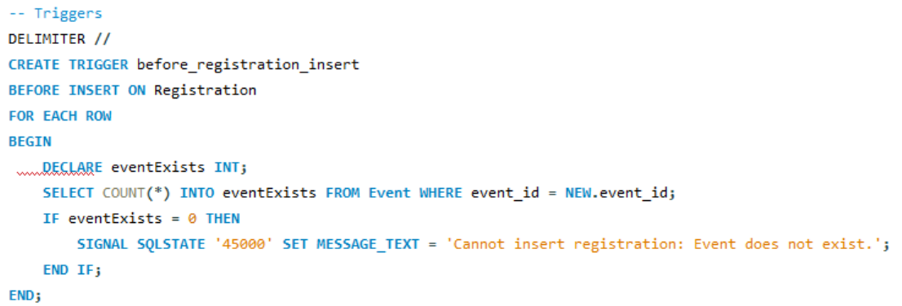
This trigger (before_registration_insert) runs before a new registration is inserted into the Registration table. It checks whether the event_id provided in the new registration actually exists in the Event table. If the event does not exist, the trigger stops the insertion and raises an error. This ensures data integrity by preventing invalid registrations for non-existent events.

2]
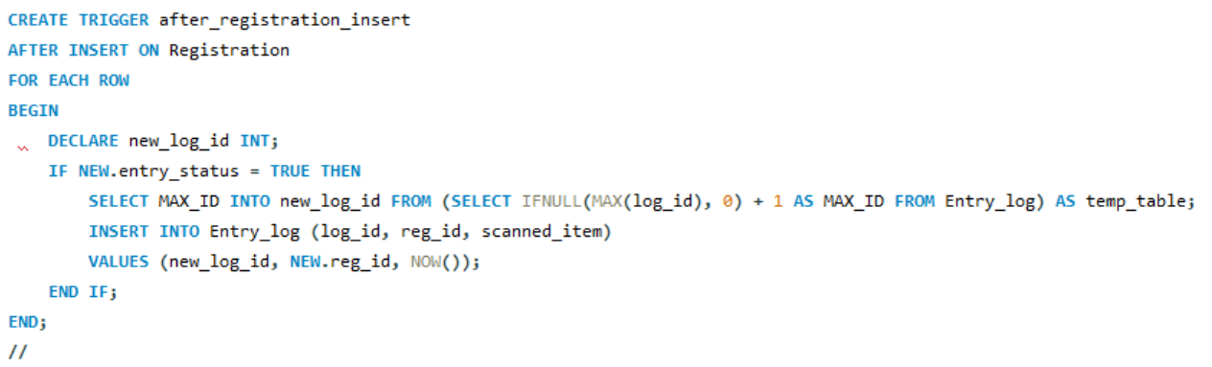
This trigger (after_registration_insert) runs after a new registration is successfully inserted into the Registration table. If the newly registered user has entry_status = TRUE, the trigger automatically creates a corresponding entry record inside the Entry_log table. It generates the next log ID and inserts the registration ID along with the current timestamp. This ensures every valid entry is automatically recorded without requiring manual logging.

3]
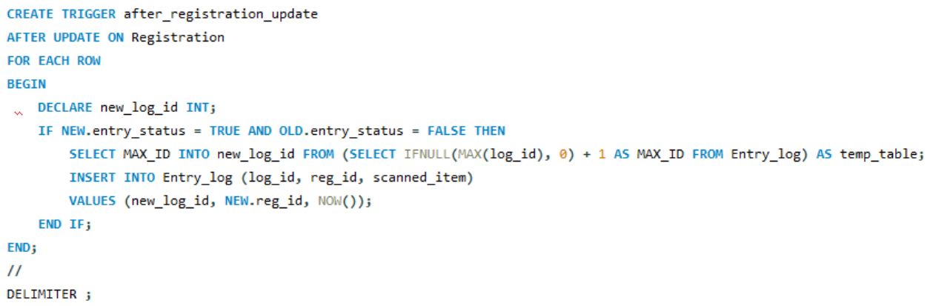
This trigger (after_registration_update) activates after a registration record is updated. It checks if the entry_status has changed from FALSE to TRUE. When such a change occurs, the trigger automatically generates the next log ID and inserts a new entry record into the Entry_log table along with the updated registration ID and the current timestamp. This ensures that every new entry activation is properly logged without manual intervention.

11] Code Snippets (Procedure/Trigger Invocation)
Example calls and executions :




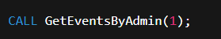

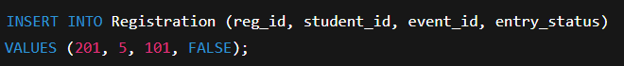

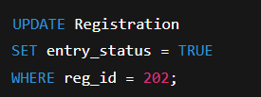

12] SQL File Contents
All the SQL commands — Create, Insert, Triggers, Procedures, Functions, and Queries — are saved in:
qr_entry_management.sql

13] GitHub Repository Link
https://github.com/pes2ug23cs091/QR-Entry_Management.git

