Satellite Land-Use Classification Using CNN Optimization and Transfer Learning on EuroSAT
Aya MRAD Kamar MASALKHI FARSHOUKH Zahraa TARHINI
Lebanese University, Faculty of Science
Abstract—This project examines land-use classification of 27,000 EuroSAT satellite images across ten classes. A three-convolution-layer CNN trained from scratch was used as a baseline, followed by controlled investigations of network depth, kernel size, stride, padding, Batch Normalization, optimizer, learning rate, scheduler and image augmentation. The baseline achieved 85.60% test accuracy. Batch Normalization, AdamW with StepLR and no augmentation were selected by validation experiments; the resulting scratch CNN attained 90.59% peak validation accuracy and 91.04% test accuracy. Pretrained ResNet-18 was then assessed using frozen features, partial fine-tuning and full fine-tuning. Full fine-tuning performed best, reaching 96.12% peak validation and 96.40% test accuracy, with increased model size and inference latency. These results establish the benefit of transfer adaptation for this dataset while revealing performance-efficiency trade-offs.
Index Terms—EuroSAT, remote sensing, CNN, Batch Normalization, transfer learning, ResNet-18.

I. INTRODUCTION
Satellite image classification supports land-use mapping, environmental monitoring and geographic analysis. The EuroSAT benchmark provides a practical multiclass setting in which visually related categories, such as crop types and vegetated land, may be difficult to separate [1]. Convolutional neural networks (CNNs) learn hierarchical spatial features from imagery, but their accuracy depends on architectural choices and optimization settings.
The project has three objectives: (1) establish a reproducible scratch-CNN baseline; (2) quantify how architecture, optimization and augmentation influence validation accuracy; and (3) compare the strongest scratch model with feature extraction and fine-tuning of an ImageNet-pretrained ResNet-18 [2]. Model selection is based on validation data, whereas the reserved test set measures final predictive performance.
II. DATASET AND PREPROCESSING
EuroSAT contains 27,000 RGB satellite images of size 64 × 64 pixels in ten classes: AnnualCrop, Forest, HerbaceousVegetation, Highway, Industrial, Pasture, PermanentCrop, Residential, River and SeaLake [1]. The notebook uses a seeded random 70%/15%/15% split: 18,900 training, 4,050 validation and 4,050 test images. The splits are reused for each model, including the ResNet comparison.
For scratch CNNs, preprocessing consists of Resize(64,64) and ToTensor. The ResNet-18 pipeline uses these same operations plus ImageNet channel normalization (means 0.485/0.456/0.406; standard deviations 0.229/0.224/0.225). DataLoaders use batch size 64, shuffled training batches, unshuffled validation/test batches and num_workers=0. A PyTorch seed of 42 controls the split and major training runs; the augmentation phase also seeds NumPy and Python random generators.
A. Experimental Protocol and Evaluation Measures
The train/validation/test sets serve different purposes. Training batches provide gradients for updating weights; the separate validation split guides epoch checkpointing and choices among architectural and training configurations. The test split is reserved for assessing the chosen checkpoints. Each reported peak validation result is the highest validation accuracy across epochs within that particular run, not necessarily its accuracy in the final epoch. This distinction matters when comparing models that have different learning-curve trajectories.
Overall accuracy is the number of correctly classified images divided by the number evaluated; class-wise accuracy is the analogous fraction within each true class. The normalized confusion matrices use row normalization, so each row describes the distribution of predicted categories for one actual EuroSAT class. Cross-entropy loss is reported as the average of the mini-batch losses for each epoch. The saved generalization gap is computed in percentage points between training accuracy at the selected epoch and peak validation accuracy; it should not be confused with test error.
All recorded training runs and timed forward passes use the CPU in the submitted notebook. Inference latency is reported per image after repeated forward passes on an input mini-batch; it excludes such work as end-to-end satellite imagery acquisition, preprocessing and deployment overhead. Model parameters count both trainable and frozen weights when assessing total model size, while the separate trainable count indicates the size of the optimized parameter subset.
III. METHODOLOGY
The experimental workflow was organized into eight notebook stages: baseline CNN development (Stage 1), architectural tuning (Stage 2), optimizer and learning-rate scheduling experiments (Stage 3), data augmentation (Stage 4), final optimized CNN training (Stage 5), ResNet-18 transfer learning (Stage 6), final model evaluation and comparison (Stage 7), and checkpoint verification with live inference (Stage 8).
A. Baseline CNN and Design Rationale
The initial CNN has three 3 × 3 convolutions with 32, 64 and 128 output channels. Stride 1 with padding 1 preserves the 64 × 64 input resolution at each convolution; a 2 × 2 max-pool after each ReLU reduces spatial size successively to 32 × 32, 16 × 16 and 8 × 8. The final 128 × 8 × 8 features are flattened to 8,192 values and classified by Linear(8192,256), ReLU and Linear(256,10). The last layer emits ten logits, one per EuroSAT class. Table I summarizes the baseline layer configuration.
TABLE I. BASELINE CNN CONFIGURATION
Layer / operation | Output / configuration
Input | 3 × 64 × 64
Conv1 + ReLU + pool | 3→32, 3×3, s1/p1; 32×32
Conv2 + ReLU + pool | 32→64, 3×3, s1/p1; 16×16
Conv3 + ReLU + pool | 64→128, 3×3, s1/p1; 8×8
Flatten + dense + ReLU | 8192→256
Output dense | 256→10 logits

Three convolutional levels were chosen as a moderate starting depth for 64 × 64 imagery: they can progress from local edges and color responses toward texture and larger patterns without the cost of a much deeper custom model. Expanding feature channels from 32 to 64 to 128 increases representational capacity as pooling reduces spatial size. A 3 × 3 kernel provides local detail with fewer weights than 5 × 5 or 7 × 7 kernels; padding 1 and stride 1 retain information before deliberate downsampling. Pooling reduces the feature-map footprint, while the 256-neuron hidden classifier combines the learned features before mapping to the ten labels. These are design motivations, not claims that the chosen sizes are mathematically optimal.
The baseline has 2,193,226 parameters and uses CrossEntropyLoss for mutually exclusive multiclass labels, Adam at learning rate 0.001, and ten training epochs [3]. Per-epoch training and validation loss, accuracy and validation per-class accuracy are logged. The checkpoint with the highest validation accuracy is saved as baseline.pth and reloaded for the unseen test evaluation.
The baseline stores all convolutional activations as feature maps until they reach the fully connected classifier. This explains why the first dense layer dominates its parameter budget: 8,192 features feed each of 256 hidden units. The design deliberately leaves both the convolutional feature extractor and classification head trainable, unlike a frozen pretrained network. Its relatively small three-block structure makes architectural changes straightforward to compare without beginning from an ImageNet initialization.
B. Controlled CNN Optimization
Architectural trials hold the same data split, batch size, loss, Adam learning rate (0.001) and ten-epoch budget while changing selected elements: two versus four convolutional layers, larger 5 × 5/7 × 7 kernels, first-convolution stride 2 or padding 0, a classifier with no hidden dense layer, and Batch Normalization after each of the three convolutions. The selected BatchNorm architecture adds normalization before ReLU, which can stabilize intermediate activations and optimization [4].
Although the experiments were organized around a single architectural factor, changing depth or the first stride also changes the size of the flattened input and therefore the parameter count of subsequent dense layers. For example, two convolution/pooling blocks end at 64 × 16 × 16 rather than 128 × 8 × 8, giving the shallower model a larger dense-layer input. Conversely, four pooling operations reduce the spatial map to 4 × 4. Parameter count is therefore measured directly for every configuration instead of assuming deeper always means larger.
With the architecture fixed, nine six-epoch runs compare SGD with momentum 0.9, Adam and AdamW, each at learning rates 10⁻², 10⁻³ and 10⁻⁴. AdamW applies decoupled weight decay 0.01 [5]. The best optimizer/rate is compared with StepLR (step_size=3; gamma=0.1), reducing the rate tenfold after every three epochs. The optimizer and scheduler are selected using peak validation accuracy rather than test results.
Four six-epoch augmentation conditions are evaluated using the selected architecture and optimizer: no augmentation; horizontal and vertical flips with padded random cropping; random affine rotation/translation with ColorJitter; and MixUp (alpha=0.2), which interpolates input pairs and combines their cross-entropy losses [6]. Transformations apply only to training images; validation uses clean images. The no-augmentation baseline reuses the corresponding optimizer/scheduler run, avoiding an unnecessary repeat.
Model selection was primarily based on peak validation accuracy, as the main objective of this project was to maximize classification performance on unseen images. However, additional metrics, including generalization gap, parameter count, training runtime, and inference latency, were also considered to assess possible overfitting, model complexity, and computational efficiency. A small generalization gap alone does not guarantee strong classification performance. Although validation accuracy was prioritized, the optimal configuration depends on the application requirements. For instance, a model with slightly lower accuracy but fewer parameters and faster inference may be preferable for resource-constrained or real-time applications. Therefore, the selected configurations represent the best choices for our accuracy-focused objective rather than universally optimal architectures.
C. Transfer Learning with ResNet-18
ResNet-18 uses residual blocks that help optimize deeper CNNs [2]. ImageNet-pretrained torchvision backbone was loaded and replaces its 1,000-class final layer with a 512→10 classifier. Three four-epoch conditions are compared: frozen feature extraction (only the new fully connected layer is trainable), partial fine-tuning (layer4 plus the classifier), and full fine-tuning (the complete network). Their trainable parameter counts are 5,130, 8,398,858 and 11,181,642, respectively. All use CrossEntropyLoss and AdamW with weight decay 0.01; the frozen model uses learning rate 0.001, and both fine-tuned variants use 0.0001 to make smaller changes to pretrained weights.
Every experiment saves the highest-validation-accuracy state_dict. In the final notebook stages, the strongest scratch CNN and full ResNet-18 are reconstructed, loaded without a fresh pretraining download, evaluated on corresponding test loaders and run on an eight-image unseen mini-batch. This provides the checkpoint-loading and live inference workflow required for the oral defense.
IV. EXPERIMENTAL RESULTS AND ANALYSIS
A. Architecture, Optimizer and Augmentation
The baseline reached 84.62% peak validation accuracy at epoch 8, with 85.60% test accuracy and a recorded 16.33-minute CPU training runtime. Table II reports all architectural validation comparisons. Adding BatchNorm increased peak validation accuracy to 88.67%, a 4.05 percentage-point improvement over the original baseline. Four convolutional layers obtained 87.60%; larger 7 × 7 kernels gave the weakest result, 79.41%, while the 7 × 7 run was exceptionally slow (381.41 minutes). Removing the hidden Linear layer simplified the classifier from 8192→256→10 to 8192→10, reducing the total parameter count from approximately 2.193 million to 0.175 million. Interestingly, peak validation accuracy increased from 84.62% to 85.56%, an improvement of 0.94 percentage points. This suggests that the features extracted by the convolutional layers may be sufficiently informative for a simpler classifier, while the reduced model complexity may also help limit overfitting. However, this explanation remains a hypothesis rather than a demonstrated cause. Since the BatchNorm configuration achieved the highest peak validation accuracy (88.67%), it was selected for subsequent experiments. Fig. 1 visualizes the architectural comparison.

TABLE II. ARCHITECTURE STUDY (TEN EPOCHS)
Model | Parameters | Peak Validation  Accuracy | Generalization  Gap (pp)
Baseline | 2.193M | 84.62% | 3.05
2 Conv layers | 4.217M | 83.88% | 8.88
4 Conv layers | 1.440M | 87.60% | −0.69
5×5 kernels | 2.359M | 83.41% | 6.43
7×7 kernels | 2.607M | 79.41% | 2.40
Stride 2 | 0.620M | 81.93% | 2.02
Padding 0 | 1.702M | 84.77% | 0.41
No hidden Linear layer | 0.175M | 85.56% | 2.20
BatchNorm | 2.194M | 88.67% | 0.01

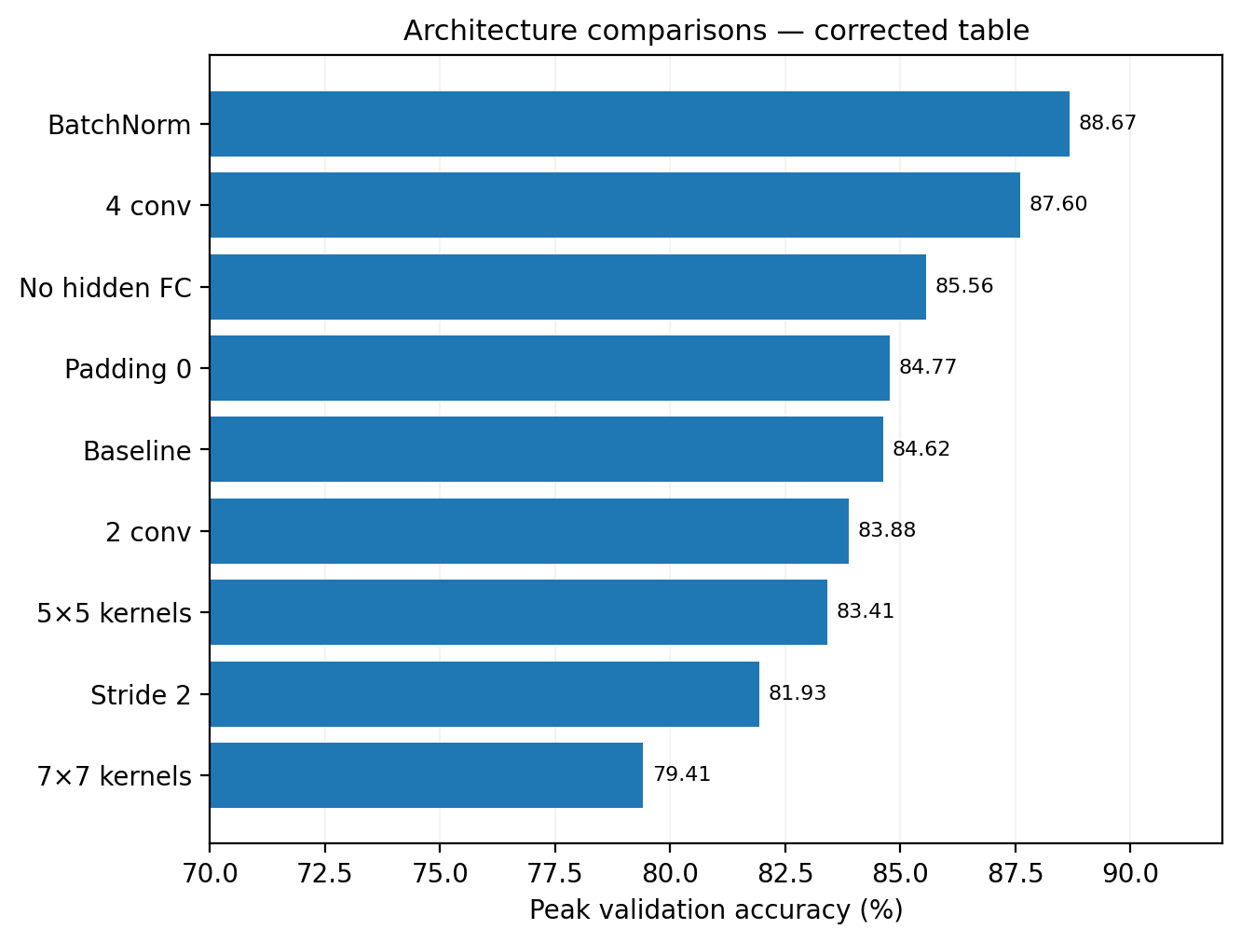
Fig. 1. Architecture validation results
The unusually high parameter count of the two-layer model (4.22 million) is explained by the 16,384-feature flattened tensor entering its hidden dense layer; the four-layer model reduces the dense input to 4,096 values and uses approximately 1.44 million parameters. The stride-2 model provides the shortest recorded architecture-run time (6.47 minutes) and a 0.4426 ms/image latency, but its validation accuracy of 81.93% makes it a poor choice when classification performance is the main objective.
For the nine optimizer/rate trials, AdamW at 0.001 produced the highest six-epoch validation accuracy (88.84%), narrowly ahead of AdamW at 0.0001 (88.72%) and Adam at 0.001 (88.67%). The 0.01 learning rate performed markedly worse for Adam and AdamW (71.14% and 73.21%). Table III lists the nine optimizer–learning-rate trials.

TABLE III. OPTIMIZER AND RATE SEARCH (SIX EPOCHS)
Optimizer | LR | Peak val.
SGD + momentum | 0.01 | 81.95%
SGD + momentum | 0.001 | 80.00%
SGD + momentum | 0.0001 | 74.69%
Adam | 0.01 | 71.14%
Adam | 0.001 | 88.67%
Adam | 0.0001 | 88.32%
AdamW | 0.01 | 73.21%
AdamW | 0.001 | 88.84%
AdamW | 0.0001 | 88.72%

The learning-rate comparison demonstrates why optimizer names alone cannot explain the results. At 0.001, both adaptive methods attained approximately 88.7–88.8% peak validation accuracy, while SGD with momentum attained 80.00%. At 0.01, Adam and AdamW both dropped well below their own smaller-rate results, indicating sensitivity to the initial step size in these particular six-epoch runs.
After selecting AdamW with a learning rate of 0.001 as the best-performing configuration in the nine optimizer–learning-rate experiments, an additional experiment was conducted to evaluate the effect of learning-rate scheduling. The selected AdamW configuration was compared with and without StepLR over six epochs. As shown in Table IV, StepLR improved peak validation accuracy from 88.84% to 90.02%, an increase of 1.18 percentage points. With step_size = 3 and gamma = 0.1, StepLR reduced the learning rate from 0.001 to 0.0001 after epoch 3. In the scheduled run, validation accuracy increased from 69.95% at epoch 3 to 90.02% at epoch 5. These results motivated selecting StepLR for subsequent experiments, although this single comparison does not establish a universally superior scheduling strategy.

TABLE IV. STEPLR SCHEDULER COMPARISON (SIX EPOCHS)
Configuration | Peak Validation Accuracy
AdamW, LR = 0.001, without StepLR | 88.84%
AdamW, LR = 0.001, with StepLR | 90.02%

The augmentation study favored the unmodified images (90.02% peak validation) over MixUp (89.78%), flips/crop (87.88%) and affine/color changes (87.56%). These differences are specific to the selected transformations, six-epoch budget and EuroSAT split; they do not establish that augmentation is generally harmful. 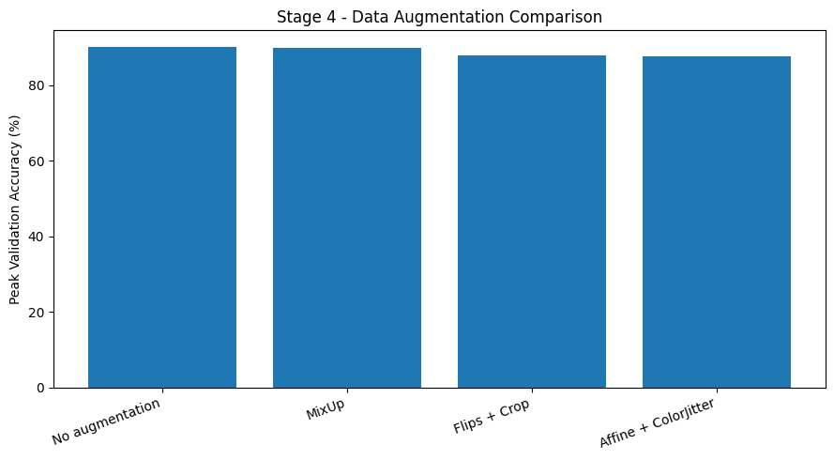
Fig. 2 illustrates the augmentation comparison.

Fig. 2. Peak validation accuracy for the four augmentation configurations
The no-augmentation and MixUp results differ by only 0.24 percentage points, substantially less than their margins over the geometric/color transformations. Because the comparison comprises one recorded run per condition, the report treats this ordering as an empirical selection criterion rather than a statistically established advantage. More seeds or tuned augmentation strengths might change that ranking. Table V summarizes the four augmentation configurations.

TABLE V. AUGMENTATION STUDY (SIX EPOCHS)
Training transform | Peak val.
None | 90.02%
MixUp | 89.78%
Flips + crop | 87.88%
Affine + ColorJitter | 87.56%

B. Final Optimized Scratch CNN
The final scratch model retained three 3 × 3 convolutional blocks (32/64/128 filters) with BatchNorm, ReLU, max-pooling and an 8192→256→10 classifier. It was trained from scratch for ten epochs using AdamW (initial learning rate 0.001, weight decay 0.01), StepLR (step 3, factor 0.1) and no augmentation. The best validation result occurred at epoch 10: 90.59% accuracy, validation loss 0.2778 and training accuracy 92.26%, giving a 1.67-point train-validation gap. The reloaded checkpoint achieved 91.04% accuracy on the reserved test split. 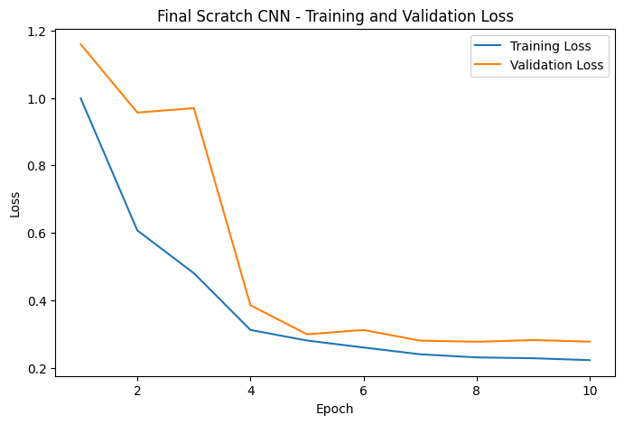
Fig. 3 and 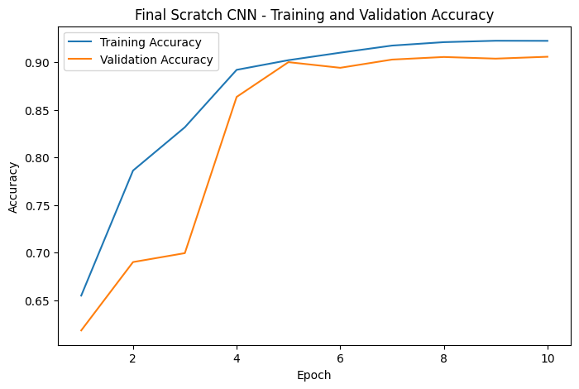
Fig. 4 show the loss and accuracy learning curves, respectively.

Fig. 3. Final scratch CNN: training and validation loss over ten epochs

Fig. 4. Final scratch CNN: training and validation accuracy over ten epochs
The loss curves decrease overall and validation accuracy stabilizes around 90%, while training accuracy stays slightly higher by the selected epoch. This indicates a modest training–validation difference, not severe divergence in the recorded final run. The model has 2,193,674 parameters, a CPU training runtime of 21.61 minutes and recorded inference latency of 1.9726 ms/image, averaged over ten forward passes on a 64-image batch.
TABLE VI. BASELINE CNN VS. FINAL OPTIMIZED CNN
Metric | Baseline CNN | Optimized CNN
Peak validation accuracy | 84.62% | 90.59%
Test accuracy | 85.60% | 91.04%
Generalization gap | 3.05 pp | 1.67 pp
Total parameters | 2,193,226 | 2,193,674
Training runtime | 16.33 min | 21.61 min
Inference latency | 1.8606 ms/image | 1.9726 ms/image

Table VI compares the original baseline CNN with the final optimized scratch CNN, demonstrating the combined effect of the architectural and training improvements. Peak validation accuracy increased from 84.62% to 90.59% (+5.97 percentage points), while test accuracy improved from 85.60% to 91.04% (+5.44 percentage points). The generalization gap decreased from 3.05 to 1.67 percentage points, indicating a smaller difference between training and validation performance. The total parameter count remained nearly unchanged, increasing by only 448 parameters, mainly due to Batch Normalization. However, training runtime and inference latency increased, highlighting the trade-off between classification accuracy and computational cost. Overall, the optimized configuration provided substantially better classification performance without a significant increase in model size.

C. Transfer Learning and Final Comparison
Full ResNet-18 fine-tuning was the strongest approach: peak validation accuracy 96.12% at epoch 3 and test accuracy 96.40%. Partial fine-tuning reached 95.01% validation and 94.64% test accuracy, whereas frozen extraction reached 85.63% and 85.58%. The scratch CNN outperformed the frozen ResNet-18, but the two fine-tuning strategies outperformed the scratch CNN. Compared with the final scratch result, full fine-tuning gained 5.36 percentage points of test accuracy.
The relative ordering of the three transfer modes also reflects how much of the pretraining representation is allowed to adapt to satellite imagery. With a frozen backbone, the classifier must work with fixed ImageNet features. Partial fine-tuning changes the final residual block and classifier, whereas full fine-tuning can adjust low- and high-level filters. The last two settings converge to strong validation accuracy within four epochs, although the study does not determine whether each has reached its best possible long-run performance. Table VII summarizes the final model performance. Table VIII lists their parameter counts and measured inference latencies. 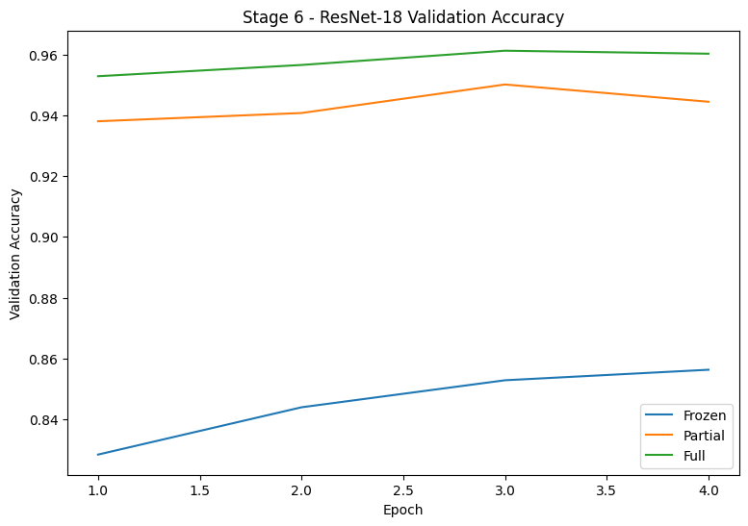
Fig. 5 compares the ResNet-18 validation-accuracy trajectories.

TABLE VII. FINAL MODEL PERFORMANCE
Model | Peak val. | Test | Gap
Optimized scratch | 90.59% | 91.04% | 1.67
ResNet frozen | 85.63% | 85.58% | −0.45
ResNet partial | 95.01% | 94.64% | 3.52
ResNet full | 96.12% | 96.40% | 2.27

TABLE VIII. PARAMETER AND CPU-COST COMPARISON
Model | Total / train. | ms/img
Scratch | 2.194M / 2.194M | 1.9726
Frozen | 11.182M / 0.005M | 3.1964
Partial | 11.182M / 8.399M | 3.4163
Full | 11.182M / 11.182M | 3.8358

Fig. 5. Validation accuracy across four transfer-learning epochs; frozen, partial and full ResNet-18
The full and partial fine-tuning curves start at substantially higher validation accuracy than frozen extraction, consistent with stronger adaptation of pretrained representations. The frozen approach requires far fewer trainable parameters, but its predictions are less accurate. Full fine-tuning achieved the highest accuracy and had the largest trainable parameter count among the ResNet variants; under the recorded CPU measurements, its inference latency was also higher than that of the scratch CNN.
Per-class testing provides more detail than overall accuracy alone. The scratch CNN performs especially well for Forest (97.06%), Residential (96.89%) and SeaLake (97.04%), while PermanentCrop (84.70%), HerbaceousVegetation (84.93%) and Highway (85.42%) remain more difficult. Fully fine-tuned ResNet-18 improves all ten reported class accuracies, notably HerbaceousVegetation (97.16%) and River (96.80%). Table IX lists per-class test accuracies, while 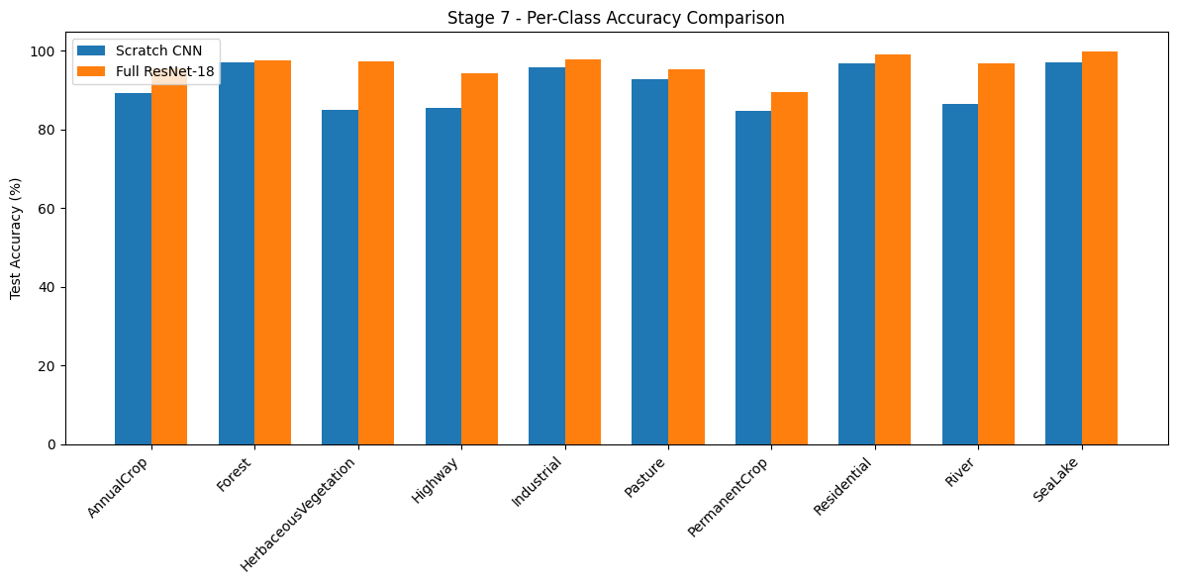
Fig. 6 illustrates the corresponding comparison.

TABLE IX. TEST ACCURACY BY EURO​SAT CLASS
Class | Scratch | Full R18
AnnualCrop | 89.19% | 95.55%
Forest | 97.06% | 97.51%
HerbaceousVegetation | 84.93% | 97.16%
Highway | 85.42% | 94.37%
Industrial | 95.77% | 97.88%
Pasture | 92.64% | 95.32%
PermanentCrop | 84.70% | 89.45%
Residential | 96.89% | 99.11%
River | 86.40% | 96.80%
SeaLake | 97.04% | 99.75%

Fig. 6. Test-set class accuracies for the two final models (notebook output).
The largest class-level increases are for HerbaceousVegetation (12.23 points), River (10.40 points), and Highway (8.95 points), calculated from the reported per-class results. The relatively modest improvement for Forest (0.45 point) indicates that this class was already recognized accurately by the scratch CNN. PermanentCrop remains the least accurate reported class for fully fine-tuned ResNet-18 (89.45%), consistent with persistent overlap among visually related land-cover types. These class-specific comparisons reinforce the overall test result without suggesting that each class contains an equal number of test images.

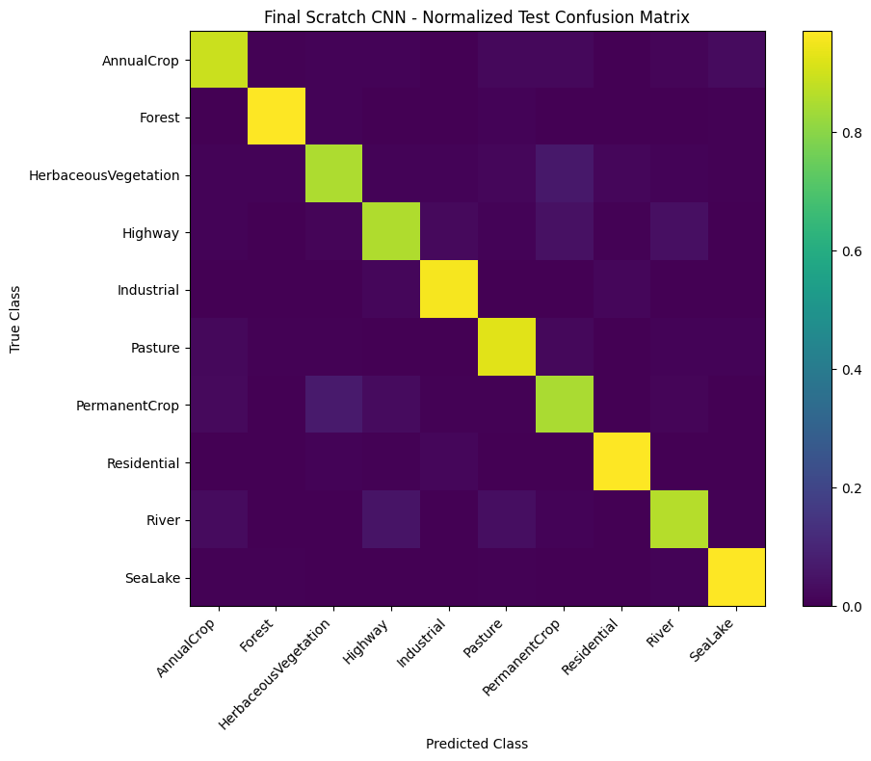
Fig. 7. Row-normalized test confusion matrix of the final scratch CNN; dark off-diagonal cells denote class confusions

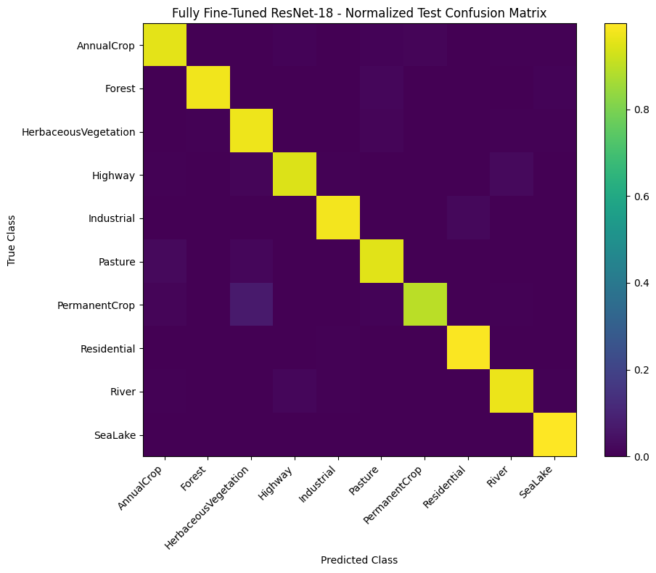
Fig. 8. Row-normalized test confusion matrix of fully fine-tuned ResNet-18 (notebook output).
The normalized matrices show stronger diagonal concentration for the fully fine-tuned model. The scratch matrix has visible confusion involving PermanentCrop with other vegetated classes and some Highway/River confusions. The reported per-class accuracies support this pattern, but the plots alone are not used to infer exact off-diagonal percentages. See Fig. 7 and Fig. 8.

D. Checkpoint Verification and Live Inference

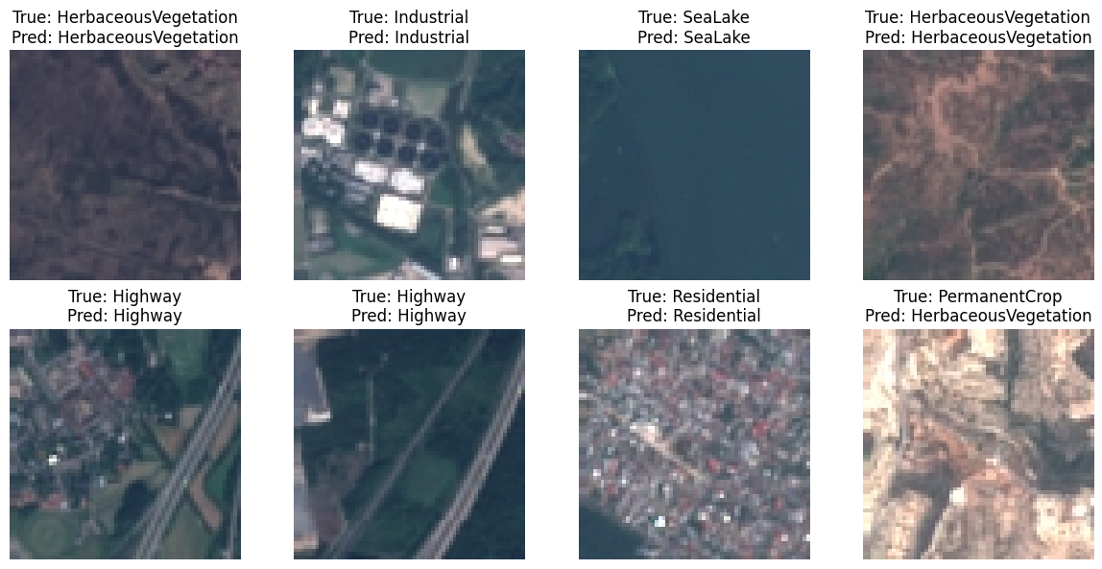
Fig. 9. Live inference on eight held-out EuroSAT test images using the fully fine-tuned ResNet-18, showing the true and predicted class labels.
To verify checkpoint functionality, the saved optimized scratch CNN and fully fine-tuned ResNet-18 models were reloaded and used to perform inference on the same eight held-out EuroSAT test images without retraining. Both models correctly classified seven out of eight images, achieving 87.5% accuracy on this mini-batch. Both models misclassified PermanentCrop as HerbaceousVegetation, illustrating the difficulty of distinguishing visually similar vegetation classes. However, the eight-image sample is too small to establish overall model performance. The complete test-set evaluation in Section IV.C provides stronger evidence of ResNet-18's superior classification accuracy (96.40%) compared with the optimized scratch CNN (91.04%). See
Fig. 9.
V. DISCUSSION
The experimental progression shows that architectural tuning and training configuration both matter. BatchNorm was the most effective isolated architectural change in the ten-epoch study, and StepLR improved the chosen AdamW setting in the six-epoch scheduler comparison. The smallest and fastest architecture was not the most accurate: stride 2 reduced parameters and CPU latency but also lowered peak validation accuracy. Likewise, 7 × 7 filters increased compute without improving validation accuracy in this setup.
No augmentation narrowly exceeded MixUp and surpassed the other tested augmentations. Potential explanations include limited six-epoch adaptation time and transformations that modify spatial or spectral patterns important to EuroSAT categories; these remain hypotheses rather than demonstrated causes. Further comparisons across seeds and longer schedules would be required before drawing general conclusions.
A reported generalization gap is calculated as training accuracy at the best-validation epoch minus peak validation accuracy. It is not identical to the test–train difference and does not by itself measure overall model quality: for example, frozen ResNet has a small negative gap but substantially lower test accuracy than the fine-tuned variants. In addition, Stage 4 measures clean training accuracy after reloading checkpoints, unlike the during-training accuracy used in other stages, so such gaps should not be treated as fully standardized across all phases.
Computational results should be interpreted with caution because inference latency was measured using CPU mini-batches, and performance may differ on other hardware, such as GPUs. The experiments used a single dataset split with a fixed random seed and tested a limited number of architectures and hyperparameter configurations. Since the experiments were not repeated with different random seeds, the variability of the reported accuracy results was not evaluated. Furthermore, the models were not tested with smaller training datasets, so it cannot be concluded whether transfer learning requires fewer training images than training a CNN from scratch.
VI. CONCLUSION
The project implemented and optimized a scratch CNN for ten-class EuroSAT land-use recognition, then compared it with three ResNet-18 transfer-learning strategies. The original scratch baseline obtained 85.60% test accuracy; the selected BatchNorm/AdamW/StepLR configuration, without augmentation, improved this to 91.04%. Full fine-tuning of pretrained ResNet-18 delivered the highest test accuracy, 96.40%, while increasing parameter count and inference latency. Future work could repeat experiments across random seeds and examine longer, matched training budgets or systematic augmentation searches.
REFERENCES
[1] P. Helber, B. Bischke, A. Dengel, and D. Borth, “EuroSAT: A Novel Dataset and Deep Learning Benchmark for Land Use and Land Cover Classification,” IEEE J. Sel. Topics Appl. Earth Observ. Remote Sens., vol. 12, no. 7, pp. 2217–2226, 2019, doi: 10.1109/JSTARS.2019.2918242.
[2] K. He, X. Zhang, S. Ren, and J. Sun, “Deep Residual Learning for Image Recognition,” in Proc. IEEE Conf. Comput. Vis. Pattern Recognit. (CVPR), 2016, pp. 770–778, doi: 10.1109/CVPR.2016.90.
[3] D. P. Kingma and J. Ba, “Adam: A Method for Stochastic Optimization,” in Proc. Int. Conf. Learn. Represent. (ICLR), 2015.
[4] S. Ioffe and C. Szegedy, “Batch Normalization: Accelerating Deep Network Training by Reducing Internal Covariate Shift,” in Proc. 32nd Int. Conf. Mach. Learn. (ICML), 2015, pp. 448–456.
[5] I. Loshchilov and F. Hutter, “Decoupled Weight Decay Regularization,” in Proc. Int. Conf. Learn. Represent. (ICLR), 2019.
[6] H. Zhang, M. Cisse, Y. N. Dauphin, and D. Lopez-Paz, “mixup: Beyond Empirical Risk Minimization,” in Proc. Int. Conf. Learn. Represent. (ICLR), 2018.

