DRAFT REPORT SECTION - STAGE 1
Stage 1 - Dataset Preparation and Baseline CNN
1. Objective and Experimental Setup
Stage 1 established the common reference pipeline for the EuroSAT land-use classification project. The objective was to create a reproducible dataset split, implement a convolutional neural network from scratch, train it without pretrained weights, and evaluate its behavior before any architectural tuning, hyperparameter search, data augmentation, or transfer learning was introduced. The resulting baseline is used as the control model for later stages.
1.1 Dataset and Preprocessing
The EuroSAT dataset contains 27,000 RGB satellite images from 10 land-use classes. A fixed random seed of 42 was used to create a 70/15/15 split, giving 18,900 training images, 4,050 validation images, and 4,050 test images. The same split indices are reused throughout the project to ensure that later controlled comparisons are performed on identical data.
Images were resized to 64 x 64 pixels, converted to PyTorch tensors, and normalized independently in each RGB channel using mean = (0.5, 0.5, 0.5) and standard deviation = (0.5, 0.5, 0.5). This maps tensor values approximately to [-1, 1]. The training DataLoader used a batch size of 64 with shuffling enabled, while validation and test loaders preserved a fixed ordering.
Setting | Stage 1 configuration
Dataset | EuroSAT
Classes | 10
Training split | 18,900 images (70%)
Validation split | 4,050 images (15%)
Test split | 4,050 images (15%)
Input size | 3 x 64 x 64
Batch size | 64
Random seed | 42
1.2 Baseline CNN Architecture
The baseline model was a compact three-block CNN trained entirely from scratch. The feature extractor used convolutional layers with channel sizes 32, 64, and 128. All convolutions used 3 x 3 kernels, stride 1, and padding 1, followed by ReLU activation and 2 x 2 max pooling. An adaptive average pooling layer reduced the final feature maps to 4 x 4 before classification. The classifier consisted of a 2,048-to-128 fully connected layer with ReLU, followed by a 128-to-10 output layer. The model contained 356,810 trainable parameters.
Component | Configuration
Conv block 1 | 3 -> 32, 3x3, stride 1, padding 1, ReLU, MaxPool2d
Conv block 2 | 32 -> 64, 3x3, stride 1, padding 1, ReLU, MaxPool2d
Conv block 3 | 64 -> 128, 3x3, stride 1, padding 1, ReLU, MaxPool2d
Pooling head | AdaptiveAvgPool2d(4 x 4)
Classifier | 2048 -> 128 -> 10
Parameters | 356,810 total / trainable
1.3 Training Protocol
The baseline was trained for 10 epochs on CPU using cross-entropy loss and the Adam optimizer with an initial learning rate of 1e-3. The best checkpoint was selected according to validation accuracy and saved as checkpoints/baseline.pth. Training loss, training accuracy, validation loss, validation accuracy, and per-class validation accuracy were recorded during training. The held-out test set was used only after baseline training to produce the final Stage 1 diagnostic metrics.
2. Baseline Results
Metric | Result
Peak validation accuracy | 87.51%
Final training accuracy | 88.07%
Final validation loss | 0.3560
Test accuracy | 88.00%
Train-validation gap at epoch 10 | 0.56 percentage points
Training runtime | 974.88 s (approximately 16.25 min)
CPU inference latency | 1.564 ms per image
Best checkpoint | checkpoints/baseline.pth
2.1 Learning Behavior and Generalization
The learning curves show rapid improvement during the first four epochs, with validation accuracy increasing from 64.00% after epoch 1 to 80.79% after epoch 4. Performance then improved more gradually, reaching a peak validation accuracy of 87.51% at epoch 10. Training loss decreased from 1.3043 to 0.3358, while validation loss decreased from 0.9979 to 0.3560. The close tracking of the training and validation curves indicates that the baseline learned useful class-discriminative features without showing a large overfitting gap over the 10-epoch run.
At the final epoch, training accuracy was 88.07% and validation accuracy was 87.51%, corresponding to a small gap of approximately 0.56 percentage points. The independent test accuracy was 88.00%, only 0.49 percentage points above the peak validation result. This close agreement between validation and test performance suggests that the baseline provides a stable reference model for the controlled experiments in Stage 2.
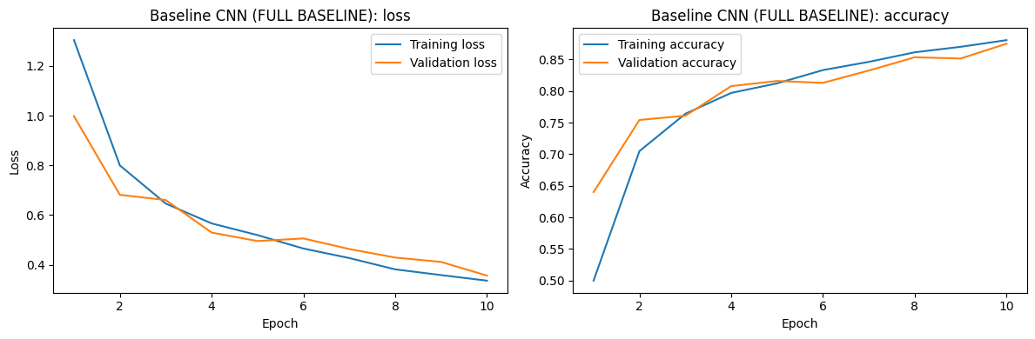
Figure S1.1. Training and validation loss and accuracy over the 10-epoch baseline run.
2.2 Per-Class Performance
Performance was not uniform across the 10 land-use classes. Residential and SeaLake achieved the highest class accuracies, while HerbaceousVegetation and Highway were the most difficult classes for the baseline. The lower accuracy of these classes indicates that they remain important targets for the architecture and augmentation experiments in later stages.
Class | Accuracy | Class | Accuracy
AnnualCrop | 86.02% | Pasture | 90.30%
Forest | 86.43% | PermanentCrop | 87.60%
HerbaceousVegetation | 74.45% | Residential | 96.44%
Highway | 81.07% | River | 89.87%
Industrial | 93.39% | SeaLake | 96.55%
2.3 Confusion-Matrix Analysis
The normalized confusion matrix is strongly diagonal, confirming that most test samples were assigned to the correct class. The strongest diagonal responses correspond to Residential, SeaLake, and Industrial, consistent with their high per-class accuracies. More noticeable off-diagonal errors occur for the weaker classes, particularly HerbaceousVegetation and Highway. These errors provide a concrete motivation for the next stage, where depth, kernel size, Batch Normalization, stride, and padding will be varied under controlled conditions.
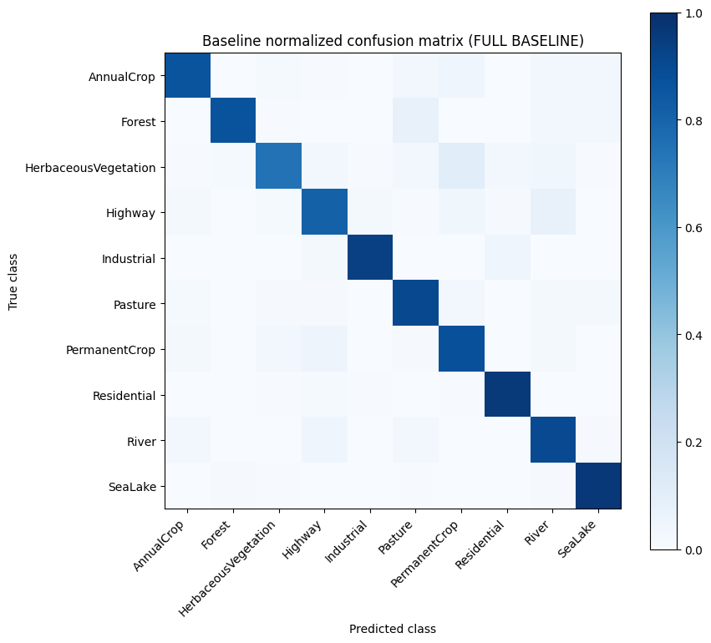
Figure S1.2. Normalized confusion matrix on the held-out EuroSAT test set.
3. Stage 1 Evaluation and Conclusion
Stage 1 successfully established a reproducible end-to-end baseline for EuroSAT classification. The three-block CNN reached 87.51% peak validation accuracy and 88.00% test accuracy with only 356,810 parameters, while maintaining a small train-validation gap. The learning curves show steady convergence across the 10 epochs and the confusion matrix confirms strong overall class separation. However, the class-level analysis also reveals substantial headroom for improvement, most clearly for HerbaceousVegetation and Highway.
The baseline is intentionally not optimized: it uses a fixed 3 x 3 convolutional design, no Batch Normalization, no data augmentation, and a single Adam learning-rate setting. Therefore, its primary role is to provide a controlled reference point rather than a final model. Stage 2 will use this reference to determine whether architectural changes improve validation performance and generalization while keeping the remaining experimental conditions fixed.
Integration note: figure/table numbering can be renumbered when this section is merged into the final 6-8 page report.

