Foundations of Artificial Intelligence
KNOWLEDGE-BASED EXPERT SYSTEM FOR DIGITAL HARDWARE DESIGN DEBUGGING
A PROJECT REPORT
Submitted by
2116240701090 – CHENTHAN AMUTHAN D
2116240701035 – AMAR GANESH S
2116240701050 – ARSHAD AA

October, 2026
BONAFIDE CERTIFICATE
Certified that this project report “KNOWLEDGE-BASED EXPERT SYSTEM FOR DIGITAL HARDWARE DESIGN DEBUGGING” is the bonafide work of “CHENTHAN AMUTHAN D (2116240701090), AMAR GANESH S (2116240701035) and ARSHAD AA (2116240701050)” who carried out the project work under my supervision.

SIGNATURE OF THE FACULTY INCHARGE
Submitted for the Practical Examination held on _______________
SIGNATURE OF THE INTERNAL EXAMINER
TABLE OF CONTENTS
CHAPTER NO. TITLE PAGE NO.
ABSTRACT 1
1. INTRODUCTION 2
1.1 BACKGROUND 2
1.2 PROBLEM STATEMENT 2
1.3 OBJECTIVES 3
1.4 SCOPE OF THE PROJECT 3
2. LITERATURE REVIEW 4
3. PROPOSED SYSTEM 6
3.1 ARCHITECTURE DIAGRAM 6
3.2 TECHNOLOGY STACK 7
3.3 WORKING PRINCIPLE 7
4. MODULES DESCRIPTION 8
4.1 MODULE 1: RTL PARSING MODULE 8
4.2 MODULE 2: SIMULATION AND VCD GENERATION MODULE 8
4.3 MODULE 3: WAVEFORM ANALYSIS MODULE 8
4.4 MODULE 4: KNOWLEDGE BASE AND INFERENCE ENGINE 9
4.5 MODULE 5: EVIDENCE CORRELATION AND REPORT GENERATION 9
4.6 MODULE 6: WEB APPLICATION AND VISUALIZATION 9
5. IMPLEMENTATION AND RESULTS 11
5.1 EXPERIMENTAL SETUP 11
5.2 RESULTS 11
6. CONCLUSION AND FUTURE WORK 13
7. REFERENCES 14

ABSTRACT
Debugging digital hardware designs is a slow and evidence-heavy activity. An engineer must examine the RTL source, the testbench stimulus, the simulation log and the waveforms together, because a fault in a design often shows itself only through the way signals behave over time. Conventional simulators display waveforms but offer no explanation of what they mean, and beginners find it hard to interpret them while experienced engineers keep applying the same diagnostic patterns by hand.
This project presents a Knowledge-Based Expert System for Digital Hardware Design Debugging, a deterministic and rule-driven assistant that reasons over both RTL structure and waveform behaviour. The system parses Verilog source with PyVerilog, compiles and simulates the design with Icarus Verilog to generate a Value Change Dump (VCD) file, and converts the same VCD into machine-readable facts using vcdvcd. GTKWave is used as the visualization layer so that the real waveform is shown to the engineer. An inference engine fires explicit hardware debugging rules over the collected facts, correlates structural and behavioural evidence, and produces an explainable report containing the evidence chain and a recommended fix. In the case study of a 4-bit counter, the system detected that the enable signal stayed at 0 for the whole simulation and that the count register started at X, and recommended asserting the enable in the testbench and adding a reset assignment in the RTL.

1. INTRODUCTION

1.1 BACKGROUND
Modern digital systems are described at the Register Transfer Level (RTL) using hardware description languages such as Verilog. Before a design is fabricated or placed on an FPGA, it is verified by simulation: a testbench applies stimulus to the design and the simulator records how the signals change with time. The behaviour of a design is therefore contained in the simulation results, not in the RTL text alone, and verification engineers spend a large share of their effort on inspecting and interpreting these results.
Expert systems are a classical branch of Artificial Intelligence in which the knowledge of a human specialist is written down as explicit rules in a knowledge base, and an inference engine applies those rules to the facts of a particular case to reach a conclusion. Because every conclusion follows from a named rule, the reasoning can be inspected and explained. This makes the technique attractive for hardware debugging, where engineers need to trust and verify the diagnosis they are given.

1.2 PROBLEM STATEMENT
Digital hardware debugging faces the following difficulties:
- Distributed evidence: RTL code, testbench stimulus, simulation output and waveforms must be inspected at the same time, and the evidence is scattered across several sources.
- Costly manual correlation: Cross-referencing signal behaviour by hand is time-consuming and error-prone, especially when timing relationships involve dozens of signals.
- Skill gap: Beginners struggle to interpret signal behaviour, while experienced engineers repeatedly apply the same diagnostic patterns. Neither group is well served by current tooling.
- No explanation from tools: RTL alone cannot reveal behaviour over time, and simulators show waveforms without any rule-based reasoning about them.
There is therefore a need for a structured and explainable debugging assistant that can correlate RTL structure with waveform behaviour and present its findings with supporting evidence.

1.3 OBJECTIVES
The objectives of the project are:
- To parse RTL and extract structural and behavioural facts from Verilog source files.
- To automate simulation by compiling the RTL and testbench, running the simulation and capturing the VCD output.
- To analyze waveforms by parsing the VCD programmatically into machine-readable signal facts.
- To apply rules by firing explicit hardware debugging rules against the extracted facts.
- To correlate evidence by joining RTL structural evidence with waveform behavioural evidence.
- To generate diagnoses in the form of explainable reports with evidence chains and recommendations.

1.4 SCOPE OF THE PROJECT
The system targets Verilog designs that can be simulated with Icarus Verilog. It is deterministic: given the same RTL, testbench and VCD, it always produces the same diagnosis, and no statistical or learned model is involved. The waveform shown to the user is always the real waveform rendered by GTKWave from the actual VCD file; the system does not redraw or fabricate waveforms. The project is intended as a debugging aid for students and engineers, and it supports the engineer’s judgement rather than replacing it.

2. LITERATURE REVIEW
This chapter reviews the areas of work on which the project is built: rule-based expert systems, hardware description and simulation tools, and existing approaches to waveform-based debugging.
Expert systems and rule-based reasoning
Expert systems emerged in the 1970s and 1980s as one of the first commercially successful applications of Artificial Intelligence. Systems such as MYCIN encoded expert knowledge as if–then rules and used an inference engine to chain them together, and, importantly, could explain how a conclusion was reached (Buchanan and Shortliffe, 1984). Jackson (1998) describes the standard architecture of such systems, consisting of a knowledge base, a working memory of facts, an inference engine and an explanation facility. Russell and Norvig (2020) present forward chaining over rules as a sound and simple inference procedure. Efficient pattern matching for large rule sets was addressed by the Rete algorithm (Forgy, 1982). This project follows the same architecture, with the knowledge base holding hardware debugging rules and the working memory holding facts extracted from RTL and waveforms.
Verilog and RTL parsing
Verilog is standardised as IEEE 1364 and is widely taught and used for describing digital hardware (IEEE, 2006; Palnitkar, 2003). Extracting information from Verilog source needs a proper parser rather than text search. Pyverilog is a Python-based toolkit that provides a Verilog parser, dataflow analyzer and code generator, and exposes the design as an abstract syntax tree (Takamaeda-Yamazaki, 2015). This makes it suitable for pulling out modules, ports and always blocks as facts for a knowledge base.
Simulation and waveform tools
Icarus Verilog is an open-source Verilog simulator that compiles a design into an intermediate form which is executed by the vvp runtime, and it can dump signal changes to a Value Change Dump (VCD) file (Williams, n.d.). GTKWave is an open-source viewer that displays VCD files with a signal hierarchy, a time axis and interactive cursors (Bybell, n.d.). The vcdvcd package is a Python library that reads VCD files and gives programmatic access to signal names, transition times and values (Santilli, n.d.). Together these tools give a fully open toolchain for producing and reading behavioural evidence.
Gap identified
Simulators and waveform viewers show what happened but do not say why, and static inspection of RTL cannot see temporal behaviour. Existing tools leave the correlation of the two to the engineer. The present work fills this gap by combining a parser, a simulator, a waveform reader and a rule-based inference engine in a single pipeline that produces explainable diagnoses.

3. PROPOSED SYSTEM
The proposed system is a deterministic hardware debugging assistant built as a six-stage pipeline. Each stage has a distinct responsibility: simulation produces the evidence, GTKWave visualizes it, vcdvcd makes it machine-readable, and the inference engine applies explicit rules to derive diagnoses. Because the diagnosis is derived only from rules and extracted facts, every conclusion can be traced back to the evidence that caused it.

3.1 ARCHITECTURE DIAGRAM
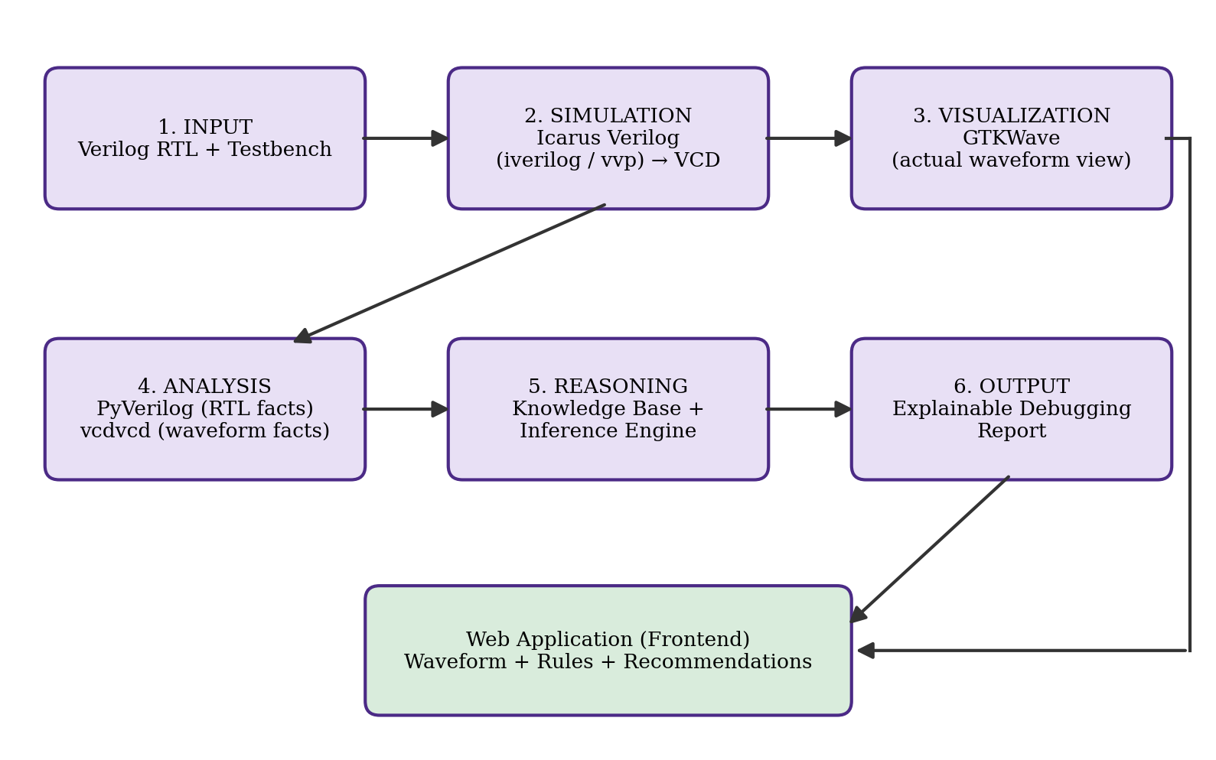
Figure 3.1: System architecture of the proposed expert system
The six stages of the pipeline are summarised in Table 3.1.
Table 3.1: Stages of the pipeline
Stage | Component | Responsibility
Input | RTL and testbench | Verilog source files supplied by the user
Simulation | Icarus Verilog | Compiles and simulates the design and produces the VCD file
Visualization | GTKWave | Renders the actual waveform for interactive inspection
Analysis | PyVerilog and vcdvcd | Convert RTL and VCD into structured facts
Reasoning | Knowledge base and inference engine | Fires debugging rules over the facts
Output | Explainable report | Diagnoses, evidence chains and recommendations

3.2 TECHNOLOGY STACK
- Python 3: core orchestration, backend logic and implementation of the inference engine.
- PyVerilog: parses the Verilog RTL source and extracts structural facts such as modules, ports and always blocks.
- Icarus Verilog: compiles the RTL and testbench and runs the simulation to produce VCD output.
- vcdvcd: converts the VCD file into machine-readable facts.
- GTKWave: renders the actual waveform visualization for interactive inspection.

3.3 WORKING PRINCIPLE
The user supplies an RTL file and its testbench. The system first extracts structural facts from the RTL. It then compiles and simulates the design, which generates a single VCD file. This file serves two purposes without any duplication of data: GTKWave reads it for visual inspection, and vcdvcd reads it for programmatic analysis. The waveform facts and the RTL facts are placed in the working memory of the inference engine, which fires every rule whose conditions are satisfied. Finally, the correlated evidence is compiled into a report showing which rules fired, what evidence supported them and what change is recommended.

4. MODULES DESCRIPTION
The system is divided into six modules. Each module has a single responsibility and passes its output to the next.

4.1 MODULE 1: RTL PARSING MODULE
This module uses PyVerilog to traverse the Abstract Syntax Tree (AST) of the Verilog source and to extract structural and behavioural facts that seed the knowledge base. For the counter module used as the case study, the module header is:
module counter(
input clk, rst, en,
output reg [3:0] count
);

The facts extracted from it are: module name = counter; inputs = {clk, rst, en}; output = count[3:0]; a sequential always block with sensitivity posedge clk; and the presence of reset logic and an enable signal. These are recorded as structural preconditions that are later matched against the waveform evidence.

4.2 MODULE 2: SIMULATION AND VCD GENERATION MODULE
This module automates the simulation with a two-command pipeline:
iverilog -o sim rtl.v tb_rtl.v
vvp sim # generates vcdfile.vcd

The VCD (Value Change Dump) file records every signal transition at every simulation timestamp, and is therefore a complete behavioural record of the design under test. A single VCD file is used for both visualization and analysis, so no data is duplicated or fabricated.

4.3 MODULE 3: WAVEFORM ANALYSIS MODULE
The waveform analysis module uses vcdvcd to parse the VCD into structured facts: signal names, transition timestamps and value sequences. For each signal it records the number of transitions, the initial value and whether the value stays constant. Figure 4.1 shows how the two consumers, GTKWave and vcdvcd, read the identical VCD produced by Icarus Verilog.
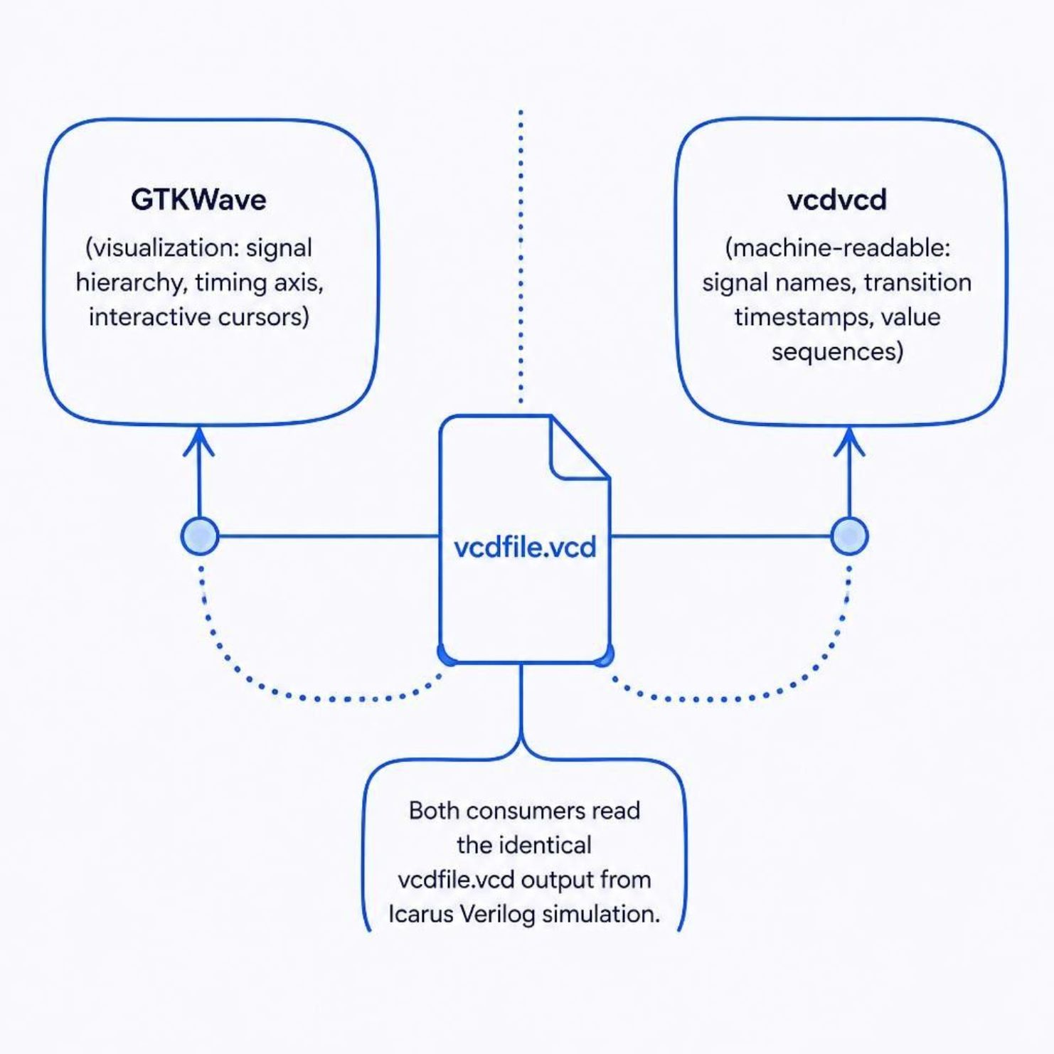
Figure 4.1: One VCD file feeding both GTKWave and vcdvcd

4.4 MODULE 4: KNOWLEDGE BASE AND INFERENCE ENGINE
The knowledge base contains explicit hardware debugging rules written in if–then form. The inference engine, implemented in Python, matches these rules against the facts in working memory and fires every rule whose conditions hold. Since each conclusion is produced by a named rule, the diagnosis is deterministic and explainable. The rules demonstrated in the case study are given in Table 4.1.
Table 4.1: Debugging rules demonstrated in the case study
Rule | Condition (evidence) | Conclusion
Enable stuck low | Sequential block gated by en, and en = 0 throughout the simulation | Counter increment is blocked by a testbench stimulus gap
Uninitialized register | Register has initial value X after reset | Reset branch does not assign a defined value

4.5 MODULE 5: EVIDENCE CORRELATION AND REPORT GENERATION
This module joins the RTL structural evidence with the waveform behavioural evidence. For example, the RTL fact that the counter has an enable input is combined with the waveform fact that the enable never changes from 0. The result is an explainable report in which each diagnosis lists the rule that fired, the supporting RTL and waveform evidence, and a recommended fix.

4.6 MODULE 6: WEB APPLICATION AND VISUALIZATION
The frontend of the web application displays the GTKWave-rendered waveform alongside the inference results and provides an “Open in GTKWave” button so that the engineer can inspect the waveform natively and interactively. No waveforms are drawn using HTML Canvas, SVG, CSS or JavaScript; every waveform artifact originates from GTKWave rendering of the actual VCD data.

5. IMPLEMENTATION AND RESULTS

5.1 EXPERIMENTAL SETUP
The system was implemented in Python 3 and evaluated on a 4-bit synchronous counter written in Verilog, with a testbench that applies clock, reset and enable stimulus. The tools used are listed in Table 5.1.
Table 5.1: Experimental setup
Item | Details
Programming language | Python 3
RTL parser | PyVerilog
Simulator | Icarus Verilog (iverilog and vvp)
Waveform analysis | vcdvcd
Waveform viewer | GTKWave
Design under test | 4-bit counter with clk, rst and en inputs and count[3:0] output
Simulation output | vcdfile.vcd

The experiment follows these steps:
- Parse counter RTL with PyVerilog and store the structural facts.
- Compile with iverilog and run with vvp to generate vcdfile.vcd.
- Parse vcdfile.vcd with vcdvcd to obtain waveform facts.
- Run the inference engine over the combined facts.
- Display the waveform in GTKWave and the diagnosis in the web application.

5.2 RESULTS
The signal observations extracted from vcdfile.vcd are shown in Table 5.2.
Table 5.2: Signal observations from vcdfile.vcd
Signal | Transitions | Observation
clk | 13 | Regular clock, expected behaviour
rst | 5 | Reset asserted and deasserted normally
en | 1 | Constant 0, potential stimulus gap
count[3:0] | 6 | Initial value = X, possible uninitialized register

The inference engine correlated these waveform facts with the RTL structure and fired two rules:
- Rule fired (enable stuck low): en = 0 throughout the simulation, so the counter increment is blocked by a testbench stimulus gap.
- Rule fired (uninitialized register): the initial value of count is X, so the reset branch does not assign a defined value.
The recommendation produced by the system is to assert en = 1 in the testbench and to add count <= 0 to the reset branch in the RTL. Both diagnoses are explainable and traceable to explicit rules, and the waveform that supports them can be opened directly in GTKWave.
The results show that the pipeline can locate both a stimulus-side problem (testbench) and a design-side problem (RTL) from a single simulation run, and that it justifies each finding with evidence, which a plain waveform viewer does not do.

6. CONCLUSION AND FUTURE WORK
Conclusion
This project developed a Knowledge-Based Expert System for Digital Hardware Design Debugging. By combining PyVerilog for RTL parsing, Icarus Verilog for simulation, vcdvcd for machine-readable waveform facts, GTKWave for real waveform visualization and a rule-based inference engine for reasoning, the system turns scattered debugging evidence into an explainable diagnosis. In the case study of a 4-bit counter, it identified a constant-low enable and an uninitialized register and suggested a specific fix for each. The approach is deterministic, transparent and traceable, which makes it useful both for beginners who need guidance and for experienced engineers who want to automate repeated diagnostic patterns.
Future work
- Extend the knowledge base with more rules, such as a clock that never toggles, a reset that is never deasserted and outputs that stay unknown.
- Support larger, multi-module designs and hierarchical signal analysis.
- Support SystemVerilog and VHDL sources.
- Use timing-relationship rules, for example between handshake signals, across many signals.
- Add automatic generation of suggested testbench patches and RTL fixes.
- Evaluate the system on a wider set of benchmark designs with known faults.

7. REFERENCES

Buchanan, B.G. and Shortliffe, E.H. (1984) Rule-Based Expert Systems: The MYCIN Experiments of the Stanford Heuristic Programming Project. Reading, MA: Addison-Wesley.
Bybell, A. (n.d.) GTKWave: Wave Viewer. Available at: https://gtkwave.sourceforge.net (Accessed: September 2026).
Forgy, C.L. (1982) ‘Rete: A Fast Algorithm for the Many Pattern/Many Object Pattern Match Problem’, Artificial Intelligence, Vol.19, No.1, pp.17-37.
IEEE (2006) IEEE Standard for Verilog Hardware Description Language, IEEE Std 1364-2005. New York: IEEE.
Jackson, P. (1998) Introduction to Expert Systems, 3rd edn. Harlow: Addison-Wesley.
Palnitkar, S. (2003) Verilog HDL: A Guide to Digital Design and Synthesis, 2nd edn. Upper Saddle River, NJ: Prentice Hall.
Russell, S. and Norvig, P. (2020) Artificial Intelligence: A Modern Approach, 4th edn. Harlow: Pearson.
Santilli, C.R. (n.d.) vcdvcd: Python Verilog Value Change Dump (VCD) Parser. Available at: https://github.com/cirosantilli/vcdvcd (Accessed: September 2026).
Takamaeda-Yamazaki, S. (2015) ‘Pyverilog: A Python-based Hardware Design Processing Toolkit for Hardware Prototyping’, Applied Reconfigurable Computing (ARC 2015), Lecture Notes in Computer Science, Vol.9040, pp.451-460.
Williams, S. (n.d.) Icarus Verilog. Available at: https://steveicarus.github.io/iverilog (Accessed: September 2026).

