QUICK NOTES! User Manual

Welcome to Quick Notes, the easy-to-use note-taking application designed to help you jot down thoughts and let your ideas flow! This app is perfect for students, professionals, or anyone who wants to note something down quickly and stay organized.

This manual will guide you through the features and functionality of Quick Notes, providing step-by-step instructions for getting started, using the application, and troubleshooting common issues.

What you need:

* A computer
* VS CODE
* Python and Tkinter installed.

1. Start-up screen: This screen is the first screen you will see upon opening our app. To start jotting down your notes, hit the “Start” button. If you wish to close the app, hit the “Exit” button.

1. Main Screen: Once you have hit the “Start” screen, you will be met with this screen. Here is where the magic happens. A text box will appear, where you are able to type out your note. We will go over the functions.

**Functions:**

Let’s start by editing the name of your note!

***“Edit Title”* button:** A second window will appear where you are able to create a name for note. Hit “Okay” when you are done!

*However*, if you leave your title empty, a different screen will pop up. You must title your note if you delete its default title!

Moving forward, we will be using “Dinner Ideas” as our new note title and wrote out content in the text box to show you additional features of our app.

***“New Note”* button:** This feature allows you to create a new note. A second tab will appear with the default screen. You are able to flip back to your original note and the new one by simply clicking the title name of your note.

Video demonstration:

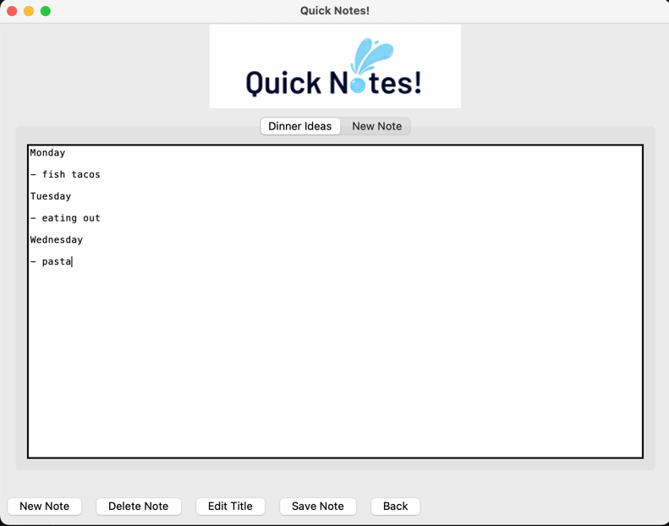

***“Save Note”* button:** This feature allows you to save your note onto your device. Simply name your note and choose your destination and hit save!

A successful note that has been saved will prompt this screen to appear:

However, if you do not have contents in your note, our application will not let you save an empty file! An error screen will be displayed.

***“Delete Note”* button:** Our last feature that this application has to offer is our delete feature. By simply hitting this button your note will...delete!

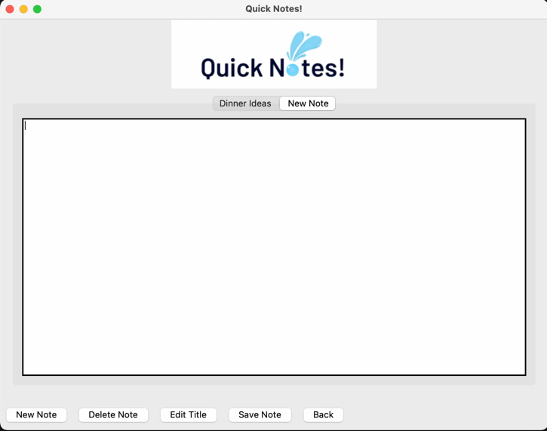Video demonstration:

***“Back”* button:** This feature will take you back to our home page!

This concludes our user manual for “Quick Notes!”