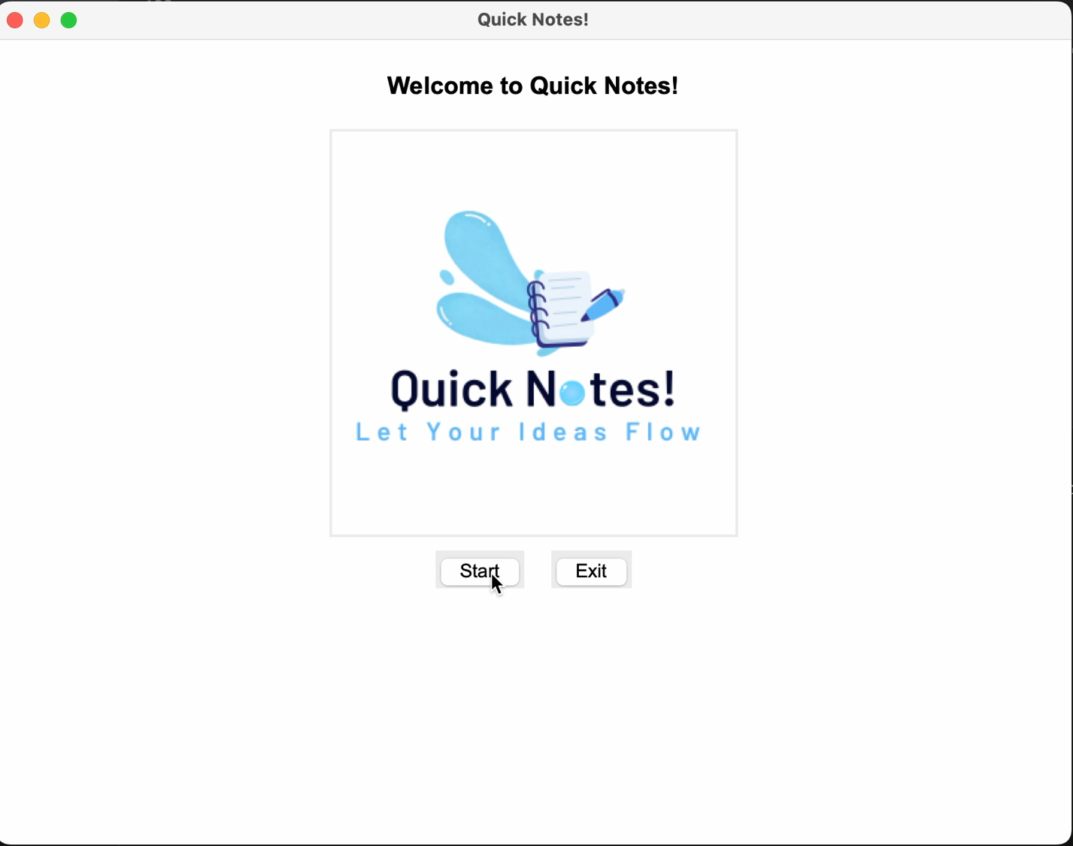

**Start Screen:**

**Test data:** By clicking the “Start” button, it should lead to the main screen of the program. When clicking the “end” screen, the app should close.

**Result**: The “start” button moves to the next screen and “end” button closes the app.

**Video demonstration:**

**Main Screen:**

**Test data:** The main should have all buttons to create a note, delete a note, edit the title, save the note, and go back to the start screen.

**Result**: All buttons are visible and are able to do their intended function.

**Photo:**

**Creating note:**

**Test data:** By clicking the “new note” button, a new tab should appear and allow the user to enter test. The user should also be able to move between tabs.

**Result:** Note is created and functions still work. Tab is created and still able to view different notes.

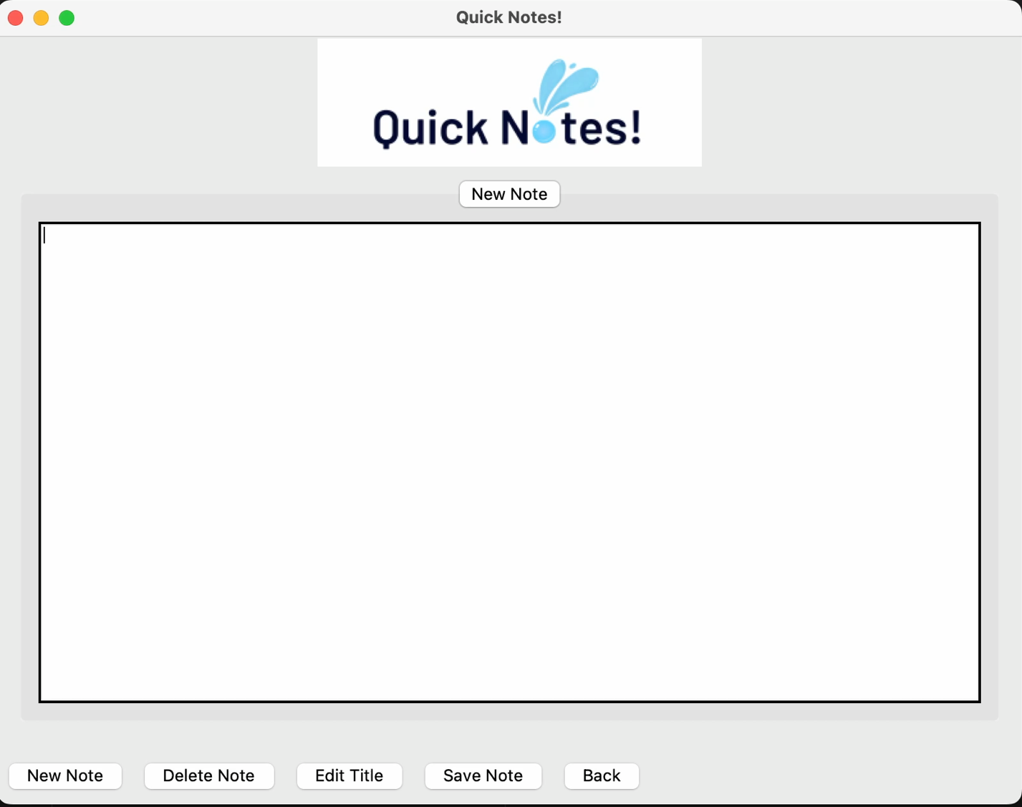**Video demonstration:**

**Deleting note:**

**Test data:** By clicking the “delete note” button, note should delete.

**Result:** Note does delete.

**Video Demonstration:**

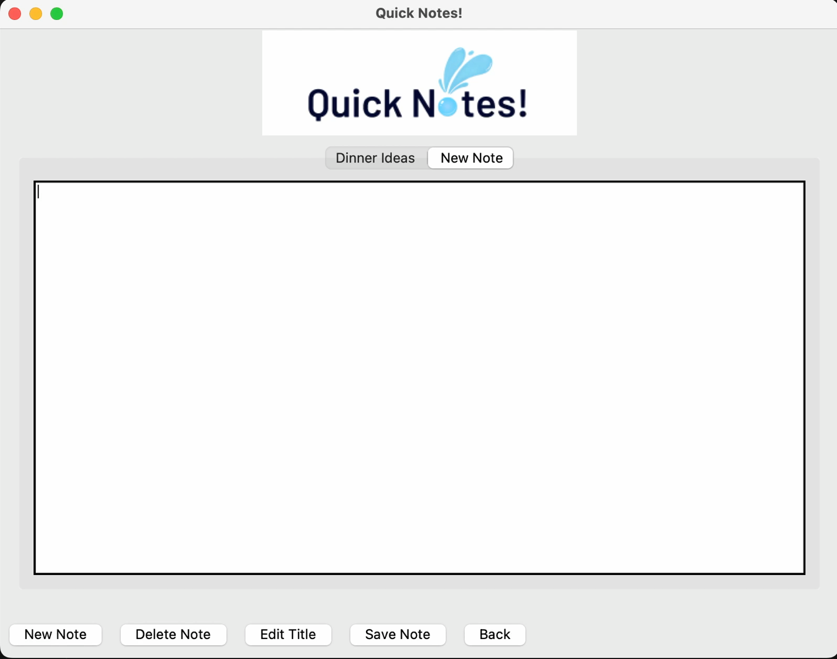

**Editing title:**

**Test data:** When button is clicked, user should be able to edit the title of their note. If user does not enter anything in, while have deleted default name, an error message will display.

**Result**: As expected, the user is able to edit title. Warning message appears.

**Video Demonstration:**

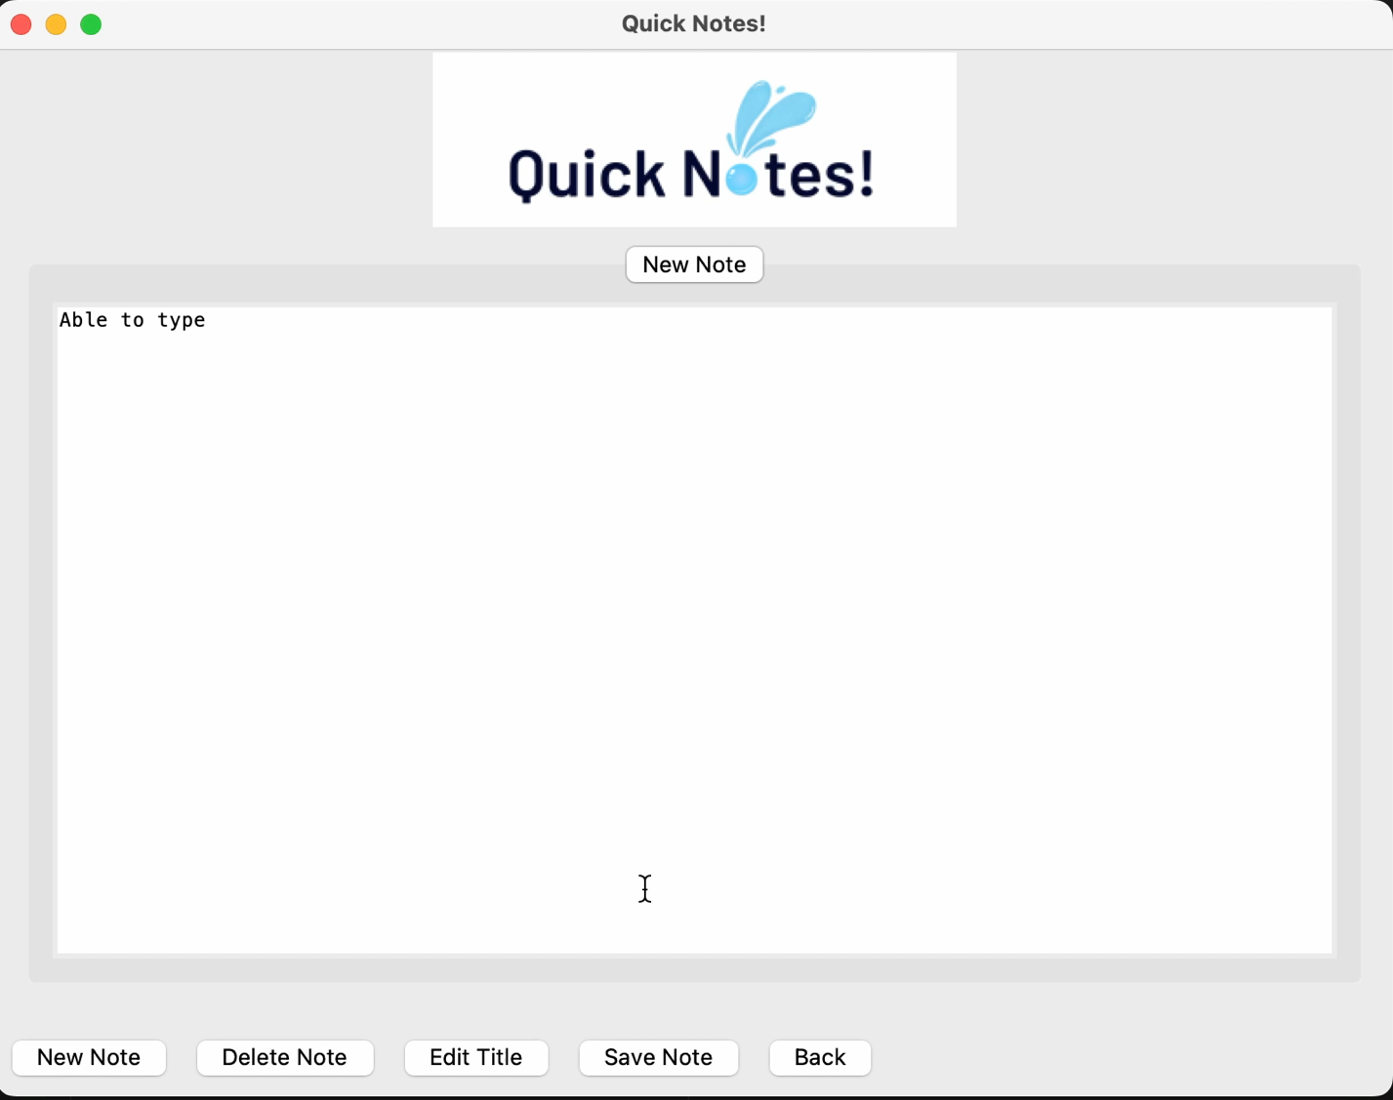

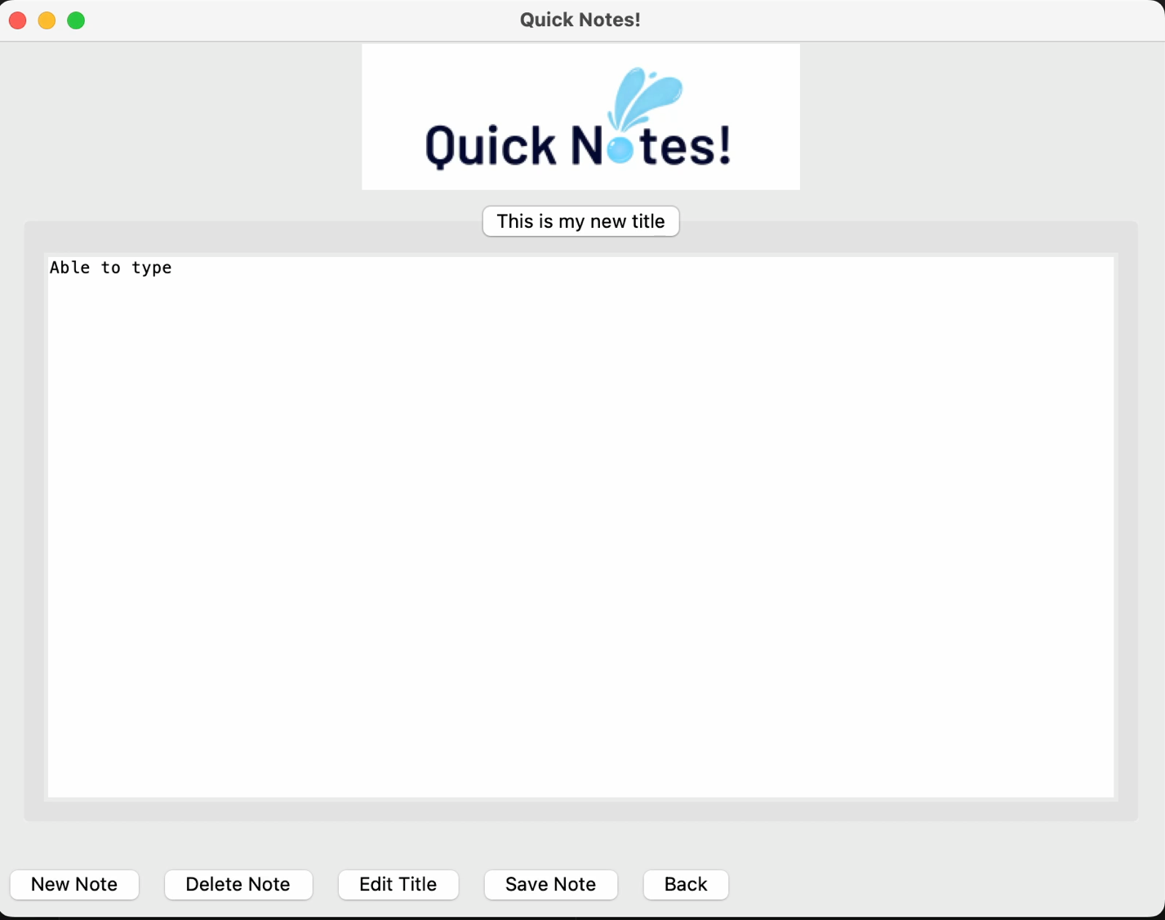**Saving note:**

**Test Data:** When user clicks “save note” button, a window will appear allowing the user to pick the text file’s name and destination. A window will appear when the note is successfully saved. If note does not have any contents, an area message will appear.

**Result:** Button work as intended, note is saved. A warning message does appear when note is empty.

**Video Demonstration 1:**

**Photo proof that text file was saved to ‘Documents’ :**

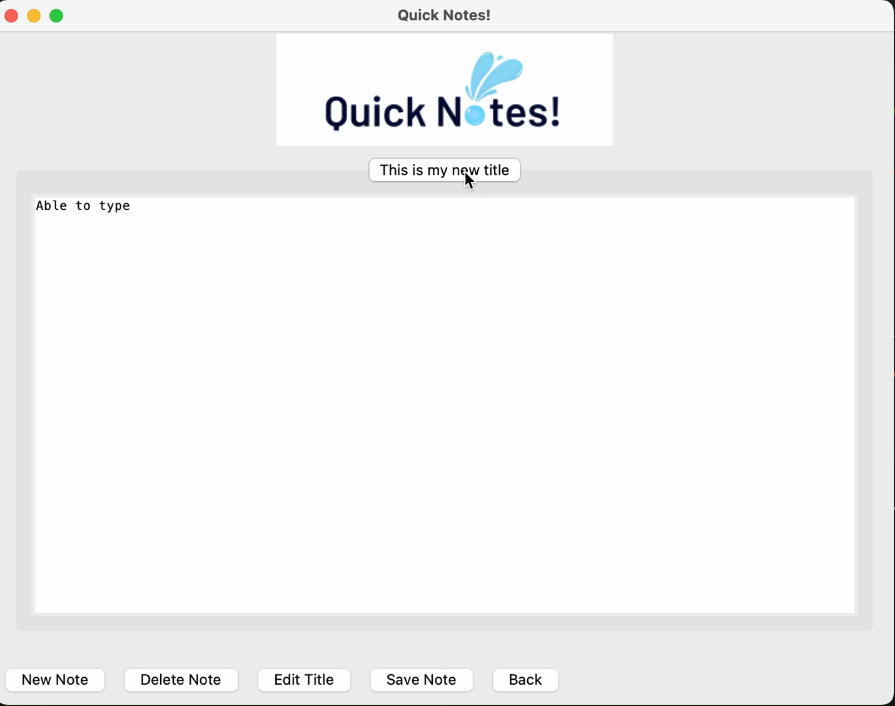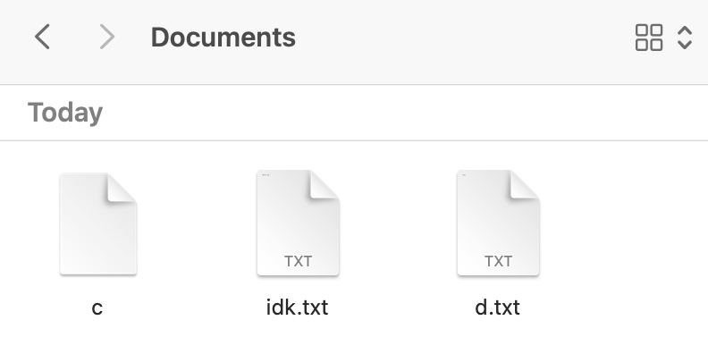

**Video demonstration 2 of error message:**