
Informatics Large Practical Coursework 2
Theodor Amariucai

Stephen Gilmore, Paul Jackson
School of Informatics
UNIVERSITY OF EDINBURGH

Table of Contents
1. Software architecture description 2
2. Class documentation 2
3. Stateful drone strategy 2
References 3

Software architecture description
My application comprises 7 different Java classes: App, Game, Map, Drone, Stateless, Stateful, Position and Direction. I identified each one of them as having a separate, well-defined purpose within the architecture, and I believe this is the correct layout when having to address the 4 principles of Object-Oriented Programming: Inheritance, Encapsulation, Abstraction and Polymorphism.
The 7 classes mentioned above each encapsulate a different. The data is hidden from the user, with only a few public methods available for other classes to interact with. Class cohesion is low because
Considering the hierarchical relationships between classes, Stateless and Stateful are both subclasses of abstract class Drone. This is in accordance with their slightly distinct logic: they bear different variables and methods as their strategy is different.

Class documentation

Class Description
The App class defines the entry point in the program: it has the main class in which command line arguments are parsed accordingly, and then passed over to the Game class which will handle other logic.
The Game class defines
The Map class defines
The Drone class defines
As part of the Drone class, I implemented the Singleton design pattern to ensure that only a single instance of the Drone class will ever be instantiated. This is a safe and straightforward way of complying with the logic of the project: under no circumstances should the Drone class have multiple instances in the same game. To enforce this in a single-threaded application such as PowerGrab, it is sufficient for the Drone class to implement the field and method as below:
private static Drone instance = null;
static Drone createInstance(Position position, long seed, boolean submissionGeneration) {
if (instance == null || submissionGeneration)
instance = new Stateless(250, 0, position, seed);
return instance;
}
The StatelessDrone class defines
The StatefulDrone class defines
The Position class defines
The Direction class is an enumeration of 16 cardinal points. In addition, it provides two static variables and a static method randomDirection().

Test classes

Stateful drone strategy
This section explains the strategy which is used by your stateful drone to improve their score relative to the stateless drone.
You should explain what is remembered in the state of the stateful drone and how this is used to improve the drone’s score.
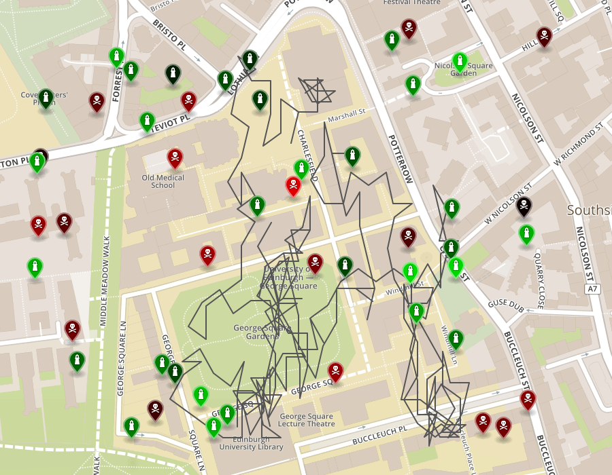
Graphical figure denoting a stateless drone flight on PowerGrab map 09/09/2019

Graphical figure denoting a stateful drone flight on PowerGrab map 09/09/2019
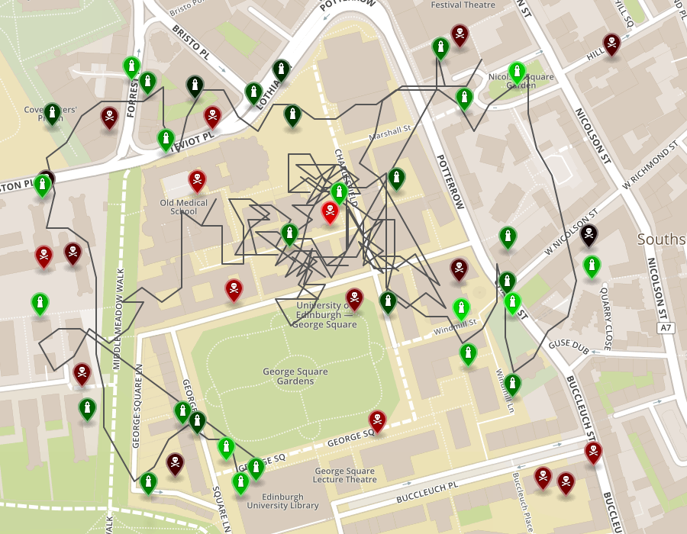
talk about the trace field

References
There are no sources in the current document

