

**Explore Weather Trends**

**Analysis and approach to extract data:**

* Checking available cities for India



* Selected New Delhi and checking respective city’s data and global data



* Used SQL joins to put global and city data for New Delhi in same table

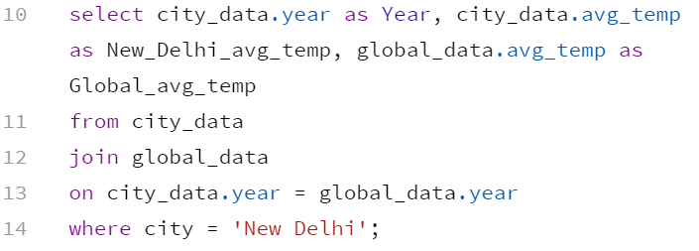

* This result was downloaded as a CSV to further calculate the moving averages.
* Microsoft Excel was used for performing the calculations and plotting the line charts.
* Line charts were drawn for the average of global and city’s temperature and then one for the moving average of global and city’s temperature.

**Calculating Moving Averages:**

* Interval: 10 years
* Note: Data was missing for the column New_Delhi_avg_temp for the years 1808-1812 and 1858-1869. This missing data was replaced by the calculated average of city temperatures which came out to be 25.17.
* Average of the temperature data for a period of 10 years was calculated by using ‘AVERAGE()’ function of Excel.

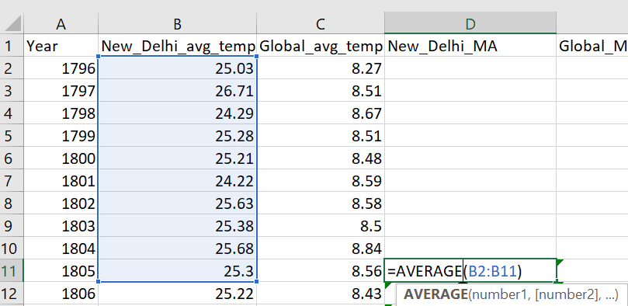

* Similar step was followed for calculating the moving average for global average temperature data too.

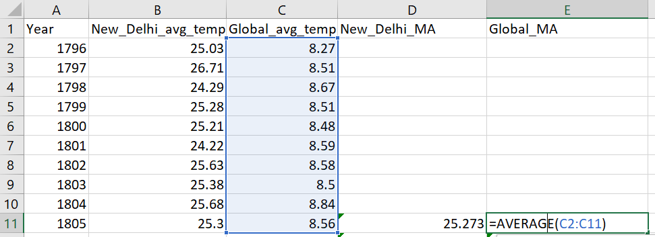

* Then these two cells (i.e, cell D11 and E11) were selected and their formulas copied. Then the whole column D and E were selected and the copied formulas were pasted into them resulting in the calculation of moving averages till the last row.

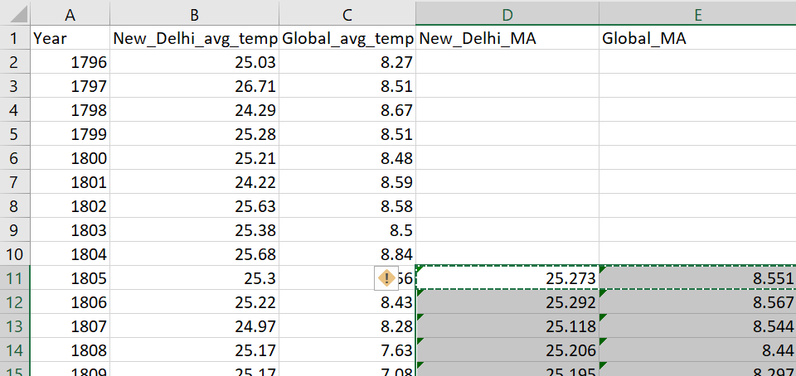

**Line Charts:**

* New Delhi and global avg. temp. trends
* 10 years MA for New Delhi and global avg. trends

**Observations:**

1. Moving average trends for both New Delhi and global temperatures have almost similar rises and falls. New Delhi’s temperature takes a dip around 1820 which can also be seen in the global temperature trend. The temperature in New Delhi and the world both rise around 1825.
2. Average temperature for New Delhi is more than the average temperature globally. This can also be explained by the fact that New Delhi lies nearer to the equator and hence all the cities of the world lying between equator and tropic of cancer have higher temperatures as compared to the global data.
3. New Delhi and global temperature trends exhibit a steady rise over the years, between 1805 and 2013, temperature has risen

by 1 degree.

1. The world is getting hotter as the years pass by. This is mostly due to rising pollution over the years due to increasing number of industries, decreasing forest cover, and vehicles emitting greenhouse gases.