Report

Khaibar Amarkhil

Group: IT-2402

# 1. Introduction

This project is my first HTML webpage created as part of the Information Technology course. The goal was to design a simple personal website using HTML that contains different sections such as About Me, Hobbies, Favorite Websites, Schedule, Layout, and Contact Form.

# 2. Project Tasks and Screenshots

## Part: Title and Meta Information

page title, author, and description.

Input

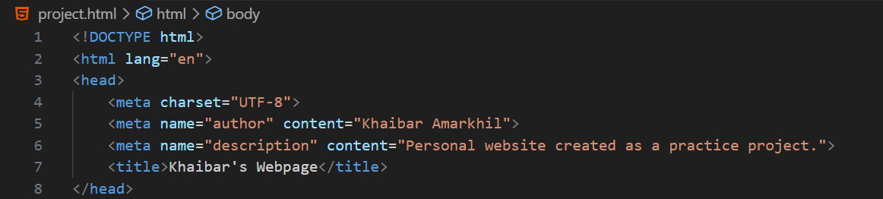

## Part: About Me Section

personal information with heading and paragraph.

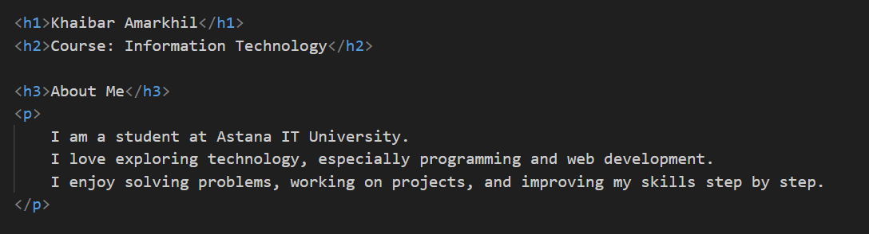

## Part: My Hobbies

list of hobbies using <ul> tags.

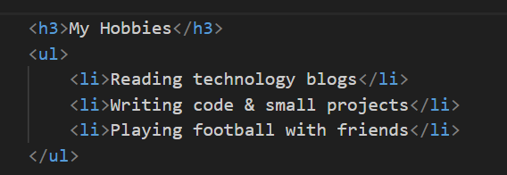

## Part: Favorite Websites

favorite websites using <ol> and <a> tags.

## Part: My Photo

image with img tag.

## Part: Button with Alert

button that shows an alert when clicked.



## Part: Weekly Class Schedule

table for class schedule.

## Part: Two-Column Layout

a simple layout using an HTML table with menu and main content.

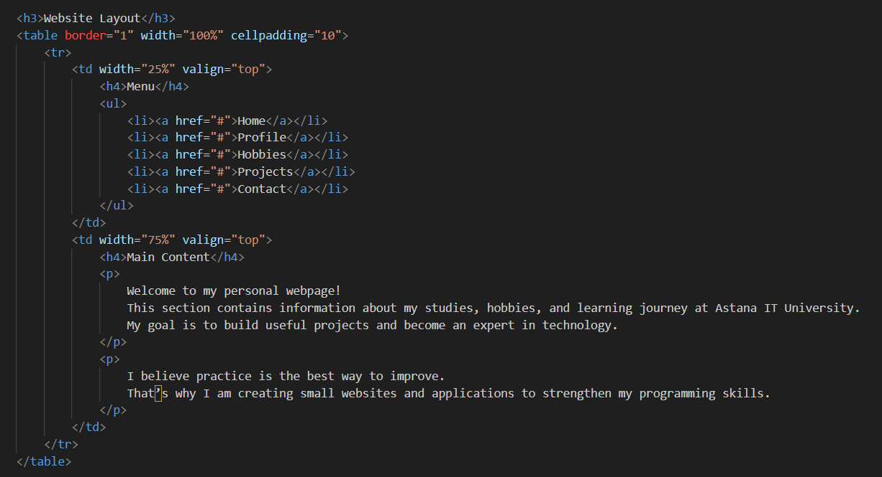

## Part: My Mood Today

text and emojis to show mood.

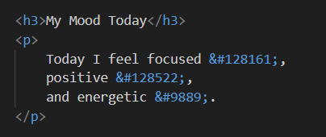

## Part: Contact Me Form

a form with input fields (name, email, favorite color).

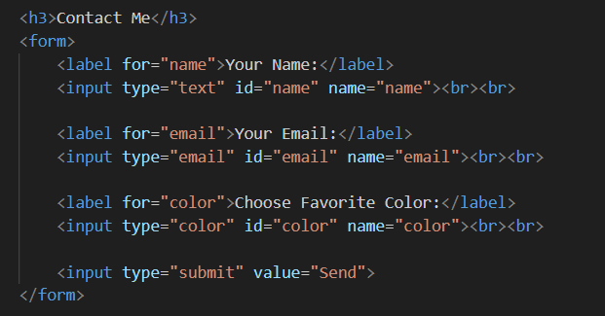

# 3. Work Process Summary

- First, I created the basic HTML structure (<!DOCTYPE html>, <html>, <head>, <body>).  
- I added metadata and page title.  
- Then, I created sections step by step: About Me, Hobbies, Websites, and Photo.  
- I used lists (ul, ol), links (a), and images (img).  
- I added an interactive button using the onclick attribute.  
- I created a class schedule with a table.  
- For layout, I used a two-column table design (Menu + Main Content).  
- I used emojis to make the 'Mood' section more fun.  
- Finally, I added a Contact Form with text, email, and color input fields.  
- After testing in the browser (Chrome), the project ran without any errors.

# 4. Conclusion

This project helped me practice HTML fundamentals such as headings, paragraphs, lists, tables, forms, images, and links. I also learned how to structure a webpage clearly and make it interactive with a button.  
  
I successfully completed all parts, and the project is working properly in the browser.