ECORATION CELL

“Don’t think about making art, just get it done

. Let everyone else decide if it’s good or bad,

whether they love it or hate it.

While they are deciding, make even more art.”

The Decoration Cell is a cell which makes the base and puts life to the fests of SRMGPC. It is one of the best off stage cells and has won many awards. This cell in our college originated in the year 2005.Since then it is becoming more and more creative. Every member of the cell has a unique and tremendous talent which motivates new talents to come and be the part of this family. Altogether we make the college lighten up and beautiful.

Our one of the best creativity is:

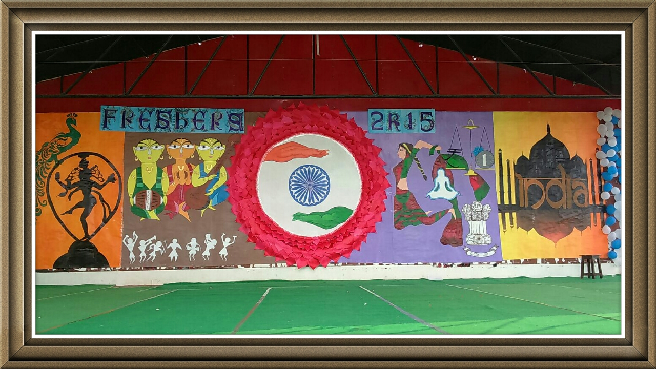

Members List

Faculty Coordinators : **Mrs. Megha Agarwal**

[I.T. Department]

Coordinators : **Deepali Gupta Anjali Soni**

B.Tech ME 3rdyr B.Tech EN 3rdyr

**Medhavi Chaubey Priya Seth**

B.Tech IT 3rdyr B.Tech ME 3rdyr

**Pratiksha Agarwal Dipika Chandra**

B.Tech EN 3rdyr B.Tech EC 3rdyr

**Shubham Chaudhary Shubham Singh**

B.Tech ME 3rdyr B.Tech ME 3rdyr

Assistant Coordinators : **Naina Mandhyan Mohd.Azahruddin**

B.Tech CS 2ndyr B.Tech ME 2ndyr

**Raj Singh Payal Gupta**

B.Tech ME 2ndyr B.Tech EC 2ndyr

**Preetish Raj Rahul Sahni**

B.Tech CS 2ndyr B.Tech ME 2ndyr

Veteran Coordinators : **Aditi Apurva Shikha Kesarwani**

B.Tech CS 4thyr B.Tech IT 4thyr

CONTACT DETAILS

Mrs. Megha Agarwal..[IT Department]

Shubham Chaudhary : 8188833391

(Coordinator)

Pratiksha Agarwal : 9532950042

(Coordinator)