
DEPARTMENT OF CSE
PROJECT ABSTRACT SUBMISSION
COURSE: SOA PROGRAMMING AND MICROSERVICES– (24SDCS03) A.Y. 2026 - 2027
TITLE OF THE PROJECT | TRUSTHIRE: INTELLIGENT FREELANCER RECRUITMENT AND TRUST-AWARE HIRING PLATFORM
S. No. | University ID | Name
1 | 2420030047 | DEEKSHITHA
2 | 2420030483 | AMARNATH .P
3 | 2420030357 | SUPRAJA GOUD.E
NAME OF THE GUIDE: |  | NAVYATHA RAVI

Abstract:
Freelance recruitment has become a practical way for organizations to access skilled professionals for short-term projects, specialized development work, and flexible hiring needs. However, finding the right freelancer is still largely dependent on keyword searches, self-reported profiles, ratings, and manual comparison of proposals. This makes it difficult for clients to judge whether a candidate’s skills, experience, portfolio, availability, and expected budget actually match the project requirements. At the same time, freelancers may find it difficult to identify relevant opportunities among a large number of job postings. Trust is another important concern, as incomplete profiles, exaggerated experience, duplicate accounts, misleading reviews, and suspicious activities can affect the reliability of a recruitment marketplace. To address these issues, TrustHire is proposed as an intelligent freelancer recruitment and trust-aware hiring platform that brings job discovery, candidate selection, hiring, and project management into a single system. The platform supports three major roles: clients who create and manage projects, freelancers who build professional profiles and apply for opportunities, and administrators who manage verification, moderation, disputes, and marketplace activity.

TrustHire is designed using a scalable microservices architecture with React, TypeScript, and Tailwind CSS on the frontend and Java, Spring Boot, Spring Data JPA, and PostgreSQL on the backend. Spring Cloud Eureka provides service discovery, while Spring Cloud Gateway acts as the central entry point for API routing and common security controls. Spring Security and JWT provide authentication and role-based access control, and Apache Kafka enables event-driven communication for activities such as job creation, proposal submission, shortlisting, hiring, milestone updates, reviews, notifications, and risk alerts. The main functional services cover authentication, user profiles, jobs, proposals, contracts, reviews and trust, notifications, and intelligence and risk analysis. A key feature of the platform is explainable candidate matching, where freelancer profiles are evaluated against project requirements using skill compatibility, experience, portfolio relevance, availability, budget, and previous project performance to generate a meaningful match score. The system also provides job quality analysis, skill-gap identification, a transparent trust score, and risk detection for suspicious marketplace behavior. These features are intended to make hiring decisions more informed rather than relying only on ratings or keyword similarity. Docker, JUnit 5, Mockito, Postman, GitHub Actions, AWS, and Terraform are used to support testing, containerization, continuous integration, deployment, and infrastructure management, resulting in a secure, maintainable, and scalable platform for modern freelance recruitment.

Project Architecture/Project Overview:

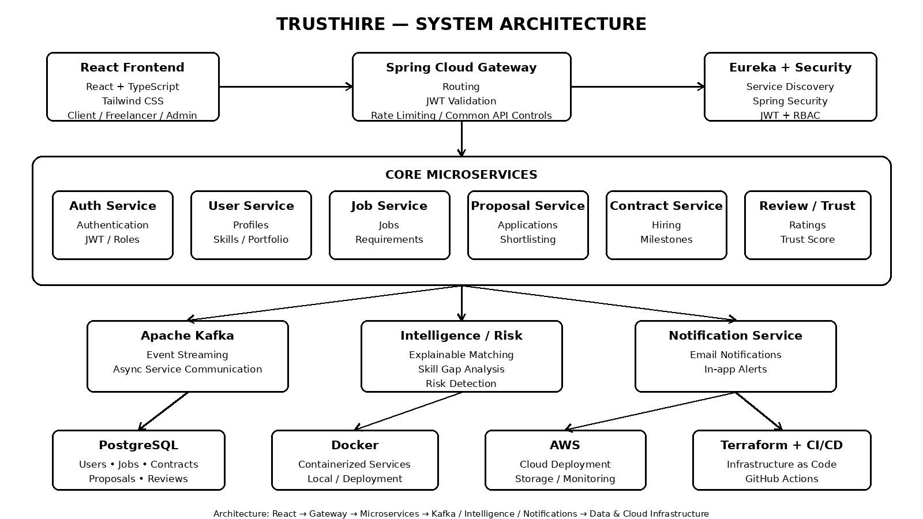
The proposed architecture separates the platform into independently deployable services while maintaining a common entry point through the API Gateway. Eureka enables service discovery, Kafka supports asynchronous event communication, PostgreSQL stores persistent marketplace data, and the Intelligence/Risk service provides explainable matching, skill-gap analysis, trust-aware recommendations, and suspicious-activity analysis. Docker, GitHub Actions, AWS, and Terraform support repeatable testing, deployment, and infrastructure management.

