Online Examination System

Software Engineering Project

Report – Phase I

By

Amarnath Mishra

Indian Institute of Information Technology Guwahati

**INTRODUCTION**

Online Examination System is a very useful application software for Educational Institutions to prepare and conduct an exam in a very safe and time saving manner, for Example it saves time taken in registration process, to check the paper and prepare mark sheet.

The document contains the list of requirements for the project. It will help in analysing the whole structure of the project. It also aims for people to understand the details of the application visually. This is the phase – I report documentation.

**Tools used for modelling different diagrams:**

* ArgoUML for use case diagram ,class diagram
* Visual paradigm for sequence, state, and activity diagrams and Data flow diagrams.

**PRODUCT DESCRIPTION**

**Features:**

Client Site:

-Home Page

-Sign in and Sign up

-user Details

-Exam search

-department

-date

-subjects

-Give Exam

-select department/subject

-select question number

-Choose correct option

-Go to next question

-Update any answer

-Conduct Exam (Examiner)

-select department

-Add Questions

-Add Options

-Select correct options

-Update Questions

-Exam instructions

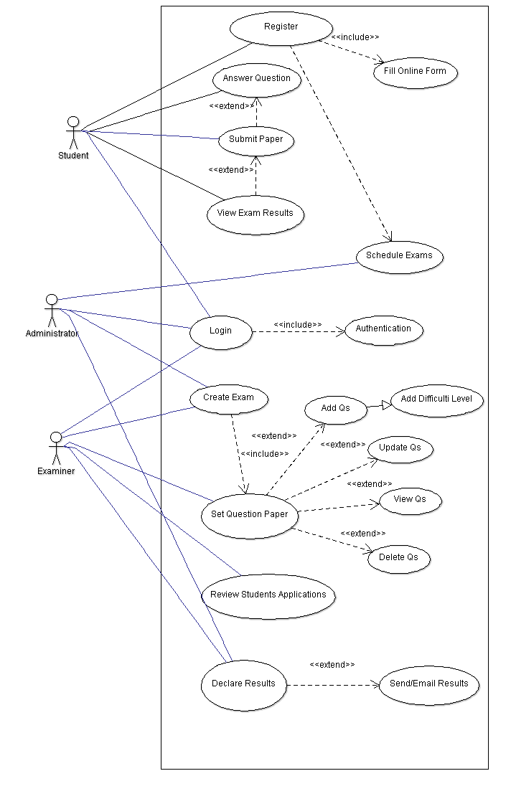

Fig. 1 Use case –Online Examination System

**Home Page**: Like all websites available online, the user can access the user home page of the Flight Booking System website, after he logs into the system. Here, if he is a student then he can search for exams and he can select a exam as per his choice and see the details.

**Login and Register**: Online Examination System also comes with the students’ registration details page, where the student can enter his details and register. He can also create a 'username' and 'password'. Moreover, he will also be able to modify his details later on.

**Search Exams**: The student can also search for the Exams available and can find the best Exam according to his choice and department.

**Give Exam**: The student can select a department and then see the different question with their question number and 4 possible options associated with that question, student can select any 1 option which he thinks that it might be correct.

**See Result:** After final done with the examination immediately students will be able to see their final score in that exam.

**Exam Instructions**: The website also provides instructions to the students on rules for the exams, and give help instructions in case is any student is not comfortable with online exams.

**Finish exam**: If user is done or want to finish exam in between the exam period, then he can click on finish button and quit and see the marks, but if he/she quit ones then he/she, further will not be able proceed in that particular exam.

**Examiners /admin Site:**

Fig. 2 Use case – Admin site

**Login:** Admin level login and Examiner’s login is different than student’s login. Admins are privileged to create exams and departments and check different student’s information and his/her results, while

**Add/modify questions:** Examiners can add questions related to their department and provide possible options for that questions along with a correct option in the question bank database.

**Add/modify Department info:** Admin should update the changes Exam information from time to time.

**Modify/Cancel Exam:** Admin can cancel or modify Exam for any important reason.

**Result:** Admin is able to see student’s marks along with their information

**SPECIFIC REQUIREMENTS:**

**External Interfaces:**

* **User Interface**
* **Hardware Interface**
* **Software Interface**

**User Interface:**

Flight Booking System consists of two types of users – Customer and Admin. Both uses graphical user interface. They can excess the application with different privileges given above in the feature and use cases.

**Hardware Interface:**

**Software Interface:**

The Product is designed in web based application through JSP, in windows. It will use MySQL for database. It will include HTML, java and JavaScript etc.

**FUNCTIONAL REQUIREMENTS:**

1. **User Registration**
   * **Description:** New student/examiner has to register with necessary details to book a give/conduct a exam.
   * **Actor:** User
   * **Input:** The user has to provide all the necessary details present in the registration form based on authorisation.
   * **Output:** All the details entered will be verified and accepted by the system into the database.
2. **User Login**
   * **Description:** student/examiner/admin logs in to the application
   * **Actor:** User-( student/examiner/admin)
   * **Input:** The user provides User Id and password for login
   * **Output:** User will be verified for authentication with the provided credentials. If those are matched, user is logged in. Otherwise, application returns login page with message of invalid credentials.
3. **Contact Us**
   * **Description:** student contacts the admin for any information or any complaint.
   * **Actor:** student
   * **Input:** User enters the complaint information with his credentials.
   * **Output:** The Application generate a complaint Id after user is verified and information is provided to Admin to resolve.