**Objet_Detection_Using_Detectron2**

Detectron 2 is framework or library and it provided you the functionality to do the object detection and also, we can load the different models.

Yolo is an algorithm as well as the framework to do the same object detection.

**Roboflow**

Roboflow provides the lots of opensource dataset with annotation and for our custom dataset it gives the interface for the annotation as well for performing the object detection, image segmentation task.

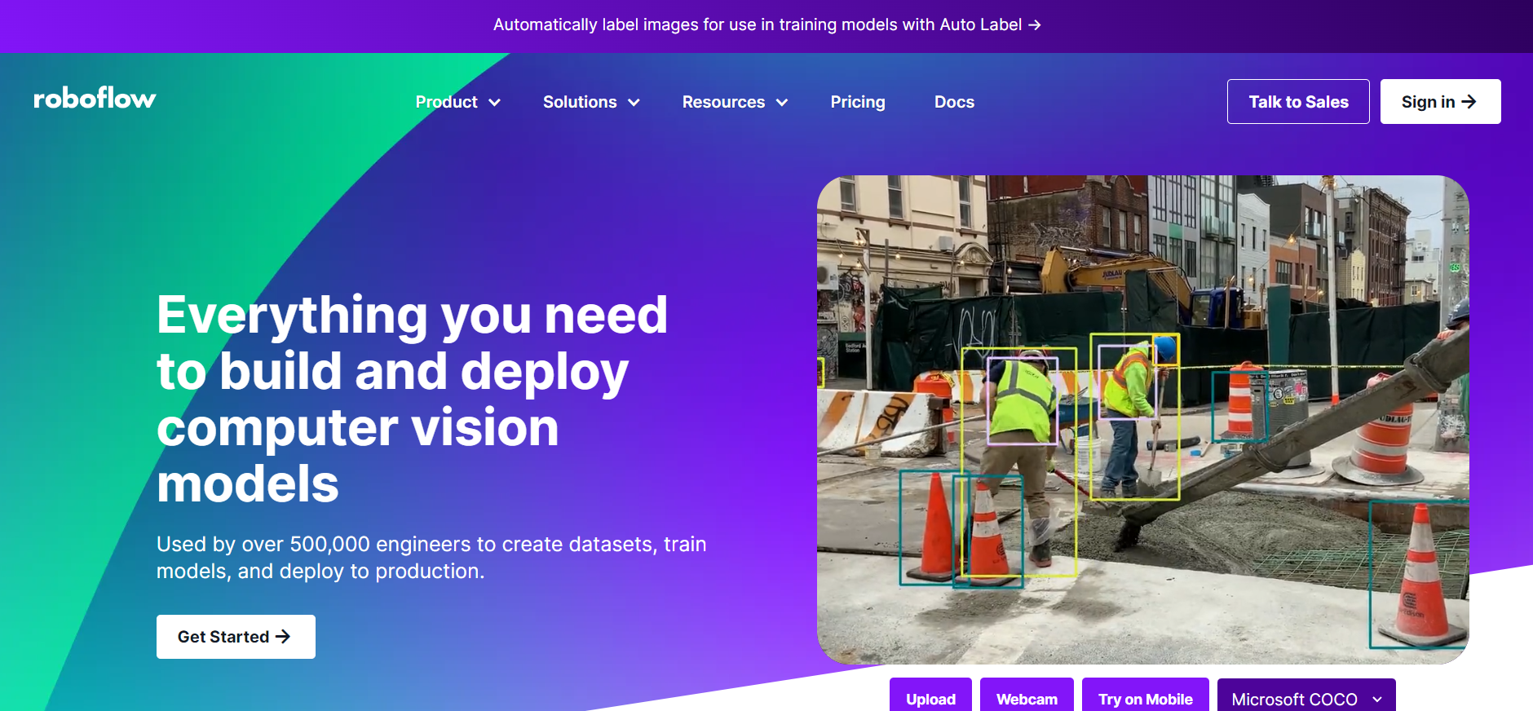



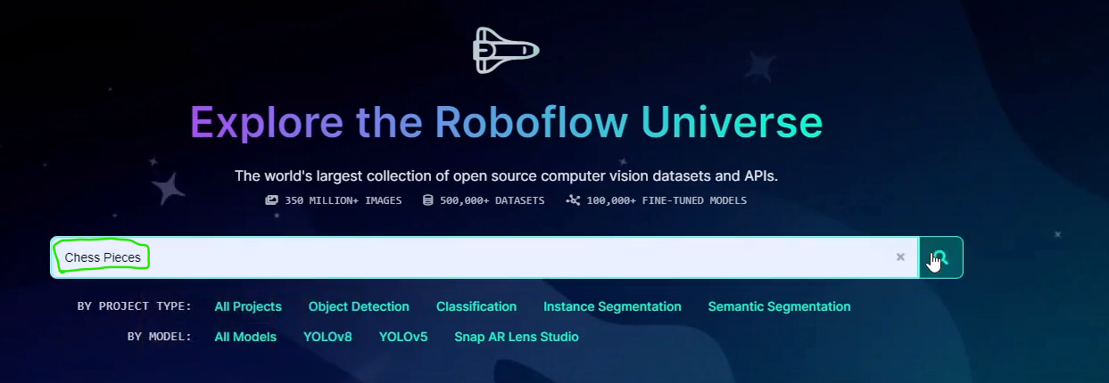

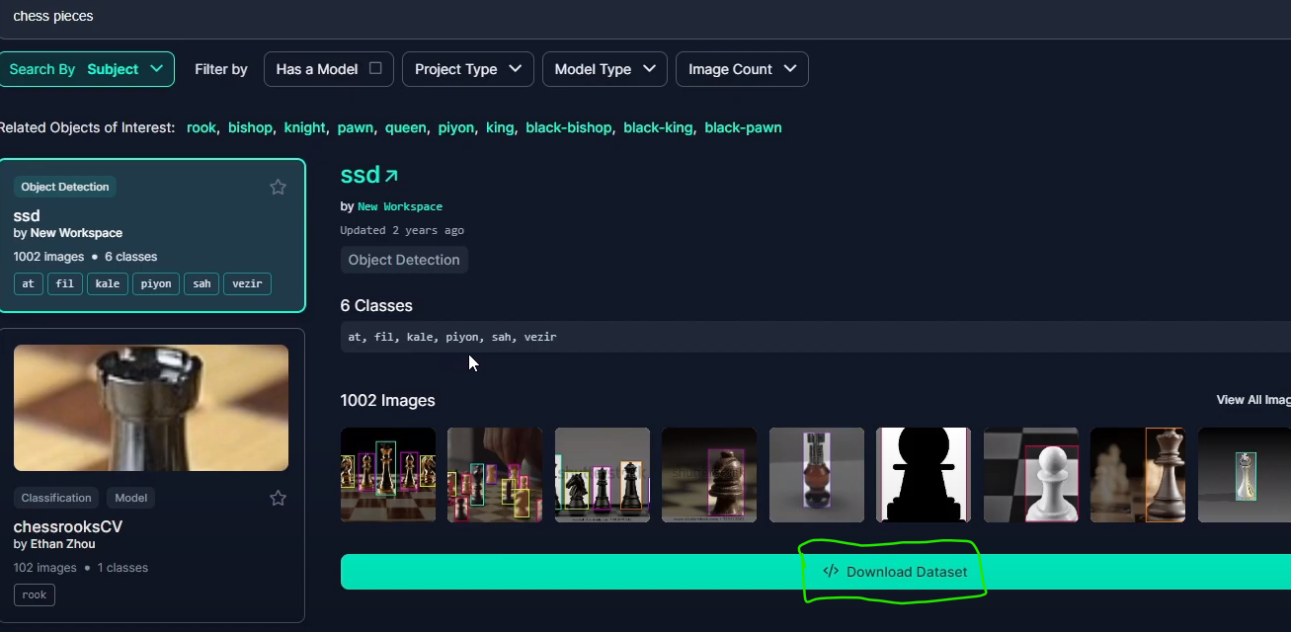

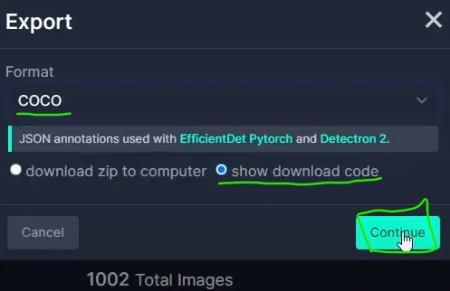

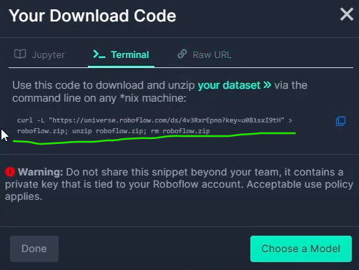



Datasets are loaded in our drive

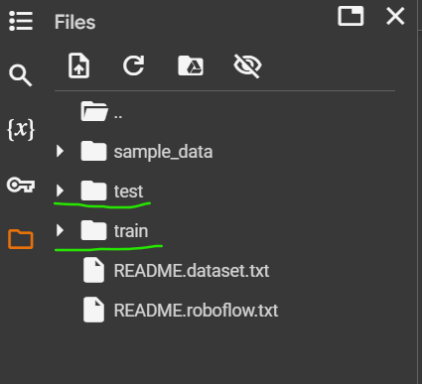

In our test and train folder we could see the file name called “annotations.coco.json” file and this file contains the details about the annotations for each and every images.

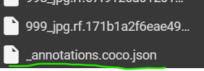

Once the training has done we could see the training folder and inside that we have a file name called model_final.pth file

