RAG_Application_Using_Langchain_MistralAI_and_Weviatedb

Weaviate

Login to your weaviate account and click ‘create cluster’

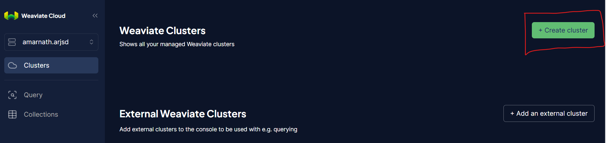

Click create

