Multilingual_AI_Voice_Assistant_With_Google_Geminipro_And_GTTS_Technology

Open the project in VSCode

Create a virtual environment

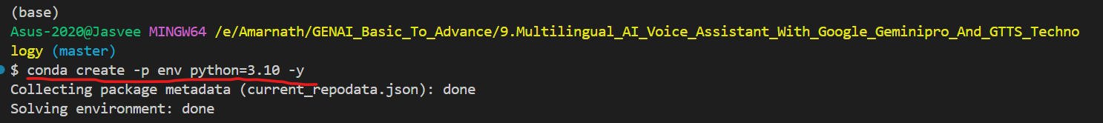

Activate the environment



Create a new file called ‘template.py’

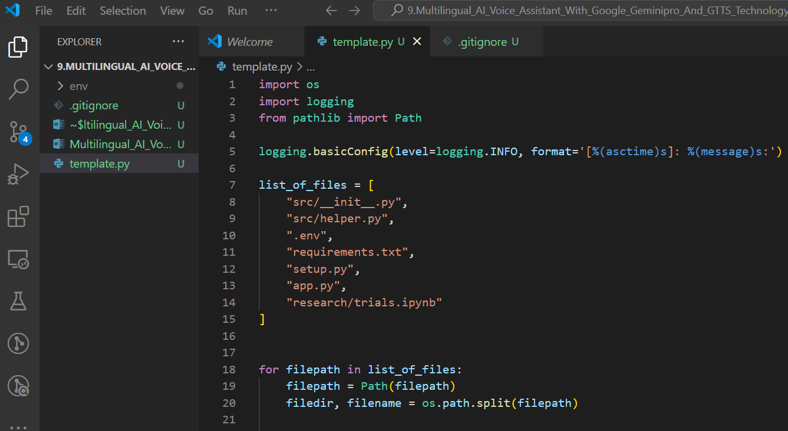

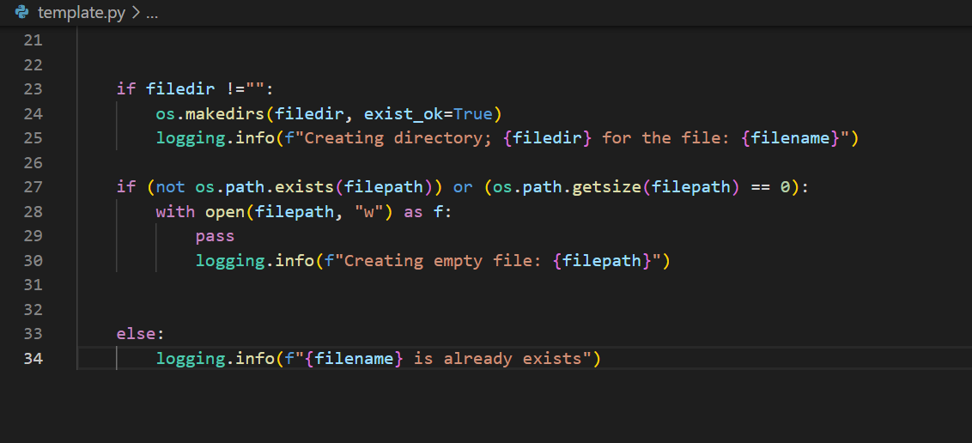

Run the template.py file to create the files and folders



Entire files will be created

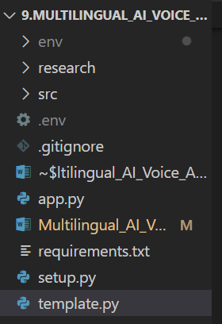

Requirements.txt – keep the necessary packages name that need to be installed for our application.

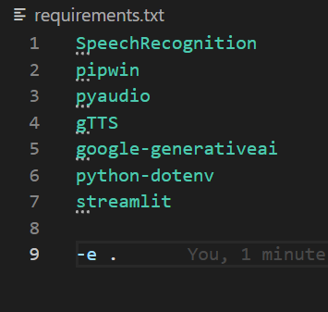

Setup.py – inorder to install the packages

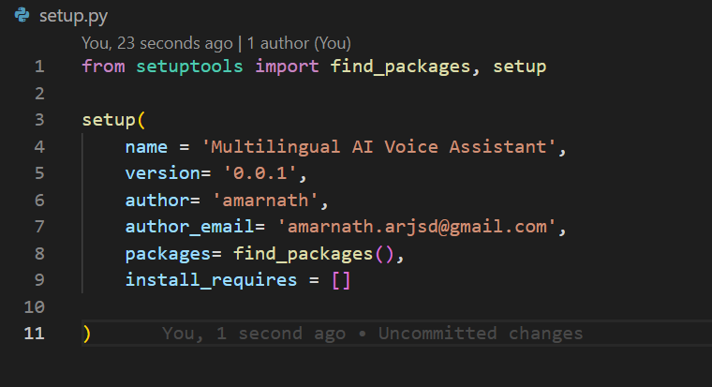

Install the packages using the command : pip install -r requirements.txt

