ML_Project

Step 1: create a new environment



Activate the environment

Command : conda activate venv/ (or) source activate /venv



Create a new file in the repository called .gitignore and choose the template as python

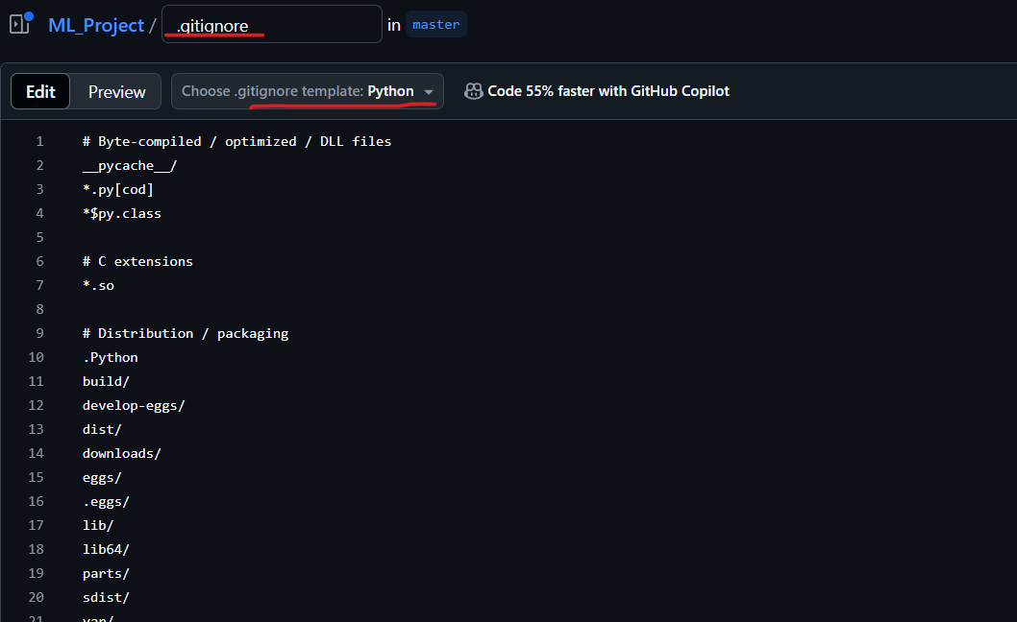

Commit the changes

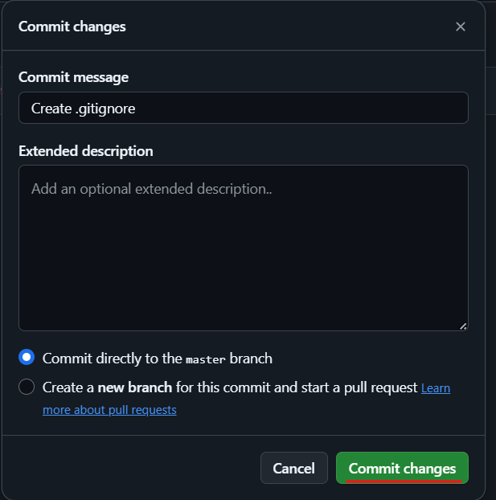

If you want to get the updated code from the repository then use the command

Git pull



Setup.py

Package in the pypy repository – just with single command we would be able to install that package.

In our project setup.py will be responsible to create my machine learning application as a package and that can be installed the whole package in our project and we can use it.

With the help of setup.py we will be able to build my entire machine learning application as a package and also we can deploy in pypy repo.