1. Java is Platform independent language.

Code written in Java with windows environment can be run on any machine – Mac, Linux

1. JRE – Java Runtime environment

Responsible for running Java Program

JDK – Java development Kit

If you want to debug your Java code, prefer to have JDK for its completeness

1. No methods should be written inside the main block and written inside the class block
2. By creating an object for the class, you can call the methods written inside the class
3. Objects are instances or references of the classes

First_Class fn = **new** First_Class();

New First_Class() assigns memory

Fn is the object name

First_Class is the datatype class

All the methods available in the class can be accessed using the object fn

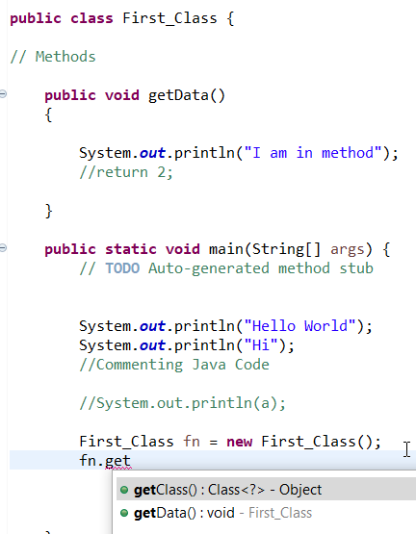

* String is one of the prebuilt class in Java

Two ways of defining strings

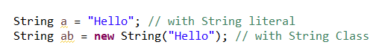

String Reverse:

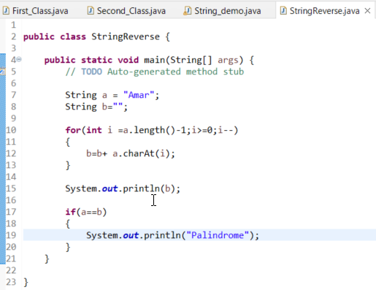

<https://www.javatpoint.com/java-oops-concepts>

Refer Eclipse for more programs

Interface:

Methods with no body

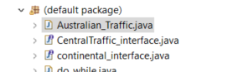

Abstraction:

“Abstraction is the process of selecting data to show only the relevant information to the user.”

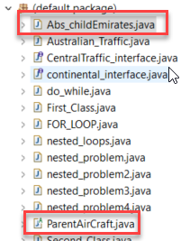

All access modifiers in abstract parent class should be **public**

Java doesn’t allow multiple inheritances, which is allowed in interfaces.

Ex: Class Z extends X, Y //False

**Polymorphism:**

**Function** **Overloading**

Either argument count should be different, or data type of argument should be different

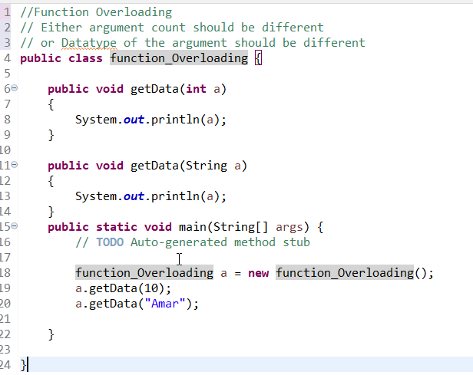

**Function** **Overriding**:

When same function with same number of arguments is present in parent and child classes, local (child) function would be executed even though parent’s method is inherited

**Arrays**:

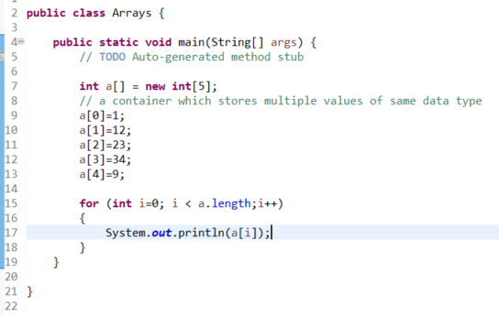

Simple Date Format Codes:

