|  |
| --- |
| International Production Center |
| Workday Enhancement Integration Performance Test Plan | |

Author: Arindam Das

Status: Validated

Version: 0.2

Date: 25/01/2019

Ref: Performance_Test_Entry_Questionnaire_GVPD V 2.0

1 Introduction 4

1.1 Context 4

1.2 Objectives 4

1.3 BU Information 4

1.3.1 Client Information 4

1.3.2 Contact Information 4

1.4 Contact Information – IPC Engineering Benchmark 4

2 Load Test Architecture 5

2.1 Production Platform 5

2.2 Test Platform 6

Platform – Material and Software 7

2.2.1 Servers description 7

2.2.2 Servers components 7

2.3 Database 8

2.4 Testing tools 8

3 Load Test Characteristics 9

3.1 Functional scenarios 9

3.2 The load test models 9

3.3 Metrology 10

3.4 Dataset 11

4 Deliverables, activities and planning 12

4.1 Requirements 12

4.2 Deliverables 12

4.3 Activities 12

4.4 Project Milestones (macro) 12

Preamble

|  |  |  |  |
| --- | --- | --- | --- |
| **Version** | **Date** | **Author** | **Recipients** |
| 0.2 | 25/01/2019 | Arindam Das | Abhishek Ranjan  Sridhar Polisetty  Amit Kulkarni  Jyothi Pujari  Ravi Kumar Rongali  Ramu Kommanapalli  Sai Chanda  SatyasuryaSivakumar Suthapalli  Pooja Mehta  James Conway  Vinay Gudivada |

Track changes

|  |  |
| --- | --- |
| Version number | Change description |
| 0.1 | Document creation |
| 0.2 | Updated sections – 1.3.1, 2.1 and 3.4 |

Associated documents

|  |  |  |  |
| --- | --- | --- | --- |
| **Name** | **Author** | **Version** | **Date** |
| Performance_Test_Entry_Questionnaire_GVPD | Ravi Kumar Rongali, Ramu Kommanapalli | 2.0 | 10/01/2019 |
| API List Dataset – CN and SG | Ravi Kumar Rongali | 2.0 | 16/01/2019 |
| Employee Dataset – CN and SG | Ravi Kumar Rongali | 2.0 | 16/01/2019 |

# Introduction

## Context

This is an enhancement of Workday Standard Integration. This application captures local payroll data of the Clients via Workday system using REST API Services.

The API Version to be tested is 2.0.

## Objectives

The key objectives are: -

* Determine Application API’s stability and capacity in terms of concurrent users supported.
* Provide overall user experience under load and identify bottlenecks if any.

## BU Information

### Client Information

|  |  |  |  |
| --- | --- | --- | --- |
| **BU name** | **BU Department** | **Business Executive** | **Sponsor** |
| GVE | GVPD | Abhishek Ranjan | Abhishek Ranjan |

### Contact Information

|  |  |  |
| --- | --- | --- |
| Name | Email 🖅 Telephone 🖁 | Role |
| Sridhar Polisetty | **Sridhar.Polisetty@ADP.com** | Application Development Manager |
| Amit Kulkarni | **Amit.kulkarni@adp.com** | Quality Assurance Manager |
| Jyothi Pujari | **Jyothi.Pujari@adp.com** | Product Specialist |
| Sai Chada | **Sai.Chada@adp.com** | Solution Architect |

## Contact Information – IPC Engineering Benchmark

|  |  |  |
| --- | --- | --- |
| Name | Email 🖅 Telephone 🖁 | Role |
| Arindam Das | [Arindam.Das1@adp.com](mailto:Arindam.Das1@adp.com) | GETS – Project Leader |
| Pooja Dilip-Mehta | [Pooja.Mehta@adp.com](mailto:Pooja.Mehta@adp.com) | GETS – Project Manager |
| James Conway | James.Conway@adp.com | GETS – Performance Testing Manager |

# Load Test Architecture

## Production Platform

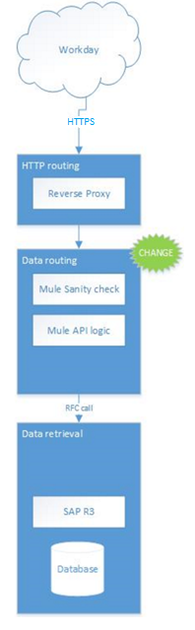

## Test Platform

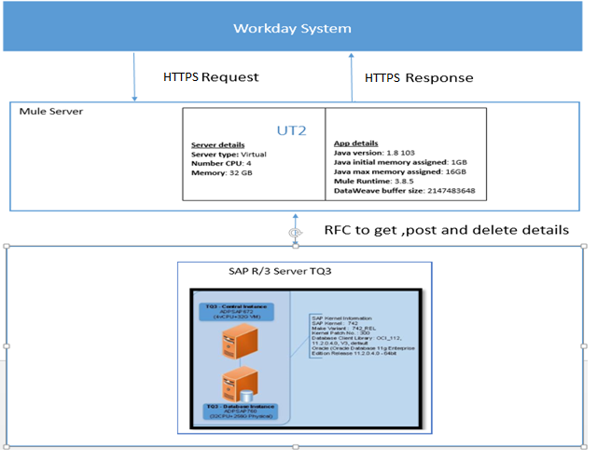

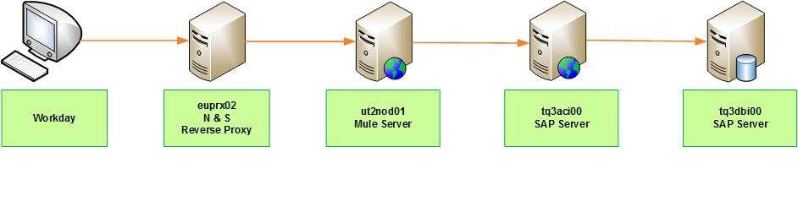

Tests will be performed in (UT2 – TQ3) environment.

Workday Enhancement API Endpoint URL: [**https://portal106.globalview.adp.com/mnccc/workday**](https://portal106.globalview.adp.com/mnccc/workday)**...**

## Platform – Material and Software

### Servers description

|  |  |  |  |  |
| --- | --- | --- | --- | --- |
| Name | Model | OS | CPU | RAM |
| Reverse proxy - euprx02.gv.esi.adp.com:8080 (adpsap662) | VM | Linux SUSE11 64 bits | 4 vCPU | 32 GB |
| Mule server - ut2nod01.gv.esi.adp.com (adpsap852) | VM | RedHat Server 7.5 | 4 vCPU | 32 GB |
| SAP Server - tq3aci00.gv.esi.adp.com (adpsap915) | VM | Linux SUSE12 64 bits | 4 vCPU | 32 GB |
| Oracle DB - tq3dbi00.gv.esi.adp.com – (adpsap993) | Physical | Linux Suse 12 64 bits | 80 vCPU | 256 GB |

All VM servers are connected via 1 Gbps and Physical servers via 20 Gbps.

### Servers components

|  |  |  |  |
| --- | --- | --- | --- |
| Service | Logical Hostname | Physical Hostname | Middleware / Software |
| Reverse Proxy | euprx02.gv.esi.adp.com | adpsap662 | Apache/httpd <Version> |
| Application Layer | ut2nod01.gv.esi.adp.com | adpsap852 | Mule-enterprise-standalone-3.8.5 |
| Business Layer | tq3aci00.gv.esi.adp.com | adpsap915 | SAP Kernel <Version> |
| Oracle Database | tq3dbi00.gv.esi.adp.com | adpsap993 | Oracle <Version> |

## Database

The relational database product Oracle (<version>) will be used. The database server in staging is ADPSAP993.

Oracle instance details:

* Instance Name – TQ3
* Port – 1546
* Logical host – tq3dbi00
* Physical host – adpsap993

## Testing tools

HP Loadrunner 12.60 will be used to:

* Create automated scripts for APIs

HP ALM 12.60 will be used to:

* Simulate user activity;
* Measure system response times;
* Collect and store system and software metrics during user simulation in order to measure and analyze the platform’s behavior under stress.

HP Sitescope 11.51 will be used to:

* Collect system and software metrics during user simulation

The test tools are provided and under the responsibility of the benchmark and load test team.

# Load Test Characteristics

## Functional scenarios

14 API’s (7-CN, 7-SG) were identified for the benchmark; these will be tested for 2 clients China and Singapore.

|  |  |  |
| --- | --- | --- |
| # of Scenarios | Workday Enhancement Integration | User type |
| SC1 | Landing Page Service | Employee |
| SC2 | Subtype Service | Employee |
| SC3 | Record Overview Service | Employee |
| SC4 | Metadata Service | Employee |
| SC5 | Master data Service | Admin |
| SC5.1 | Create Record | Admin |
| SC5.2 | Edit Record | Admin |
| SC5.3 | Delete Record | Admin |
| SC6 | Dropdown Value Service | Employee |
| SC7 | Value Callback Service | Employee |

## The load test models

Below round of tests would be run for both SG and CN APIs.

|  |  |  |  |  |  |  |
| --- | --- | --- | --- | --- | --- | --- |
| # | Objective | Concurrent VUsers | Scenario used | Ramp up rate | Steady state | Ramp down rate |
| LT 1 | Capacity objective | 200 | 100% SC1 | 1 user started per second | 200 users for 1 hour | 1 user stopped per seconds |
| LT 2 | Capacity objective | 200 | 100% SC2 | 1 user started per second | 200 users for 1 hour | 1 user stopped per seconds |
| LT 3 | Capacity objective | 200 | 100% SC3 | 1 user started per second | 200 users for 1 hour | 1 user stopped per seconds |
| LT 4 | Capacity objective | 200 | 100% SC4 | 1 user started per second | 200 users for 1 hour | 1 user stopped per seconds |
| LT 5 | Capacity objective | 200 | 100% SC5 | 1 user started per second | 200 users for 1 hour | 1 user stopped per seconds |
| LT 6 | Capacity objective | 200 | 100% SC6 | 1 user started per second | 200 users for 1 hour | 1 user stopped per seconds |
| LT 7 | Capacity objective | 200 | 100% SC7 | 1 user started per second | 200 users for 1 hour | 1 user stopped per seconds |
| LT 8 | Capacity objective | 200 | SC1 – SC7 combined  (Equal Distribution) | 1 user started per second | 200 users for 1 hour | 1 user stopped per seconds |

## Metrology

Transactions:

* Number of virtual users
* Transaction throughput
* Transaction response time

Linux Server:

* CPU Utilization
* Interrupt Rate
* Average Load
* Context Switch Rate
* Paging rate
* Page-in rate
* Page-out rate
* Disk Utilization

Reverse Proxy:

* #Busy Workers
* #Idle Worker
* Hits/sec
* Kbytes/sec

JMX:

* Active Sessions
* Expired Sessions
* Rejected Sessions
* Access Count
* Cache size
* Hits count
* Total Garbage Collection Time
* Total Garbage Collection Count
* GC Thread Count
* GC Duration
* Loaded Class Count
* Unloaded Class Count
* Heap Memory Usage
* Peak Thread Count
* HTTP Request Count

Oracle:

* V$SYSSTAT/logons current
* V$SYSSTAT/opened cursors current
* V$SYSSTAT/user commits
* V$SYSSTAT/user rollbacks
* V$SYSSTAT/user calls
* V$SYSSTAT/session logical reads
* V$SYSSTAT/CPU used by this session
* V$SYSSTAT/DB time
* V$SYSSTAT/concurrency wait time
* V$SYSSTAT/application wait time
* V$SYSSTAT/user I/O wait time
* V$SYSSTAT/session connect time
* V$SYSSTAT/messages sent
* V$SYSSTAT/messages received
* V$SYSSTAT/enqueue timeouts
* V$SYSSTAT/enqueue waits
* V$SYSSTAT/enqueue deadlocks
* V$SYSSTAT/enqueue requests
* V$SYSSTAT/physical reads
* V$SYSSTAT/physical writes
* V$SYSSTAT/redo size

## Dataset

API List (for CN and SG) and Employee Dataset have been provided by Workday Team.

# Deliverables, activities and planning

## Requirements

* A complete test platform with the application under test fully installed and configured.
* The availability of each technical support in case we need help during the benchmark.
* A data set with enough records to enable the simulation of the expected load.
* The list of users credentials to simulate the expected number of users.
* The validation of this document.

## Deliverables

* Performance Test Plan at the beginning of the test.
* Tests execution results (response times, metrics…) after each load test.
* Final Test Report (graphs, data and analyses)

## Activities

Below listed activities are under the responsibility of the Benchmark Team.

|  |  |
| --- | --- |
| **Activity** | **Duration (days)** |
| Preparation | 2 |
| Setup | 3 |
| Executions | 7 |
| Reporting | 2 |
| **Total** | **14** |

## Project Milestones (macro)

|  |  |  |
| --- | --- | --- |
| Phase | Milestone | Target date |
| Preparation | Test plan document completed and validated by BU | 23/01/2019 |
| Setup | Prerequisites setup (Network Flows and Monitoring Setup) | 28/01/2019 |
| Scripting (functional scenarios) and data validation | 28/01/2019 |
| Execution | Load test executions start – SG | 29/01/2019 |
| Benchmark scenario results – SG | 31/01/2019 |
| Load test executions start – CN | 01/02/2019 |
| Benchmark scenario results – CN | 06/02/2019 |
| Reporting | **Delivery of Benchmark report** | 08/02/2019 |

It’s important to note that these dates depend on:

* The application availability and scenario content.
* The results of each load test execution. It means that if the application generates errors the bench can be stopped waiting corrections.
* The availability of all participants on the project.