REGRESSION

PEARSON CORRELATION

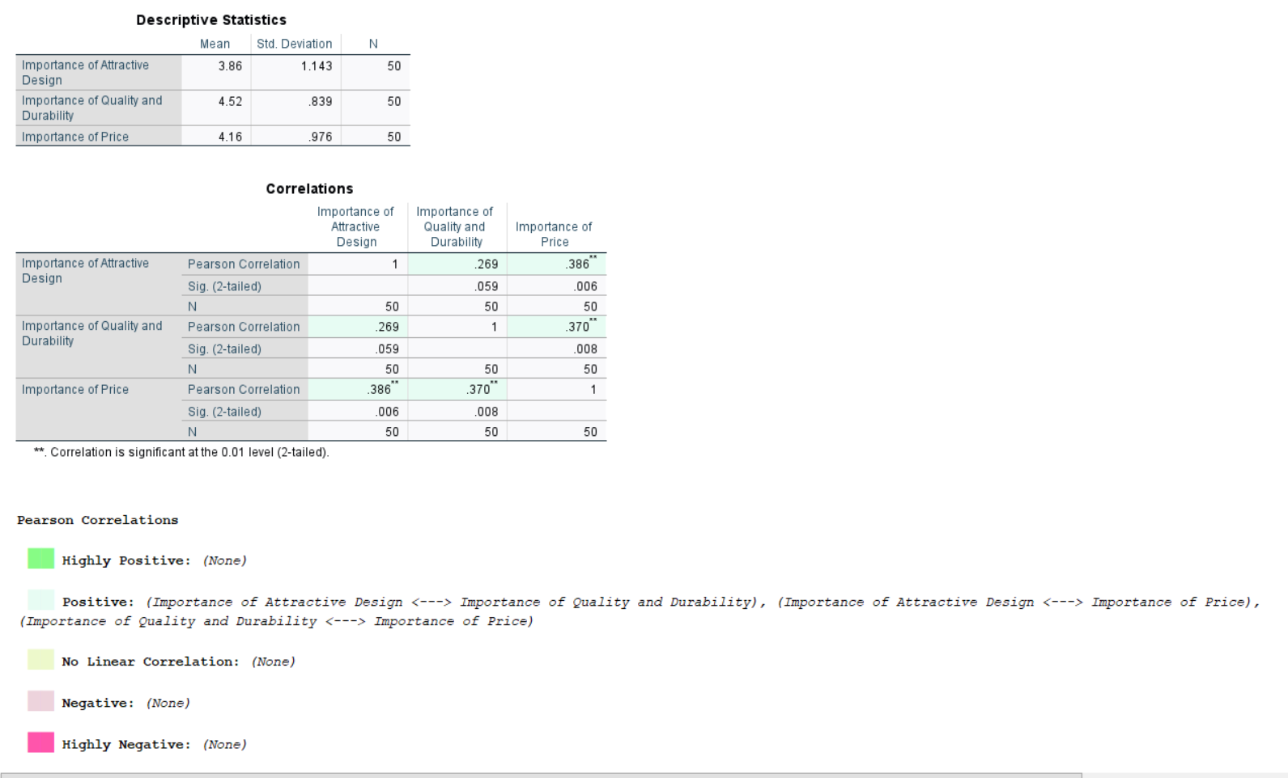

FREQUENCIES

