DDLC(Documentation Development Life Cycle)
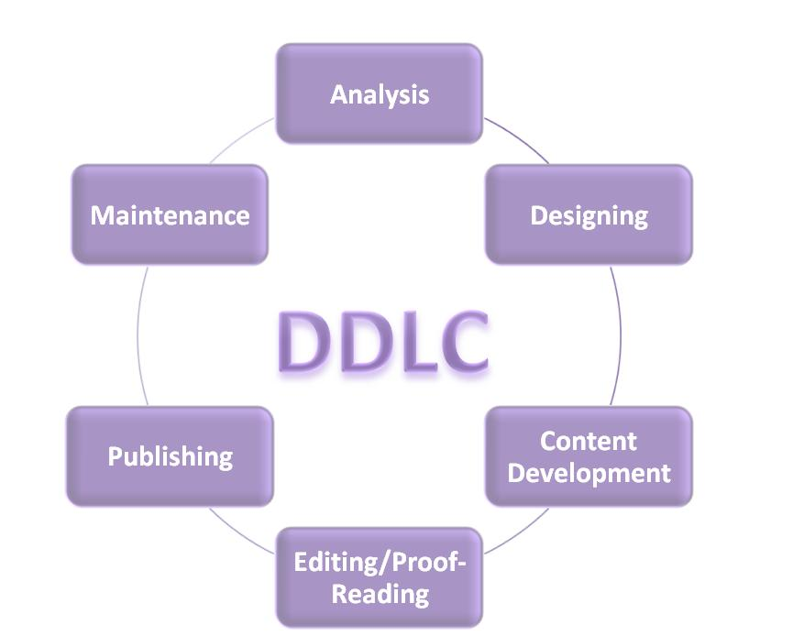

Document Development Life Cycle (DDLC) is considered as the complete life cycle of a documentation task. Software documentation requires a well-defined methodology for the successful completion. DDLC should encompass and go along with Software Development Life Cycle (SDLC) because both are parallel as well as intertwined.

Requirement analysis:
Requirement Analysis is an important phase of the Document Development Life Cycle. In this phase the technical writer gathers the useful material for the project and understands and analyzes all the information of the project.

Designing:
At this stage some estimates are decided like approximate pages, format of the document, several representation styles, etc. Subject knowledge, good writing skills, sufficient information about the project will help the technical writer to make a quality document.

Developing the content:
At this stage content is developed as per the design prospective and in accordance with planning of the documents at previous stages. A smart technical writer will use graphical illustrations for a better understanding by the end reader.

Editing/proof-reading:
At this stage, the document is thoroughly read by the writer, and also verified by a third party. It checks for all sorts of grammatical errors. This verification ensures that the document is ready for publishing.

Publishing:
Document is published by parent authority of the document. Generally technical documents are published either in digital format on internet or in hard-copies and distributed along with module (e.g. Software, Gadget etc.). Several Publication options can be used as per the distribution requirement of document.

Maintenance:
At this stage collection of further updates, modification is done. Also time to time updated backup is taken.

