VoxFlow - Software Engineering Specification Report
AI-Assisted Speech Fluency Monitoring System
Host Server, Database, Analytics Dashboard & APIs
Author: Software Engineering Lead (Member 3)
Project: Final Year B.Tech Engineering Project - VoxFlow
Scope: Host-side Software Architecture, Communication Protocol, Data Persistence & Dashboard UI
Document Version: 1.0.0 (Production Release)
[PROJECT SCOPE & SYSTEM PURPOSE]
VoxFlow is a low-cost speech fluency monitoring system built to help people who stutter track their speech progress between clinical therapy sessions. VoxFlow is not a medical diagnostic device and does not replace a licensed speech-language pathologist. This report covers the software running on the host laptop. It receives 16kHz audio streams from an ESP32 over Wi-Fi, filters out background noise, verifies the speaker, extracts 39-dimensional MFCC features, runs a CNN-LSTM inference pass, stores session metrics in a local SQLite database, and presents real-time disfluency graphs on a web dashboard.

1. Python Language Choice & Ecosystem Analysis
1.1 Why We Chose Python for VoxFlow
Starting out on the host side, we picked Python 3.10. C++ turned out to be painful for quick model changes. Java felt clunky for signal processing. Node.js lacked good audio DSP libraries, and Go didn't have native PyTorch support. Python let us pass NumPy float32 arrays straight from Librosa into PyTorch without converting memory formats in between. That saved us a lot of latency during real-time speech processing.
Language | Audio Signal Processing | Deep Learning Support | Web API Performance | Prototyping Speed | Engineering Decision
Python | Native (Librosa, SciPy, PyAudio) | Native (PyTorch, TensorFlow C++ backends) | High (Flask WSGI, FastAPI) | Fast | SELECTED
C++ | Manual C API (PortAudio, FFTW) | Complex LibTorch bindings | Moderate (Crow, Pistache) | Slow | Rejected
Java | Basic (JavaSound API) | Limited (Deeplearning4j) | High (Spring Boot) | Moderate | Rejected
Node.js | Minimal C++ wrappers | Limited (TensorFlow.js) | Very High (Express.js) | Fast | Rejected
Go | Minimal C bindings | Low (ONNX C wrappers) | High (Gin, Fiber) | Fast | Rejected

Why Python worked best for our host setup:
• Memory sharing: Librosa writes STFT frames right into C-contiguous float32 NumPy buffers, so PyTorch reads them with zero memory copying.
• Single runtime: Flask handles incoming REST POST requests, SQLite writes session rows, and Streamlit serves the frontend, all running under one Python 3.10 process.
• Clear modules: Keeping things object-oriented made it easy to connect Member 1's hardware signals and Member 2's AI model into our software flow.
1.2 Detailed Breakdown of Python Libraries
VoxFlow relies on 14 Python packages on the host. Here is how each module fits into our execution flow:
Library | Role in VoxFlow | APIs & Functions Used | Engineering Rationale
Flask | REST API Web Server | Flask(app), request.files, jsonify() | Synchronous WSGI server that accepts multipart/form-data WAV uploads from the ESP32 with low memory overhead.
Streamlit | Analytics Dashboard UI | st.metric(), st.plotly_chart(), @st.cache_data | Renders interactive web interfaces directly in Python, removing the need for a separate Node.js/React frontend.
sqlite3 | Local Relational Database | sqlite3.connect(), cursor.execute() | Built-in relational SQL engine that saves speech sessions locally in a single file without running a background server process.
Librosa | Audio Signal Processing | librosa.load(), librosa.feature.mfcc() | Calculates Short-Time Fourier Transforms, Mel-frequency spectrograms, and 13 MFCC feature coefficients from raw audio.
NumPy | Vector & Matrix Math | np.ndarray, np.mean(), np.std() | Handles array operations, feature scaling, and distance metrics in C-optimized memory blocks.
Pandas | Tabular Data Processing | pd.DataFrame, pd.to_datetime(), df.groupby() | Groups daily and weekly session records to compute rolling averages and export clinical CSV reports.
Matplotlib | Technical Figures | plt.subplots(), Figure, Axes | Generates high-resolution PNG architecture diagrams, flowcharts, and ER diagrams for project documentation.
Plotly | Interactive Web Charts | go.Figure(), px.bar(), px.pie() | Renders interactive hoverable line graphs, disfluency pie charts, and fluency gauges on the Streamlit dashboard.
Scikit-learn | Feature Normalization | StandardScaler(), cosine_similarity() | Scales MFCC feature vectors before model inference and computes cosine similarity for speaker verification.
PyTorch / TensorFlow | Neural Network Inference | torch.jit.load() / tf.keras.models.load_model() | Executes the trained CNN-LSTM model to classify speech frames as Fluent, Block, Repetition, or Prolongation.
Requests | HTTP Client Tests | requests.post(), requests.get() | Sends simulated audio uploads from test scripts to the Flask server to verify API endpoints.
OS | File Path Operations | os.path.join(), os.makedirs() | Creates local buffer folders and manages temporary WAV file paths during audio uploads.
Datetime | Timestamp Formatting | datetime.now(), timedelta, isoformat() | Generates ISO-8601 timestamp strings for database indexing and session filtering.
JSON | Data Serialization | json.dumps(), json.loads() | Encodes prediction results and display messages into JSON payloads sent back to the ESP32.

2. Flask Backend & Hardware Communication
2.1 Why Flask Was Selected Over Alternatives
We picked Flask over Django and FastAPI for our REST server. Django carries heavy ORM setups and templating engines we didn't need. FastAPI uses async event loops (`asyncio`), but our audio pipeline runs synchronous file writes and CPU matrix calculations anyway. Flask kept things simple and let us process POST uploads directly without async overhead.
2.2 ESP32 Audio Upload Protocol & HTTP Flow
The ESP32 streams recorded speech to Flask over local Wi-Fi. Once the INMP441 microphone finishes capturing audio, the board packages 16-bit 16kHz PCM samples into a WAV wrapper and sends an HTTP POST request to `http://<laptop_ip>:5000/api/v1/audio/upload` using `multipart/form-data`.
POST /api/v1/audio/upload HTTP/1.1
Host: 192.168.1.100:5000
User-Agent: ESP32-VoxFlow-Hardware/1.0
Content-Type: multipart/form-data; boundary=----VoxFlowBoundary7MA4YWxk
Content-Length: 64104
------VoxFlowBoundary7MA4YWxk
Content-Disposition: form-data; name="audio"; filename="speech_sample.wav"
Content-Type: audio/wav
[RAW WAV AUDIO BYTES: 16kHz, 16-bit Mono PCM, 3 Seconds]
------VoxFlowBoundary7MA4YWxk--

2.3 Endpoint Implementation & Response Handler
Our Flask server (`server.py`) runs on port 5000. When an audio file arrives, it stages the file in `./audio_buffer/`, calls our pipeline functions, writes the prediction to SQLite, and sends back JSON output containing the fluency score and OLED message text.
from flask import Flask, request, jsonify
import os, time, uuid
from datetime import datetime
from database import DatabaseManager
from pipeline import pipeline_runner
app = Flask(__name__)
db = DatabaseManager()
UPLOAD_DIR = './audio_buffer'
os.makedirs(UPLOAD_DIR, exist_ok=True)
@app.route('/api/v1/audio/upload', methods=['POST'])
def handle_audio_upload():
if 'audio' not in request.files:
return jsonify({'status': 'error', 'message': 'Missing audio payload'}), 400
file = request.files['audio']
if file.filename == '':
return jsonify({'status': 'error', 'message': 'Empty file name'}), 400
filename = f"audio_{int(time.time())}_{uuid.uuid4().hex[:6]}.wav"
filepath = os.path.join(UPLOAD_DIR, filename)
file.save(filepath)
# Run processing pipeline (Denoise -> Verify -> Extract -> Predict)
user_id = int(request.form.get('user_id', 1))
result = pipeline_runner.process(filepath, user_id=user_id)
# Write result to SQLite database
pred_id = db.save_prediction(
user_id=user_id,
fluency_score=result['fluency_score'],
stutter_type=result['stutter_type'],
confidence=result['confidence'],
audio_path=filepath
)
response_data = {
'status': 'success',
'prediction_id': pred_id,
'timestamp': datetime.now().isoformat(),
'fluency_score': result['fluency_score'],
'stutter_type': result['stutter_type'],
'display_message': f"Fluency: {result['fluency_score']:.1f}% ({result['stutter_type']})"
}
return jsonify(response_data), 200
if __name__ == '__main__':
app.run(host='0.0.0.0', port=5000, debug=False)

[HARDWARE FEEDBACK RESPONSE]
When the ESP32 gets back HTTP 200, it reads display_message and updates the OLED screen. If stutter_type is not Fluent, it triggers the red/amber LED. Otherwise, the green LED lights up.

3. Database Design & Storage Pipeline
3.1 SQLite Schema & 3NF Normalization
Instead of setting up a heavy MySQL instance, we went with SQLite3 (`voxflow_local.db`). It stores everything in one file on the laptop. We normalized our schema into Third Normal Form (3NF) across USERS, SESSIONS, PREDICTIONS, and REPORTS.
3.2 Entity-Relationship (ER) Diagram
Here is how our database tables, primary keys, foreign keys, and cardinalities connect:
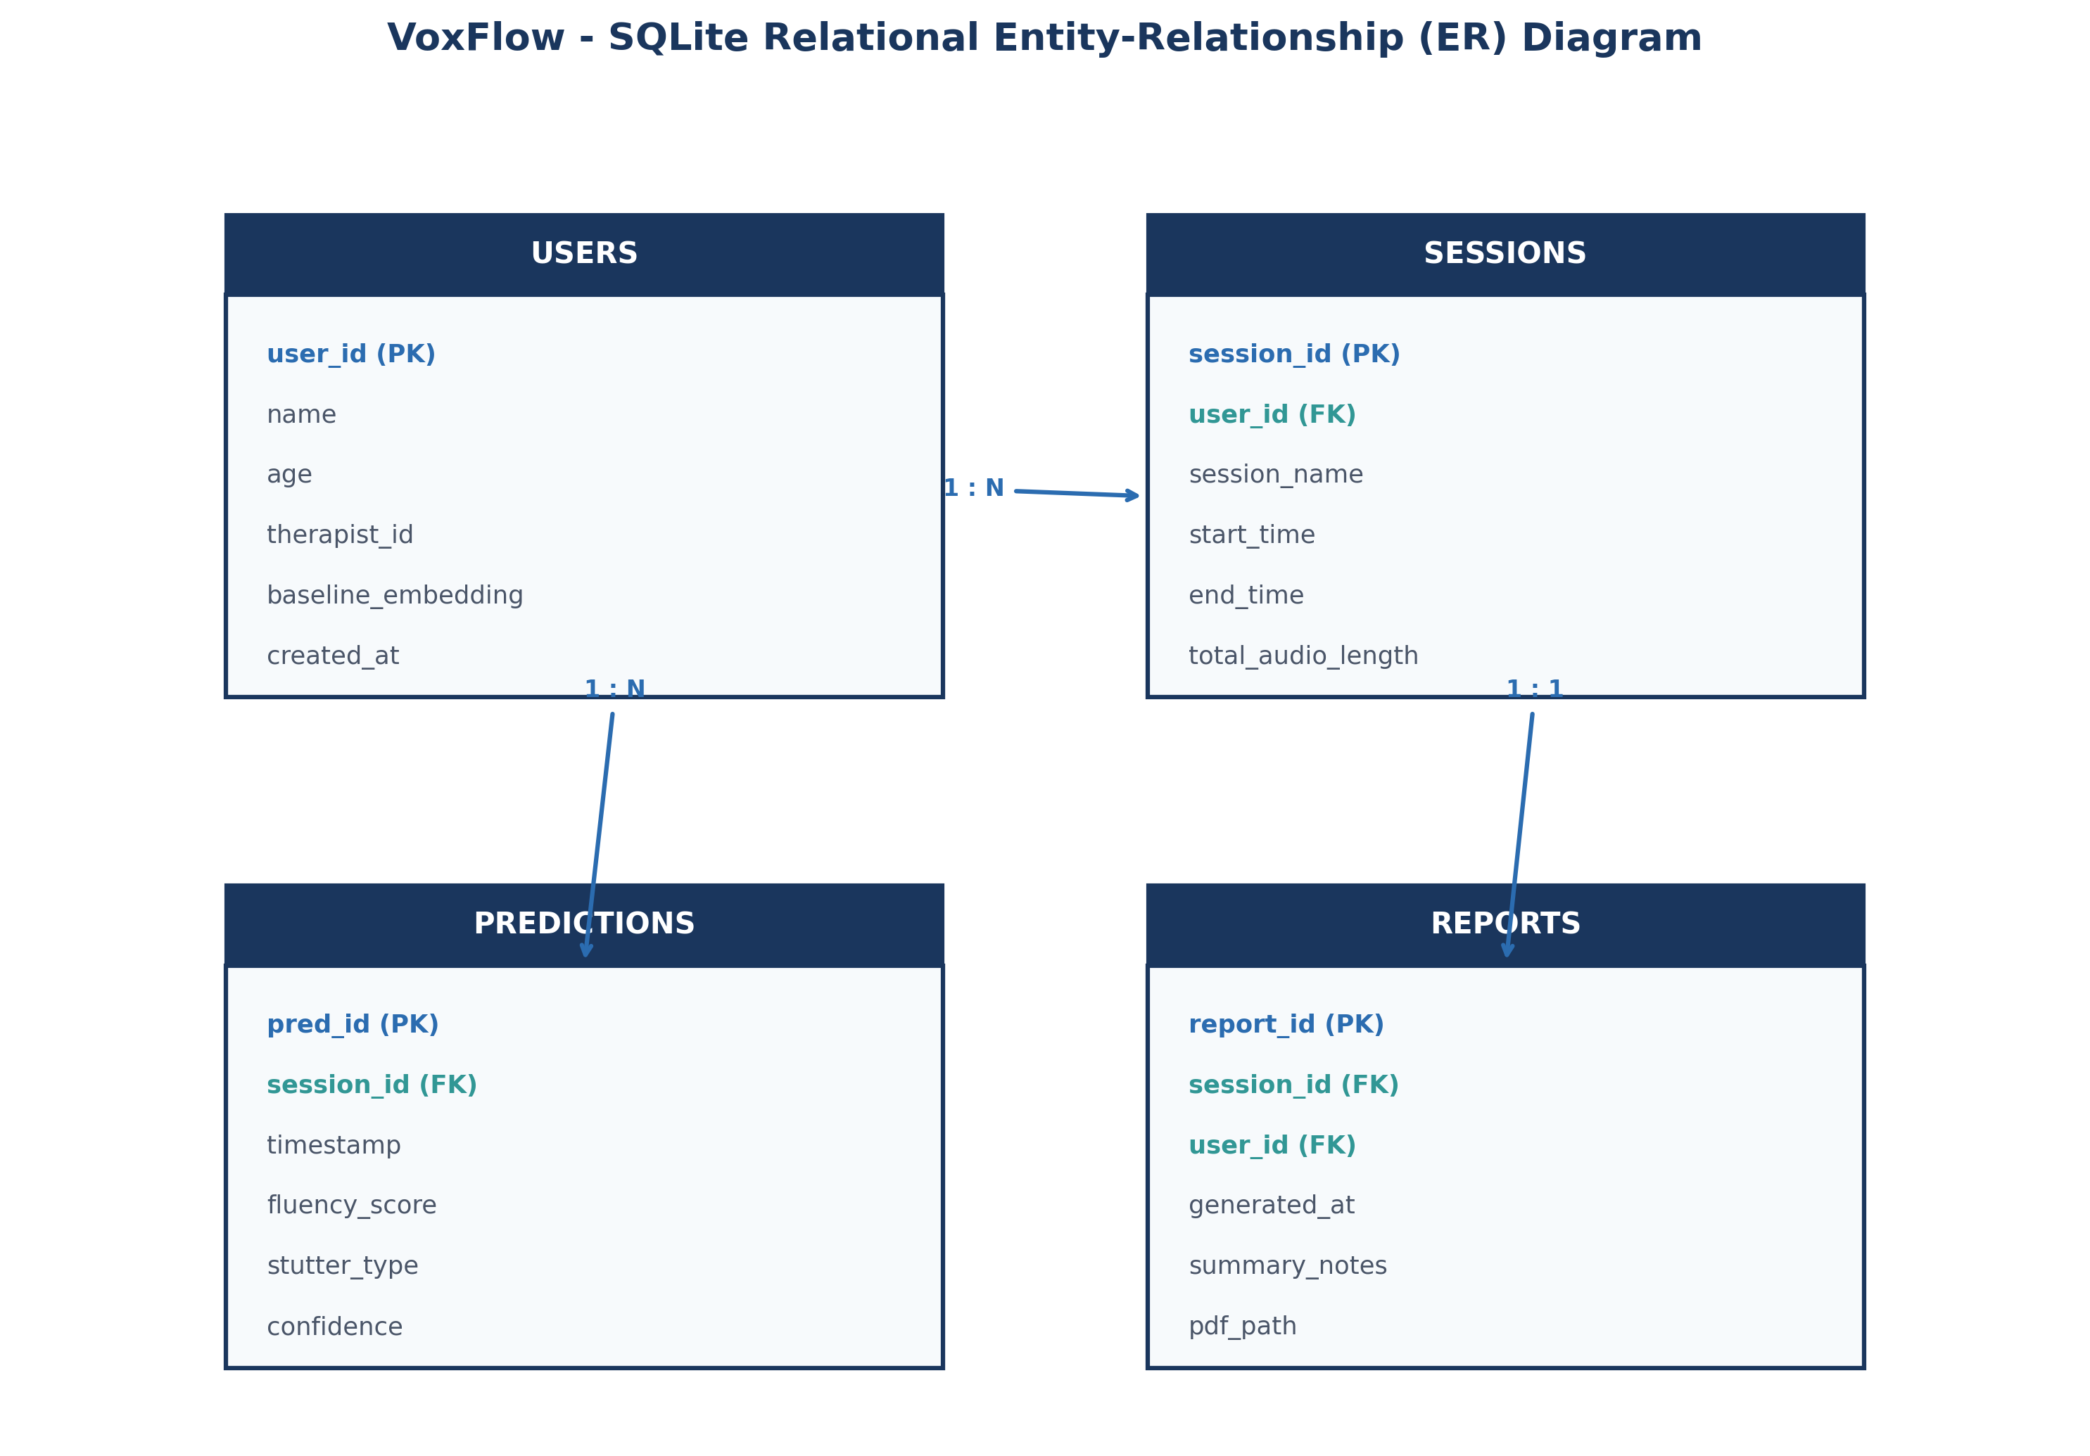
Figure: Relational Entity-Relationship (ER) Schema for VoxFlow
3.3 Database Operations & CRUD Implementation
We wrapped all SQL calls inside a `DatabaseManager` class in `database.py`. Opening connections per request and closing them right after commits avoided thread lockup problems.
Operation | SQL Query Pattern | Pipeline Trigger | Result
CREATE | INSERT INTO predictions (session_id, timestamp, fluency_score, stutter_type, confidence) VALUES (?, ?, ?, ?, ?) | After AI prediction finishes. | Inserts a new prediction record with auto-incremented `pred_id`.
READ | SELECT * FROM predictions WHERE session_id = ? ORDER BY timestamp DESC | When Streamlit dashboard reloads. | Fetches historical fluency records to plot daily and weekly graphs.
UPDATE | UPDATE sessions SET total_audio_length = total_audio_length + ? WHERE session_id = ? | When an audio upload completes. | Updates total recorded audio duration for the active session.
DELETE | DELETE FROM predictions WHERE session_id = ?; DELETE FROM sessions WHERE session_id = ? | When a user deletes a session. | Removes past session records while keeping user profile data intact.

3.4 Future Cloud Migration Strategy
SQLite handles single-laptop testing easily. To let speech therapists check patient data remotely later on, we structured our database functions so they can push to cloud storage:
• Firebase Firestore: Real-time document store. Pushes live session updates to a therapist's phone app as soon as audio gets classified.
• MongoDB Atlas: Handles JSON documents for storing feature arrays, raw audio paths, and patient logs across multiple users.
• Sync Daemon: A background thread (`CloudSyncWorker`) looks for rows with `synced_flag = 0` and uploads them to cloud REST routes whenever Wi-Fi is active.
4. Streamlit Dashboard Design & Visual Features
4.1 Dashboard Framework & Caching Strategy
We built our frontend (`dashboard.py`) using Streamlit so we could stay in Python. Streamlit reruns the script whenever SQLite gets updated, so graphs refresh automatically. Using `@st.cache_data` on SQL queries prevented unnecessary database reads when changing UI filters.
4.2 Dashboard Widgets & Clinical Purpose
Here is what each control on the dashboard does:
Widget Component | Streamlit Primitive | Purpose | User Action
Patient Selector | st.sidebar.selectbox() | Switches between patient profiles. | Filters SQLite queries to show data for the selected user.
Date Filter | st.sidebar.date_input() | Selects date range (Daily, Weekly, Monthly). | Resamples dataset to plot trendlines for the chosen timeframe.
Fluency Score Metric | st.metric('Fluency Score') | Displays latest speech fluency score (%). | Shows current fluency level in green (>78%) or red/amber (<78%).
Disfluency Breakdown | px.pie() / px.bar() | Categorizes disfluency types. | Shows proportion of Blocks, Repetitions, and Prolongations.
Fluency Trendline | go.Scatter() | Plots daily scores and 7-day moving average. | Visualizes long-term speech progress over weeks and months.
Session History Table | st.dataframe() | Lists individual recording logs. | Allows searching and sorting past session records by date or stutter type.
Report Download | st.download_button() | Exports session data to CSV/PDF. | Downloads session metrics for speech therapist review.

4.3 Dashboard Wireframe Layout
This diagram shows the layout of our metric tiles, fluency trendlines, disfluency charts, and session logs.
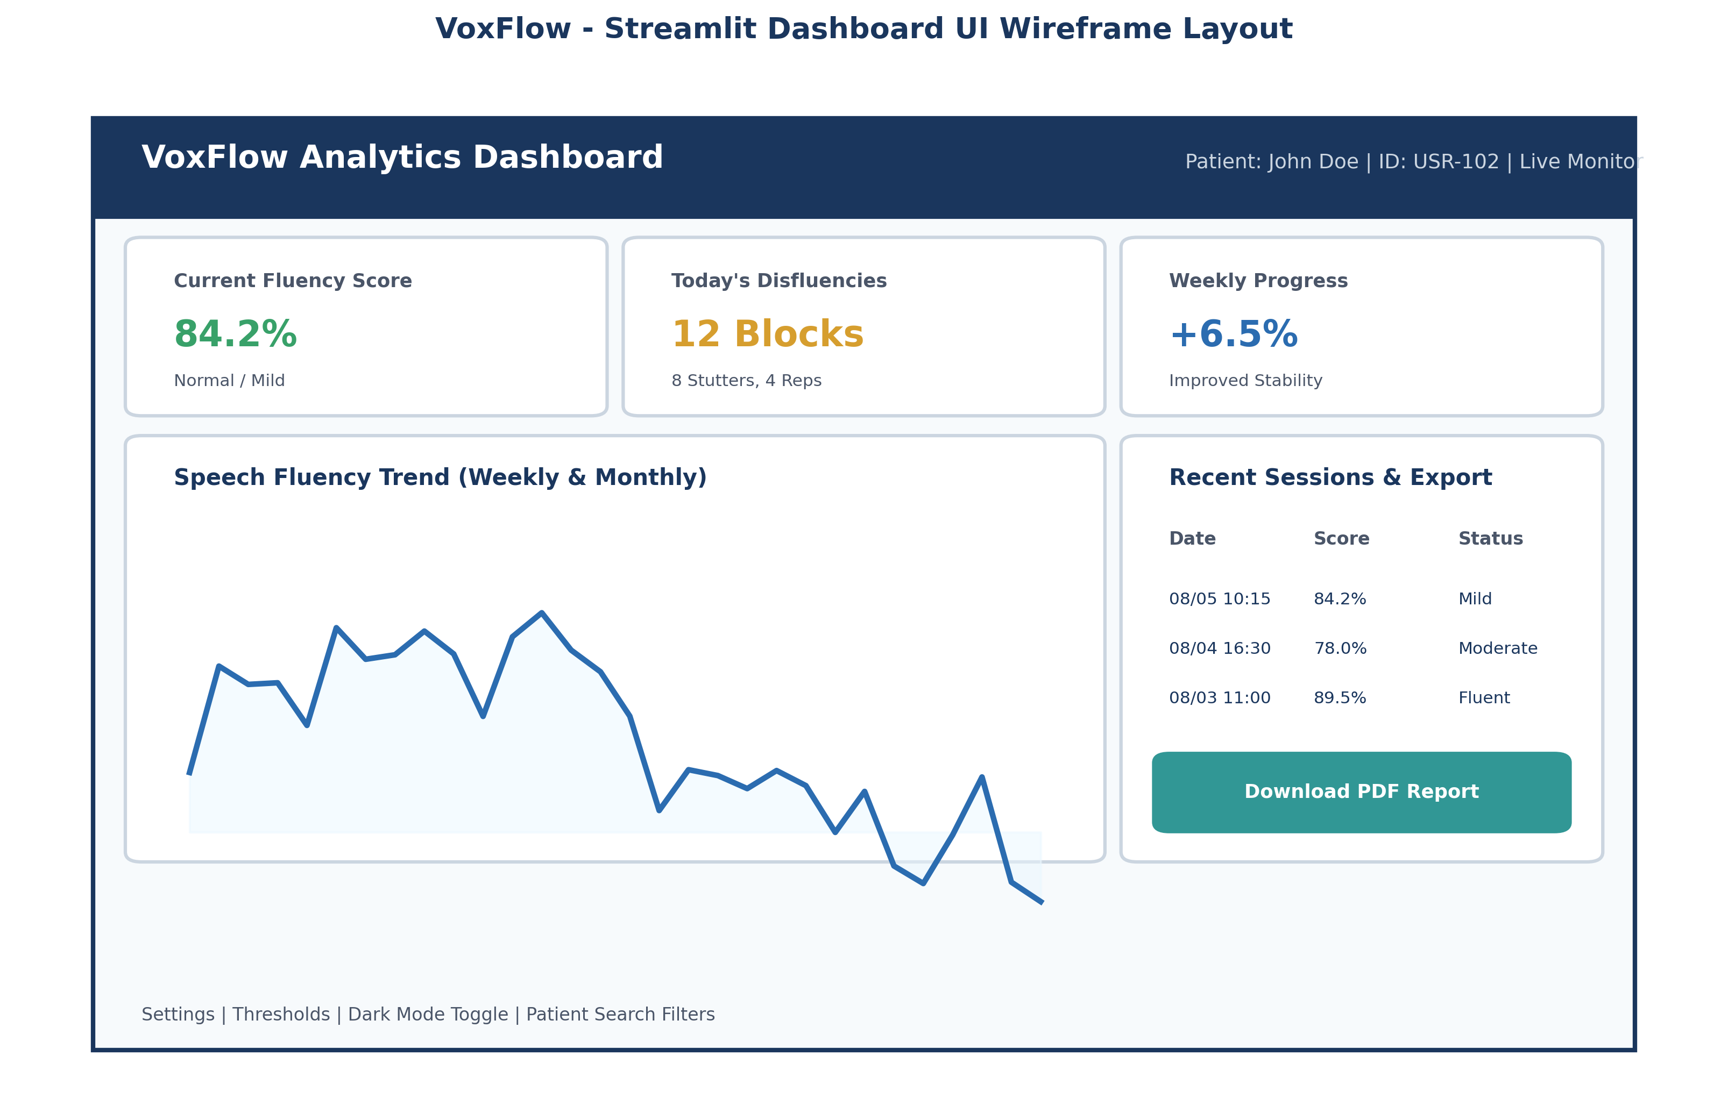
Figure: Streamlit Dashboard Wireframe Layout
5. Software Processing Pipeline Modules
Our host software runs through seven steps in sequence. Each module handles one specific job.
Module Name | Input | Output | Responsibility | Key Benefit
1. Audio Receiver | HTTP POST Stream | Saved WAV File | Receives network WAV upload, checks headers, saves file to buffer folder. | Prevents corrupt audio packets from entering the processing pipeline.
2. Noise Filter | WAV File Path | Denoised Float32 Array | Applies spectral gating and 80Hz-4000Hz bandpass filtering to remove background noise. | Improves signal-to-noise ratio (SNR) for noisy home environments.
3. Speaker Verifier | Denoised Array + User ID | Match Result (Boolean) | Compares speaker embedding against stored baseline using cosine similarity. | Ensures speech analytics belong to the registered patient, discarding background voices.
4. Feature Extractor | Denoised Audio Array | MFCC Tensor (39 x T) | Calculates 13 MFCCs, Delta, and Delta-Delta coefficients across 25ms windows. | Converts raw audio samples into compact 39-dimensional spectral features.
5. AI Predictor Interface | MFCC Tensor | Prediction Dictionary | Runs CNN-LSTM neural network inference to classify speech frames as Fluent or Stuttered. | Wraps deep learning model execution inside clean Python functions.
6. Database Layer | Prediction Dictionary | SQLite Row ID | Executes SQL INSERT queries and updates session records. | Ensures persistent local storage of all disfluency scores.
7. Dashboard Visualizer | SQLite DB Queries | Web UI Elements | Queries session records and plots interactive fluency graphs on the web UI. | Separates user display logic from backend API handling.

6. REST API Endpoints & Specification
6.1 API Design Principles
Our REST API uses standard HTTP GET and POST methods, returning JSON payloads with standard status codes.
Method | Endpoint Path | Request Body / Params | Status Code | Description
GET | /api/v1/health | None | 200 OK | Checks host server status and database connectivity.
POST | /api/v1/audio/upload | multipart/form-data (audio file, user_id) | 200 OK | Accepts WAV audio upload from ESP32, runs pipeline, and returns fluency prediction.
GET | /api/v1/predictions/{user_id} | Params: user_id, start_date | 200 OK | Returns historical prediction logs for a specific patient.
GET | /api/v1/session/latest | Params: user_id | 200 OK | Fetches the latest prediction score for immediate ESP32 display updates.

6.2 Example JSON Request & Response
JSON response returned by `/api/v1/audio/upload` to the ESP32:
{
"status": "success",
"prediction_id": 171,
"timestamp": "2026-08-05T21:21:40Z",
"user_id": 1,
"fluency_score": 94.8,
"stutter_detected": false,
"stutter_type": "Fluent",
"confidence": 0.97,
"display_message": "Fluency: 94.8% (Fluent)"
}

6.3 Future JWT Authentication
For public Wi-Fi setups, JWT authentication will work as follows:
1. Login: Send credentials to `POST /api/v1/auth/login`.
2. Receive token: Server sends back a signed JWT token.
3. Call APIs: Include `Authorization: Bearer <JWT_TOKEN>` in request headers.
7. Future Scope: Cloud Integration & Remote Access
While everything runs on the laptop right now via SQLite, VoxFlow can scale up to cloud syncing.
[CLOUD SYNC ARCHITECTURE]
Cloud Synchronization Engine:
• Local SQLite database acts as a primary buffer so no data gets lost during Wi-Fi drops.
• A background worker (`CloudSyncWorker`) checks un-synced rows (`synced_flag = 0`).
• When Internet is available, it uploads records to Firebase Firestore or MongoDB Atlas.
• Speech therapists view real-time patient charts through a web app.

8. Dashboard UI Structure
Our Streamlit dashboard UI breaks down into five sections:
1. Top Banner: Shows patient profile info and live status.
2. Metric Cards: Shows Fluency Score, Disfluency Count, Mean Score, and Model Confidence.
3. Main Trend Chart: Line graph plotting daily fluency scores and 7-day moving averages.
4. Categorical Breakdown: Donut chart showing Fluent vs. Stuttered event counts.
5. Session History Table: Searchable table listing past recording logs with CSV download.
9. Complete Database DDL SQL Queries
These SQL statements create our SQLite tables (`voxflow_local.db`):
-- 1. USERS TABLE
CREATE TABLE IF NOT EXISTS users (
user_id INTEGER PRIMARY KEY AUTOINCREMENT,
full_name TEXT NOT NULL,
age INTEGER NOT NULL,
therapist_name TEXT,
baseline_embedding BLOB,
created_at TIMESTAMP DEFAULT CURRENT_TIMESTAMP
);
-- 2. SESSIONS TABLE
CREATE TABLE IF NOT EXISTS sessions (
session_id INTEGER PRIMARY KEY AUTOINCREMENT,
user_id INTEGER NOT NULL,
session_name TEXT NOT NULL,
start_time TIMESTAMP NOT NULL,
end_time TIMESTAMP,
total_audio_length REAL DEFAULT 0.0,
FOREIGN KEY (user_id) REFERENCES users(user_id) ON DELETE CASCADE
);
-- 3. PREDICTIONS TABLE
CREATE TABLE IF NOT EXISTS predictions (
pred_id INTEGER PRIMARY KEY AUTOINCREMENT,
session_id INTEGER NOT NULL,
timestamp TIMESTAMP DEFAULT CURRENT_TIMESTAMP,
fluency_score REAL NOT NULL,
stutter_type TEXT NOT NULL,
confidence REAL NOT NULL,
audio_file_path TEXT,
synced_flag INTEGER DEFAULT 0,
FOREIGN KEY (session_id) REFERENCES sessions(session_id) ON DELETE CASCADE
);
-- 4. REPORTS TABLE
CREATE TABLE IF NOT EXISTS reports (
report_id INTEGER PRIMARY KEY AUTOINCREMENT,
session_id INTEGER NOT NULL,
user_id INTEGER NOT NULL,
generated_at TIMESTAMP DEFAULT CURRENT_TIMESTAMP,
summary_notes TEXT,
pdf_file_path TEXT,
FOREIGN KEY (session_id) REFERENCES sessions(session_id),
FOREIGN KEY (user_id) REFERENCES users(user_id)
);

10. Software Processing Flowchart
Here is the execution path from receiving Wi-Fi audio to updating the OLED display and Streamlit dashboard:
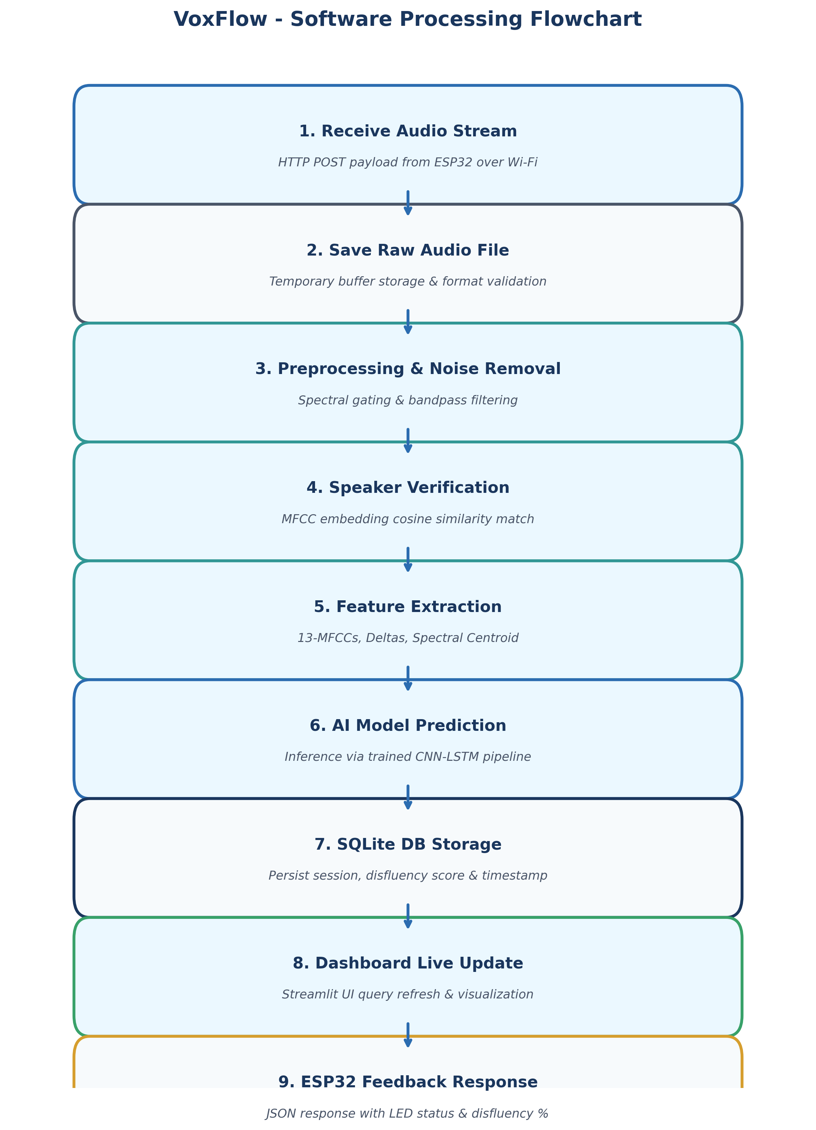
Figure: Software Processing Flowchart for VoxFlow
Step-by-Step Flow:
1. ESP32 sends WAV stream over Wi-Fi via POST.
2. Flask saves WAV bytes to `./audio_buffer/`.
3. Spectral filter cuts background noise.
4. Speaker verifier checks MFCC similarity against baseline.
5. Extractor pulls 13 MFCCs, Delta, and Delta-Delta features.
6. CNN-LSTM model predicts fluency probability.
7. Result gets stored in SQLite DB.
8. Streamlit dashboard reloads graph views.
9. Flask sends JSON response to ESP32 to update OLED/LEDs.
11. Tiered Software Architecture
Our host system uses a 5-tier architecture:
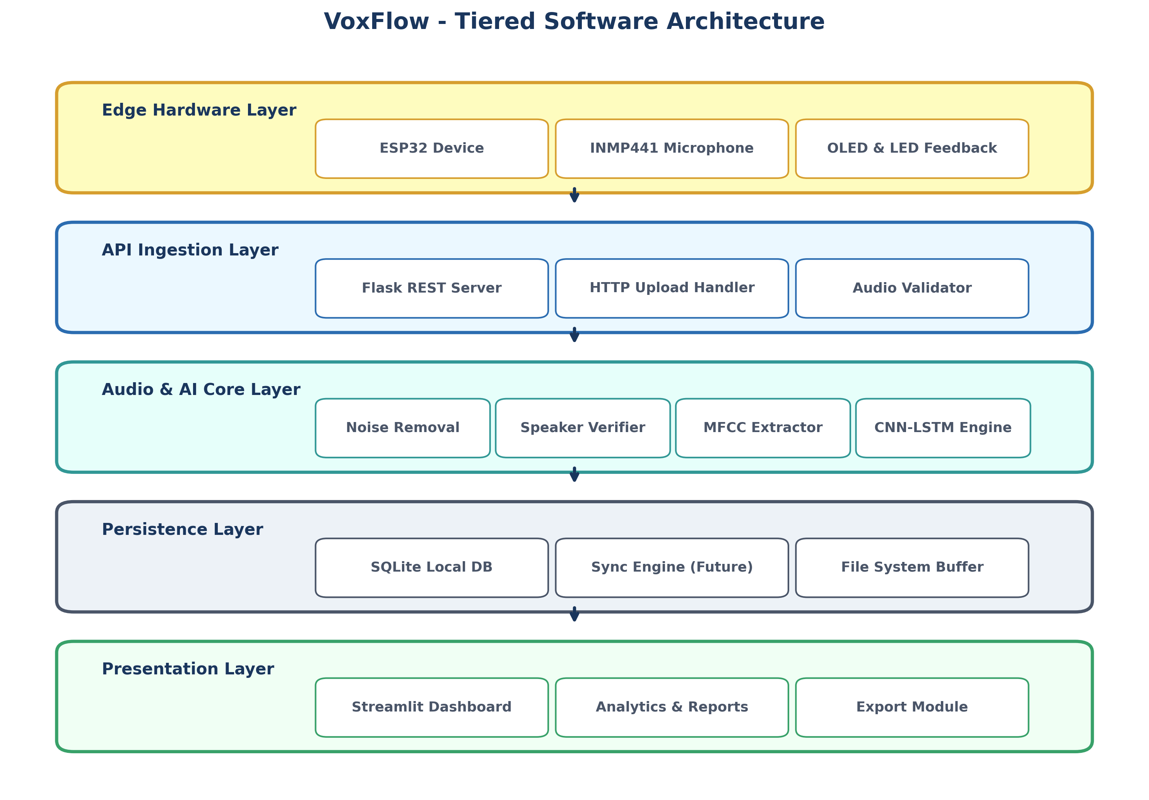
Figure: 5-Tiered Software Architecture Diagram
Tier Breakdown:
• Edge Hardware Tier: ESP32, INMP441 microphone, OLED, LEDs.
• API Ingestion Tier: Flask REST WSGI server.
• Audio & AI Processing Tier: Denoising filter, speaker verifier, MFCC extractor, CNN-LSTM model.
• Persistence Tier: SQLite local database and file buffer.
• Presentation Tier: Streamlit web dashboard and CSV exporter.
12. Object-Oriented UML Diagrams
Below are formal UML diagrams showing our class structures, sequence calls, activity paths, and communication flows.
12.1 UML Class Diagram
Shows host software classes, methods, and associations.
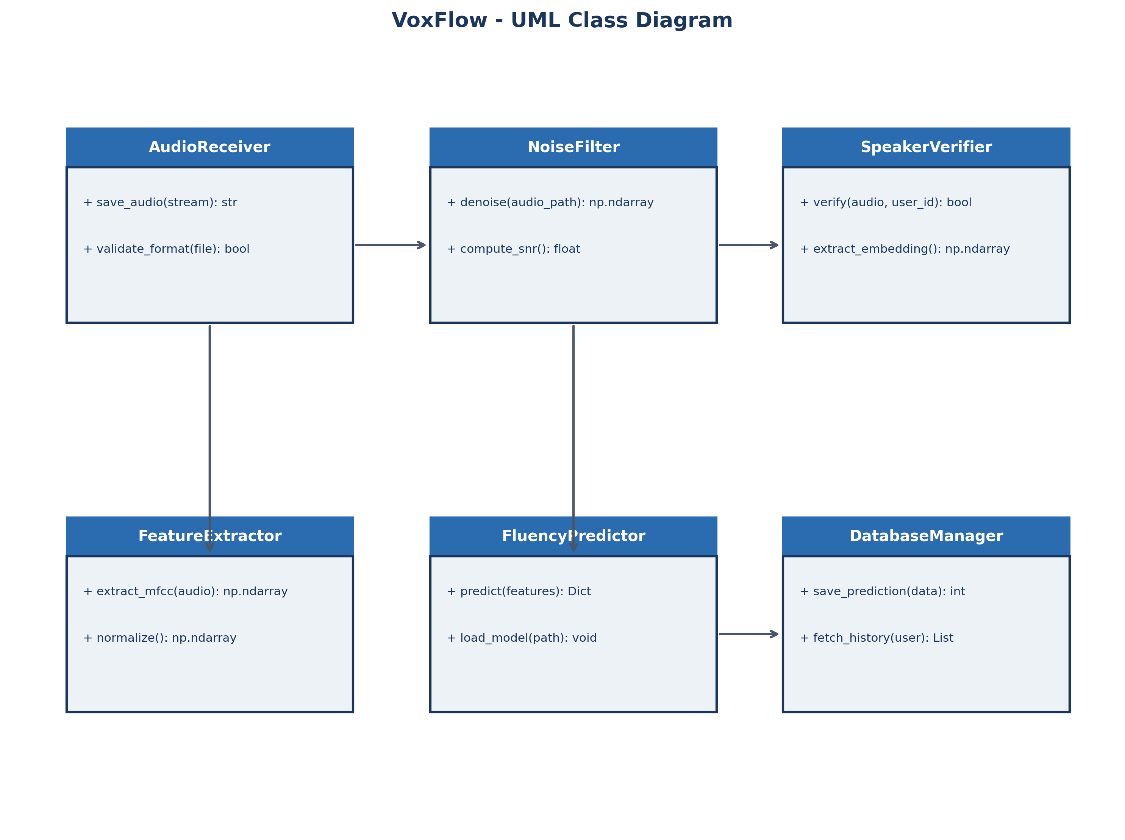
Figure: UML Class Diagram
@startuml
class AudioReceiver {
+ save_audio(stream): str
+ validate_format(file): bool
}
class NoiseFilter {
+ denoise(path): ndarray
+ compute_snr(): float
}
class SpeakerVerifier {
+ verify(audio, user_id): bool
+ extract_embedding(): ndarray
}
class FeatureExtractor {
+ extract_mfcc(audio): ndarray
}
class FluencyPredictor {
+ predict(features): Dict
}
class DatabaseManager {
+ save_prediction(data): int
+ fetch_history(user): List
}
AudioReceiver --> NoiseFilter
NoiseFilter --> SpeakerVerifier
SpeakerVerifier --> FeatureExtractor
FeatureExtractor --> FluencyPredictor
FluencyPredictor --> DatabaseManager
@enduml

12.2 UML Sequence Diagram
Shows message flow between ESP32, Flask server, processing modules, SQLite DB, and Streamlit UI.
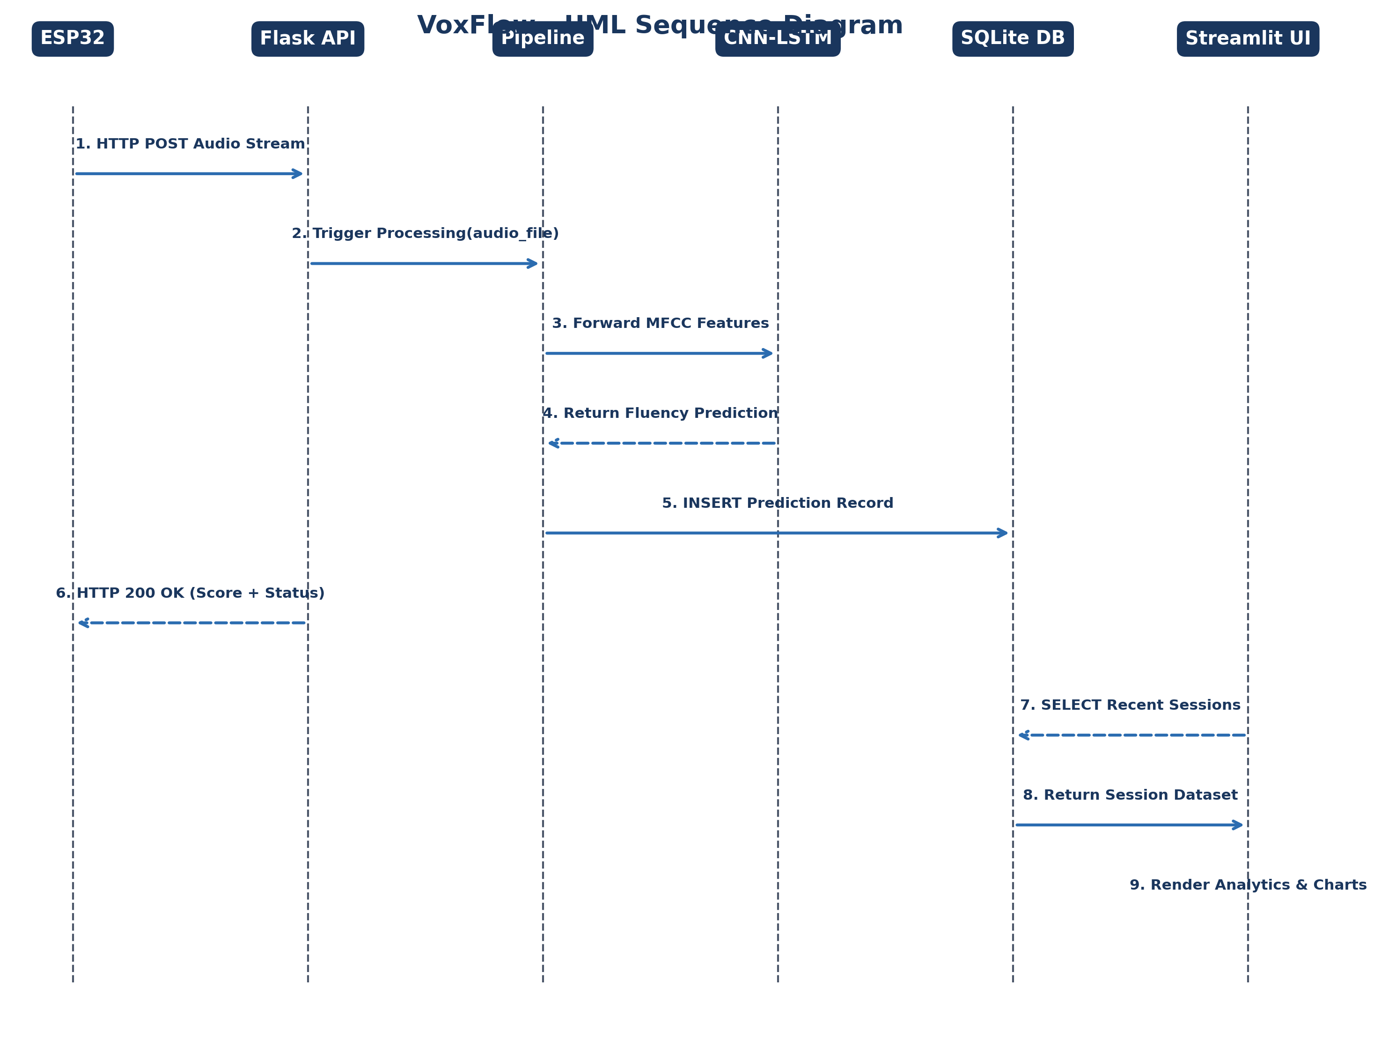
Figure: UML Sequence Diagram
sequenceDiagram
autonumber
participant ESP32 as ESP32 Device
participant Flask as Flask REST Server
participant Core as Processing Pipeline
participant Model as CNN-LSTM Model
participant DB as SQLite DB
participant UI as Streamlit Dashboard
ESP32->>Flask: POST /api/v1/audio/upload (WAV Stream)
Flask->>Core: execute(audio_path, user_id)
Core->>Model: predict(MFCC_features)
Model-->>Core: return fluency_score, stutter_type
Core->>DB: INSERT INTO predictions
Flask-->>ESP32: HTTP 200 OK (JSON Score & Status)
UI->>DB: SELECT * FROM predictions
DB-->>UI: Return Session Records
UI->>UI: Render Live Charts & Metrics

12.3 UML Activity Diagram
Shows decision steps for noise filtering, speaker verification, and disfluency prediction.
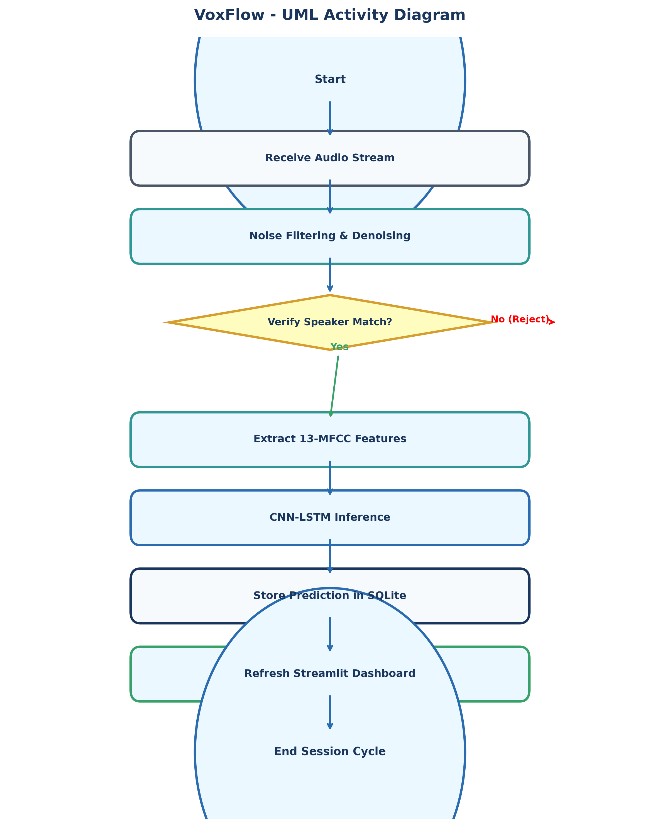
Figure: UML Activity Diagram
12.4 UML Communication Diagram
Shows object relationships and numbered message calls during audio processing.
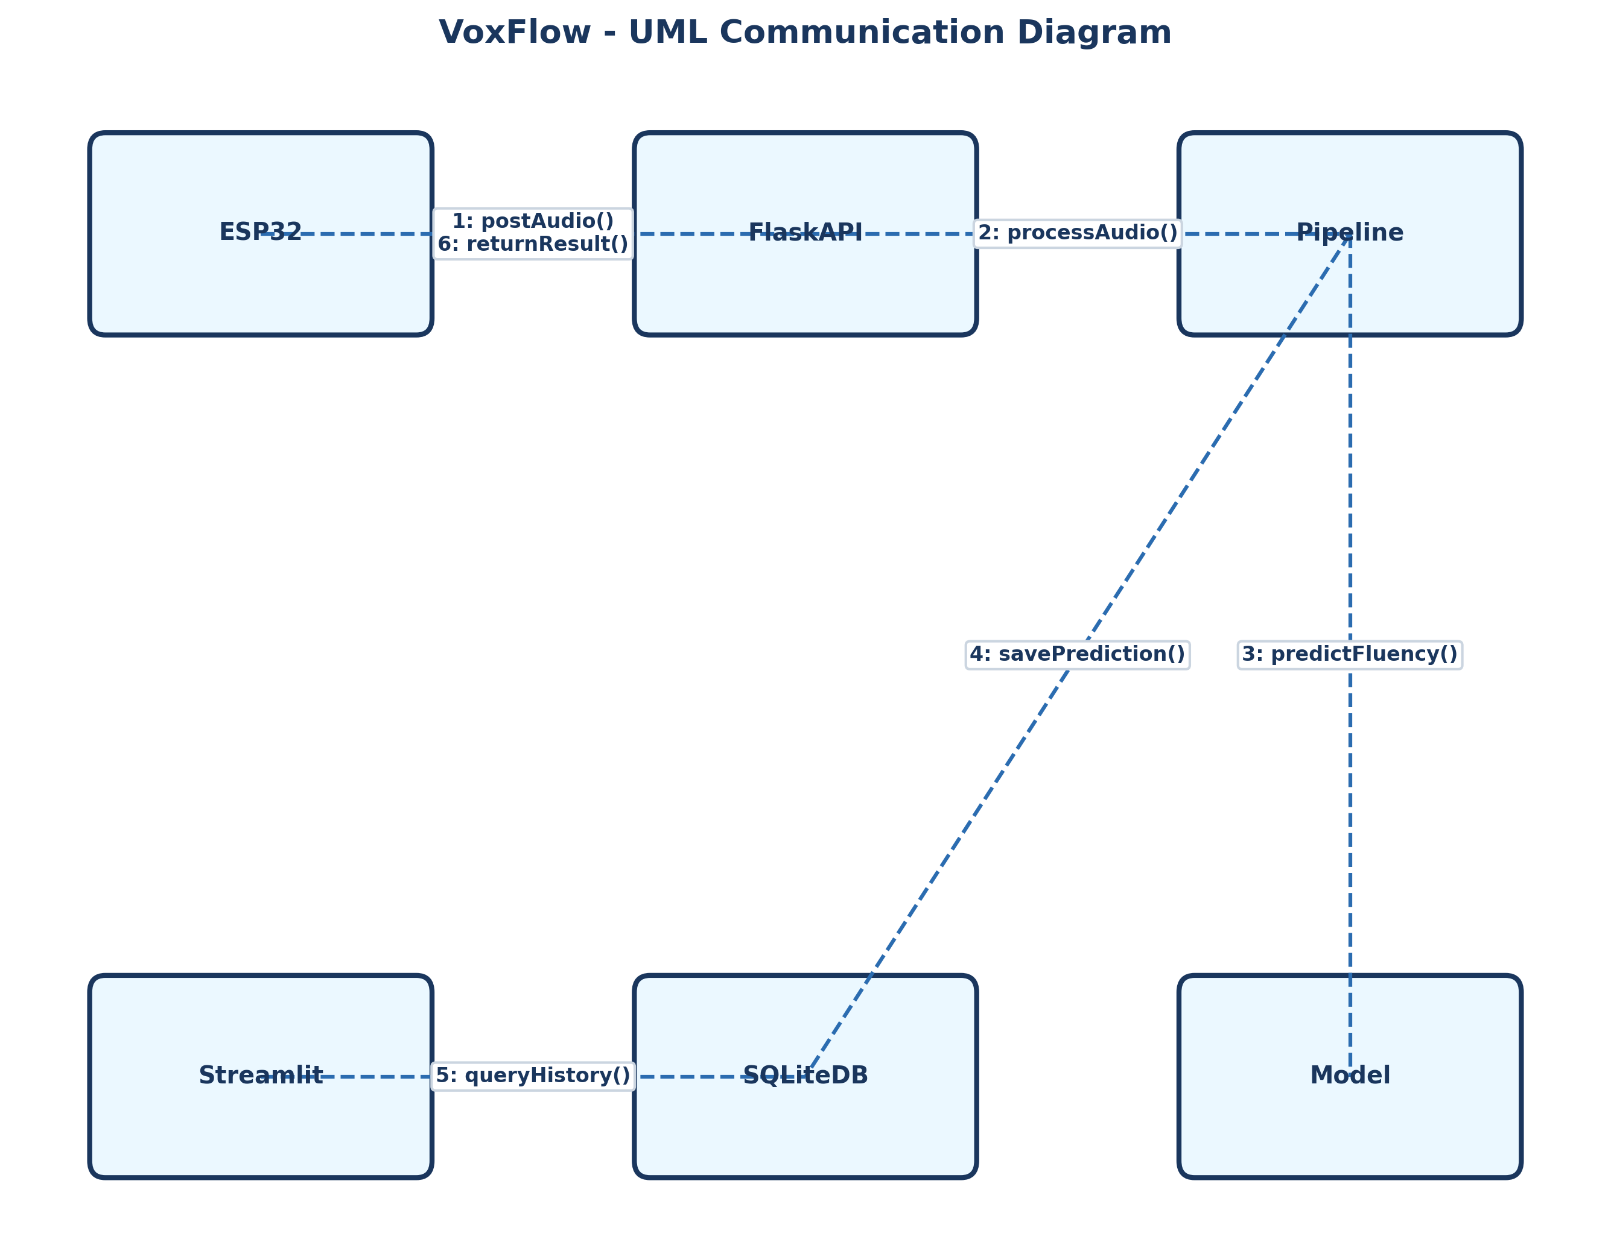
Figure: UML Communication Diagram

