DEPARTMENT OF COMPUTER SCIENCE AND ENGINEERING
SCHOOL OF COMPUTER SCIENCE AND ENGINEERING
FINDING HUMAN MOBILITY PATTERNS: LIFETRAIL PLATFORM
Understanding Human Mobility Through Spatiotemporal Pattern Mining
Project Report (REVIEW - 1)

Submitted by:
R. Amarender Reddy - 23MIA1012
Under the Guidance of:
Vignesh U
Department of Computer Science and Engineering

1. Abstract
Human mobility understanding plays a key role in urban infrastructure planning, public transit scheduling, location-based services, and epidemic contact tracking [1], [5]. This proposal outlines LifeTrail, a unified spatiotemporal data mining framework intended to extract movement behavior from raw high-density GPS trajectory logs collected in the Microsoft GeoLife dataset [1]. Unlike conventional next-location prediction models that rely purely on black-box forecasting, LifeTrail focuses on discovering structural movement behaviors through Spatial Data Mining (Stay Point Detection [1] and DBSCAN Clustering [3]) and Sequential Data Mining (PrefixSpan Pattern Mining [2]). We propose to isolate semantic stay points, identify spatial hotspots with convex hull boundaries, mine recurring daily commute routines with support and confidence metrics, compute mobility fingerprints (Radius of Gyration and Shannon entropy regularity [4]), and flag trajectory anomalies. The platform will be delivered through a full-stack web application built using Python FastAPI, SQLite, React, Vite, TailwindCSS, Leaflet, and Plotly.
2. Introduction and Literature Review
GPS trajectory data collected by smartphones and vehicle sensors contains rich spatiotemporal information [5]. However, raw coordinates lack semantic context and contain sampling noise. Zheng et al. [1] proposed distance-temporal stay point extraction, defining stay points as stationary hubs where a user remains within a spatial radius for a specified duration. For spatial density analysis, Ester et al. [3] introduced DBSCAN, which identifies arbitrary-shaped density clusters without requiring the number of clusters to be fixed in advance. In sequential mining, Pei et al. [2] introduced PrefixSpan, demonstrating that prefix-projected pattern growth avoids expensive candidate sequence generation. Song et al. [4] investigated human mobility predictability, demonstrating high routine predictability in human movement patterns.
3. Existing Systems and Limitations
Existing location analytical tools exhibit major technical limitations:
- Rule-Based Bounding Box Approaches: Simple spatial bounding boxes introduce severe boundary slicing errors and fail to discover irregular hotspot shapes [5].
- Combinatorial Candidate Generation: Classical sequence mining algorithms (Apriori/GSP) generate millions of candidate sub-sequences across dense GPS logs, leading to memory and computational bottlenecks [2].
- Black-Box Next-Location Predictors: Deep learning models (LSTM/RNN) forecast next coordinates but fail to provide human-explainable rules or mobility fingerprints [4].
4. Problem Statement
Analyzing raw GPS trajectory logs directly presents four main challenges: (1) high GPS measurement noise and irregular sample intervals [5], (2) lack of semantic location labels [1], (3) computational state explosion when searching for multi-step movement routines across continuous spatial coordinates [2], and (4) difficulty in identifying subtle behavioral anomalies against baseline travel routines [4].
5. Project Objectives and Scope
The main technical objectives for LifeTrail are:
- To construct an automated data ingestion pipeline for the Microsoft GeoLife trajectory dataset [1].
- To implement Stay Point Detection (Li et al. [1]), proposing a spatial distance threshold dist_thresh between 150m and 250m and a time duration threshold time_thresh between 15min and 30min.
- To apply DBSCAN spatial clustering [3] using Haversine distance, proposing tuning parameters around epsilon between 0.3km and 0.6km and min_samples between 2 and 3 to extract spatial hotspots and convex hull polygons.
- To apply PrefixSpan sequential pattern mining [2] on discretized cluster sequences, proposing a minimum support ratio min_support between 10% and 20%.
- To calculate mobility fingerprints (Radius of Gyration Rg and Shannon Entropy Regularity Index [4]) for monitored subjects.
- To build an interactive dashboard featuring Leaflet trajectory replay and Plotly analytics.
6. Proposed Methodology and Architecture
The proposed system architecture consists of three core components: Data Ingestion Pipeline, Spatiotemporal Mining Engine, and Interactive Web Client [5]. Figure 1 illustrates the proposed architectural pipeline.
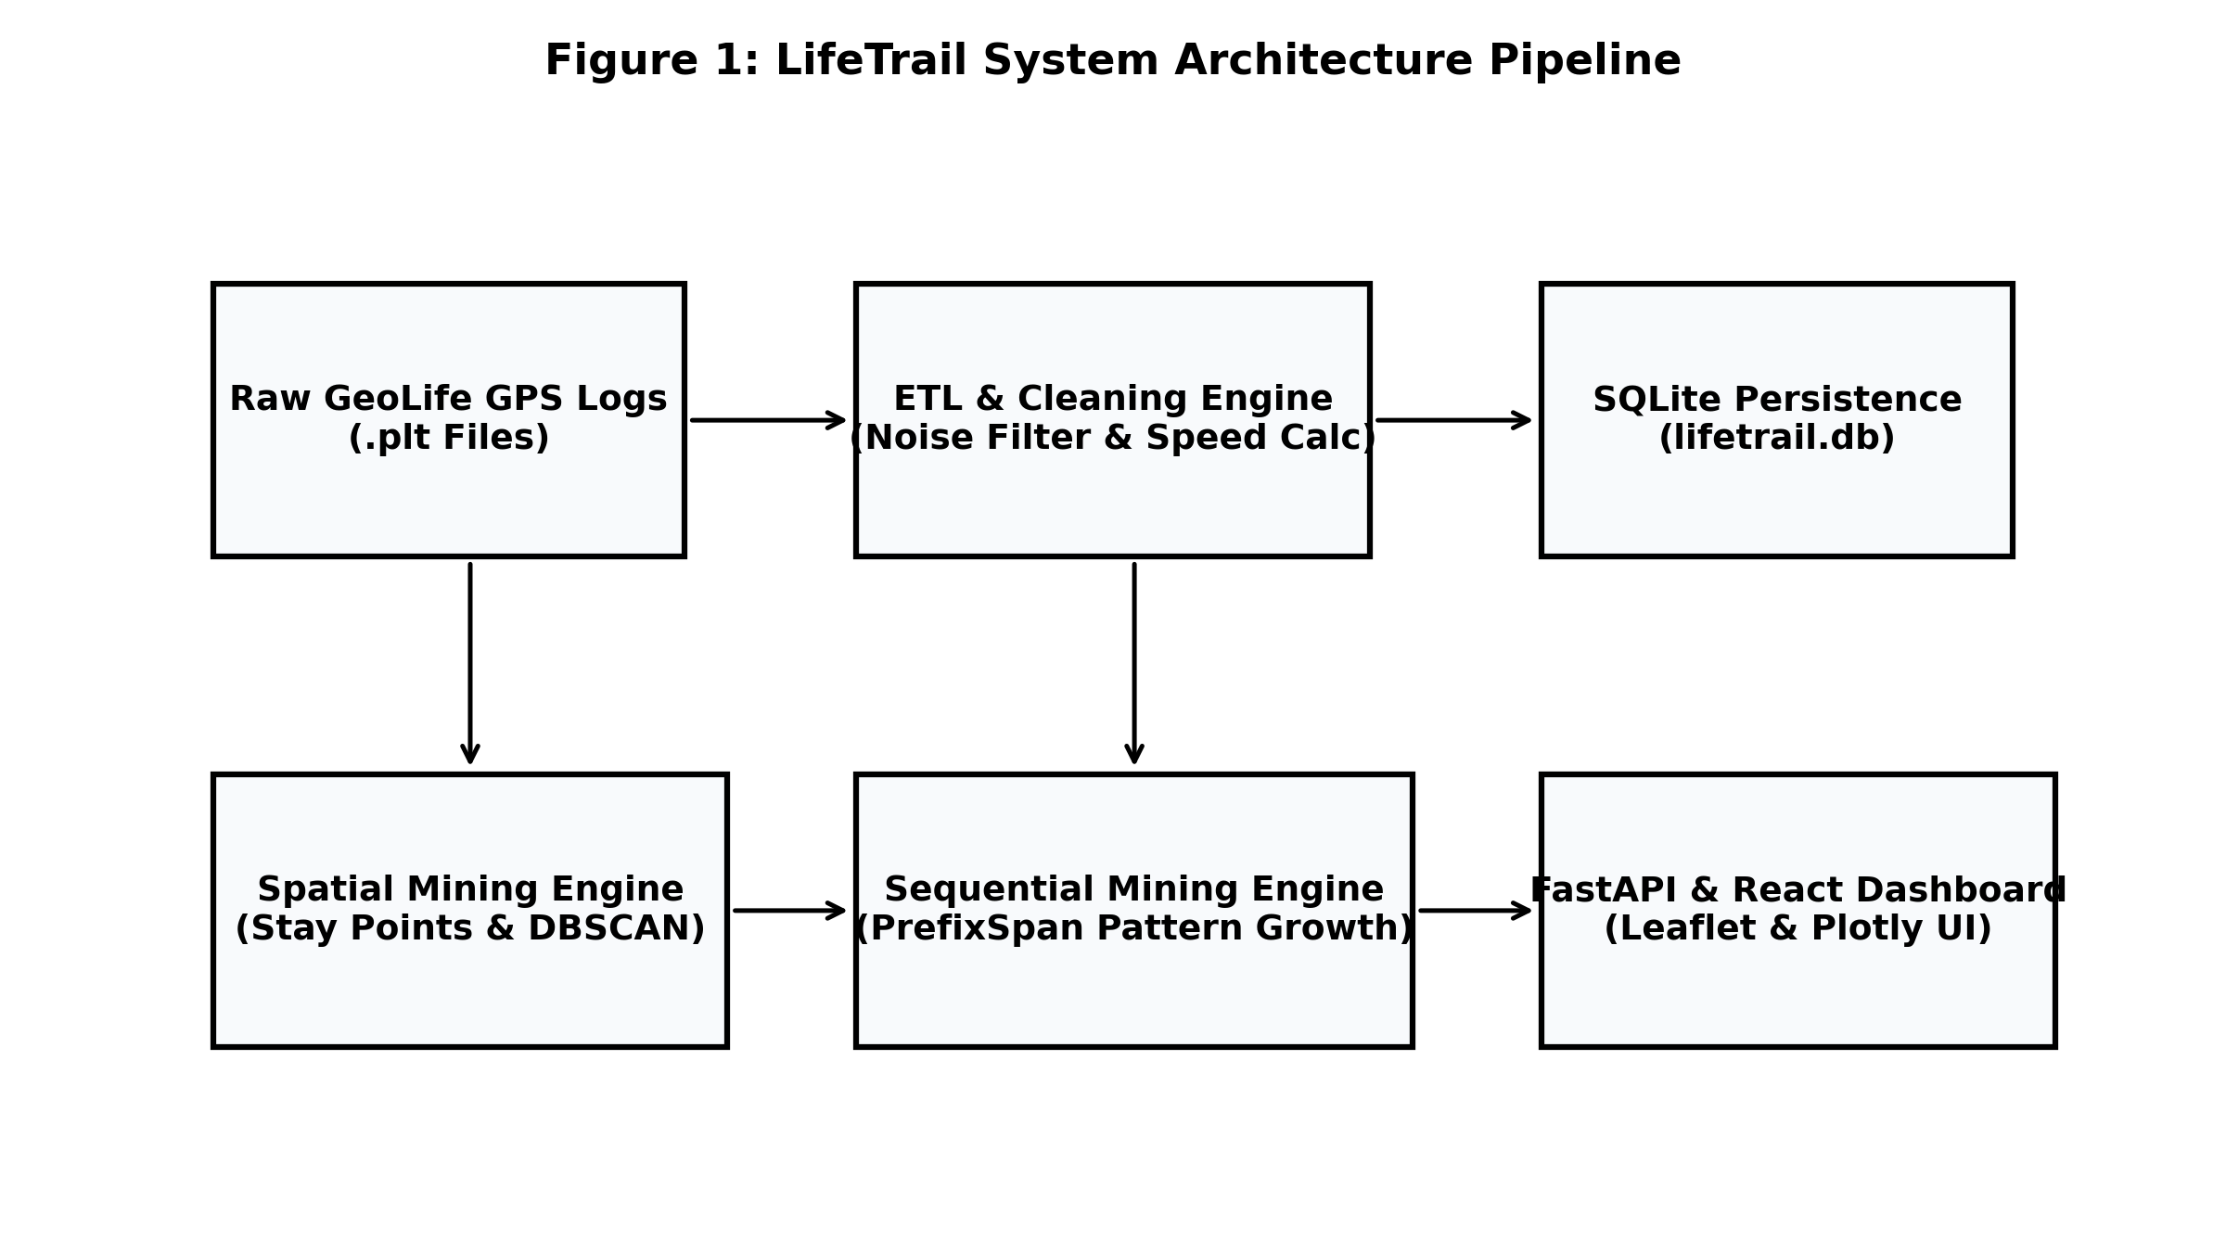
Figure 1: LifeTrail Proposed System Architecture Pipeline
7. Project Scope and Novelty
The project scope focuses on high-density GPS trajectory analysis. Novelty lies in combining spatial stay point clustering with non-candidate-generation PrefixSpan sequence mining to deliver explainable, interpretable mobility fingerprints and anomaly explanations.
8. Proposed Work Plan and Implementation Phases
The project implementation follows a structured five-phase development lifecycle:
- Phase I (Requirement Analysis & Data Acquisition): Review spatiotemporal data mining literature, formalize mathematical objectives, and acquire Microsoft GeoLife trajectory logs [1].
- Phase II (Spatial Preprocessing & Stay Point Pipeline): Construct automated .plt dataset loader, implement noise filtering, and build distance-temporal Stay Point Detection algorithm [1].
- Phase III (DBSCAN & PrefixSpan Mining Engine): Implement Haversine DBSCAN spatial clustering, convex hull polygon generation, and PrefixSpan pattern growth sequential miner [2], [3].
- Phase IV (Full-Stack Application Development): Build FastAPI REST endpoints, design SQLite database ORM models, and develop React + Vite + Leaflet web UI.
- Phase V (Empirical Benchmarking & Documentation): Perform runtime performance benchmarks, anomaly recall testing, user fingerprint validation, and report compilation.
References
[1] Y. Zheng, Q. Li, Y. Chen, X. Xie, and W. Y. Ma, 'Understanding mobility based on GPS data,' in Proc. ACM Ubicomp, 2008, pp. 312-321.
[2] J. Pei, J. Han, B. Mortazavi-Asl, J. Wang, H. Pinto, Q. Chen, U. Dayal, and M. C. Hsu, 'Mining sequential patterns by pattern-growth: The PrefixSpan approach,' IEEE Trans. Knowl. Data Eng., vol. 16, no. 11, pp. 1424-1440, Nov. 2004.
[3] M. Ester, H. P. Kriegel, J. Sander, and X. Xu, 'A density-based algorithm for discovering clusters in large spatial databases with noise,' in Proc. KDD, 1996, pp. 226-231.
[4] C. Song, Z. Qu, N. Blumm, and A. L. Barabási, 'Limits of predictability in human mobility,' Science, vol. 327, no. 5968, pp. 1018-1021, 2010.
[5] Y. Zheng, 'Trajectory data mining: an overview,' ACM Trans. Intell. Syst. Technol., vol. 6, no. 3, pp. 29:1-29:41, May 2015.

