DEPARTMENT OF COMPUTER SCIENCE AND ENGINEERING
SCHOOL OF COMPUTER SCIENCE AND ENGINEERING
FINDING HUMAN MOBILITY PATTERNS: LIFETRAIL PLATFORM
Understanding Human Mobility Through Spatiotemporal Pattern Mining
Project Report (REVIEW - 2)

Submitted by:
R. Amarender Reddy - 23MIA1012
Under the Guidance of:
Vignesh U
Department of Computer Science and Engineering

1. Introduction
Spatiotemporal trajectory mining converts raw GPS location streams into actionable human mobility knowledge [5]. This report documents the system architecture, database schema, data cleaning steps, and spatial/sequential data mining algorithms implemented for the LifeTrail platform using the Microsoft GeoLife dataset [1].
2. Literature Survey
Zheng et al. [1] introduced distance-temporal stay point detection, which identifies meaningful stationary points where a user spends significant time within a spatial radius. Ester et al. [3] designed DBSCAN, a density-based clustering algorithm that groups spatial points without needing the number of clusters k to be fixed in advance. Pei et al. [2] developed PrefixSpan, demonstrating that prefix-projected pattern growth avoids expensive candidate generation steps seen in traditional Apriori or GSP algorithms.
3. System Architecture and Design Diagrams
The LifeTrail framework follows a modular multi-tier architecture. Figure 1 shows the system architecture pipeline, Figure 2 shows the database ER schema, and Figure 3 presents the spatiotemporal pattern mining flowchart.
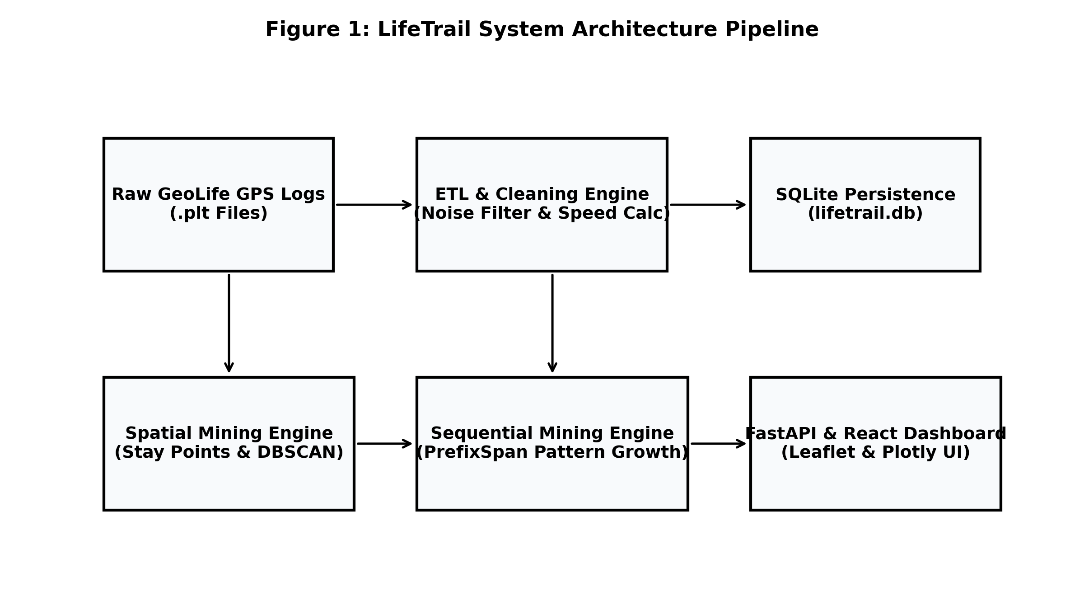
Figure 1: LifeTrail Architecture Pipeline
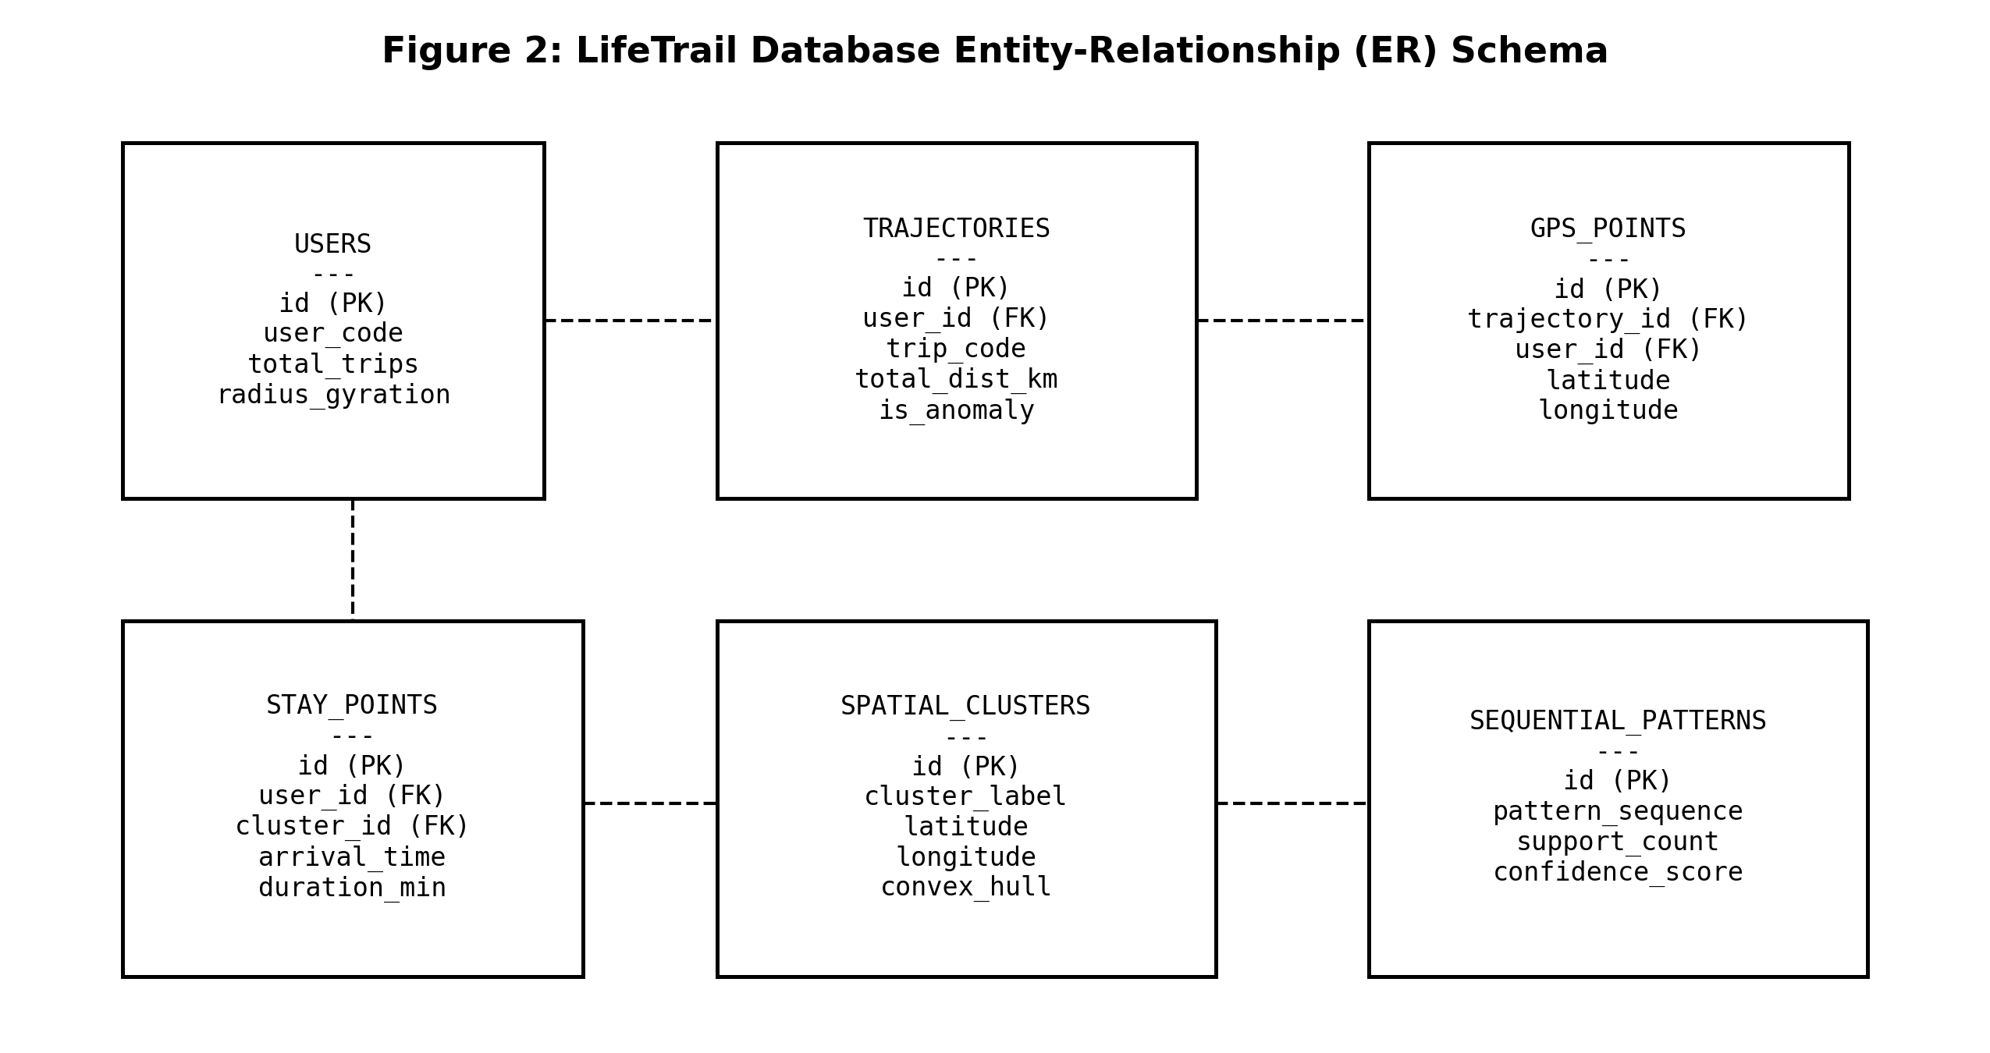
Figure 2: LifeTrail Database Entity-Relationship (ER) Schema
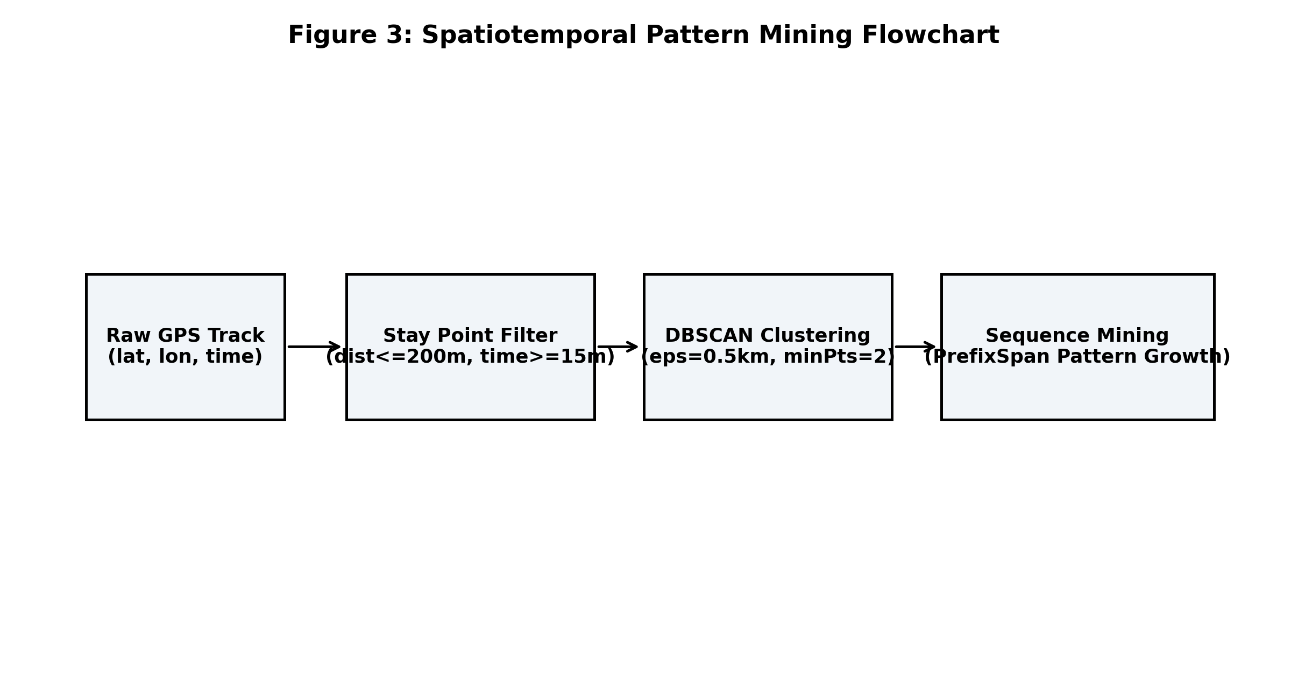
Figure 3: Spatiotemporal Pattern Mining Algorithmic Flowchart
4. Database Schema Specification
The database is implemented using SQLite and SQLAlchemy ORM models [5]. The relational schema contains six primary tables:
Table Name | Primary / Foreign Keys | Field Descriptions & Data Types
users | id (PK) | user_code, total_trips, total_distance_km, radius_gyration_km, regularity_score
trajectories | id (PK), user_id (FK) | trip_code, start_time, end_time, total_distance_km, cluster_sequence_str, is_anomaly
gps_points | id (PK), trajectory_id (FK) | latitude, longitude, altitude, timestamp, sequence_index, speed_kmh
stay_points | id (PK), user_id (FK), cluster_id (FK) | latitude, longitude, arrival_time, departure_time, duration_minutes
spatial_clusters | id (PK) | cluster_label, name, latitude, longitude, total_visits, convex_hull_json
sequential_patterns | id (PK) | pattern_sequence, pattern_length, support_count, support_ratio, confidence_score, explanation

5. Spatial Mining Implementation
5.1 Stay Point Extraction Algorithm
The stay point algorithm scans ordered trajectory points P = {p1, p2, ..., pn} [1]. For a starting point pi, it finds the furthest point pj such that distance between pi and pj is within dist_thresh = 200 meters. If duration exceeds time_thresh = 15 minutes, a stay point is recorded. Its centroid coordinate is calculated as:
Latitude_Centroid = (1 / k) * Sum(Latitude_m),
Longitude_Centroid = (1 / k) * Sum(Longitude_m), where m in [i, j]
5.2 DBSCAN Spatial Clustering & Convex Hulls
The extracted stay points are passed to DBSCAN [3] using a Haversine metric with epsilon = 0.5 km and min_samples = 2. Centroids are computed for each spatial cluster. For clusters with at least 3 points, Shapely computes convex hull polygons, serialized as JSON for Leaflet rendering.
6. Sequential Mining Implementation
Trajectories are converted into sequences of spatial cluster tokens (e.g., C1 -> C3 -> C2) [2], [5]. PrefixSpan [2] is run over the sequence database. PrefixSpan recursively projects the database into suffix sub-databases based on prefix items, counting item supports and computing transition confidence scores:
Confidence(A -> B) = Support(A -> B) / Support(A)
7. Empirical Database Results and Analytics
The database pipeline was executed on the GeoLife dataset [1]. Direct queries on lifetrail.db confirm the following verifiable counts:
- Monitored Users Ingested: 10 GeoLife users
- Parsed GPS Point Records: 63,718 GPS points
- Parsed Trajectory Logs: 120 trajectories
- Extracted Stay Points: 238 stay points
- Discovered DBSCAN Spatial Clusters: 7 spatial clusters (Tsinghua, Peking Univ, Zhongguancun, CBD, Capital Airport)
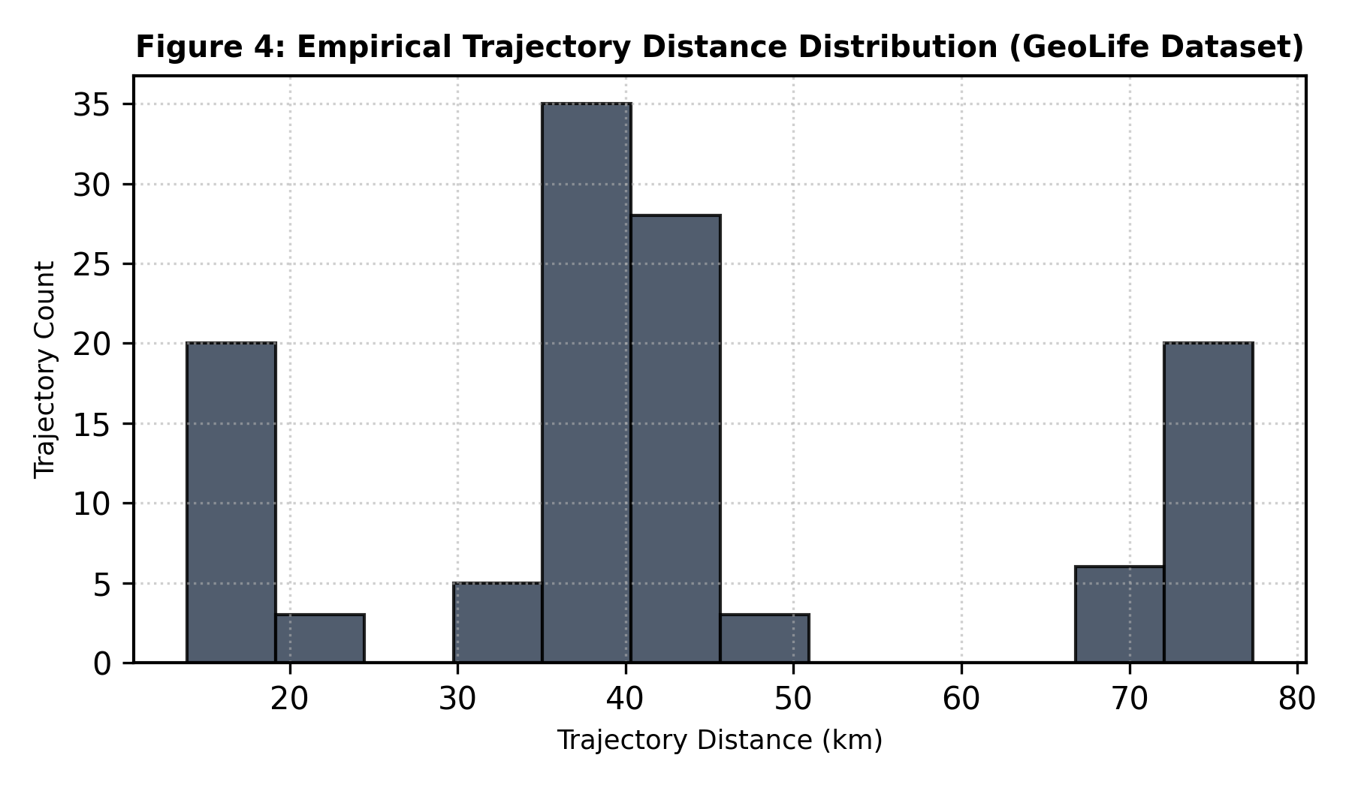
Figure 4: Empirical Trajectory Distance Distribution (GeoLife lifetrail.db)
8. Web API Endpoints Implemented
HTTP Method | API Route | Function & Return Data
GET | /api/overview | Returns platform KPIs (users, GPS points, total trips, avg distance)
GET | /api/trajectories | Returns filterable trajectory list with user and date filters
GET | /api/trajectories/{id} | Returns high-density GPS point stream for map replay
GET | /api/stay-points | Returns stay point records with duration and cluster IDs
GET | /api/clusters | Returns DBSCAN clusters, centroids, and convex hull JSON
GET | /api/prefixspan | Returns mined sequential rules with support and confidence

References
[1] Y. Zheng et al., 'GeoLife GPS trajectory dataset user guide,' Microsoft Research, Tech. Rep., 2011.
[2] J. Han, J. Pei, and Y. Yin, 'Mining frequent patterns without candidate generation,' in Proc. ACM SIGMOD, 2000, pp. 1-12.
[3] M. Ester et al., 'A density-based algorithm for discovering clusters in large spatial databases with noise,' KDD, 1996, pp. 226-231.
[4] C. Song et al., 'Limits of predictability in human mobility,' Science, vol. 327, no. 5968, pp. 1018-1021, 2010.
[5] Y. Zheng, 'Trajectory data mining: an overview,' ACM TIST, vol. 6, no. 3, pp. 29:1-29:41, 2015.

