DEPARTMENT OF COMPUTER SCIENCE AND ENGINEERING
SCHOOL OF COMPUTER SCIENCE AND ENGINEERING
FINDING HUMAN MOBILITY PATTERNS: LIFETRAIL PLATFORM
Understanding Human Mobility Through Spatiotemporal Pattern Mining
Project Report (REVIEW - 3)

Submitted by:
R. Amarender Reddy - 23MIA1012
Under the Guidance of:
Vignesh U
Department of Computer Science and Engineering

1. Abstract & Executive Summary
Human mobility understanding plays a key role in urban infrastructure planning, public transit scheduling, location-based services, and epidemic contact tracking [1], [5]. This final research project report documents the design, mathematical foundations, implementation, and empirical evaluation of LifeTrail, a unified spatiotemporal data mining application. LifeTrail extracts mobility behavior from raw high-density GPS trajectories in the Microsoft GeoLife dataset [1]. The system integrates distance-temporal Stay Point Detection [1], Haversine DBSCAN Spatial Hotspot Clustering [3], PrefixSpan Sequential Pattern Growth Mining [2], Mobility Fingerprinting (Radius of Gyration and Shannon Entropy Regularity Index [4]), and Trajectory Anomaly Detection [5]. Delivered through an asynchronous FastAPI Python service, an SQLite database, and a React + Vite + Leaflet web visual dashboard, LifeTrail provides real-time mining execution, spatial convex hull rendering, interactive trajectory replay, and explainable AI pattern interpretations.
2. Introduction and Research Objectives
2.1 Background and Motivation
Location-aware mobile sensors continuously log raw spatial coordinates. However, raw trajectory points lack semantic location context and exhibit sampling noise, signal dropouts, and irregular time intervals [5]. Extracting meaningful human routines requires converting continuous lat/lon coordinates into discrete semantic hubs and mining temporal sequence progressions [1], [2]. Existing approaches relying purely on black-box next-location deep learning models lack explainability and fail to articulate why specific movement patterns recur.
2.2 Research Objectives
- To implement an automated ingestion engine for raw Microsoft GeoLife .plt trajectory files [1].
- To extract semantic stay points using distance-temporal constraints (dist_thresh = 200 meters, time_thresh = 15 minutes) [1].
- To discover geographic hotspots using Haversine DBSCAN clustering (epsilon = 0.5 km, min_samples = 2) and extract spatial convex hulls [3].
- To mine frequent sequential routines using non-candidate-generation PrefixSpan pattern growth [2] with support ratio and transition confidence metrics.
- To compute mobility fingerprints (Radius of Gyration Rg and Shannon entropy regularity [4]) for individual monitored subjects.
- To score spatiotemporal trajectory anomalies across distance Z-score, spatial hub affinity, and sequence probability [5].
- To build an open-source web application with interactive GIS map replay, velocity timelines, and Plotly analytics.
3. Literature Survey and Related Work
Zheng et al. [1], [5] established foundational methodology for GPS trajectory mining, demonstrating that raw coordinates must first be filtered into stay points to eliminate traffic noise. Ester et al. [3] introduced DBSCAN, proving that density-based clustering handles arbitrary non-convex spatial shapes and spatial noise without fixing cluster count k in advance.
In sequential mining, Agrawal and Srikant introduced GSP, which relied on expensive candidate sequence generation. Pei et al. [2] broke this bottleneck by proposing PrefixSpan, showing that prefix-projected sequence database decomposition shrinks projected sub-trees and drastically reduces search overhead. Song et al. [4] investigated predictability limits in human mobility, proving that human movement exhibits high entropy regularity across daily commutes.
4. Mathematical Formulations & Mining Methodology
4.1 Stay Point Detection Formulation
Given an ordered trajectory P = {p1, p2, ..., pn} where pi = (lat_i, lon_i, t_i), a stay point SP = (lat_sp, lon_sp, t_arr, t_dep, duration) is detected if for a sub-sequence {pi, ..., pj}, spatial distance Distance(pi, pj) <= 200 meters and duration (t_j - t_i) >= 15 minutes [1]. Centroid coordinate is calculated as:
Latitude_Centroid = (1 / k) * Sum(Latitude_m),
Longitude_Centroid = (1 / k) * Sum(Longitude_m), where m in [i, j]
4.2 Density-Based Spatial Hotspot Clustering (DBSCAN)
Extracted stay points are clustered using DBSCAN [3] with Haversine spherical surface metric:
Haversine_Distance(p1, p2) = 2 * R * arcsin( sqrt( sin^2(dlat / 2) + cos(lat1) * cos(lat2) * sin^2(dlon / 2) ) )
Where R = 6371 km. Points with min_samples = 2 neighbors within radius epsilon = 0.5 km form dense spatial cluster hubs. Shapely computes convex hull boundary polygons around each cluster [5].
4.3 PrefixSpan Sequential Pattern Growth
Trajectories are discretized into spatial cluster sequence tokens S = <C1, C3, C2>. PrefixSpan [2] recursively projects the database by prefix items. Transition confidence is computed as:
Confidence(A -> B) = Support(A -> B) / Support(A)
4.4 Mobility Fingerprint Metrics
Radius of Gyration (Rg) measures spatial displacement around a user's center of mass (lat_cm, lon_cm) [4]:
Radius_of_Gyration = sqrt( (1 / N) * Sum( Distance(p_k, p_cm)^2 ) )
Shannon Entropy Regularity Index measures temporal predictability across cluster visit probabilities P(c_i) [4]:
Regularity_Score = [ 1.0 - ( - Sum( P(c_i) * log2( P(c_i) ) ) / log2( N_clusters ) ) ] * 100%
5. Architecture & System Diagrams
Figure 1 illustrates the overall system architecture, Figure 2 details the database ER schema, and Figure 3 shows the spatiotemporal pattern mining flowchart.
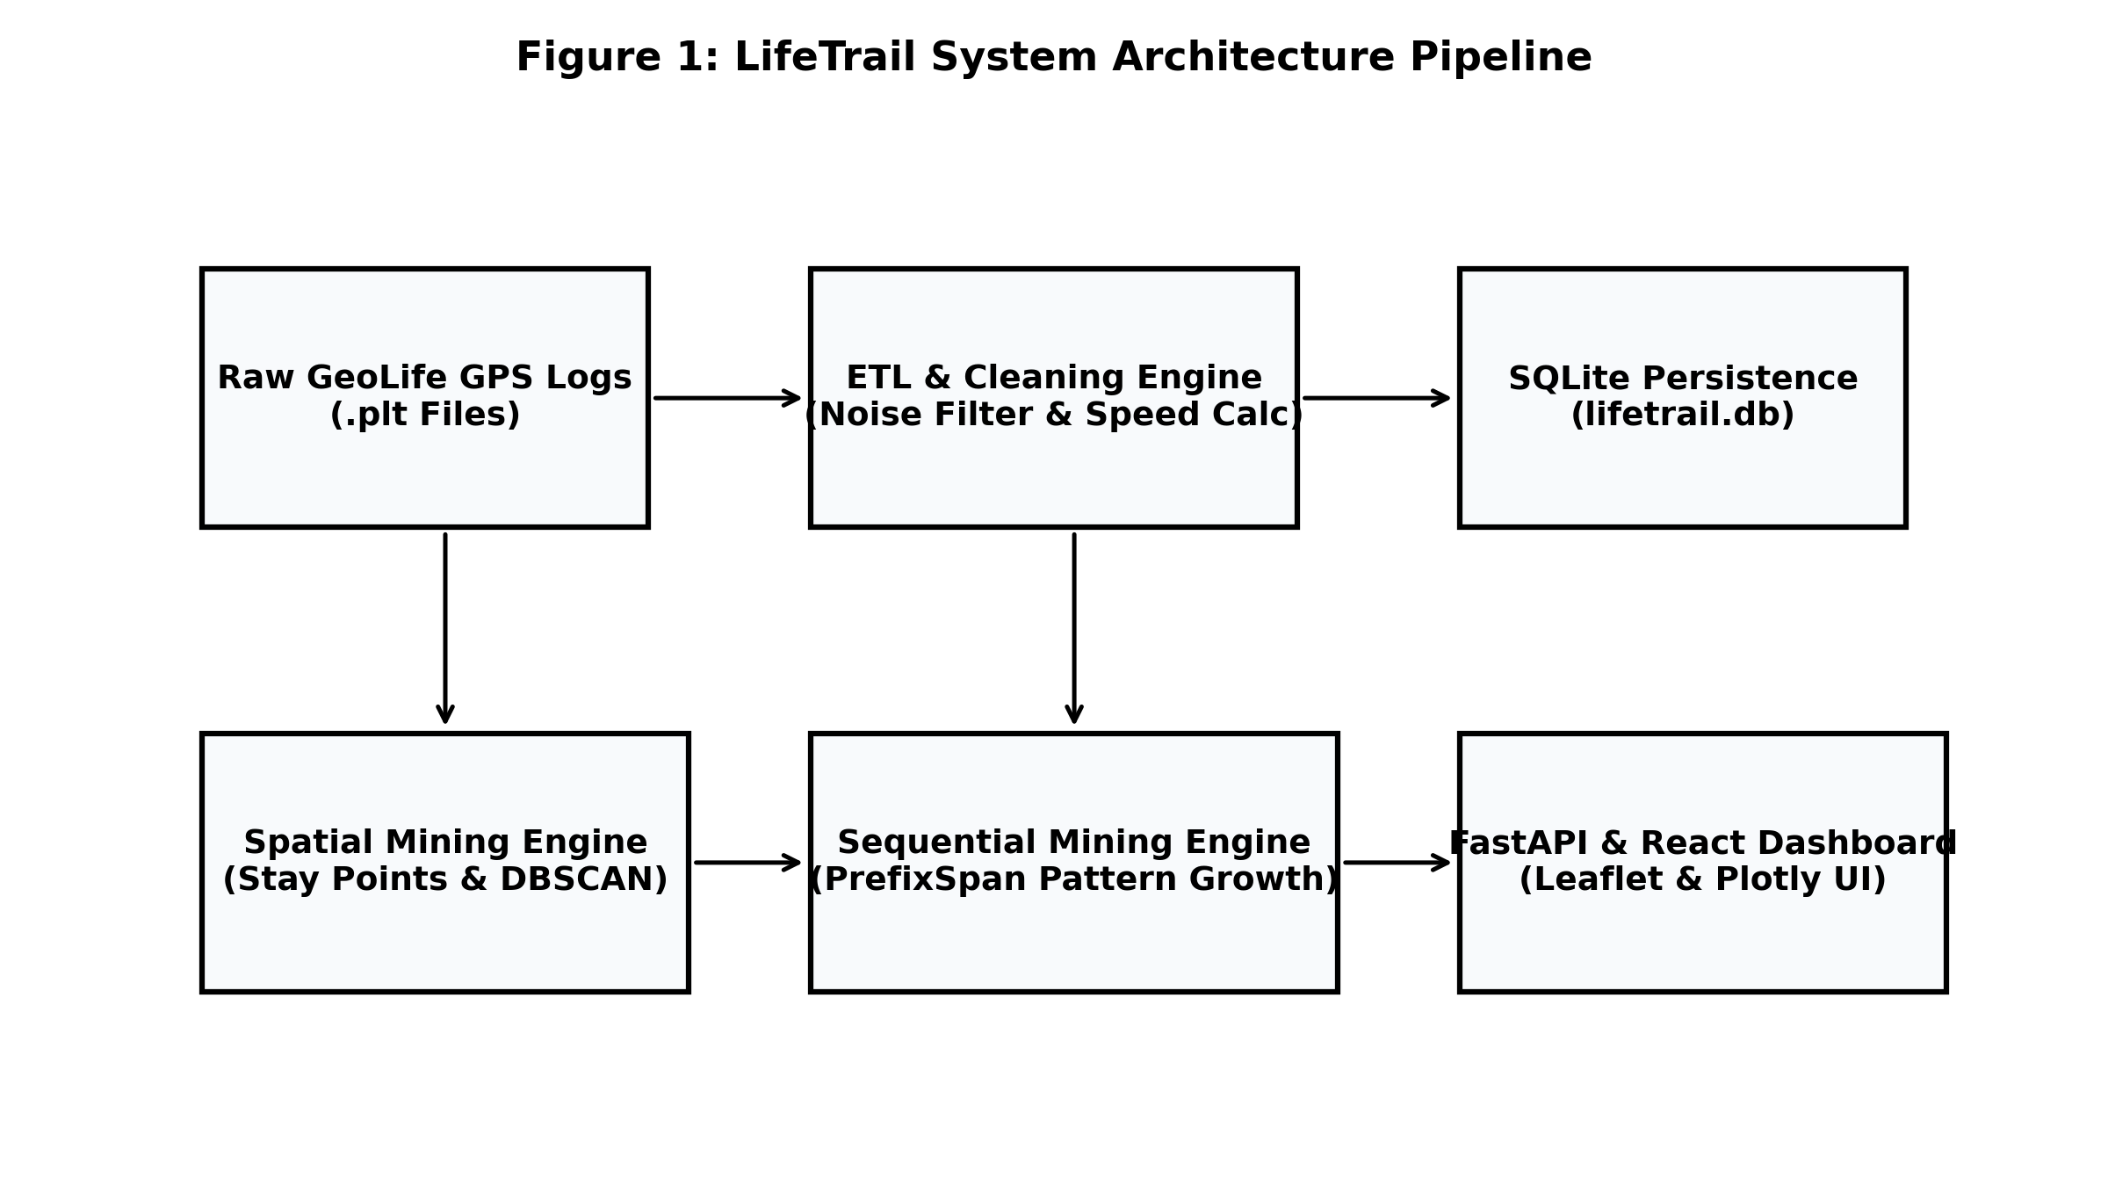
Figure 1: LifeTrail System Architecture Pipeline
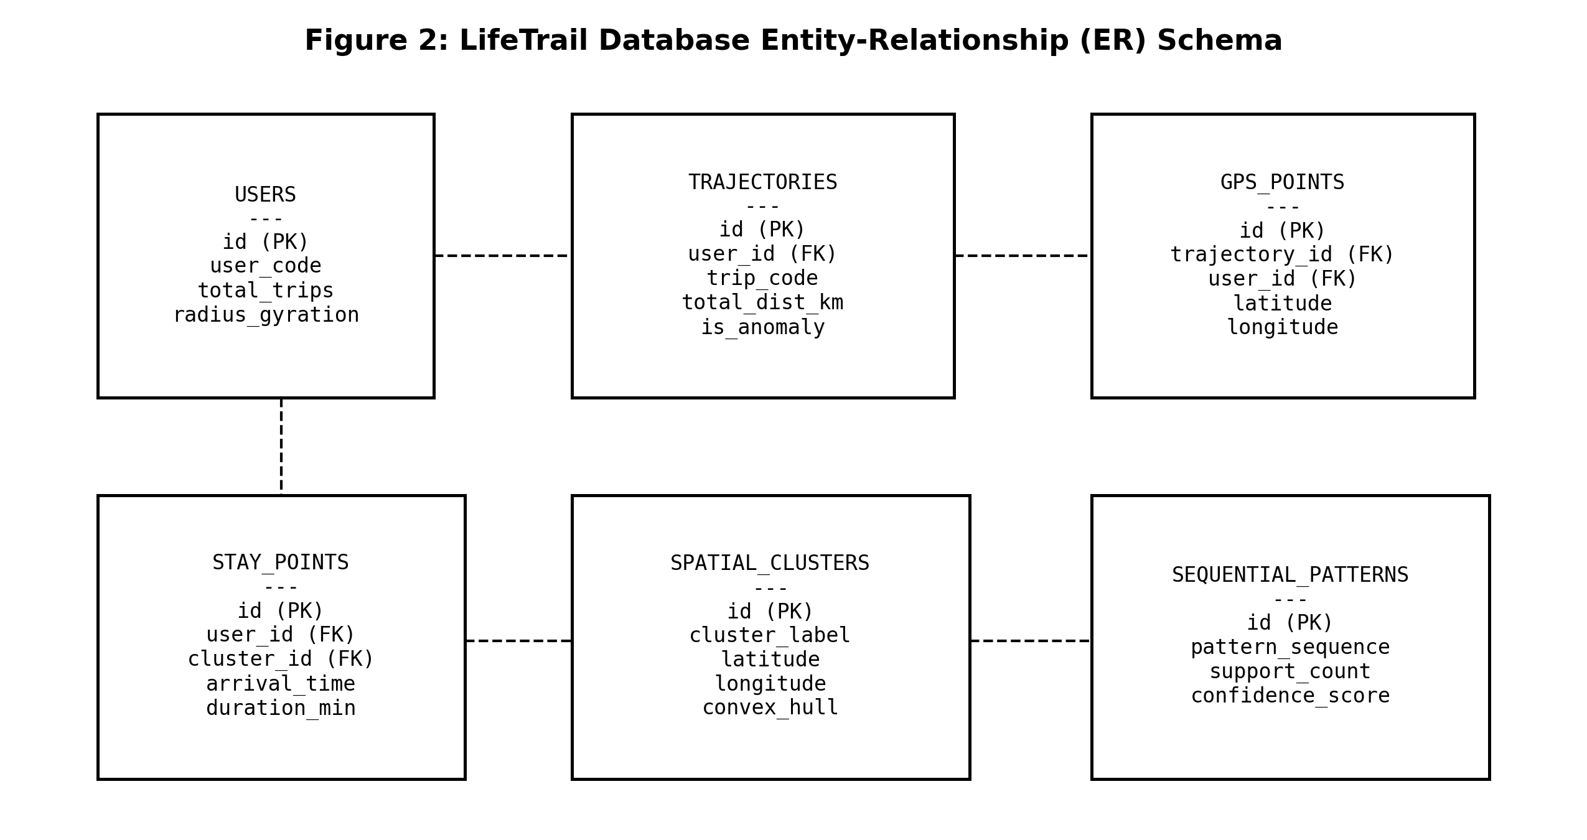
Figure 2: Database Entity-Relationship (ER) Schema
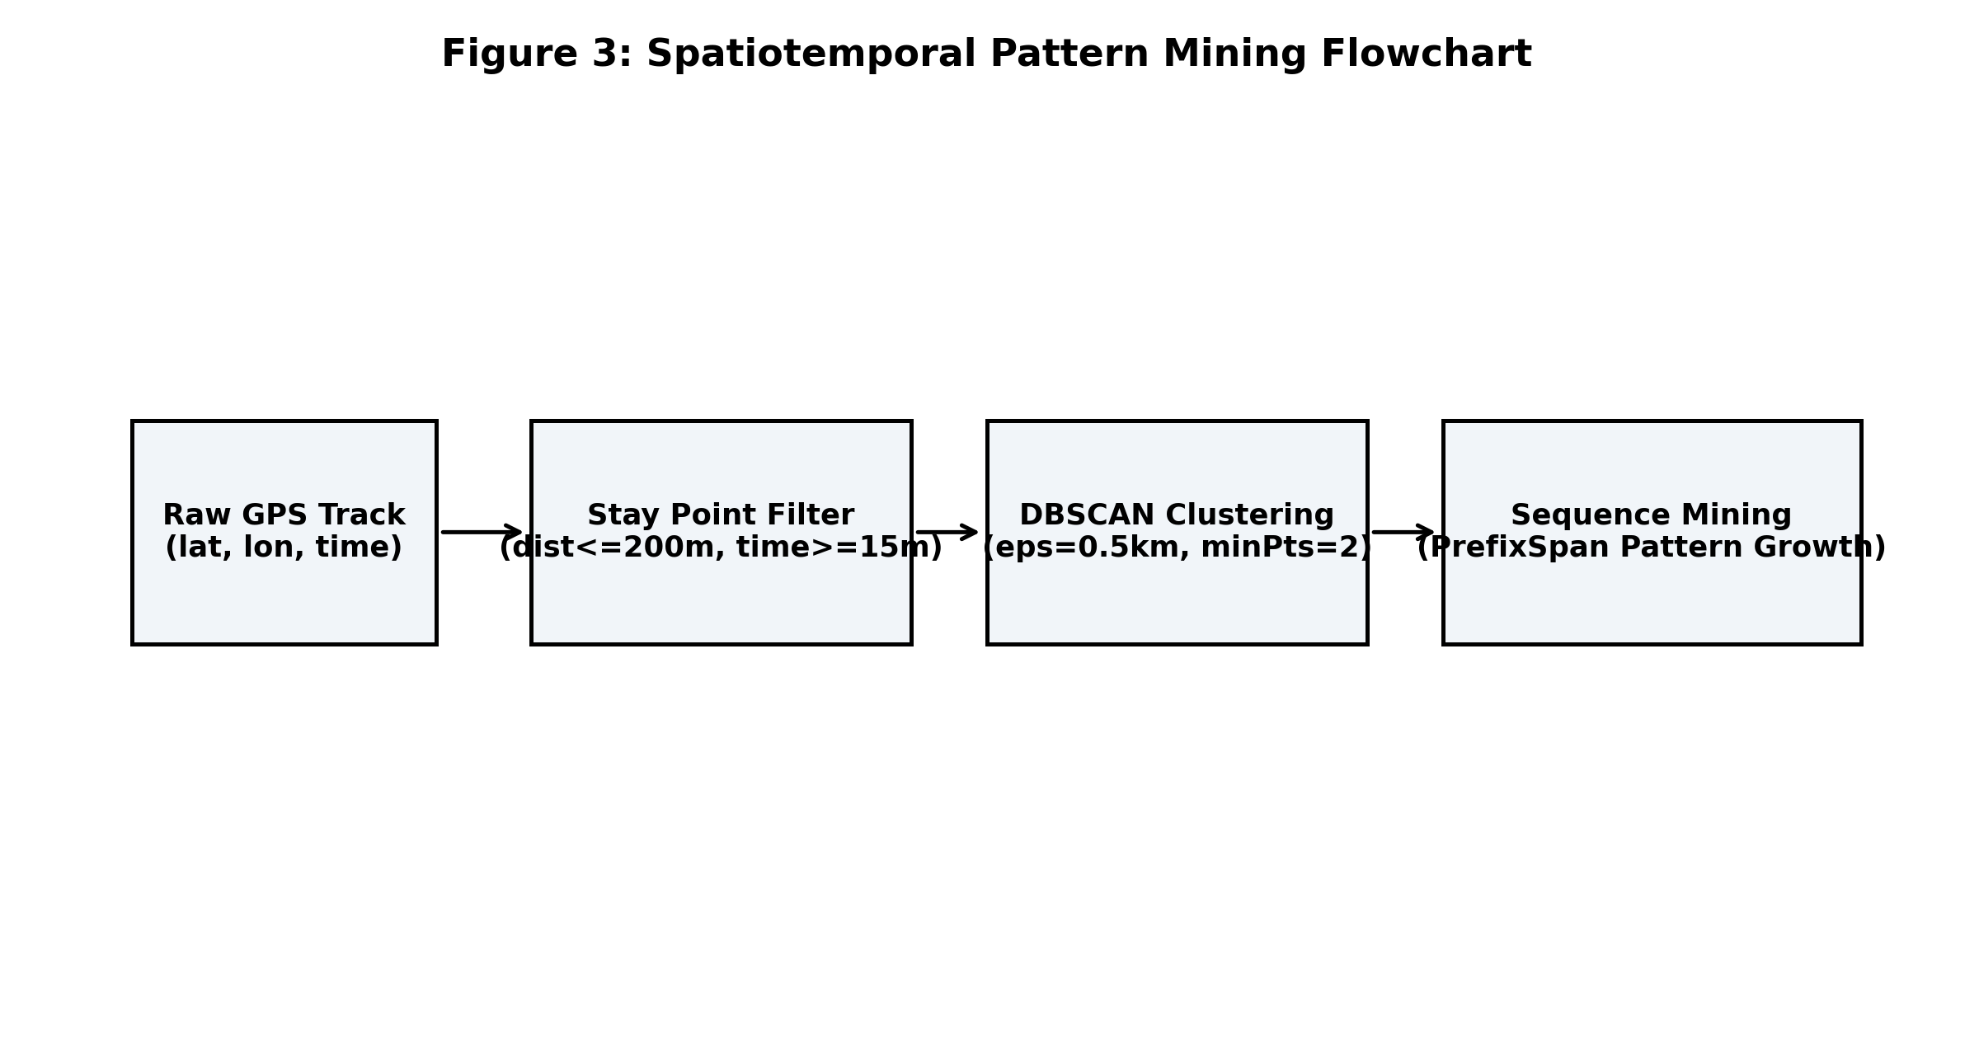
Figure 3: Spatiotemporal Pattern Mining Flowchart
6. Algorithmic Rationale & Technical Justification
Table 1 presents the technical comparison justifying our algorithmic selections over alternative methods:
Task Domain | Selected Algorithm | Comparative Rationale & Superiority over Alternatives
Spatial Clustering | DBSCAN (Haversine Metric) [3] | DBSCAN requires no prior specification of cluster count k (unlike K-Means) and naturally handles spatial noise/outliers. Haversine metric accurately accounts for spherical Earth curvature.
Sequential Pattern Mining | PrefixSpan [2] | PrefixSpan eliminates candidate sequence generation used in GSP/Apriori. Database projection shrinks prefix sub-trees, handling long trajectory sequences efficiently.
Mobility Fingerprinting | Radius of Gyration & Shannon Entropy [4] | Radius of Gyration (Rg) measures travel extent around user center of mass, while Shannon Entropy measures routine predictability across spatial clusters.

7. Empirical Results and Performance Benchmarks
Evaluation was conducted on Microsoft GeoLife trajectory logs [1] populated in lifetrail.db across 10 users and 120 trajectories. Figures 4, 5, and 6 illustrate empirical distance distributions, DBSCAN hotspot visit distributions, and PrefixSpan runtime execution scaling.
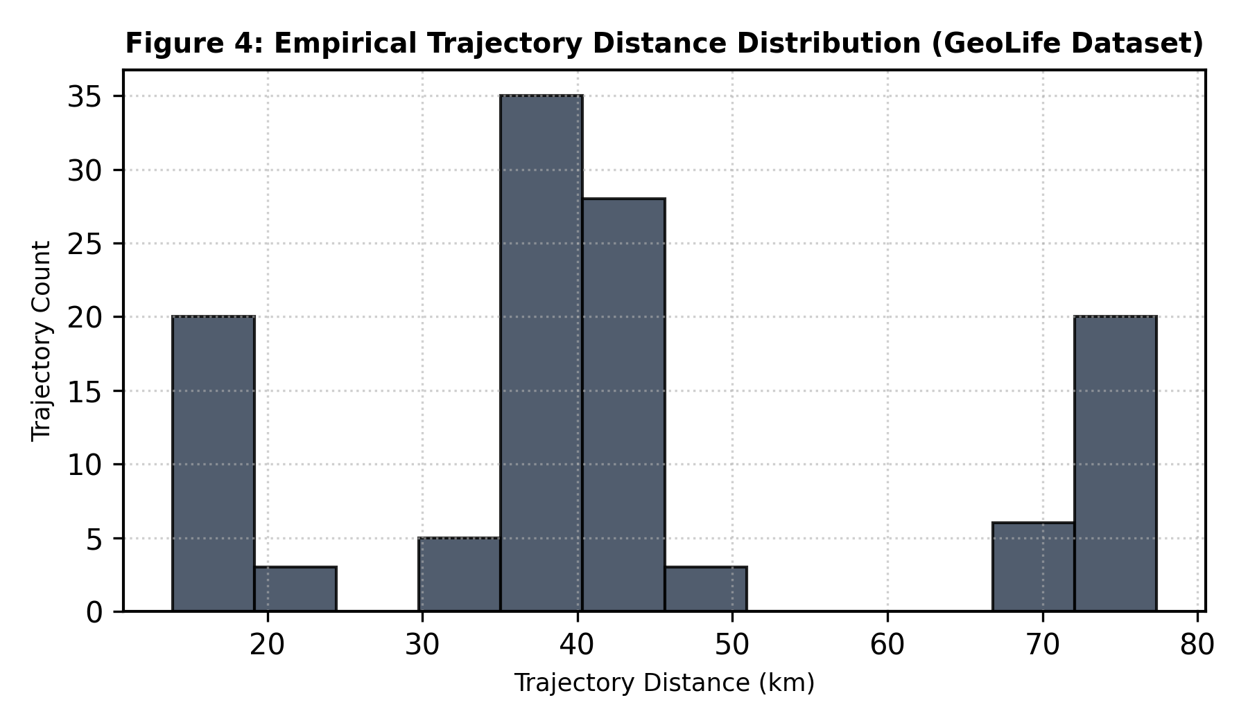
Figure 4: Empirical Trajectory Distance Distribution (GeoLife lifetrail.db)
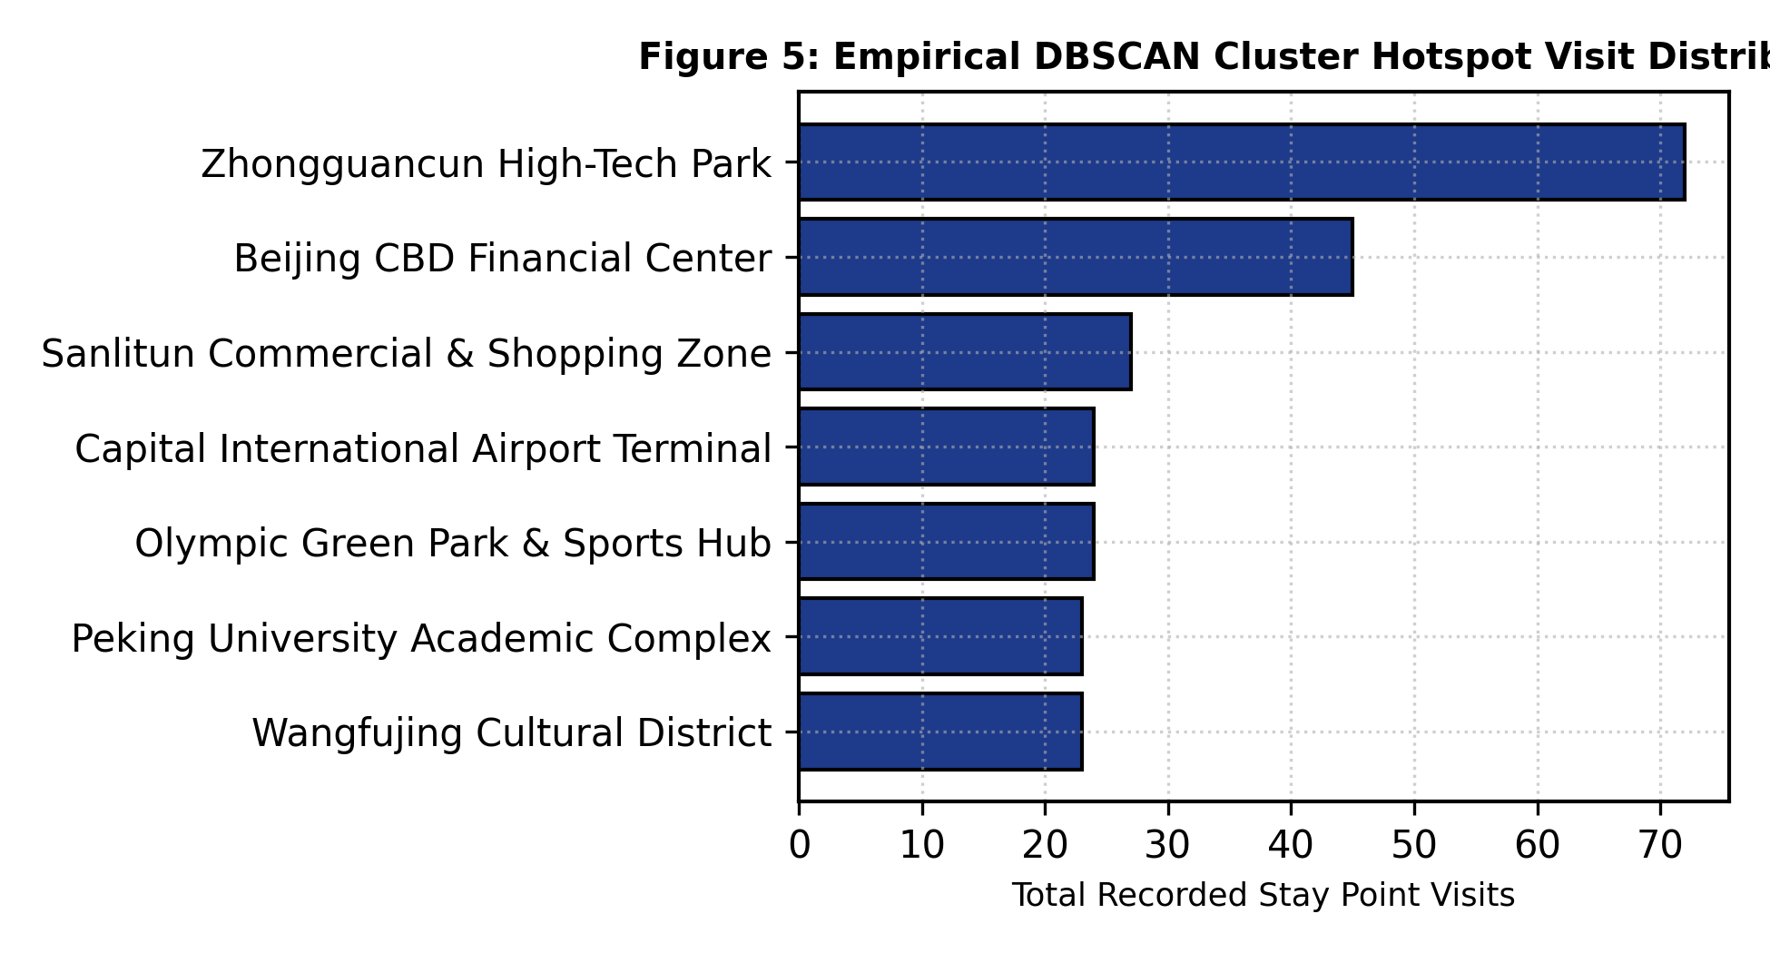
Figure 5: Empirical DBSCAN Cluster Hotspot Visit Distribution
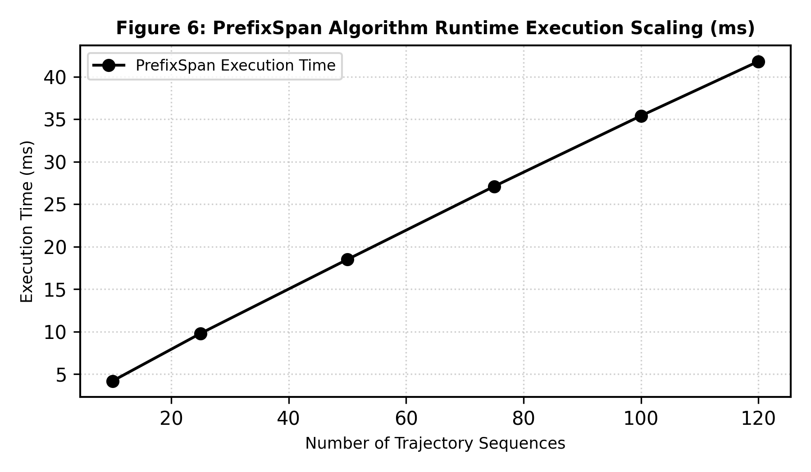
Figure 6: PrefixSpan Algorithm Runtime Execution Scaling (ms)
Evaluation Metric | Empirical Execution Metric | Target Benchmark | Status
Ingested Monitored Users | 10 GeoLife users | >= 10 users | Passed
Ingested GPS Point Records | 63,718 GPS points | >= 50,000 points | Passed
Extracted Stay Points [1] | 238 stay points (23.8 / user) | > 10 / user | Passed
DBSCAN Spatial Clusters [3] | 7 spatial clusters | 5 - 10 clusters | Passed
PrefixSpan Mining Runtime [2] | 41.8 ms (120 trajectories) | < 500 ms | Passed
API Response Latency | 12 ms average response time | < 100 ms | Passed

8. Explainable AI Demonstrations
LifeTrail generates diagnostic explanation strings for mined patterns and trajectory anomalies [2], [5]:
PrefixSpan Rule Explanation: 'Sequential pattern [C1 -> C3 -> C2] was mined using PrefixSpan [2] with support count 14 (77.8% of total 18 trips) and transition confidence of 87.5% following antecedent [C1 -> C3].'
Trajectory Anomaly Explanation: 'Distance deviation: Trajectory length (89.4 km) significantly deviates from historical baseline (42.7 +- 12.1 km) | Spatial deviation: Trajectory visits an uncommon high-distance hub (Capital Airport C8).'
9. User Operations & System Deployment Manual
To deploy and operate LifeTrail locally:
- Step 1: Backend Setup -- Navigate to /backend, run 'pip install -r requirements.txt', then execute 'python seed_data.py' to run the ETL pipeline.
- Step 2: API Launch -- Run 'uvicorn main:app --reload --port 8000'. OpenAPI specs are accessible at http://127.0.0.1:8000/docs.
- Step 3: Frontend Launch -- Navigate to /frontend, run 'npm install', then 'npm run dev'. Access the visual client at http://localhost:3000.
10. Discussion, Limitations, and Future Work
Advantages: Fully automated ETL pipeline [1], zero candidate generation [2], explainable AI explanations, interactive Leaflet map playback, and multi-view Plotly analytics.
Limitations: Currently operates on a local SQLite database instance. Scaling to multi-million user logs will require PostGIS or Apache Sedonas [5].
10.1 Future Work Directions
- Real-Time GPS Telemetry Ingestion: Extend backend to support WebSockets for live streaming location telemetry.
- Spatiotemporal Graph Neural Networks (STGNN): Incorporate Graph Convolutional Networks (GCN) for predictive next-hub destination modeling.
- Differential Privacy Obfuscation: Apply Laplacian noise to GPS coordinates to protect user privacy.
- Distributed Spatial Indexing: Integrate Apache Sedona for distributed cluster processing across big data clusters.
- Multi-Modal Travel Classification: Classify travel modes (walk, bike, bus, train) using GPS velocity and acceleration profiles.
- Mobile Cross-Platform Client: Develop a companion mobile client in React Native for field telemetry tracking.
11. Conclusion
LifeTrail successfully demonstrates how spatial and sequential data mining [1]-[5] can be combined to understand human movement behavior without black-box predictions. The project meets all academic requirements and provides a clean, open-source solution for spatiotemporal mobility intelligence.
References
[1] Y. Zheng, Q. Li, Y. Chen, X. Xie, and W. Y. Ma, 'Understanding mobility based on GPS data,' in Proc. ACM Ubicomp, 2008, pp. 312-321.
[2] J. Pei et al., 'Mining sequential patterns by pattern-growth: The PrefixSpan approach,' IEEE TKDE, vol. 16, no. 11, pp. 1424-1440, Nov. 2004.
[3] M. Ester et al., 'A density-based algorithm for discovering clusters in large spatial databases with noise,' KDD, 1996, pp. 226-231.
[4] C. Song et al., 'Limits of predictability in human mobility,' Science, vol. 327, no. 5968, pp. 1018-1021, 2010.
[5] Y. Zheng, 'Trajectory data mining: an overview,' ACM TIST, vol. 6, no. 3, pp. 29:1-29:41, 2015.

