Female:

|  |  |  |  |  |  |  |  |
| --- | --- | --- | --- | --- | --- | --- | --- |
| GND | GND | PWR | PWR | White w/orange stripe | White w/blue stripe | White w/green stripe | White w/brown stripe |
| GND | GND | PWR | PWR | Orange | Bue | Green | Brown |

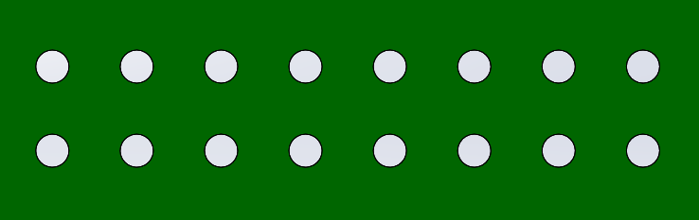

Male:

|  |  |  |  |  |  |  |  |
| --- | --- | --- | --- | --- | --- | --- | --- |
| White w/brown stripe | White w/green stripe | White w/blue stripe | White w/orange stripe | PWR | PWR | GND | GND |
| Brown | Green | Blue | Orange | PWR | PWR | GND | GND |

