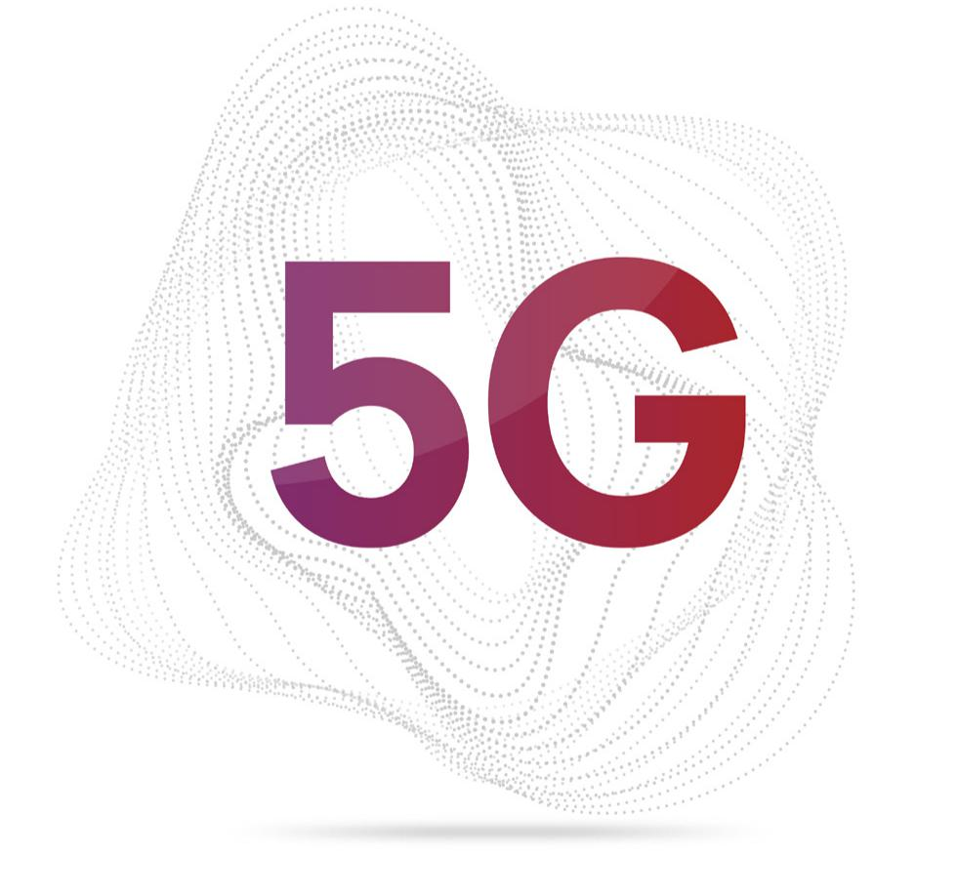
KNOWING

Authored by: Amar Nath Singh

Manager Managed Services
Skype: amar_ns
Email: amar.singh@subex.com
Website: www.subex.com
Subex Limited, RMZ Ecoworld, Outer Ring Road,
Devarabisanahalli, Bangalore – 560037, India.

Document Title

Version 1.0
INDIA  Subex Limited  Adarsh Tech Park  Outer Ring Road  Devarabisanhalli  Bangalore - 560,037, India  Tel: +91 80 6659 8700  Fax: +91 80 6696 3333  www.subexworld.com | USA  Subex, Inc  12101 Airport Way Suite 300  Broomfield, CO  Tel: +1 303 301 6200  Fax: +1 303 301 6201 | SINGAPORE  Subex (Asia Pacific) Pte Limited  Pte Limited  175A Bencoolen Street  #06-06/07 Burlington Square  Singapore 189650  Tel: +65 6338 1218  Fax: +65 6338 1216
CANADA  Subex Americas Inc.  30 Fulton Way  Richmond Hill, Ontario  Canada L4B 1E6  Tel: +1 905 886-7818  Toll free:+1 877 899-4612  Fax: +1 905 886-9076 | UK  Subex (UK) Limited  3rd Floor, Finsbury Tower  103-105 Bunhill Row  London, EC1Y 8LZ UK  Tel: +44 20 7826 5420  Fax: +44 20 7826 5437 | DUBAI  Subex Limited Office  # 1304, Al Shatha Tower,  Dubai Media City,  P.O. Box: 502520, Dubai,  United Arab Emirates  Tel: +971 4 3642591  Fax: +971 4 3697648

IMPORTANT NOTICE
This document constitutes confidential and proprietary information of Subex Limited. The contents of this document may be accessed and/or used solely by a licensee of Subex Limited software product(s) and solely in connection with the licensee’s authorized use of such product(s), or as otherwise expressly permitted by Subex Limited in writing. All other uses are prohibited. This document may not in any event be disclosed to any third party without the prior written authorization of Subex Limited.
Subex™ is the trademark of Subex Limited. All other brands and product names identified in this publication are trademarks or registered trademarks of their respective companies or organizations.
Copyright© Subex Limited
All rights reserved. No part of this document may be reproduced or transmitted in any form or by any means, electronic or mechanical, including photocopying, recording, or information storage and retrieval systems for any purpose without the express written permission of Subex Limited.

Abstract
The objective of this white paper is to bring to light facts about 5G technology. How it is different from 4G and what new Business opportunites 5G brings along with it.
Revision History
Sl. No. | Date | Author | Version
1 | 05-May-2017 | Amar Nath Singh | Initial Draft
2 | 08-May-2017 | Amar Nath Singh | Updated

Table of Contents
1. Preface 6
2. What is new in 5G? 6
3. 5G Features 7
4. Conclusion 9
5. 4G vs. 5G 11
6. References 11

Preface
5G promises to deliver much more than just higher data rates and more capacity. It targets new kinds of ultra-reliable, mission-critical services. Examples include, applications that will allow doctors to remotely control medical procedures or give consumers new levels of control over their homes or cars, and beyond. 5G aims to effectively connect virtually everything—from simple sensors to complex robots, all while further enhancing traditional mobile broadband service. That means next generation of applications, services and use cases will have extreme variation in requirements. To meet this challenge, 5G will require a whole new user-centric design that can scale and adapt to billions of connected things, provide new ways of connecting everything, and enhance cost and energy efficiency.

What is new in 5G?
5G is envisioned to be a unified platform for all types of spectrum and bands, from low bands below 1 GHz to emerging higher bands like mmWave, supporting a wide range of new kinds of services, while offering opportunity for new deployment, subscription, charging and business models

Mobile is already the biggest technology platform in the history. 3G introduced the concept of mobile broadband, and the popularity of smartphones combined with the advent of 4G resulted in the explosion of ever-increasing mobile data traffic that we call the 1000x mobile data challenge. Thanks to the rapid development of mobile computing and the robust LTE Advanced roadmap, the industry is on track to meet the challenge. The 1000x challenge is being addressed by 3G, 4G, and Wi-Fi, and through the growing deployment of small cells along with more spectrum.
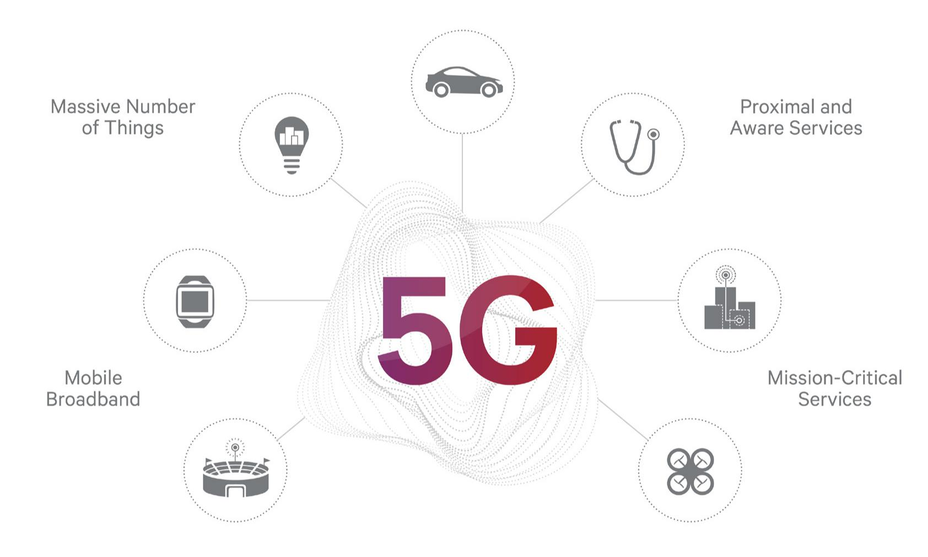

Given that positive prognosis for the future, the question arises, why do we need 5G, and what can it do for us that 4G can’t? The answer is that the vision for 5G is to not only provide better broadband with higher capacity and higher data rates at much lower cost, but also to address entirely new challenges that span far beyond, to enable new services, empower new types of user experiences, and connect new industries.

Looking beyond today’s trends, 5G aims to connect virtually everything, to go beyond needs of what humans can currently perceive, to meet requirements for new classes of services, with new levels of reliability and latency, and to bring new capabilities for control, discovery, and awareness to life. A vision of this magnitude requires not just a new way of thinking but a different kind of a network. 4G LTE initially provided better mobile broadband, but LTE Advanced in many ways is already heading in the same transformational direction as 5G.

5G Features

So, what does this new kind of network entail? Such a network could be defined by four characteristics:

SCALABILITY AND ADAPTABILITY

5G will have the ability to scale and adapt across an extreme variation of use cases such as uniform, fiber-like broadband everywhere (not just higher peak data rates) services; ultra-reliable, mission-critical services such as controlling the power grid or remote medical procedures (where failure is not an option); and connecting everything from simple sensors to complex robots, which also means supporting billions of ultra-low energy devices needing expansive coverage, at very-low data rates and at ultra-low cost.

USER CENTRIC DESIGN

The design approach for 5G is rooted in keeping the user at its center. Whether the user is a human, a device, or a “thing,” it will bring content, connectivity, and computing close to the user. For connectivity, users are more than mere end points, they are integral parts of the network (offering “edgeless” connectivity). This distributed approach combined with virtualized network functions will not only reduce latency, but also significantly improve cost and energy efficiency, which are key objectives for any new-generation technology.

To scale for billions of connected things, reduce latency, and improve cost and energy efficiency, 5G needs a holistic approach that keeps the user at the center. This means, bringing not only connectivity, but computing and content close to the user. Depending on the use case, the user could be a human with a device or wearable, a connected thing such as a sensor, or a connected vehicle such as a car. Bringing the connectivity, computing and content closer to the user is of paramount importance to provide instant and immersive visual and audio experiences based on real-time input from on-device cameras and sensors, on-device content (or content cached at the network edge), as well as a way to utilize new ways of discovering and connecting directly to relevant things around the user.

UNIFIED PLATFORM

5G will unify access across all types of spectrum and bands, unify all that has been added to 4G, (such as LTE broadcast), and improve upon new, broader dimensions (beyond that of previous generations) to enable a wide range of new kinds of services. And the unified platform needs to be scalable for new deployment, business and pricing models as well as be suited for realizing new breeds of applications, services and use cases.

DEVICES ARE NO LONGER JUST ENDPOINTS

In a world with billions of connected things, 5G will make it possible for the user to connect to relevant things that are nearby and, in many cases that connection will be made directly, without having to go back and forth through a central network. In 5G where connectivity is user-centric, the user is no longer the endpoint of the network, but rather an integral part of it. New ways of connecting will be possible. Devices will connect with one another directly, for both discovery and communication.
Devices will “multi-hop,” relaying connectivity to things around the user (and the device), as explained below.

- Device-to-device connectivity seeks out (discovers) relevant information within proximity of the user, and has the ability to communicate directly with other devices. Already introduced in 4G, the proximal discovery concept will be leveraged and expanded further in 5G.

Multi-hop is a mode of connectivity where devices act as hubs and relays for other devices, even forming a mesh network. It will be controlled by operators utilizing their licensed spectrum, as well as by users using unlicensed spectrum. A sample use case is in machine-to-machine (m2m) communication where a simple device lacks the power needed to reach macro towers or small cells. In such a scenario, other devices that are connected to the macros/small cell form a “multi-hop” or mesh network to extend the coverage and connect the unconnected device.
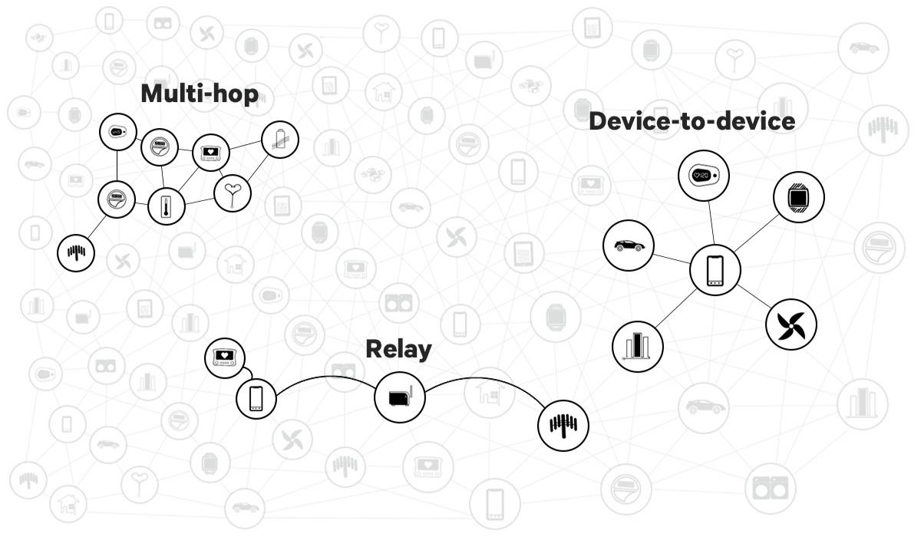

As evidenced by its defining characteristics, 5G is not just a new generation of technology, but a fundamentally new kind of a network needed to address the expanded connectivity needs of the next decade and beyond.

Conclusion
At the dawn of the new generation of wireless, the vision for 5G is still aspirational, yet deeply rooted in the collective wisdom gained though many years of technology development and commercialization. The extreme variations of anticipated needs for the next-generation is guiding its development. The vision is to create a new generation of technology that is scalable and adaptable enough to support new kinds (and levels) of services and use cases ranging from connecting simple sensors to mission-critical applications like remote control medical procedures to complex robots. The goal is not only to make mobile broadband faster and better, but to provide uniform, “fiber-like” broadband everywhere.

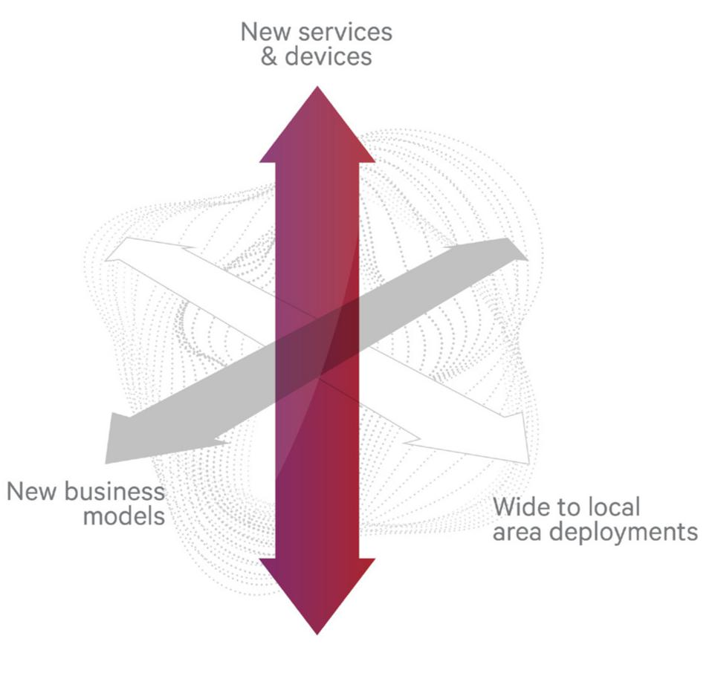
The same he user-centric approach is at the heart of 5G, where connectivity, computing, and content all come together, close to the user, be it a human, a vehicle, a
machine, or a thing. From a connectivity perspective, these users will no longer be mere end-points, they will be integral parts of the network, creating “edgeless” connectivity.
5G is envisioned to be a unified platform to address the expanded connectivity needs of the next decade and beyond, not only providing the most appropriate connectivity, but also offering opportunities for new deployment models, sharing models, charging/subscription models. A key enabler is the unified air interface that is scalable and adaptable across all spectrum types, both below and above 6 GHz, licensed and unlicensed spectrum, and across an extreme variation of services.

Through its common single core network, 5G will support 4G and Wi-Fi access, as well as simultaneous 5G, 4G, and Wi-Fi connectivity with multimode devices enabling seamless introduction of 5G services, and protecting operators’ investments. The vision for 5G is to usher in a new era in which connectivity, computing, and content become inseparable parts of every “body” and every “thing,” making invisible magic happen. It aims to be a transformational force in enabling new services, connecting new industries, and empowering new user experiences of the next decade and beyond, where LTE Advanced is blazing a similar path—a transformative path forward.

4G vs. 5G
1. First and foremost, while the LTE-based 4G networks are going through a rapid deployment, 5G networks mostly comprise of research papers and pilot projects. The wireless industry is broadly targeting 2020 for the widespread deployment of 5G networks.
2. Wireless networks till 4G mostly focused on the availability of raw bandwidth, while 5G is aiming on providing pervasive connectivity to lay grounds for fast and resilient access to the Internet users, whether they are on a top of a skyscraper or down under a subway station. Although LTE standard is incorporating a variant called machine type communications (MTC) for the IoT traffic, 5G technologies are being designed from grounds up to support MTC-like devices.
3. The 5G networks are not going to be a monolithic network entity and will be built around a combination of technologies: 2G, 3G, LTE, LTE-A, Wi-Fi, M2M, etc. In other words, 5G will be designed to support a variety of applications such as the IoT, connected wearables, augmented reality and immersive gaming.
Unlike its 4G counterpart, 5G network will offer the ability to handle a plethora of connected devices and a myriad of traffic types. For example, 5G will provide ultra-high-speed links for HD video streaming as well as low-data-rate speeds for sensor networks.
5. Finally, 5G will spearhead the use of cognitive radio techniques to allow the infrastructure to automatically decide about the type of channel to be offered, differentiate between mobile and fixed objects, and adapt to conditions at a given time. In other words, 5G networks will be able to serve the industrial Internet and Facebook apps at the same time.

References
- Web

