G4AB1_BED_GRADEDPROJECT4 SCREENSHOTS

1. ADD ROLE

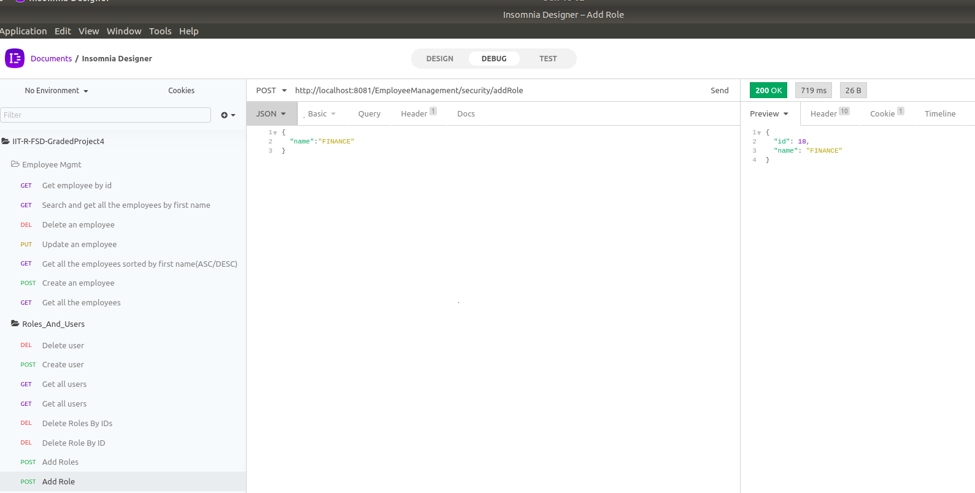

2. ADD USER

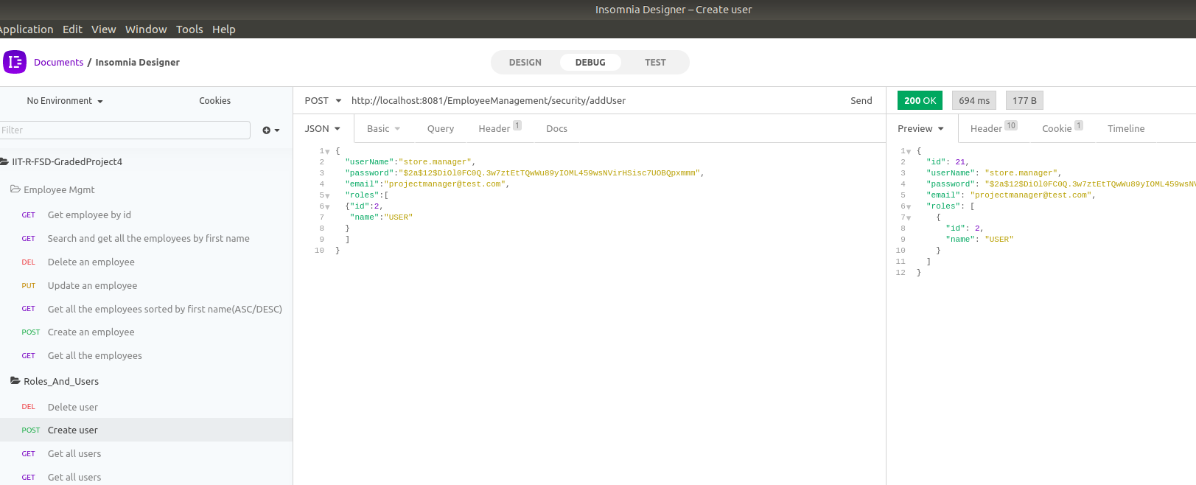

3. ADD AN EMPLPOYEE
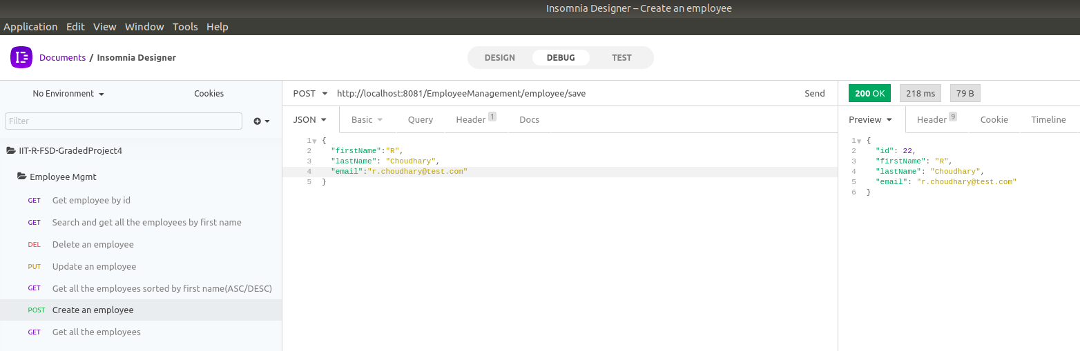

4. LIST ALL EMPLOYEES
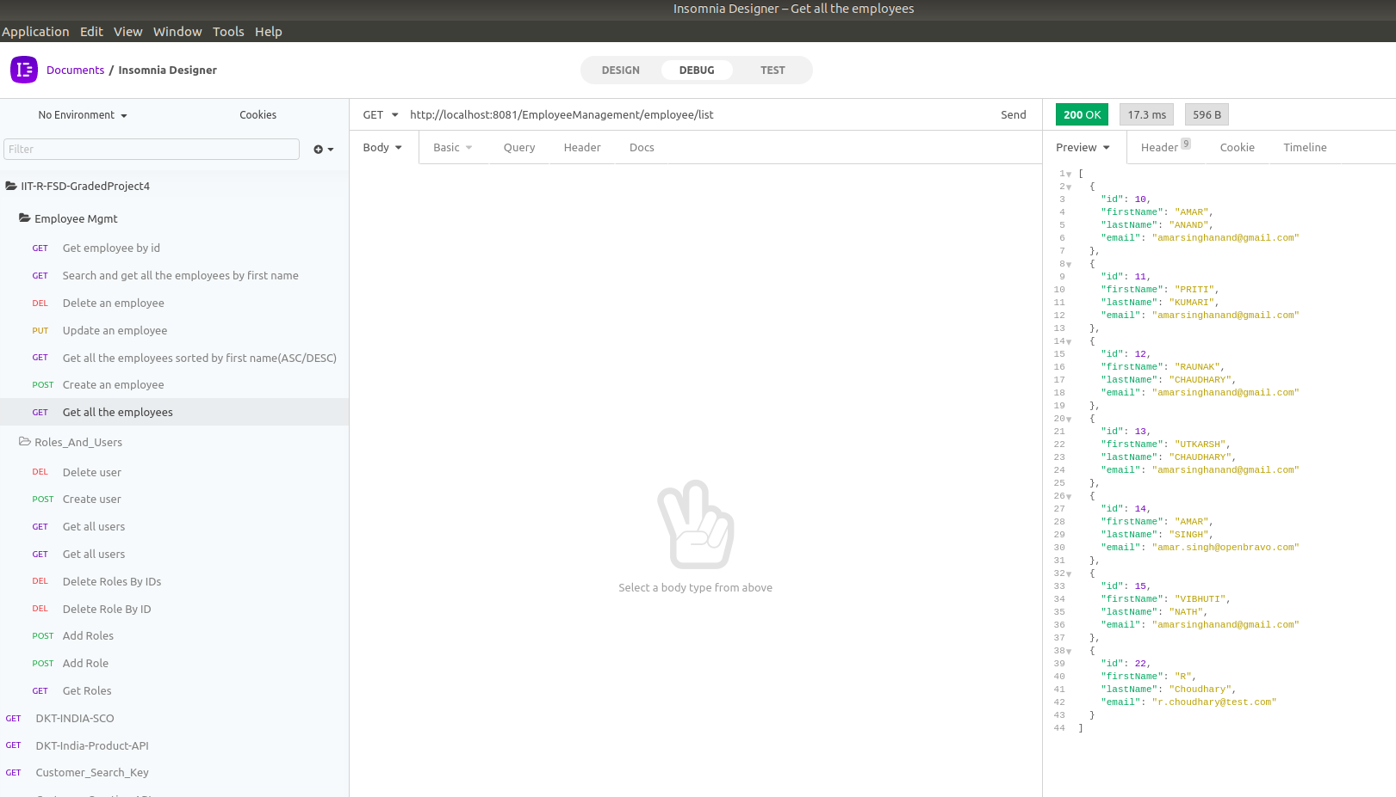
5. GET AN EMPLOYEE BY ITS ID
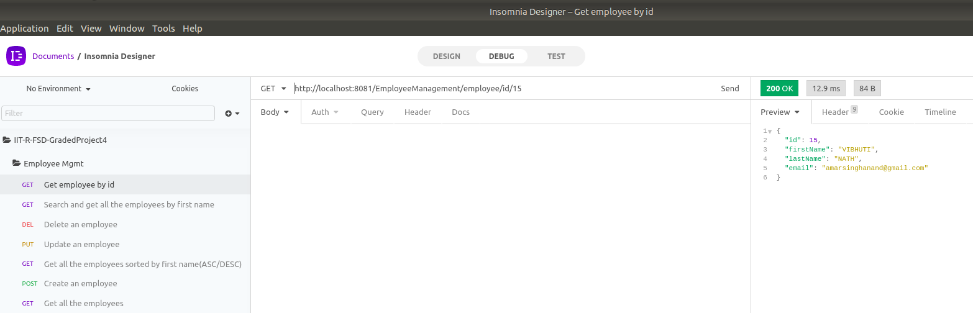

6. UPDATE AN EMPLOYEE
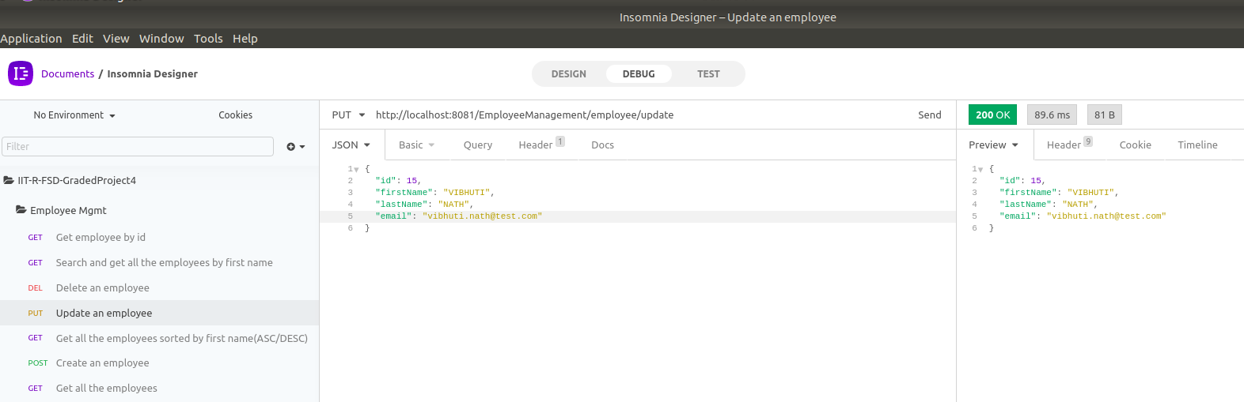

7. DELETE AN EMPLOYEE
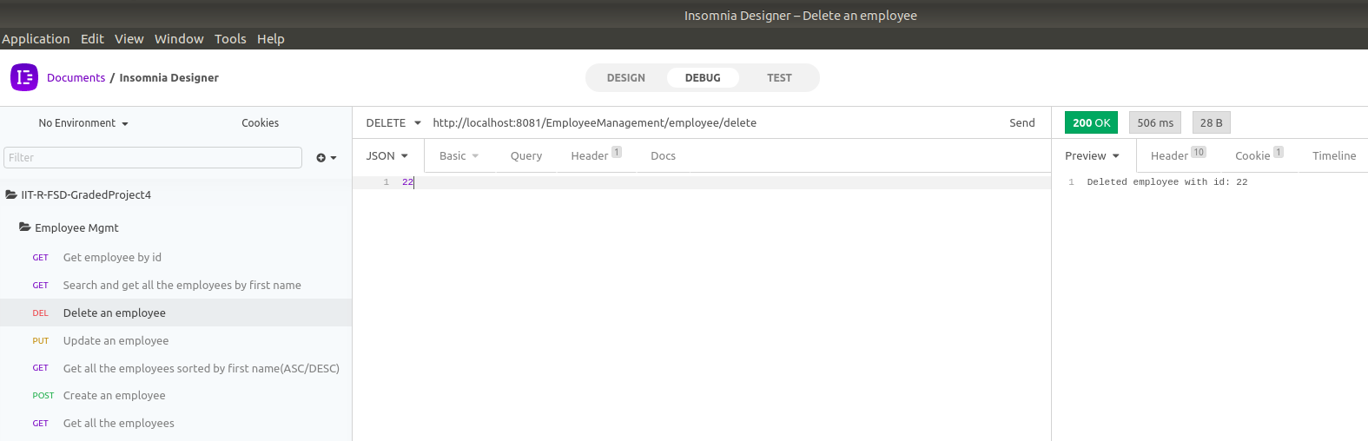

8. SEARCH EMPLOYEE BY FIRST NAME

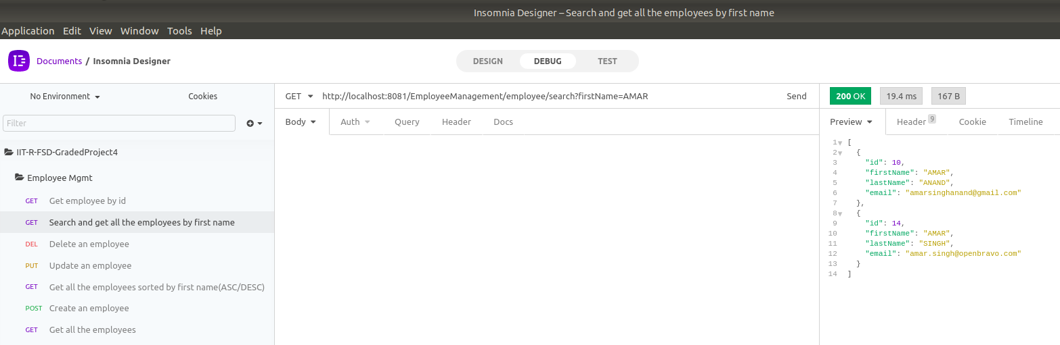

9. SORT EMPLOYEE LIST IN ASCENDING ORDER
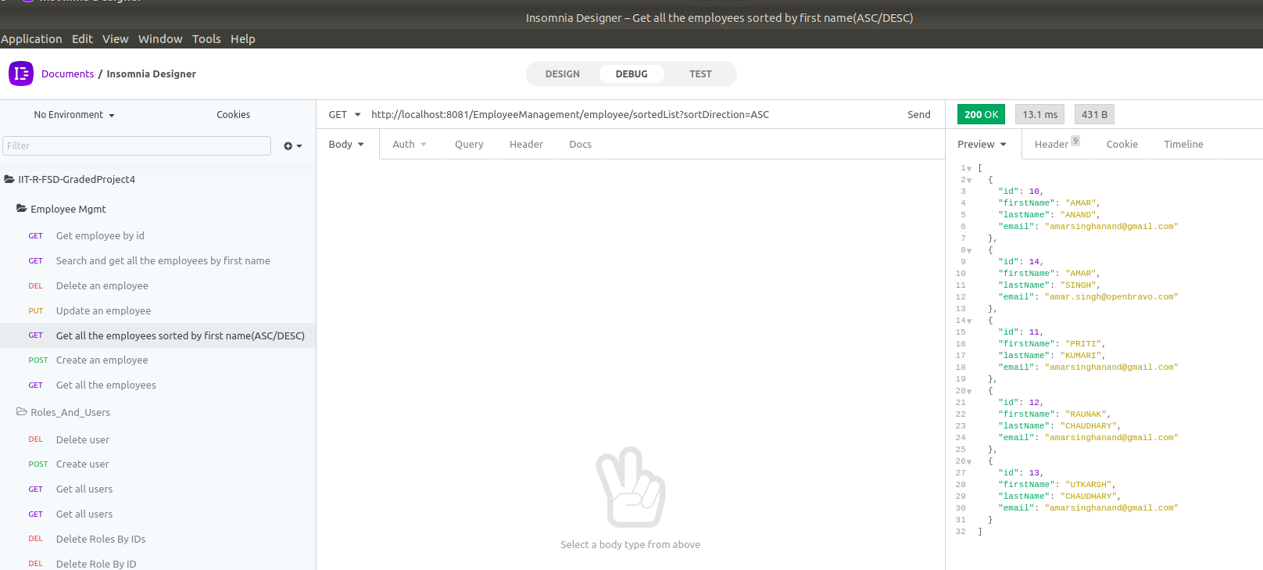

10. SORT EMPLOYEE LIST IN DESCENDING ORDER

