**AI-Embeded Virtual Personal Trainer**

**Team Member**

Vineela Reddy Sirasanambeti

Himaja Boinapally

Jyothika Raj Samineni

Lakshmi Surekha Maddukuri

**Goals and Objectives:**

**Motivation:**

The motivation for our project is increase of consciousness in people regarding their health and fitness in today’s evolving society. As a result, there is a surging demand for personalized fitness solutions that cater to individual needs and lifestyles. Unfortunately, not everyone has the time, resources, or access to expert guidance. This creates a pressing need for an innovative solution.

The goal of our project is to create a virtual personal trainer by combining the strengths of Natural Language Processing and Artificial Intelligence. This virtual trainer will act as a personalized diet and exercise coach, assisting users in successfully achieving their health and fitness goals. It enables users to make educated decisions and enhance their general well-being by providing customized fitness regimens and nutritional advice.

The importance of this project can be seen in its ability to communicate fitness coaching and make it available to a larger audience. No matter where someone lives or their financial situation, our virtual trainer makes sure that they can get access to high-quality fitness advice. Additionally, this research fits in with the greater movement of utilizing AI to improve people's lives, especially in the context of health and wellbeing.

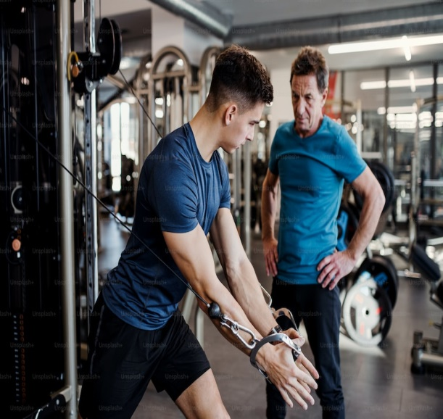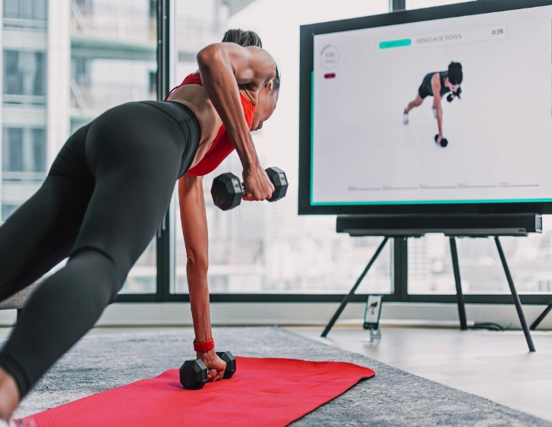

**Objectives:**

Our project is focused on a number of ambitious goals that are aimed at creating a virtual fitness coach powered by artificial intelligence that is especially attentive to the various and changing needs of clients. These goals are crucial for the successful completion of our project, but they also have significant implications for addressing the growing need for personalized wellness plans.

The main purpose is to develop a virtual fitness coach powered by simulated intelligence who can recognize and respond to each client's unique health objectives, dietary preferences, and needs. This objective is crucial to the project since it influences the central insight of the virtual coach. To accomplish this, our group will utilize cutting edge AI calculations and information driven methods to guarantee that the virtual mentor can precisely decipher and answer client input, regardless of how assorted or explicit their wellness prerequisites might be.

The subsequent goal centers around making an easy to understand versatile application interface that works with consistent connection among clients and the virtual mentor. This point of interaction will act as the essential resource, permitting clients to handily include their wellness objectives, dietary inclinations, and other significant data. Guaranteeing an easy to understand experience is principal to support far reaching reception and make the advantages of the virtual mentor open to people of every innovative foundation.

The other important goal includes the execution of Normal Language Handling (NLP) calculations to empower regular and natural correspondence among clients and the virtual coach. Clients ought to have the option to collaborate with the coach in plain language, making the experience conversational and locking in. Utilizing NLP methods will upgrade the virtual mentor's capacity to furnish precise reactions and construct compatibility with clients, adding to a more powerful instructing experience.

The fourth and last goal spins around the conveyance of customized exercise routine schedules and dietary proposals in view of clients' feedback. This is a definitive incentive of our undertaking. By fitting wellness plans and nourishing counsel to individual inclinations and imperatives, we engage clients to assume command over their wellbeing and wellness venture. This personalization guarantees that clients get direction that lines up with their extraordinary requirements, improving the probability of accomplishing their wellness objectives.

In outline, these goals are the foundations of our venture, all in all attempting to make a man-made intelligence driven virtual fitness coach that is savvy, available, conversational, and customized. Accomplishing these targets will contribute essentially to tending to the developing interest for customized wellness arrangements and improving by and large wellbeing and prosperity.

**Significance:**

The meaning of this undertaking is highlighted by its convenient reaction to the developing wellbeing and health scene. As people progressively focus on their prosperity, the interest for customized wellness arrangements has flooded. Our simulated intelligence improved virtual fitness coach tends to this request head-on, adjusting impeccably with the continuous wellbeing and health pattern.

By conveying customized wellness plans and nourishing counsel, this task goes past simple comfort; it effectively adds to the comprehensive prosperity of clients. It engages people to carry on with better existences, advancing long haul medical advantages and cultivating positive way of life changes.

Additionally, the task takes out topographical and monetary obstructions, democratizing master wellness training. Presently, people from varying backgrounds, no matter what their area or monetary assets, can get to great wellness direction.

This drive is essential for a more extensive development utilizing man-made intelligence to upgrade individuals' lives. It addresses a substantial illustration of how man-made intelligence innovations can be bridled for positive social effect, underlining wellbeing and wellness enhancements as a center feature of worked on personal satisfaction. As the world keeps on embracing computer based intelligence to improve society, our undertaking remains as a brilliant illustration of computer based intelligence driven development zeroed in on upgrading people's wellbeing and wellness levels, subsequently working on their general personal satisfaction.

**Features:**

Deliverables:

A portable application with an instinctive and easy to understand interface for easy collaboration with the virtual coach.

A refined NLP-based conversational man-made intelligence fit for understanding and answering clients' wellness inquiries and inclinations.

Customized exercise plans and dietary suggestions, consistently refreshed in light of client progress.

Mix with wearable wellness trackers for constant observing and criticism.

Uniqueness:

Personalization: The virtual coach adjusts to individual objectives and inclinations, offering a profoundly modified wellness experience.

Ongoing following: Combination with wearables guarantees that clients get constant criticism on their wellness process.

**Milestones:**

Milestone 1: Data collection and Data Cleansing.

Milestone 2: Performing the NLP techniques for language understanding.

Milestone 3: Performing the machine learning techniques for Recommendations.

Milestone 4: Integrating all the modules for the results.

**Techincal Features:**

Use NLP libraries spaCy , NLTK, n-gram model of language for normal language understanding.

Execute a proposal framework for customized wellness and dietary plans.

Frame Works like Scikit- learn or Pytorch will be used to perform machine learning for recommends. We are planning to use CNN technique.

Incorporate with APIs of wellness data sets for exercise ideas.

**Data Set link:**

[https://www.kaggle.com/datasets/niharika41298/gym-exercise-data 4](https://www.kaggle.com/datasets/niharika41298/gym-exercise-data%204)

**References**

1. Topol, E. J. (2019). Elite execution medication: the combination of human and man-made brainpower. Nature Medication, 25(1), 44-56.

2. Goldberg, Y. (2016). An introduction on brain network models for normal language handling. Diary of Man-made reasoning Exploration, 57, 345-420.

3. Swartz, A. M., and Repetition, A. E. (2017). Assessing wearable innovation for actual work reconnaissance. Diary of Active work and Wellbeing, 14(10), 823-826.

4. Vandelanotte, C., Müller, A. M., Short, C. E., Hingle, M., Nathan, N., Williams, S. L., and Lopez, M. L. (2016). Past, present, and fate of eHealth and mHealth exploration to work on active work and dietary ways of behaving. Diary of Sustenance Training and Conduct, 48(3), 219-228.

5. Heer, J., and Shneiderman, B. (2012). Intelligent elements for visual examination. Interchanges of the ACM, 55(4), 45-54.

6. Li, H., Wu, J., and Gao, Y. (2020). Investigating the determinants of clients' duration expectation in wellness application: A drawn out assumption affirmation model. Worldwide Diary of Data The executives, 50, 227-240.

7.Prochaska, J. O., and Velicer, W. F. (1997). The transtheoretical model of wellbeing conduct change. American Diary of Wellbeing Advancement, 12(1), 38-48.

8.Jurafsky, D., and Martin, J. H. (2020). Discourse and Language Handling: A Prologue to Normal Language Handling, Computational Semantics, and Discourse Acknowledgment (third ed.). Pearson.

9.Leavitt, N. (2016). Portable application advancement: What you want to be aware. PC, 49(5), 82-86.