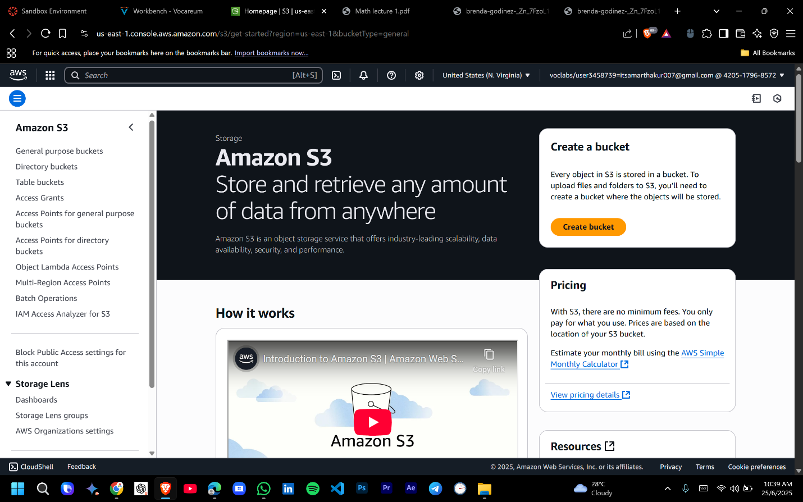

**Step 1: Create an S3 Bucket for Website Hosting**

**Step 2: Upload Website Files**

**Step 3: Configure S3 Bucket Policy for Public Access**

**Step 4: Register a Domain (if needed) in Route 53**

**Step 5: Create a Hosted Zone in Route 53**

**Step 6: Set Up CloudFront for Content Delivery**

**Step 7: Update Route 53 DNS Records**

**Step 8: Verify and Test the Website**

