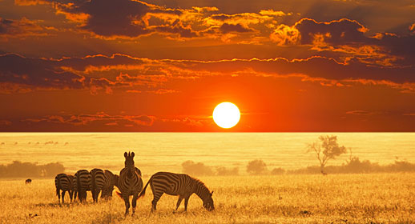
The Adventure Tour at Serengeti National Park
Traveller

The Serengeti National Park is a Tanzanian national park in the Serengeti ecosystem in the Mara and Simiyuregions. It is famous for its annual migration of over 1.5 million white bearded (or brindled) wildebeest and 250,000zebra and for its numerous Nile crocodile.

The Maasai people had been grazing their livestock in the open plains of eastern Mara Region, which they named "endless plains", for around 200 years when the first European explorer, German Oscar Baumann, visited the area in 1892. The name "Serengeti" is an approximation of the word used by the Maasai to describe the area, siringet, which means "the place where the land runs on forever."

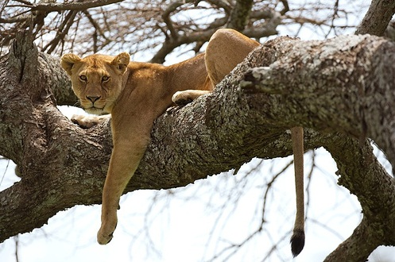
Day 1
Join tour in Arusha

Day 2
Drive to Manyara National Park;
Afternoon Game Drive
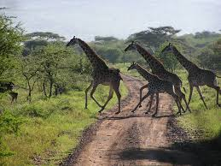
Day 3
Game drives in the Serengeti National Park

Day 4
Return to Arusha

