Header

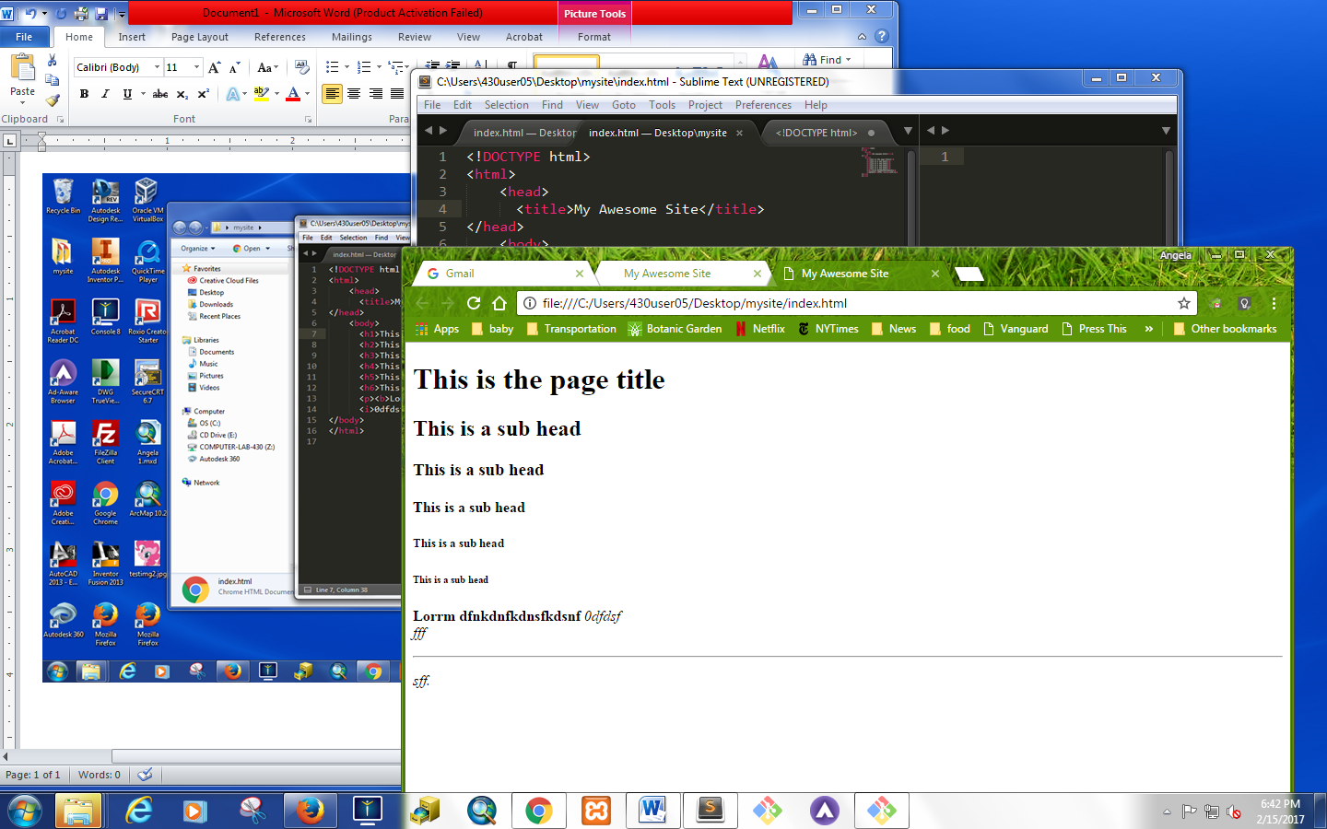

Body Text

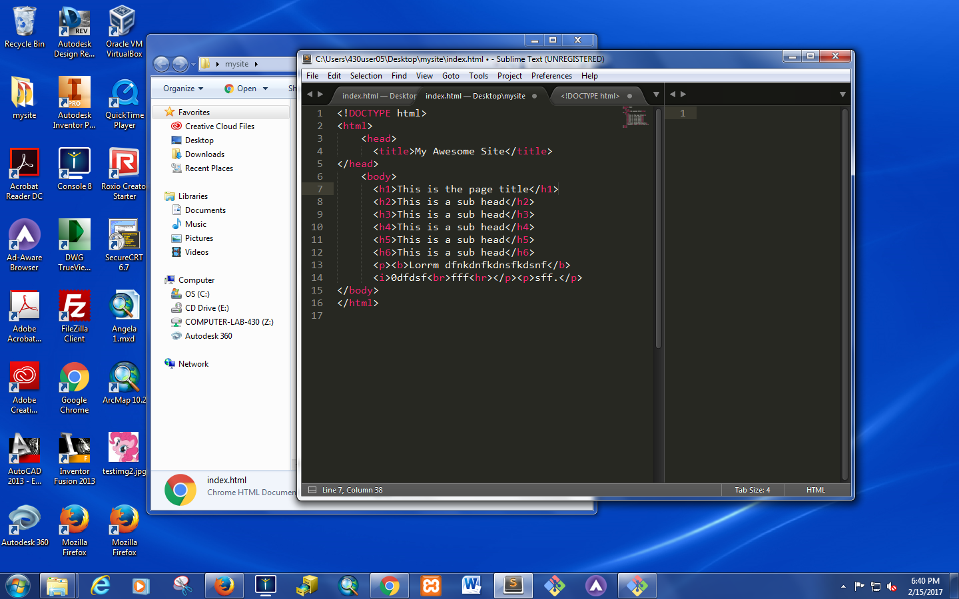

Html has 6 headers

H1 used for titles

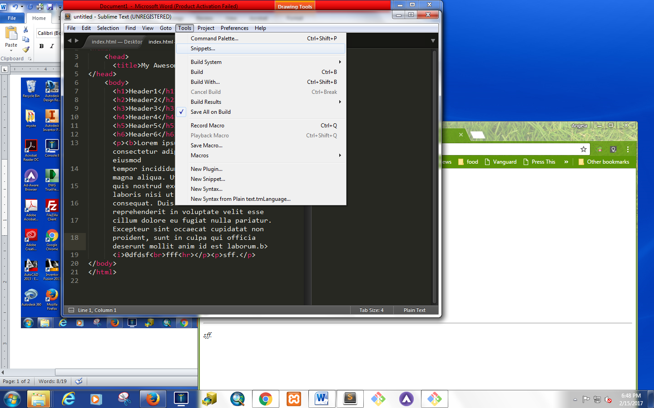

Lorem ipsum

* **Line break = one line <br>**
* **Paragraph = double space <p>**
* **Horizontal rule = horizontal line = <hr>**
* **Difference between relative paths = path to file that exist in route directory i.e. (relative to the document you are working off of)**
* **Absolute path starts with https or http (click copy image address)**
* **<a> = is used for links**
* **Open as a separate tab (enter information as “target")**
  + **<a href="https://www.facebook.com/beyonce/" target="_blank">Bey's fb </a>**

**<ol>**

**<li> thing A </li>**

**<li> thing B </li>**

**</ol>**

**<ul>**

**<li> stuff A </li>**

**<li> stuff B </li>**

**</ul>**

1. *thing A*
2. *thing B*

* *stuff A*
* *stuff B*

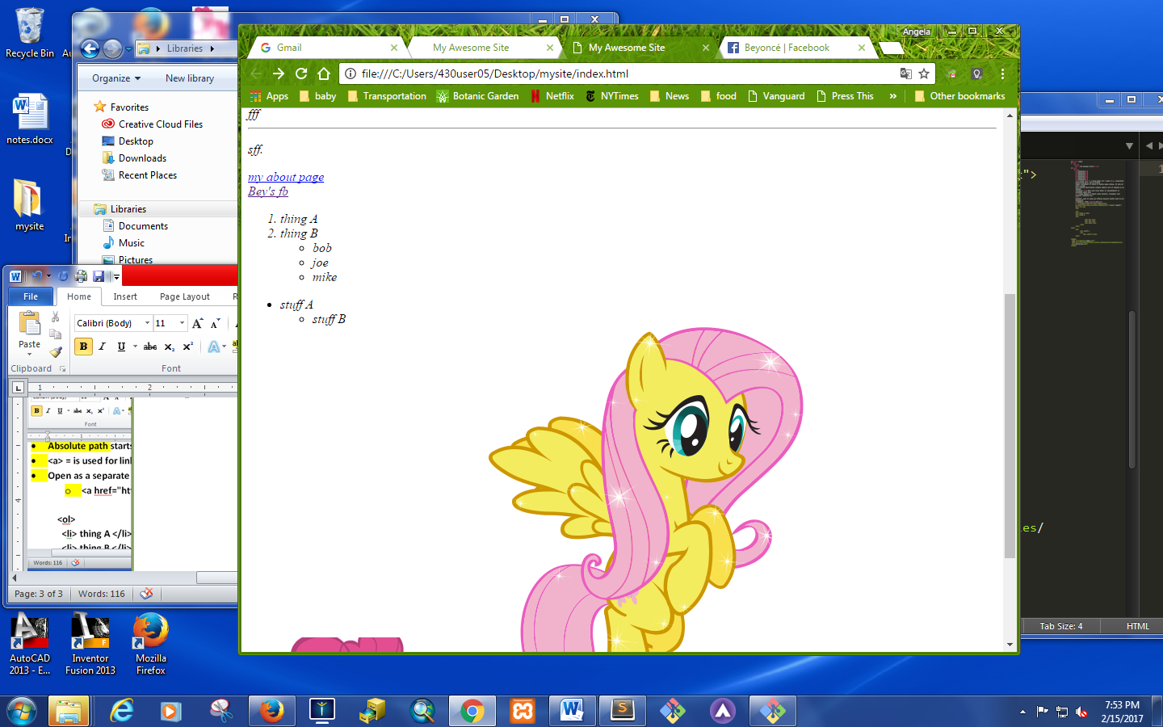   

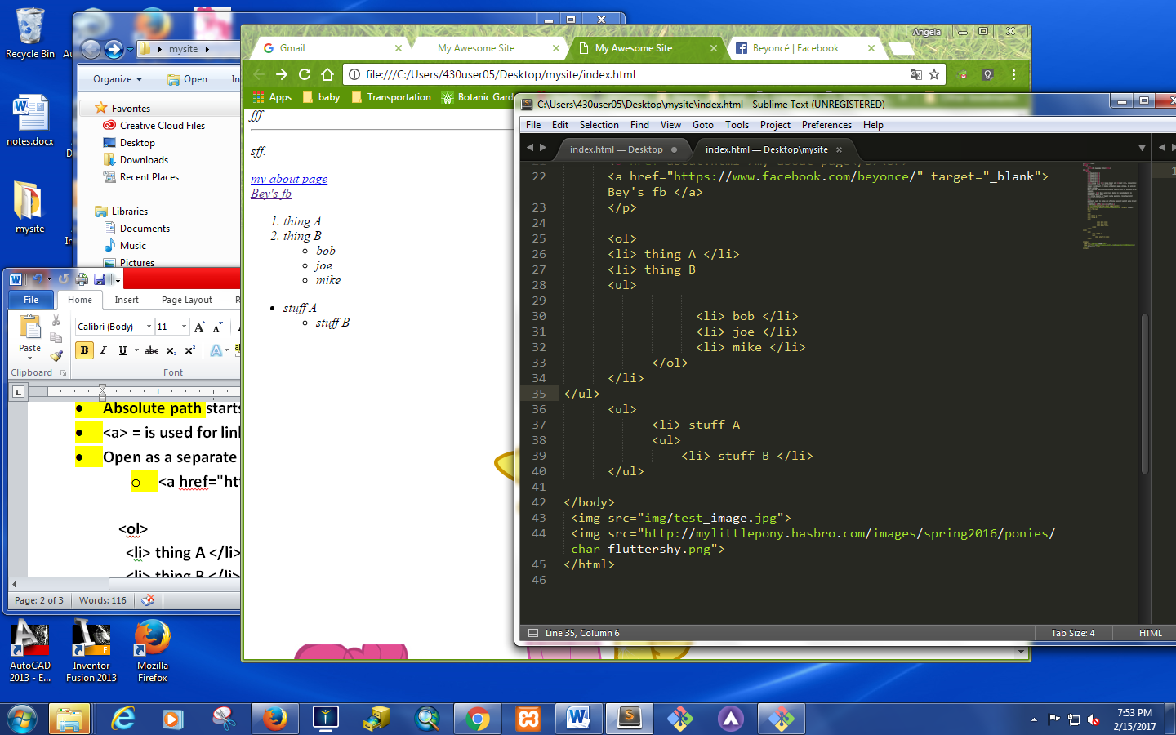

opoip

**<iframe width="560" height="315" src="https://www.youtube.com/embed/sOnqjkJTMaA?rel=0" frameborder="0" allowfullscreen></iframe>**

**HTML Input Types:**

**https://www.w3schools.com/html/html_form_input_types.asp**

