The Method of Fundamental Solutions (MFS)

→ 1964 proposed by Kupradze and Aleksidz [1]
→ charge simulation method, fundamental collocation method, superposition method , fundamental solution method, etc.

In 2D, fundamental solution of Laplace equation: 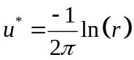

Laplace Equation
Governed equation:
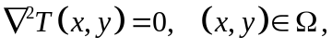
Boundary condition
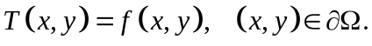
Choosepoints on the boundary, say 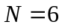, as shown in the following figure
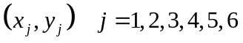
2 1 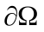

 6
3
5
4

Select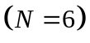 source points outside the domain:
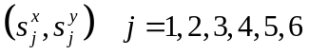

2 1

6
3
5
4

The approximate solution can be written as a linear combination of fundamental solutions：
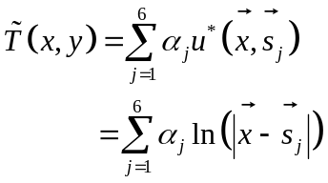

For the first boundary point 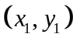, we have：
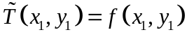
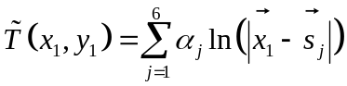
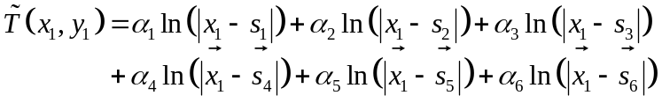
where
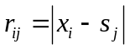.
From the boundary condition at , we have the following equation
Similarly, from the second boundary point and the corresponding boundary condition, we have the following equation：
From the rest of boundary points and boundary conditions, we obtain：

The above six equations can be written in the following matrix form:
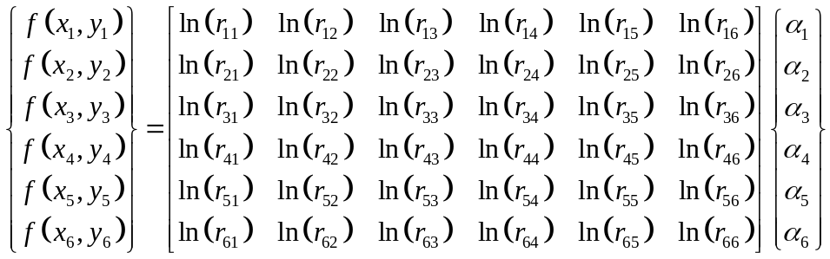
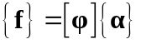
The undetermined coefficients 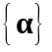 can be obtained by solving the above linear equations:
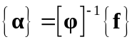

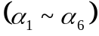 can be considered as the strength of the source points.
Next, we can evaluate the approximate solution 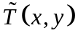at any interior points.
Suppose we would like to find the approximate solution at 7th point 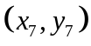.

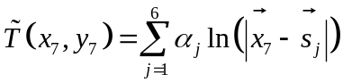
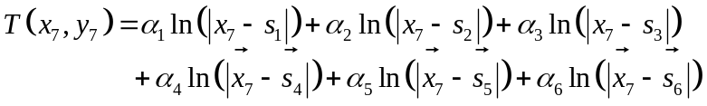

Suppose we have the Neumann boundary condition on points 4,5, and 6, then
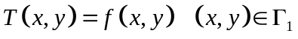
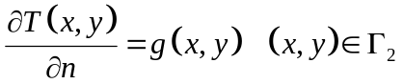
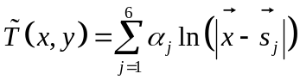
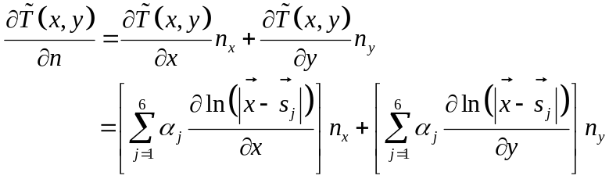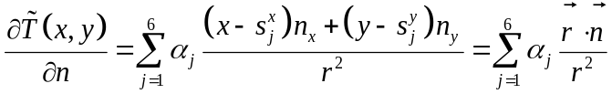
where
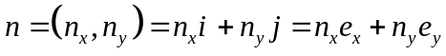

From the 4th boundary point, we have：
From the 5th boundary point, we have：
From the 6th boundary point, we have：

In the matrix form, we obtain
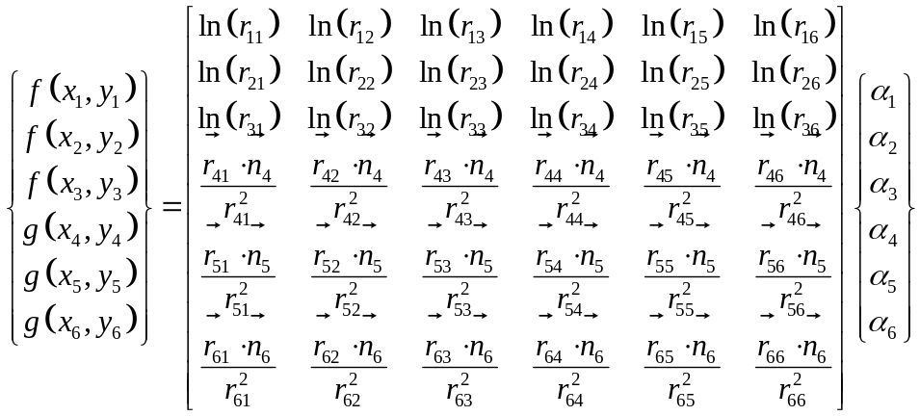

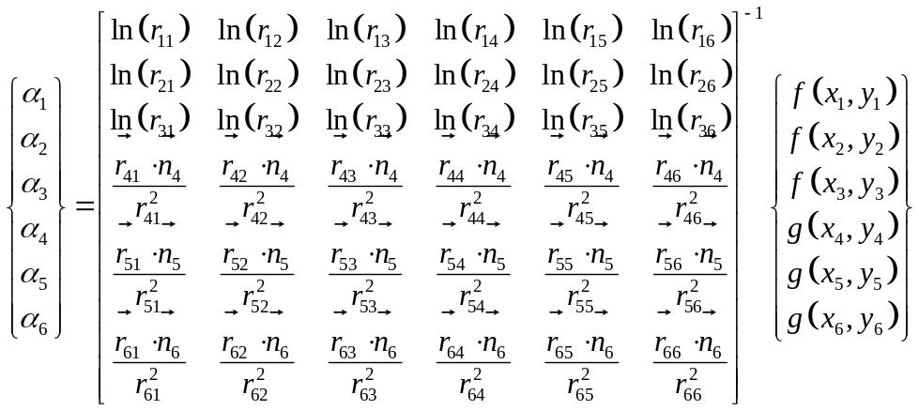

→ For 3D, the fundamental solution of Laplace equation is given by
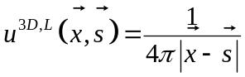
→ The solution procedure of the 3D Laplace equation is the same as above.
→ The MFS is a boundary-type meshless method.

References:
1. V.D. Kupradze and M.A. Aleksidze, The method of functional equations for the approximate solution of certain boundary value problems, USSR Computational Mathematics and Mathematical Physics, 4, 82-126, 1964.

