Optimal Shape Parameter for Reconstruction of PEAKS Using LOOCV

**Assignment # 02**

Submission Date: 09/28/2015

**Rizwan Zahoor**

Laboratory of Multiphase Processes,

Faculty of Physics, University of Nova Gorica Slovenia

# Problem

PEAKS function is a build-in MATLAB function, which is obtained by translating and scaling Gaussian distribution. It is defined in the domain

[-3, 3] x [-3, 3] as follows:



In the 1st assignment it was reconstructed using ,

* Multi Quadric,
* Gaussian,

The shape parameter was calculated using.

In this assignment the Leave-One-Out Cross Validation (LOOCV) will be used to estimate the optimal shape parameter. The results will be compared by choosing shape parameter by other strategies.

## Goal/Objective

It is required reconstruct the PEAKS function using following Radial basis functions,

* Multi Quadric,
* Gaussian,

In each case 30x30 interpolation points will be used as mesh grid points. 16x16 test points will be used for each case.

Shape parameter will be estimated using LOOCV and results will be compared by choosing arbitrary shape parameters.

# Introduction

Leave-One-Out cross-validation (LOOCV) is a validation technique to evaluate the results in statistics analysis.

For a given interpolation points set, the LOOCV take out a single point to estimate the error of RBF approximation which constructed by the rest N - 1 data points. Therefore, the test points for searching an optimal shape parameter can be omitted by repeated N times this procedure for whole interpolation points set.

To actually operate the LOOCV to select an optimal shape parameter, the given interpolation points set  need to be take out a single data points  with corresponding remaining N - 1 data set:

, can be used to construct the approximation 



The LOOCV method can be even more precise, and, unlike previous methods, offers additional precision when utilized with double precision arithmetic.

# Radial basis functions

Radial basis functions are largely used to solve the scattered data approximation in multi-dimensional problems.

A common approach in dealing with scattered data problem is to assume that the trial function is a linear combination of radial basis functions. A radial basis function (RBF) is a real-valued function whose value depends only on the distance from the origin, so that; or alternatively on the distance from some other point , called a center, so that. Any function  that satisfies the property  is a radial function.

Interpolation involves taking given known data points and creating a virtual surface, an interpolant, which must pass through all the known data points. Therefore, in order to recover an unknown function, from a given dataset, containing N distinct scattered data points in the domain, , a necessary assumption for RBF interpolation is that the unknown function, , can be expressed as linear combinations,

### .

Where,  is Euclidian norm  is a kernel which contain any RBF and .

For current assignment following RBFs will be used to reconstruct the given PEAKS function. If given data points  have no noise then by forcing the exact interpolation condition, coefficients  can be calculated. This then provide us the system of equation,

,

Where,  and  is the distance matrix that can be found as,



### Multi Quadric



Where, 

### Gaussian



Where, 

# Results

## Multi Quadrics

*“Leave one out cross validation”* (LOOCV) algorithm is used to find the optimal shape parameter between different intervals and maximum error is computed at the found shape parameter. 900 number of interpolation points were selected and 256 test points were selected for evaluation. Table 1 shows the optimal shape parameter found using LOOCV function provided and error was estimated along with the CPU time for each search.

Table : Optimal shape parameter between different intervals using LOOCV using multi quadric RBF.

|  |  |  |  |  |
| --- | --- | --- | --- | --- |
| **Sr. No.** | **MinC - MaxC** | **Optimal Shape Parameter** | **Error** | **CPU Time** |
| 1 | [0 - 2] | 1.833062 | 2.144E-08 | 2.773839 |
| 2 | [0 - 4] | 2.111456 | 4.608E-09 | 3.683535 |
| 3 | [0 - 6] | 1.854104 | 1.955E-08 | 3.496088 |
| 4 | [0 - 8] | 2.211988 | 1.618E-08 | 4.017649 |
| 5 | [0 - 10] | 2.601133 | 2.556E-07 | 4.179348 |
| 6 | [0 -12] | 1.766419 | 2.700E-08 | 3.981079 |
| 7 | [0 - 14] | 1.888843 | 8.193E-08 | 4.501626 |
| 8 | [0 - 16] | 9.888544 | 5.173E+00 | 4.904727 |
| 9 | [0 - 18] | 1.629365 | 2.262E-08 | 4.687962 |
| 10 | [0 - 20] | 1.826941 | 2.175E-08 | 4.702425 |

Arbitrary values of shape parameter were selected in order to evaluate the error and optimal shape parameter is calculated as in Figure 1.

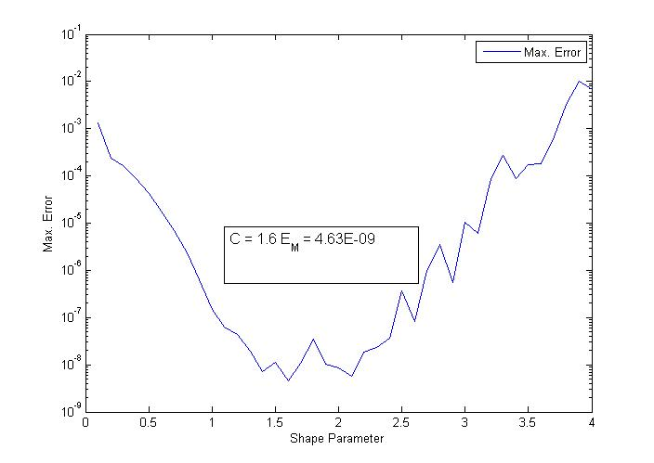

Figure. : Maximum error evaluated by choosing arbitrary values of shape parameter.

Shape parameter found using  is 0.9682 with maximum error 2.004530e-007.

## Gaussian20 x 20 Grid

*“Leave one out cross validation”* (LOOCV) algorithm is used to search the optimal shape parameter between given intervals of shape parameter and maximum error is computed at the found shape parameter. 900 number of interpolation points were selected and 256 test points were selected for evaluation. Table 2 shows the optimal shape parameter found using LOOCV function provided and error was estimated along with the CPU time for each search.

Table : Optimal shape parameter between different intervals using LOOCV using Gaussian RBF.

|  |  |  |  |  |
| --- | --- | --- | --- | --- |
| **Sr. No.** | **MinC - MaxC** | **Optimal Shape Parameter** | **Error** | **CPU Time** |
| 1 | [0 - 2] | 1.013156 | 5.417E-11 | 3.303148 |
| 2 | [0 - 4] | 1.890233 | 1.439E-07 | 2.791499 |
| 3 | [0 - 6] | 1.868801 | 1.124E-07 | 2.862911 |
| 4 | [0 - 8] | 1.894251 | 1.506E-07 | 3.225655 |
| 5 | [0 - 10] | 1.882699 | 1.321E-07 | 5.055357 |
| 6 | [0 -12] | 1.875913 | 1.222E-07 | 4.430684 |
| 7 | [0 - 14] | 1.827866 | 6.808E-08 | 5.273815 |
| 8 | [0 - 16] | 1.907484 | 1.744E-07 | 5.000964 |
| 9 | [0 - 18] | 1.892006 | 1.469E-07 | 4.324306 |
| 10 | [0 - 20] | 1.878536 | 1.259E-07 | 4.50745 |

Arbitrary values of the shape parameter were selected and error was estimated at each point.

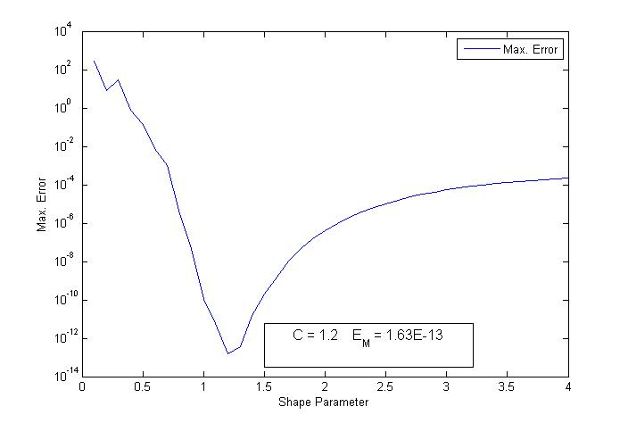

Figure. : Maximum error evaluated by choosing arbitrary values of shape parameter.

# Conclusions

The use of the LOOCV algorithm enables us to select a good shape parameter which is critical to ensure appropriate numerical accuracy. It is found that the search results for optimal shape parameter are well stable and its simplicity in implementing enable its preference using in various class of problems.

Shape parameter found using in multi quadric and Gaussian RBFs is 0.9682 with maximum error 2.004530e-007 and 4.301883e-010.