Solution of Partial Differential Equation Using KANSA Method

**Assignment # 03**

Submission Date: 5/11/2015

**Rizwan Zahoor**

Laboratory of Multiphase Processes,

Faculty of Physics, University of Nova Gorica Slovenia

**Problem Statement**

The partial differential equation (P.D.E) is defined as follows



The exact solution of the above system is, where the computational domain is defined by the following function,

.

In this assignment, Kansa’s method is used to solve this P.D.E with the following ways:

* Using IMQ-RBF, where.
* Using 100 boundary points and 200, 300 and 400 uniformly distributed interior points respectively and show the best accurate solution with the optimal c.
* Using another 120 points inside the domain to test error.

## Boundary Conditions

The domain has the mixed bound conditions, i.e.  is Dirichlet boundary above the X-axis and  is Neumann boundary below the X-axis.

# Kansa's Method (RBF Collocation Method)

Considering the Poisson equation,

,

Where f and g are the known functions. Assuming the solution of the Poisson problem of this form can be approximated by the linear combination of radial basis functions as i.e. IMQ,

, where the distance between the Euclidian centers  and 

**Inverse Multi Quadric RBF**



Now using these derivatives in the Poisson equation it will take the following form,



Now from here we can write the above equation for boundary and interior points as follows,



From these equations we can write in, where the element of the matrix will be filled as,

Solution is formed only for Dirichlet boundary condition so; the matrix will take the following form,



**Normalized Inverse Multi Quadric RBF**



From these equations we can write in, where the element of the matrix will be filled as,

Solution is formed only for Dirichlet boundary condition so; the matrix will take the following form,



**Results**

Different numbers of points are selected on the boundary and inside. In addition to this 117 test points are generated inside to calculate the error. LOOCV technique is used to find the optimal shape parameter.

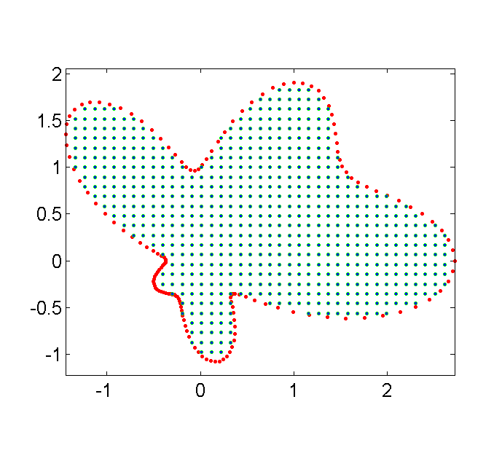

Figure : Domain representing the Dirichlet boundary points, interior points and test points.

The inverse multi quadric RBF is used to calculate the solution of partial differential equation using the subject (KANSA) method. The results are compared with the normalized inverse multi quadric RBF. The optimal shape parameter is found using two strategies as,

1. *Leave one out Cross Validation* (LOOCV)
2. Looking for the optimal shape parameter by calculating the error at each point

Table 1-a: Optimal shape parameter for KANSA method using Inverse Multi Quadric RBF,

(k1 = 606, k2 = 150 and kt = 134).

|  |  |  |  |
| --- | --- | --- | --- |
| Shape Parameter  [MinC – MaxC] | Optimal Shape Parameter | RMS Error | CPU TIME  [Sec] |
| [0 - 2] | 1.633 | 7.015E-6 | 2.54 |
| [0 - 4] | 1.903 | 9.899E-5 | 3.08 |
| [0 - 6] | 1.416 | 1.100E-4 | 2.23 |
| [0 - 8] | 1.962 | 3.724E-5 | 3.68 |
| [0 - 10] | 2.564 | 3.915E-3 | 3.20 |
| [0 - 12] | 2.397 | 5.605E-5 | 2.85 |
| [0 - 14] | 5.418 | 1.803E-3 | 3.47 |
| [0 - 16] | 2.734 | 5.555E-5 | 3.51 |
| [0 - 18] | 2.055 | 4.293E-5 | 4.32 |
| [0 - 20] | 6.923 | 2.489E-3 | 3.29 |

Table 1-b: Optimal shape parameter for KANSA method using Inverse Multi Quadric RBF,

(k1 = 768, k2 = 150 and kt = 150).

|  |  |  |  |
| --- | --- | --- | --- |
| Shape Parameter  [MinC – MaxC] | Optimal Shape Parameter | RMS Error | CPU TIME  [Sec] |
| [0 - 2] | 1.233 | 4.019E-6 | 4.049 |
| [0 - 4] | 3.056 | 2.644E-4 | 5.07 |
| [0 - 6] | 2.252 | 3.079E-2 | 4.67 |
| [0 - 8] | 3.013 | 4.819E-4 | 5.39 |
| [0 - 10] | 3.819 | 2.043E-3 | 4.95 |
| [0 - 12] | 4.083 | 2.260E-3 | 5.59 |
| [0 - 14] | 2.043 | 2.151E-4 | 5.96 |
| [0 - 16] | 2.334 | 1.533E-4 | 6.40 |
| [0 - 18] | 2.631 | 1.976E-4 | 4.73 |
| [0 - 20] | 5.236 | 8.828E-4 | 5.80 |

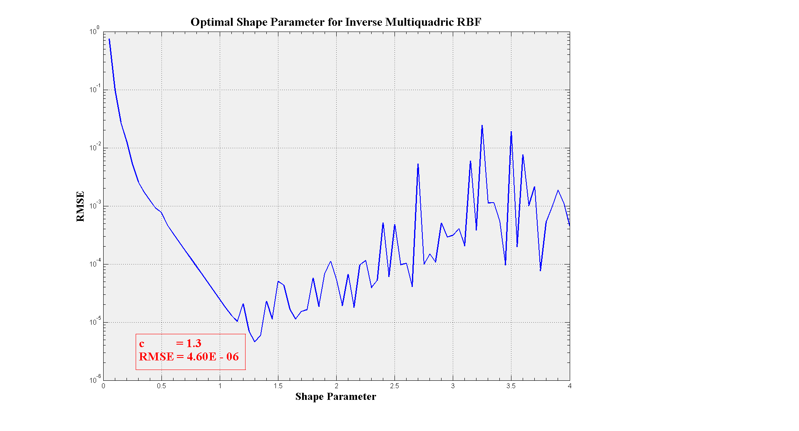

Figure 2: Optimal shape parameter by calculating the error at each point between c = 0.0 – 4.0 with, k1 = 606, k2 = 150 and kt = 134 using inverse multi quadric RBF.

Similarly the normalized inverse multiquadric RBF is use for soving PDE for various number oif interior and boundary points. Optimal shape parameter is found using LOOCV and calculating the error at various points between an interval.

Table 2-a: Optimal shape parameter for KANSA method using Normalized Inverse Multi Quadric RBF, (k1 = 606, k2 = 150 and kt = 134).

|  |  |  |  |
| --- | --- | --- | --- |
| Shape Parameter  [MinC – MaxC] | Optimal Shape Parameter | RMS Error | CPU TIME  [Sec] |
| [0 - 2] | 1.024 | 2.830E-5 | 3.55 |
| [0 - 4] | 0.891 | 1.125E-5 | 3.33 |
| [0 - 6] | 1.121 | 4.960E-5 | 2.49 |
| [0 - 8] | 1.178 | 6.584E-5 | 3.21 |
| [0 - 10] | 0.879 | 9.981E-6 | 3.57 |
| [0 - 12] | 0.745 | 2.843E-6 | 3.73 |
| [0 - 14] | 0.770 | 3.632E-6 | 3.05 |
| [0 - 16] | 0.469 | 9.109E-5 | 3.33 |
| [0 - 18] | 0.824 | 6.155E-6 | 3.23 |
| [0 - 20] | 1.1079 | 4.623E-5 | 3.22 |

Table 2-b: Optimal shape parameter for KANSA method using Normalized Inverse Multi Quadric RBF, (k1 = 768, k2 = 150 and kt = 150).

|  |  |  |  |
| --- | --- | --- | --- |
| Shape Parameter  [MinC – MaxC] | Optimal Shape Parameter | RMS Error | CPU TIME  [Sec] |
| [0 - 2] | 1.138 | 2.189E-5 | 4.54 |
| [0 - 4] | 1.009 | 9.376E-6 | 3.62 |
| [0 - 6] | 1.011 | 9.531E-6 | 6.04 |
| [0 - 8] | 0.871 | 4.810E-6 | 5.28 |
| [0 - 10] | 0.927 | 9.647E-6 | 4.47 |
| [0 - 12] | 1.303 | 5.125E-5 | 5.27 |
| [0 - 14] | 0.744 | 5.920E-6 | 5.43 |
| [0 - 16] | 0.805 | 2.894E-6 | 5.14 |
| [0 - 18] | 1.087 | 1.598E-5 | 7.08 |
| [0 - 20] | 1.1479 | 2.317E-5 | 5.51 |

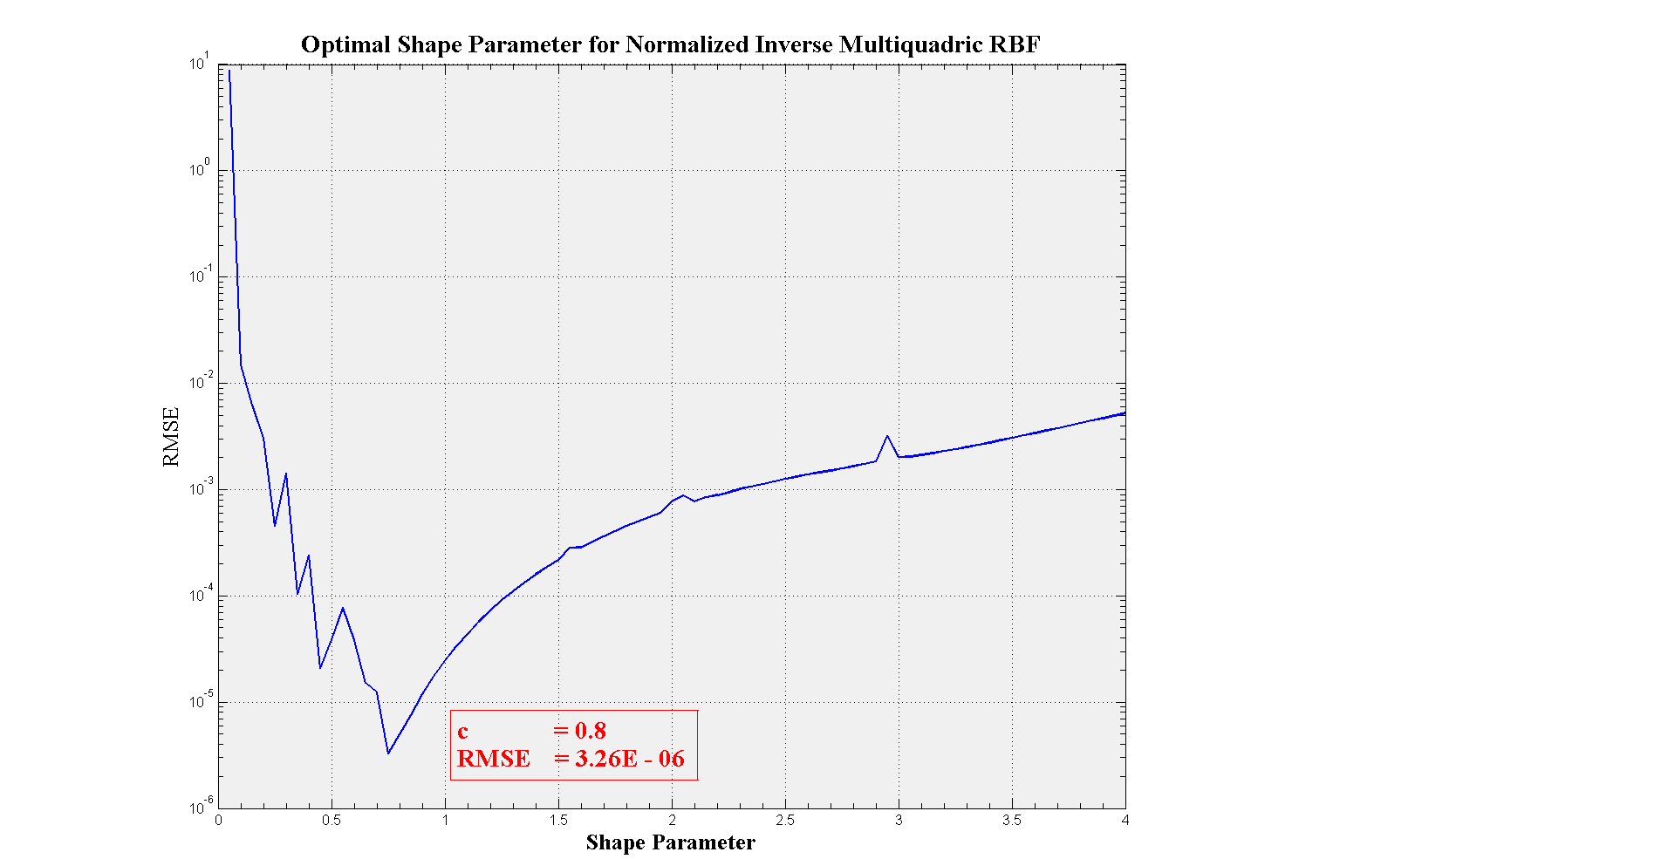

Figure 3: Optimal shape parameter by calculating the error at each point between c = 0.0 – 4.0 with, k1 = 606, k2 = 150 and kt = 134 using normalized inverse multi quadric RBF.

Conclusions

The inverse multi quadric (IMQ) RBF is used to calculate the solution of given elliptical partial differential equation. The results calculated for various interior and boundary points are well stable except few jumps with IMQ. The results obtained by LOOCV technique as in table (1-a) and (1-b) behave well in accordance with, when arbitrary shape parameters are used to calculate the RMSE at each point as in figure (2).

After normalizing the given RBF solution is again calculated for different shape parameters shown in figure (3) and then compared with the LOOCV and found better in agreement than the results obtained from IMQ without normalization. The solution is much more stable with the use of normalized IMQ.