**Image Compression**

% Read the picture of the tiger, and converts it to black and white.

tiger = rgb2gray(imread('tiger.jpg'));

% Downsize the sample, just to avoid dealing with high-res images.

tiger = im2double(imresize(tiger,.5));

imshow(tiger)； %plot the tiger

% Compute SVD of the tiger

[U, S, V] = svd(tiger);

% Plot the magnitude of the singular values (log scale)

sigmas = diag(S);

figure; plot(sigmas); title('Singular Value');

%figure; semilogy(sigmas);

figure; plot(cumsum(sigmas) / sum(sigmas));

title('Cumulative Percent of Total Sigmas');

n = 100; % rank=n, choose first n singular values

approx_sigmas = sigmas(1:n);

approx_S = diag(approx._sigmas);

approx_tiger = U(:,1:n) * approx_S * V(:,1:n)';

imshow(approx_tiger)

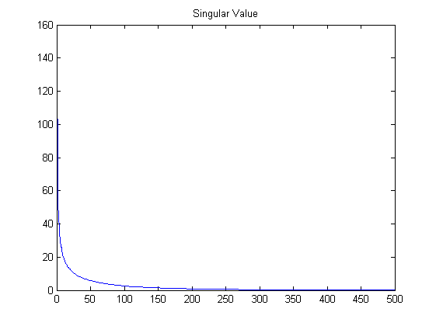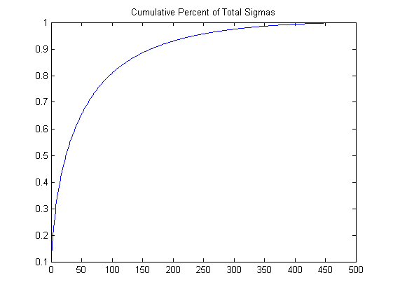

Singular values Cumulative percent of total singular values

