Amartya Sinha  
PPHA 39930  
Assignment 1  
January 14, 2024

Q1. In class, we derived the Earth’s surface temperature using a simple energy balance model with a one-layer atmosphere. Now, you’ll derive the energy balance with a partly transparent atmosphere.

(a) Draw a diagram like the one on slide 36/120 in “Climate change crash course” lecture slides, but this time *include a term and arrows for a partially transparent atmosphere*

(b) Write out the energy balance equations for an atmosphere with an emissivity1, ϵ.

(c) Solve the equations for TS, the temperature of the Earth’s surface

(d) Assume the following values and calculate TS: S = 1370 Wm−2; ϵ = 0.78; A = 0.3

(e) One of our neighbours, Mars, has an average solar constant of SM = 589 Wm−2, an albedo of AM 0.24, and a surface temperature of -46◦C. What would its atmospheric emissivity, ϵM, need to be to achieve that surface temperature?

Added dotted lines to represent energy absorbed and radiated by a partially transparent atmosphere, with the emission represented by ϵ.

b) Based on the slide, we know that:

Incoming solar radiation: S/4  
Reflected by Earth’s atmosphere: AS/4, where A represents albedo  
Absorbed by earth’s surface: (1-A)(S/4)  
Emitted by Earth’s surface: σTS­­4, where TS is Earth’s surface temperature  
Absorbed by the atmosphere: (1- ϵ)σTS4, where ϵ is the emissivity of the atmosphere  
Emitted by the atmosphere back to space: ϵσTe4  
Emitted by the atmosphere back to Earth’s surface: ϵσTe4

c) Energy balance equation for the Earth’s surface: (S/4)(1 – A) = ϵσTS4  
Solving for TS, we get:

d) Given S = 1370 Wm-2, ϵ = 0.78 and A = 0.3  
We know that the Stefan-Boltzmann constant σ = 5.67 x 10-8 Wm-2K-4  
Substituting this value in the above, we get

or TS = 271.344 K, or approximately -1.806 C

d)

Q2. In late 2019 and early 2020, Australia witnessed some of the worst bushfires in history. There has been concern that precipitation has been gradually decreasing in many parts of Australia over the last 60 or so years. Not all such beliefs are necessarily supported by actual data.

One of the most useful historical climate datasets is the Global Historical Climate Network dataset. Go to [NOAA Climate Data Online](https://www.ncdc.noaa.gov/cdo-web/) and you can find daily, monthly, or annual summaries of reporting weather stations from all over the world. For this assignment, I’ve prepared a dataset for you. Download the file perth airport.csv from Canvas. This is the monthly total precipitation (in mm) and temperature (in ◦C) records at Perth Airport (station ID: IWMO 94610), in southwestern Australia. You are going to explore some trends. The data are available from 1944 to 2019. Such a long station history makes possible a wealth of statistical experiments. Perth is known to have a “Mediterranean climate” - most of its precipitation is in the winter, very little is during summer.

(a) Plot a figure of the monthly climatology of precipitation. That is, the average for each month of the year taken across the years 1981-2010. What is the rainiest month?

(b) Plot the July rainfall for each year (since 1944) in the dataset and fit a linear trend line. Interpret the trend. Perform a statistical test that the later period (1981-2010) is statistically different than the earlier period (1951-1980). What is the result?

(c) Rainfall may occur over all winter months. Take the average across May-August and plot the trend in average winter rainfall (since 1944). Interpret the trend. Run your test again. What is the result?

Q2. a) The rainiest month on average across 1981 to 2010 is July, as evident from the below bar plot of the monthly climatology of precipitation.

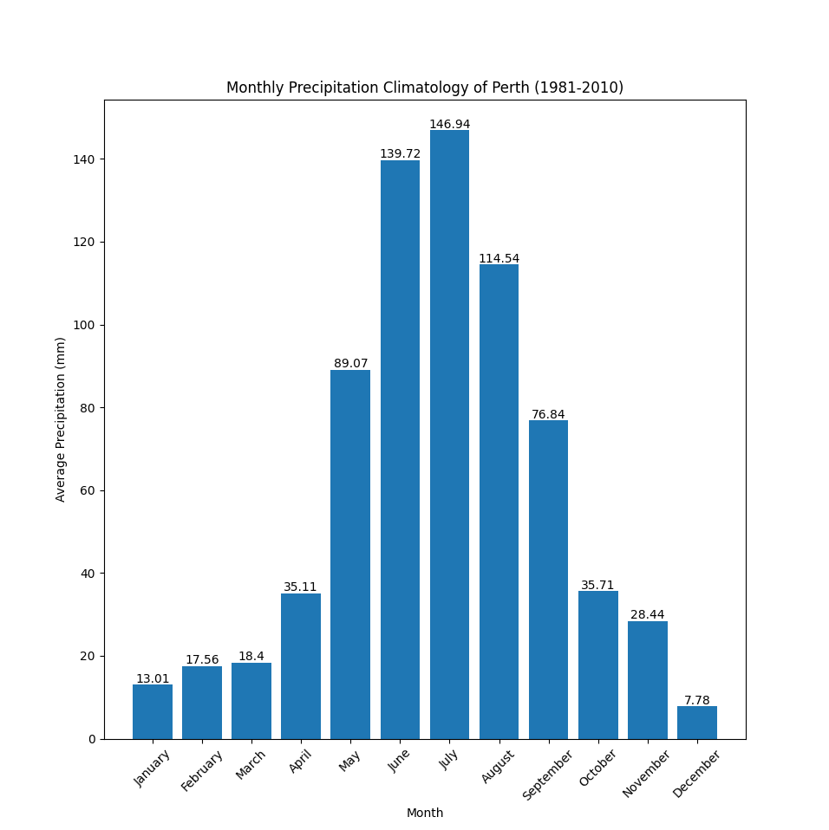

b) The trend line for the rainfall in July over the years 1944-2019 in Perth shows a slight downward trajectory, indicating a decrease in rainfall in the month of July over the years.

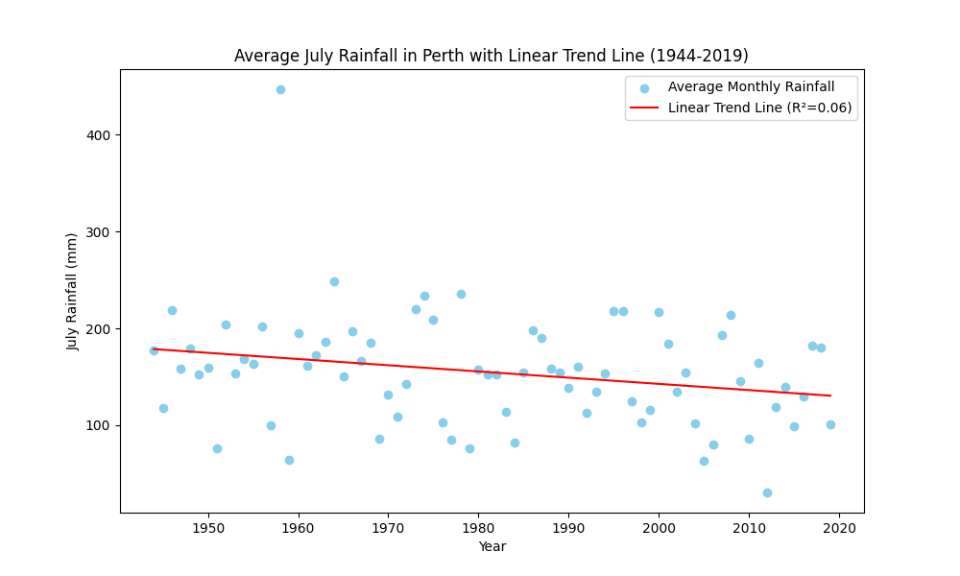

Based on the two-sample t-test performed using the scipy library in Python (see attached file), we see that the difference between the two periods is not statistically significant (fail to reject H0). This means that there is insufficient evidence to conclude that there is a significant difference in July rainfall between the earlier period (1951-1980) and the later period (1981-2010). Based on the available data and the statistical test performed, the variation in July rainfall observed between the two periods could be due to random chance rather than a systematic, significant change.

c) The trend line for rainfall during winter months in Perth over 1944 to 2019 shows a clear downward trajectory over time, indicating a steady decline in rainfall over the years. While there are outliers, the R-squared value of 0.28 shows a weak but present correlation between years and decrease in rainfall.

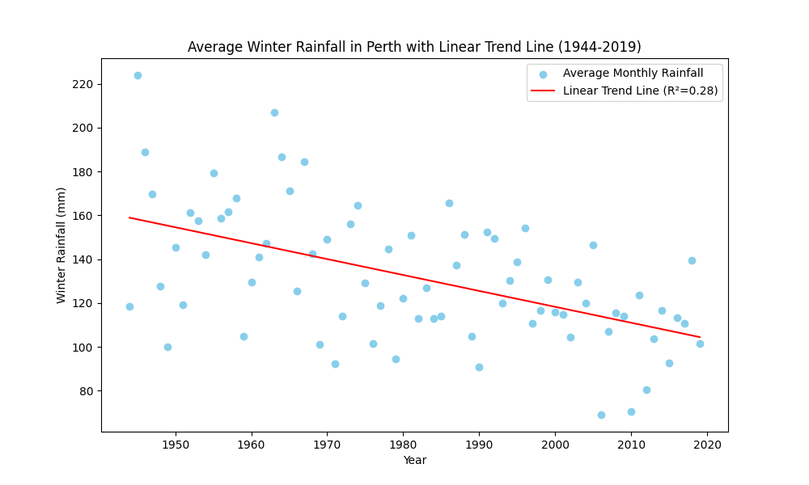

The result of the two-sample t-test shows that the difference in average winter rainfall trend is statistically significant. This is determined by comparing the p-value (0.005177858501204699) to the significance level (0.05). Since the p-value is less than the significance level, we reject the null hypothesis (H0), which typically states that there is no effect or no difference.

In this context, rejecting H0 means that there is a statistically significant difference in the average winter rainfall trend between the two periods being compared. The positive t-statistic of 2.905853284992847 indicates that the average winter rainfall in the later period is higher than in the earlier period.

However, it’s important to note that while the difference is statistically significant, it doesn’t necessarily mean it is practically significant or meaningful. The magnitude of the difference and its potential impact should also be considered. Additionally, this is a simple analysis and there may be other factors at play that are not considered in this test. For a more comprehensive understanding, a more detailed analysis could be performed considering other variables and using more complex statistical models.